L2

Lake House, now the Fontainebleau Inn

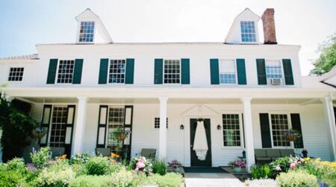

Location: 2800 State Route 228, Alpine, New York.
Built: 1814.

History
The property now known as the Fontainebleau Inn, on the shore of Cayuta Lake in Schuyler County, New York, originated in the early nineteenth-century settlement of the lake by the Lawrence family. Following the Revolutionary War, the family acquired extensive lands around what was then commonly called Kayutah Lake, and several brothers established residences there, forming one of the area’s earliest and most enduring settlement clusters.

The earliest Lawrence residence associated with the site was built or occupied by Joseph Lawrence (1783–1817). His stay at Cayuta Lake was brief, owing to ill health, and he died young in 1817. Contemporary and later local accounts referred to his dwelling simply as the “Lake House,” a descriptive term that persisted in regional memory. This early house does not appear to have served as the principal family seat and underwent little subsequent development.
In 1814, Joseph’s elder brother Samuel Lawrence (1773–1837) constructed a more substantial lakeside house that became the primary Lawrence family residence on Cayuta Lake. Samuel settled permanently in the area with his wife Elizabeth and later served in the New York Assembly and the United States Congress. The house he built replaced or absorbed the earlier Lawrence occupation and emerged as the dominant family property on the lake.
During the later nineteenth century, the house passed through collateral lines of the Lawrence family. It was eventually inherited by Mrs. Henrietta Lawrence Butler, widow of Dr. George H. Butler, who received the property from her uncles Abraham Lawrence and Dr. Jonathan Lawrence, and from her aunt Jane Lawrence Campbell. This inheritance reflects the consolidation of Lawrence family holdings as the original Cayuta Lake generation died out.
As Cayuta Lake evolved from an early settlement landscape into a resort area, the Lawrence house transitioned from a private family residence to commercial hospitality use. Renamed the Fontainebleau Inn, it became a prominent lodging and social destination on the lake. Despite later adaptations, the building remains the surviving architectural expression of the Samuel Lawrence house of 1814, while preserving through name and tradition the memory of Joseph Lawrence’s earlier “Lake House.”

Lawrence Family

Legendary and Misattributed Origins
For centuries, imaginative genealogists embellished the remote ancestry of the Lawrences. Because the Roman family of the Laurentii existed, some assumed that the English Lawrences must descend from them. Others linked the family to various prominent medieval or early modern Lawrences simply because of the shared surname.

A recurring tradition claimed descent from a Sir Robert Lawrence of Ashton Hall, said to have “planted the banner of the Cross on the battlements of St. Jean d’Acre” during the Third Crusade and to have received knighthood and arms from Richard the Lionheart. His descendants supposedly included Sir James Lawrence, who married Matilda Washington; a Lawrence Washington who purchased the Mount Vernon estate and left it to his half-brother George Washington; and a Henry Lawrence (1600–1664), a political leader during the English Civil War and one of the patentees of Connecticut in 1635.
These associations are interesting possibilities for connecting the American Lawrences to wider English and Colonial history, but no reliable evidence links these individuals to the Long Island Lawrences.

Proven English Origins
The earliest ancestor who can be identified with reasonable certainty is John Lawrence, chief burgess of St. Albans in 1553 and mayor of that city from 1567 to 1575. He married Katerin Beaumont. Their son John married Margaret Robertes in 1586; they had Thomas Lawrence. The family was already established in St. Albans, and the speed with which they succeeded in the colonies suggests they may have brought both capital and political acumen from England.

Emigration to New England
The earliest fully documented ancestral line begins with Thomas Lawrence (1589–1625) of St. Albans, Hertfordshire. He married Joan Antrobus (1592–1659) and had three sons:
• William Lawrence (1622–1689)
• Thomas Lawrence (1619–1703)
• Joseph Lawrence (1618–1667)
Thomas died in England. His widow Joan married John Tuttle (1596–1656), and the entire combined family sailed to Massachusetts on the Planter in 1635 with Gov. Winthrop of the Massachusetts Bay Colony. From this point forward, documentation is far more secure, though the frequent repetition of the name John Lawrence occasionally causes confusion.

Early American Settlement and Prosperity
The Lawrences appear to have arrived with some means and, soon after moving to Long Island, became among the wealthiest families in New Netherland. They quickly rose in political and commercial life.

They were either already inclined toward Quakerism before leaving England or attached themselves to the Society of Friends soon after arrival. They were associated with the early Quaker communities in Flushing, Long Island, and intermarried with many of the prominent Quaker families of that meeting.
By 1770, the family had accumulated enough wealth and stability that Jonathan Lawrence retired to a house once owned by his great-grandfather, Thomas Lawrence the Settler.

Reputation, Finance, and Public Trust
Quaker families earned reputations for honesty, and the Lawrences became trusted in commercial and financial matters. Members of the family were involved in the founding of the New York Stock Exchange, and several served as its presidents. Their stability reinforced this trust: Lawrence families tended to remain in the same houses for generations, one member even dying at an advanced age in the same room in which he had been born.

Marriage Patterns and Interconnections
The Lawrences followed the biblical injunction to “be fruitful and multiply” with enthusiasm. Ten or more children per household was not uncommon, and many survived to adulthood. As a result, Lawrence cousins frequently married each other, intertwining lineages. Early Quaker discipline opposed cousin marriages, prompting some Lawrences to leave Friends and join other churches, notably the Episcopal Church.

The families into which the Lawrences married often treated the connection as prestigious and repeated the Lawrence name across generations. An English collateral line, the Jones baronets, even adopted the hyphenated surname Lawrence-Jones.

Social Standing in New York
The Lawrences were among the seventeenth-century elite of New Amsterdam and stood among the oldest families of New York, comparable to old Dutch merchant families. In the nineteenth century, they intermarried with other long-established families, including the Alexandre family, adding a Catholic line to the broader kin network. They made fewer alliances with the nouveau riche of the Gilded Age, though some marriages connected them with the Vanderbilts and similar families.

Upon reading Edith Wharton, one Lawrence descendant exclaimed, “These are my people!”—a remark that captures the family’s affinity with the old, understated New York elite rather than the ostentatious climbers of the Gilded Age.

Public Role and Character
The Lawrences were prominent in New York life but less so on the national political stage. Apart from Captain James Lawrence of “Don’t give up the ship!” fame—whose relationship to the Long Island Lawrences is doubtful—the family name rarely appears in standard American history texts. Their influence was more often exercised in the second tier of American society: finance, commerce, and civic life. Their legacy ranges from the New York Stock Exchange to architectural contributions to the White House.

The Lawrences and Slavery
Family members stood on both sides of the slavery question. In general, they advocated gradual manumission rather than immediate abolition, though some owned enslaved people and defended the institution. They tended to avoid public extremes or confrontational politics, likely because such conflicts threatened commercial relationships that extended across religious and political boundaries.

Descent to the Post–World War II Smith Generation
All direct descendants of Thomas Lawrence (1589–1625) are cousins. Because cousin marriages occurred frequently, many modern descendants are related to the Lawrences through multiple lines. Ancestry.com often prefers to describe such connections by elaborate in-law relationships rather than the more accurate repeated cousinships. In this encyclopedia, the relationships are described as Ancestry.com presents them to Mary Elizabeth Alexandre Smith Podles, the representative of the post–World War II Smith generation.

Her siblings are: Kennedy Smith, Edward Caldwell Smith, Frederick Alexandre Smith, Mark Smith, and Anne Templeton Smith.

Line of Descent:

Thomas Lawrence to Mary Elizabeth Smith
——— ❦ ———
Gen. 1 – Thomas Lawrence (1589–1625)
Gen. 2 – William Lawrence (1622–1680), son of Thomas
Gen. 3 – Joseph Lawrence (1668–1759), son of William
Gen. 4 – Richard Henry Lawrence (1691–1781), son of Joseph
Gen. 5 – John Lawrence (1732–1794), son of Richard Henry
Gen. 6 – John Burling Lawrence (1774–1844), son of John
Gen. 7 – Edward Newbold Lawrence (1805–1839), son of John Burling
Gen. 8 – Frederick Newbold Lawrence (1834–1916), son of Edward Newbold
Gen. 9 – Elizabeth Boyce Lawrence (1862–1906), daughter of Frederick Newbold
Gen.10 – Mary Elizabeth Alexandre (1894–1970), daughter of Elizabeth Boyce Lawrence
Gen.11 – Mary Elizabeth Rutter (1920–2003), daughter of Mary Elizabeth Alexandre
Gen.12 – Mary Elizabeth Alexandre Smith (1951– ), daughter of Mary Elizabeth Rutter
——— ❦ ———

Lawrence Family Cemetery
Location and Description
The Lawrence Family Cemetery is located at the corner of 216th Street and 42nd Avenue in Bayside, Queens, New York. It is one of three family burial grounds historically owned by the Lawrences in Queens, of which two still survive. The cemetery occupies part of the land originally deeded to John Lawrence (1618–1699) and his younger brother William Lawrence (1622–1680) in 1645 by Governor Willem Kieft of New Netherland.

Historical Background
John Lawrence, one of the original grantees of the land on which the cemetery stands, served as Mayor of New York City in the late seventeenth century, holding office in 1672 and again in 1691. For many generations the Lawrences used part of the property as a family picnic ground known as “Pine Grove,” a name that reflects the wooded setting that once characterized the area.

Burials
There are between forty and fifty graves within the cemetery grounds. Interments began in 1832 and continued until 1939. Among those buried there are notable members of the Lawrence family, including:
• Cornelius W. Lawrence, Mayor of New York City
• Judge Effingham Lawrence
• Frederick Newbold Lawrence
• Mary Nicolls Lawrence, second wife of Mayor Andrew H. Mickle
The cemetery provides a small but significant record of a family whose members were deeply entwined with the history of New York from the seventeenth century onward.

Landmark Designation and Preservation
The Lawrence Family Cemetery was designated a New York City Landmark on August 2, 1967. The site is currently managed by the Bayside Historical Society. The New York City Landmarks Preservation Commission, in its 1967 designation, described the cemetery as “an important and impressive small burial plot situated in a tree-shrouded landscaped enclosure” containing “handsome headstones marking the last remains of the descendants and heirs of a Seventeenth Century New York family associated with the historical, political and cultural growth of our City and our Country.”

Lawrence Family Graveyard (Dutch Kills / Astoria)
Location and Description
The Lawrence Family Graveyard stands at the southeast corner of 20th Road and 35th Street in the Steinway/Ditmars section of Astoria, Queens. The half-acre plot is enclosed by masonry walls and iron fencing and today lies mid-block within a residential grid. It contains approximately 89 graves. (Landmarks Preservation Commission, designation report, April 19, 1966.)

Historical Background
According to the New York City Landmarks Preservation Commission, burials here date to 1703, when Major Thomas Lawrence was interred. The site remained in family use into the twentieth century; Miss Ruth Lawrence, described as the last family member resident in Astoria, was buried here in 1956. The roster includes numerous officeholders and military figures connected to the Astoria/Newtown branch of the family.

Burials
Prominent interments named by the LPC include Major Jonathan Lawrence (1737–1812), a Revolutionary War figure and public official. Period journalism and later local histories expand the list, but the LPC remains the most authoritative single synopsis.

Landmark Designation and Stewardship
The site was designated a New York City Landmark on April 19, 1966 (LP-0136). The designation report emphasizes both the historical significance of those buried and the aesthetic character of the grounds. Local volunteers and caretakers restored the cemetery after episodes of vandalism in the mid-twentieth century.
Lawrence Homestead I
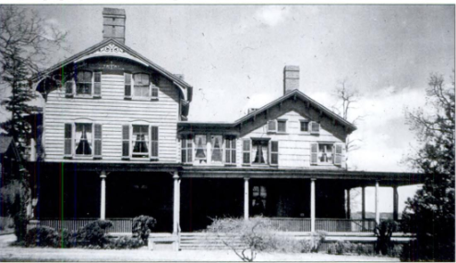

Location: Bayside, Queens
Built: 1645; many additions
Architectural Description
The Lawrence Homestead at Bayside, Queens, was a large, multi-period frame house reflecting more than three centuries of continuous adaptation. By the late nineteenth century, the surviving structure presented as a three-story manor house with two attics, containing approximately fourteen principal rooms, four full baths, additional service rooms and bath, front and rear living rooms, a dining room, and several principal bedrooms. Its scale and internal complexity distinguished it from later suburban houses and reflected its long use as a principal family seat rather than a single-generation dwelling.

The original house of 1645 was of heavy timber-frame construction, weatherproofed with axe-hewn wooden shingles and secured with hand-wrought iron nails. Thick, broad doors were specifically noted as a defensive feature. Later built-in bookcases lined the walls of many rooms. Franklin fireplaces were incorporated into the living and dining rooms, combining eighteenth-century technology with later domestic comfort. Interior furnishings included black walnut and mahogany furniture, some imported from England and preserved in use across generations.
In 1878, a substantial addition was constructed, including a wrap-around porch that unified older sections of the house and gave the homestead the appearance seen in late nineteenth- and early twentieth-century photographs. This porch visually transformed the earlier core into a more expansive country manor while retaining its vernacular frame character. The grounds formed an integral part of the architectural ensemble, featuring mature elms, maples, fruit trees, locusts, planes, and weeping willows. A giant purple beech planted by a member of the Lawrence family more than seventy years earlier stood near the entrance, and a group of four horse-chestnut trees was repeatedly celebrated in contemporary accounts. A 1927 photograph records that formal flower beds were laid out over a large Indigenous shell mound, indicating the site’s pre-colonial occupation (below).
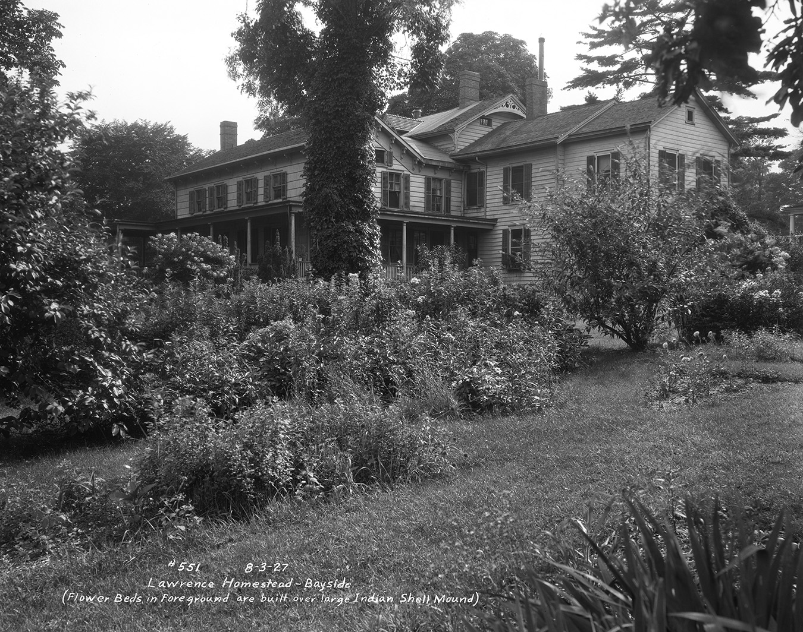

History
The Lawrence Homestead was the ancestral home of the Lawrence family for nine generations and dates to 1645, when William Lawrence is said to have built on the site. The property functioned as a continuous family domicile from the seventeenth century through the early twentieth century, making it one of the longest-held family properties on Long Island.
Originally, the house was substantially larger than its later form. In 1822, Effingham Lawrence partially dismantled earlier sections of the homestead in order to salvage heavy timbers for the construction of his nearby Stone House, a practice consistent with the reuse of valuable materials within extended family estates. Subsequent generations retained and adapted the remaining structure rather than replacing it, resulting in a layered building that embodied multiple architectural periods.
The homestead was closely associated with prominent members of the Lawrence family and their public roles. Tradition held that John Lawrence, Revolutionary-era judge advocate at the trial of Major John André and later a United States Senator and federal judge, resided there. The property was also tied to colonial governance through family tradition surrounding Elizabeth Smith Lawrence and Sir Philip Carteret, Colonial Governor of New Jersey, further enhancing its symbolic importance within Lawrence family memory.
By the late nineteenth century, the homestead served not only as a residence but also as a ceremonial family center. It was the setting for what was described as the final Lawrence wedding held at the ancestral home: the marriage of Dorothy Quincy Lawrence to George Hopper Fitch. Shortly thereafter, Dorothy’s grandmother, Mrs. Effingham Lawrence, offered to donate the house and approximately twenty acres of surrounding land to the City of New York, with the intention that it be preserved as an outdoor museum commemorating North Shore and colonial history.
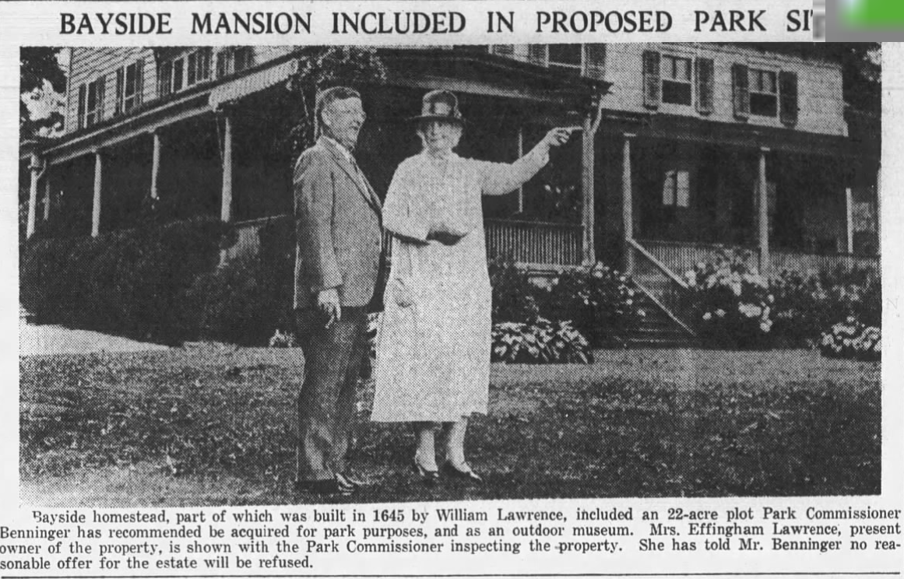
Although the house later suffered fire damage and the museum plan was not permanently realized, the Lawrence Homestead remained into the twentieth century a rare example of a continuously occupied colonial family house. Its long history of partial demolition, reuse, expansion, and preservation made it an unusually rich physical record of family continuity, architectural evolution, and early settlement patterns in northeastern Queens.

Lawrence Homestead II

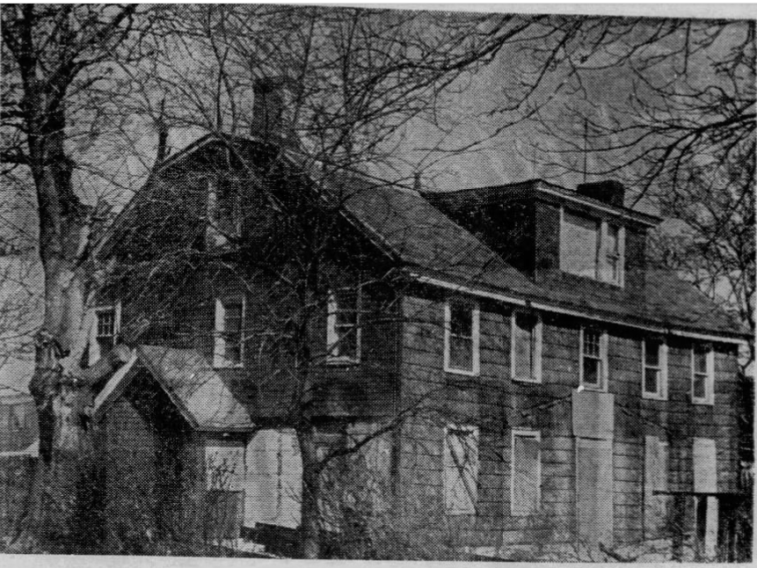
Location: originally 14th Avenue in College Point, Queens
Built: 1770

History
According to tour information, this house was bought in 1774 by Leonard Lawrence (1741-1821). The Lawrence family lived in it until 1874. In 1972 the house was moved to Old Bethpage Village on Long Island.

The color photos are of the restored house.

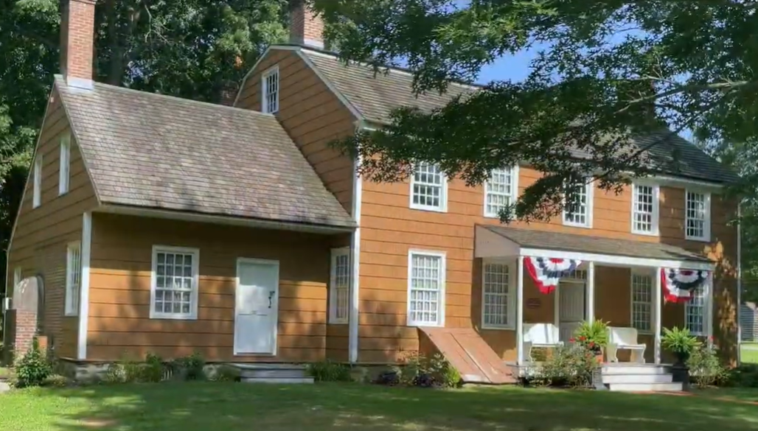
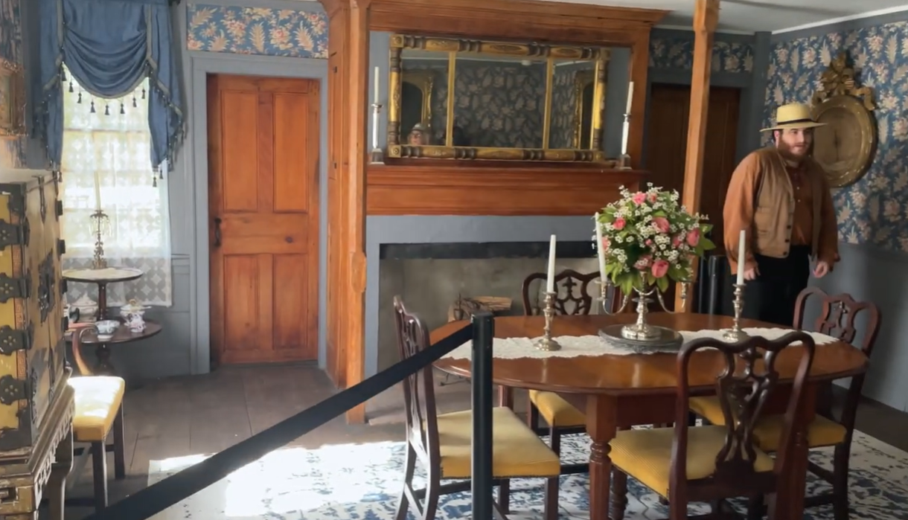
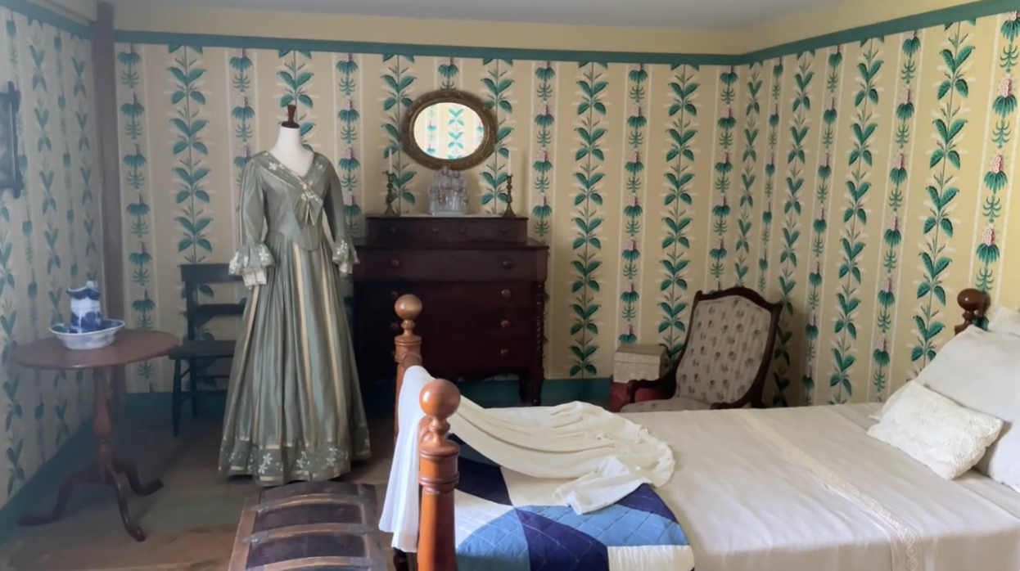

Lawrence House at 45 East 59th Street

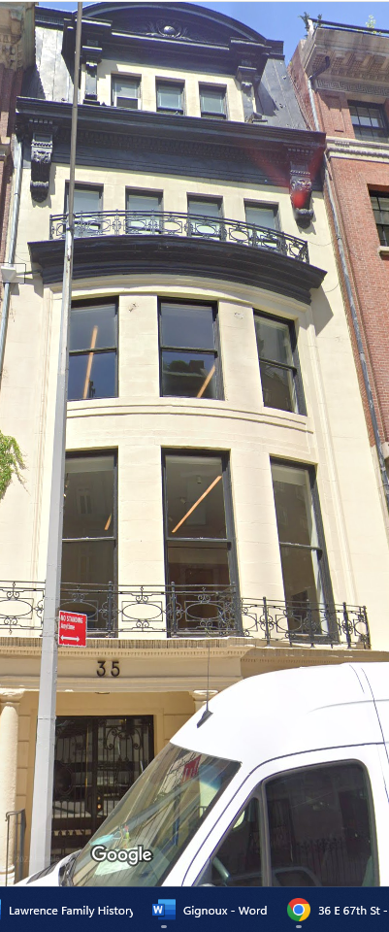
Location: between Madison and Park Avenues, Manhattan, New York.
Built: 1881, rebuilt 1903
Architect of rebuild: Bradford Lee Gilbert

Architect in 1903
Bradford Lee Gilbert (1853–1911) was a prominent New York architect whose career bridged nineteenth-century masonry traditions and the emerging age of steel-frame construction. He is best known for designing the Tower Building (1889) at 50 Broadway, widely regarded as New York City’s first true skyscraper and an early experiment in steel-frame, curtain-wall construction. Gilbert also maintained a large and varied practice that included railroad stations, institutional buildings, and elite private residences. In residential work, he was particularly skilled at dramatic remodelings, as in his 1903 Beaux-Arts transformation of 35 East 67th Street for J. Henry Alexandre, where he reimagined an earlier Victorian brownstone as a modern, French-influenced townhouse.

Architectural Description
As remodeled in 1903, 35 East 67th Street became a refined Beaux-Arts townhouse with strong French influences. The renovation removed the original Victorian brownstone façade and stoop, replacing them with a smooth stone exterior and a street-level entrance. The façade is organized vertically with large, curved and rectangular window groupings, wrought-iron balconies, and a pronounced mansard roof, giving the building the character of an early twentieth-century Parisian hôtel particulier adapted to a New York townhouse scale. Although the structural core of the 1881 building was retained, the exterior and principal interior arrangements were thoroughly modernized to reflect Edwardian-era tastes and the social ambitions of its owner.
In 1903, the house was purchased from the Joseph Suydam Stout family by James Henry Alexandre, a prominent New York shipping and business figure, and his wife Elizabeth Boyce Alexandre. Alexandre immediately commissioned Bradford Lee Gilbert, one of New York’s most innovative architects, to remake the house as a fashionable private mansion. The Alexandres resided there until Henry Alexandre’s death in 1912, after which the property passed through heirs.
By the mid-twentieth century, the house had been altered from its original single-family use and converted into apartments, reflecting broader changes in Upper East Side residential patterns. In the late twentieth and early twenty-first centuries, the building became associated with the neighborhood’s gallery district, housing high-end art and rare-book dealers while retaining much of its architectural character.

Lawrence House at 68 St, Louis, New Orleans

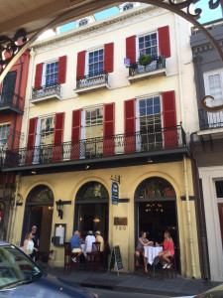

The mansion at 68 St. Louis Street (renumbered 720 St. Louis Street after the 1890s) is a Transitional-style (Federal/Greek Revival) buildingBuilt for Pierre Soulé, a French émigré and U.S. Senator, around 1829–1833.

Ir was adquired by Effungham Lawrence of Magnolia Plantation before the Civil War. Historical notes from the Vieux Carré Survey describe it as the "Effingham Lawrence Mansion" as early as the 1860s, with one 1866 newspaper reference (New Orleans Times) noting it was "known more than half a century ago as the Effingham Lawrence Mansion"
He sent his wife and children there during the Civil War. His wife died teher during an epidemic,
Lawrence experienced financial diffisultie sin the mid 1870s.
• Sheriff's sales in 19th-century New Orleans often resulted from court judgments, foreclosures, or succession (estate) issues.
• This one stemmed from litigation involving Mrs. Campbell Fair (likely a creditor or litigant) against Lawrence.
• The buyer, Henry Shepard, acquired it for $6,000—a significant sum then, reflecting the property's value despite the forced sale.

• Later entries in the chain (e.g., January 22, 1877, COB Vol. 107, p. 963) show another transfer to Henry Clay Warmouth (possibly a relative or associate; note: this may tie to Henry Clay Warmoth, Louisiana's Reconstruction-era governor, or a family connection, though records list "Warmouth") via Henry Clay Warmouth vs. Succession of Effingham Lawrence (father)—indicating probate/estate proceedings after Lawrence's death in 1878.

Lawrence House at 295 Breezy Way, Lawrence, Long Island.

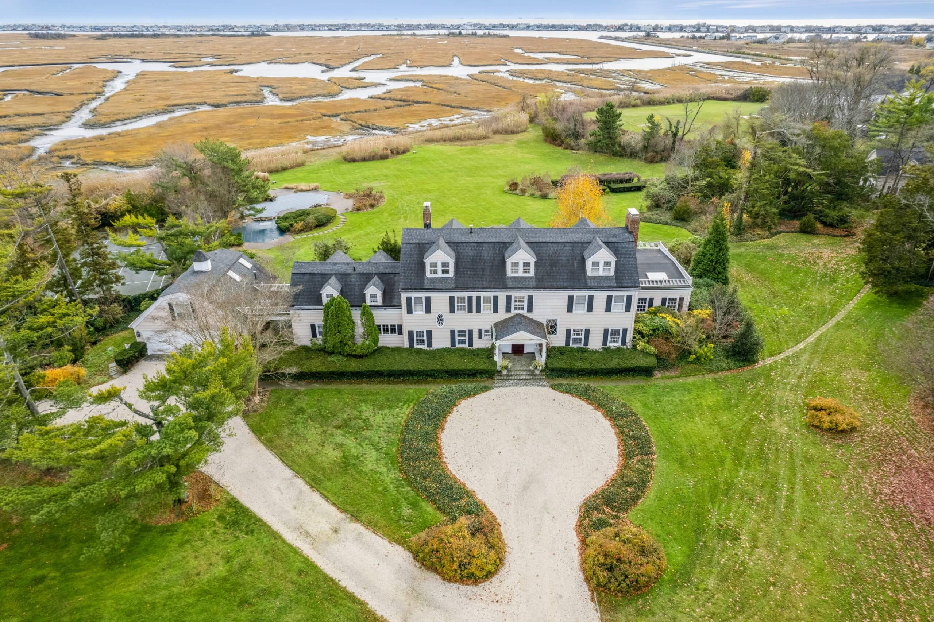

Location: at 295 Breezy Way, Back Lawrence, Lawrence, Long Island, new York.

Built: 1893

Architectural Description
The main house at 295 Breezy Way was constructed in 1893 as a Center Hall Colonial–style mansion, purpose-built for members of the Lawrence family. The house encompassed approximately 10,000 square feet and was sited prominently on landscaped grounds designed to emphasize privacy, symmetry, and views toward the surrounding waterways.
Architectural features associated with the house included:
- a formal center-hall plan,
- high ceilings and large-scale reception rooms,
- multiple fireplaces (reported as at least five),
- formal dining and living rooms,
- later additions including an elevator, sauna, wet bar, and extensive walk-in closets.
The house reflected the mature phase of Gilded Age suburban estate design on Long Island’s South Shore, blending colonial revival aesthetics with modern conveniences added over time.

History
The house was built expressly for the Lawrence family and remained in family hands for over a century. It functioned as a generational residence, passing through successive descendants as other Lawrence estates in the village were subdivided or sold.

By the late twentieth and early twenty-first centuries, the house was no longer occupied as the principal residence of the family, though it remained under Lawrence ownership.

The property also contains a smaller secondary house at 285 Breezy Way. There the last Lawrence family member associated with the estate, Alice Lawrence, resided. She was a direct descendant of the Lawrence family that developed Back Lawrence and gave the Village of Lawrence its name upon incorporation in 1897. She appears to have been the final Lawrence family custodian of the Breezy Way estate.

Lawrence House at 969 Fifth Avenue

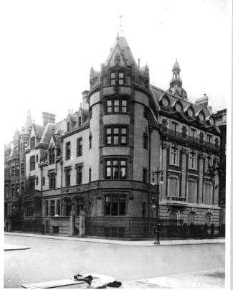
Location: southeast corner of East 78th Street and Fifth Avenue, Manhattan, New York.
Built:1887–1889
Architect: Richard Morris Hunt

Architect
Richard Morris Hunt (1827–1895), the preeminent Gilded Age architect, designed the residence. Hunt, trained at the École des Beaux-Arts in Paris, introduced French Renaissance and château-inspired styles to American domestic architecture, earning commissions from titans like the Vanderbilts (e.g., their Marble House and Biltmore), Astors, and other ultra-wealthy clients. He co-founded the American Institute of Architects and established the first architectural school in the U.S. at his Tenth Street Studio Building. For Lawrence, Hunt applied his mastery of the François I (French Renaissance Revival) mode, blending ornate asymmetry, rich detailing, and dramatic verticality ideal for a corner site—evoking Loire Valley châteaux like Chenonceau or Blois while adapting to New York's urban context.

Architectural Description
The five-story mansion was a picturesque French Renaissance fantasy executed in beige brick with brownstone trim, often called a "gingerbread confection" for its elaborate, whimsical ornamentation and intricate facade work. Hunt emphasized the corner prominence with a massive circular tower anchoring the Fifth Avenue and 78th Street intersection, creating a bold, commanding silhouette visible across from Central Park. The design featured high mansard-like roof elements, rich sculptural details, and vertical drama that rose impressively above the avenue. The main entrance was on East 78th Street via a grand stone stoop, while the prestigious address remained 969 Fifth Avenue. It epitomized the eclectic, ostentatious residential style favored by New York's elite in the late 1880s.
Although the formal entrance was placed on East 78th Street and approached by a substantial stone dog-legged stoop, the house claimed the more prestigious address of No. 969 Fifth Avenue.
History
Lawrence built the mansion as his primary Manhattan residence during Fifth Avenue's golden era of private palaces. He and Sarah Bates Lawrence (whom he married in 1867; she died in 1926) raised their family there. The family occupied it for decades, but high property taxes (as noted in family accounts) eventually prompted Lawrence to move to Westlands, his house in Bronxville. . It sold in December 1918 for about $1.5 million.

Plans were soon announced to demolish the mansion and erect a luxury apartment hotel on the site. On May 4, 1919, The Sun reported that the proposed structure would be among the most luxurious of its kind ever built, designed by George and Edward Blum.
The proposal provoked intense opposition from civic and preservationist groups, most notably the Fifth Avenue Association, which argued that apartment houses constituted an “invasion” that would destroy the character of the last intact stretch of Millionaires’ Row. Fifth Avenue, they asserted, was a matter of national pride whose appearance concerned all New Yorkers. The opposition succeeded temporarily, and the project was halted.
Although the apartment project was blocked, the Lawrence mansion did not return to use as a private residence. The property passed rapidly through multiple owners. In 1921, William Van Duzer Lawrence himself repurchased the house out of foreclosure for approximately $200,000, but this proved only a temporary measure. In January 1923, the building was sold again, reportedly for $210,000, reflecting the sharply diminished market for large private mansions on Fifth Avenue.
Demolished in 1937 by developer Kensington Estates, Inc., to clear the site for modern high-rise use. Architect Irving Margon designed the replacement: a slender 16-story apartment building completed around that era (with elements dating to 1926–1937 transitions), now 969 Fifth Avenue—a cooperative featuring a dark-brown brick facade, stone base, 12 luxury apartments. This reflected the broader mid-20th-century trend of replacing Gilded Age mansions with apartments.

Lawrence Name in Place Names

Places Named After Members of the Long Island Lawrence Family
Lawrence, Long Island, New York
The village of Lawrence, located in the Town of Hempstead, was named for three Lawrence brothers—Alfred, Newbold, and George Lawrence—who acquired land there in the 1850s to create a summer community for prominent New Yorkers. They developed the railroad station at Lawrence Avenue and constructed the connecting roads. Their efforts shaped Lawrence into an exclusive resort colony and later a residential community, now one of the “Five Towns” of Long Island.
Lawrence Park, Bronxville, New York
The Lawrence Park Historic District in Bronxville was developed by William Van Duzer Lawrence (1842–1927), whose branch of the family became prominent in Westchester. He personally oversaw the design and construction of the initial homes and encouraged notable writers and artists to settle there. Among the residents were Otto Henry Bacher, Hobart Nichols, William Thomas Smedley, Tudor Jenks, Kate Douglas Wiggin, Edmund Clarence Stedman, and Alice Wellington Rollins. The district contains nearly one hundred architecturally or historically significant buildings and is listed on the National Register of Historic Places.
Sarah Lawrence College, Bronxville, New York
Sarah Lawrence College was named for Sarah Bates Lawrence, wife of William Van Duzer Lawrence, who founded the institution. Established initially as a women’s college emphasizing the arts and individualized education, it later became coeducational and remains one of the leading liberal arts colleges in the United States. The naming reflects the philanthropic spirit and educational interests of this branch of the Lawrence family.
Lawrence Rocks, Victoria, Australia
The Lawrence Rocks are two small rocky islets with an adjacent reef off the coast of Portland, in the state of Victoria, Australia. They are remnants of an extinct volcano composed of basalt and tuff. The islets were sighted on 5 December 1800 by Lieutenant James Grant aboard HMS Lady Nelson and were named for Captain Effingham Lawrence, a member of the Lawrence family and one of the Elder Brethren of Trinity House, the English maritime authority.

Places Named After Captain James Lawrence (Connection to This Family Uncertain)
A number of American places bear the Lawrence name because of the national fame of Captain James Lawrence (1781–1813), the naval officer best remembered for his dying command, “Don’t give up the ship!” during the War of 1812. Whether Captain Lawrence belongs to the Long Island Lawrence family has been often asserted but remains unproven; the matter is discussed under his individual entry in this encyclopedia.
Lawrence, New Jersey (formerly Maidenhead)
Originally called Maidenhead, this township lay along the dividing line between East and West Jersey. On 24 January 1816, it was renamed Lawrence in honor of Captain James Lawrence.
Lawrenceville, New Jersey
The village within Lawrence Township was likewise renamed for Captain James Lawrence in 1816. William Maltbie, the first postmaster, suggested the name “Lawrenceville.”
Lawrence School (now The Lawrenceville School), New Jersey
The Maidenhead Academy, founded in the eighteenth century, retained its original name even after the township became Lawrence. In 1828 it was renamed Lawrenceville High School in honor of Captain Lawrence, and it evolved into the present-day Lawrenceville School, one of the leading preparatory schools in the United States.

Lawrence, Abraham Riker (1780–1863)

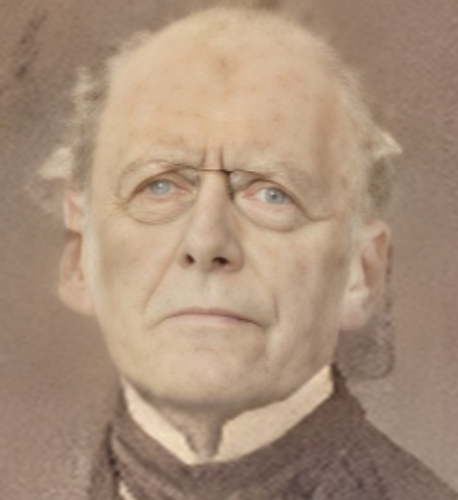

Parents: Jonathan Lawrence (1737–1812) and Ruth Riker (1746–1818).
Spouse: None recorded.
Children: None recorded.
Kinship: Uncle of the wife of the third great-granduncle of the post–World War II Smith generation

Early Life and Education
Abraham Riker Lawrence was born in New Hackensack, Dutchess County, New York. He received a classical education and graduated from Columbia College in 1797. After college he entered the mercantile profession, training in the New York store of Lieutenant Governor John Broome.
Business Career
In 1801 he entered into business with his cousin, John Lawrence, and remained in that partnership for ten years. He subsequently formed a business with his youngest brother, William T. Lawrence. His commercial experience brought him into contact with influential political and financial figures of the early nineteenth century.
Public Service and Political Activity
Abraham became active in the Democratic-Republican Party during the era in which James Madison and George Clinton represented competing visions for the young nation. In 1812, when the non-importation laws threatened to ruin New York merchants, Lawrence joined Washington Irving and others to petition Congress for relief. In 1818 he was appointed appraiser of imported goods for the federal government, responsible for detecting violations of customs laws.
Railroad and Municipal Leadership
In 1836 Lawrence was elected president of the New York and Harlem Railroad Company. During his administration, the line was extended from City Hall to the Harlem River, laying an early foundation for the city’s rail infrastructure. In 1847 he entered municipal government as Alderman of the 8th Ward, continuing the family’s long tradition of civic involvement.

Lawrence, Abraham Riker (1832–1917)

Justice of the Supreme Court of New York

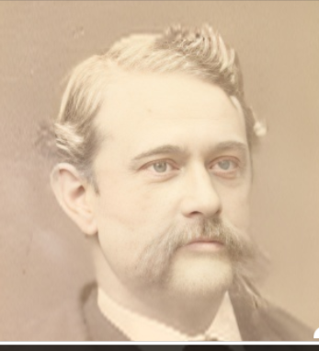

Parents: John Lawrence Lawrence (1785–1849) and Sarah Augusta Smith (1794–1877).
Spouse: Elizabeth “Eliza” Williams Miner (1838–1915).
Children: William Miner Lawrence (1861–1935) and Ruth Woodhull Lawrence (1866–1956).
Kinship: Brother-in-law of the third great-granduncle of the post–World War II Smith generation.
Early Life and Education
Abraham Riker Lawrence was born into a prominent New York family long associated with public service. He attended private schools and then studied law at Ballston Spa Law School in Ballston Spa, New York. He was admitted to the bar in 1853.
Early Legal and Public Career
Shortly after his admission to the bar, Lawrence was appointed Assistant Corporation Counsel of New York City, serving from 1853 to 1856 and again from 1857 to 1858. In 1859 he published Compilation of the Tax Laws of the State of New York, with Notes of Cases, which became a useful reference work for lawyers and legislators.
He entered state-level public service in 1867 as a member of the New York State Constitutional Convention. He was also a founder of the Association of the Bar of the City of New York in 1870, and later served as a vice-president of the Association in 1905 and 1906.
Political Activity and Mayoral Candidacy
In 1870 Lawrence was a leading member of Apollo Hall, the Democratic reform movement established by State Senator James O’Brien to combat the corruption of Boss Tweed’s Tammany Hall. His support for reform did not prevent both Tammany Hall and the Greeleyites from selecting him in 1872 as the Democratic candidate for mayor of New York City. At the time he maintained a law practice at 25 Nassau Street. He finished second in that race, losing to the Republican candidate, William Frederick Havemeyer.
Judicial Career
Lawrence was elected a Justice of the Supreme Court of New York in 1873. He served with distinction for twenty–eight years, until December 31, 1901, and was re–elected in 1887. After his formal retirement, he continued to serve in a judicial capacity as the official Referee of the Supreme Court from 1911 until his death.
Notable Case: “M’Liss” Litigation
During his tenure on the bench, Lawrence heard a number of widely followed cases. One was connected indirectly to his cousin, Joseph Effingham Lawrence, through a theatrical rights dispute originating in San Francisco involving dramatizations of Bret Harte’s story M’Liss. In Widmer v. Greene & Thompson, 56 How. Pr. 91 (N.Y. Sup. Ct., filed Sept. 15, 1878), Lawrence continued a temporary injunction against a rival production of M’Liss while the matter was tried. Contemporary theatrical reporting noted that on September 14, 1878, “Judge Lawrence of the Supreme Court” heard arguments on the injunction. For background on how the controversy originated on the West Coast, see Bret Harte, Mark Twain and The Golden Era.
Affiliations and Honors
Judge Lawrence was active in leading New York societies and cultural institutions. He was a member of the Union Club, the Century Club, and the Manhattan Club. He belonged to the Society of Colonial Wars, serving as Chancellor in 1895, and was involved with the American Rifle Association. He also served as the twenty–fifth president of the Saint Nicholas Society of the City of New York from 1882 to 1883.
In recognition of his long service, a dinner was held in his honor at Delmonico’s upon his retirement from the bench, hosted by John Edward Parsons, then president of the Bar Association.
Death and Burial
Abraham Riker Lawrence died at his home at 69 Washington Place in New York City on February 14, 1917. He was buried at the Lawrence Family Cemetery.

Lawrence, Albert Effingham (1851–1923)

Parents: Effingham Nicholl Lawrence (1815–1889) and Margaret Clendenning Buckley (1816–1897).
Spouse: Rebecca Elizabeth Spooner (1851–1943).
Children: Margaret Alden Lawrence (1879–1951), Effingham Nicholl Lawrence (1887–1963), Winifred Hentz Lawrence (1891–1972).
Kinship: Third cousin three times removed of the post–World War II Smith generation.

Early Life and Family Background
Albert Effingham Lawrence was born into the long–established Lawrence family of New York. His father, Effingham Nicholl Lawrence, was a businessman active in the storage and handling of imported goods, and Albert followed him into that line of work.
Career
Lawrence entered the firm of his father, known as Lawrence, Son & Gerish, a storage warehouse business specializing in imported merchandise. The business was typical of the Lawrence family’s participation in New York’s mercantile life, especially in industries connected with shipping and foreign trade. Albert later moved to Yonkers in the 1880s. Due to declining health, he retired from business earlier than he might otherwise have done.
Affiliations and Interests
He was a member of the Masonic fraternity, continuing a pattern of civic and fraternal engagement common among Lawrence men of his generation. He also belonged to the New York Entomological Society, indicating an interest in scientific pursuits at a time when amateur natural history societies flourished in the New York metropolitan area.
Death
Albert Effingham Lawrence died in 1923. His widow, Rebecca Elizabeth Spooner, survived him by two decades and died in 1943.

Lawrence, Albert Gallatin (1836–1887)

Brigadier General, U.S.A.

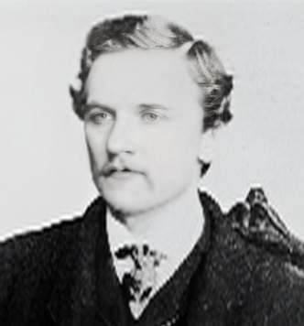

Parents: William Beach Lawrence (1800–1881) and Esther Rogers Gracie (1801–1857).
Spouse: Eveline McLean “Eva” Kingsbury Taylor (1845–1917).
Child: Esther Gracie Lawrence (1872–1976).
Kinship: Fourth cousin six times removed of the post–World War II Smith generation.
Family Background
Albert Gallatin Lawrence was born into a family prominent in diplomatic and political circles. His father, William Beach Lawrence, served as Lieutenant Governor of Rhode Island and as Acting Governor. Through his mother, he descended from the influential Gracie family of New York. Albert’s siblings included William Lawrence; Isaac Lawrence; Esther Gracie Lawrence, who married first Dr. W. L. Wheeler and later Count Felix von Voss–Giewitz of Mecklenburg–Schwerin; Cornelia Beach Lawrence, who married Baron von Klenck; and James Gracie King Lawrence, who married Catherine Augusta Le Roy.
Education and Early Career
Lawrence attended Harvard College and continued at Harvard Law School, graduating with a law degree in 1858. Although admitted to the bar, he chose not to practice law. He instead entered the diplomatic service as attaché of the United States legation in Vienna, having declined an appointment as Secretary of the Legation.
Civil War Service and Military Distinction
At the outbreak of the Civil War, Lawrence returned to the United States and was commissioned a captain in the 54th New York Volunteer Infantry. In 1864 he was promoted to lieutenant colonel and given command of the 2nd Regiment United States Colored Cavalry in Virginia. On January 15, 1865, he led the assault on Fort Fisher, losing his left arm in the engagement. For his gallantry, he received a brevet promotion to Brigadier General of U.S. Volunteers on March 25, 1865. His heroism earned him the popular title “the Hero of Fort Fisher.”
Marriage and Diplomatic Appointment
In September 1865 Lawrence married Eveline McLean “Eva” Kingsbury, the youngest daughter of Gen. Joseph Pannell Taylor and niece of President Zachary Taylor. She was the widow of Capt. Henry Walter Kingsbury, who had been killed at Antietam, and an heiress of the Kingsbury estate.
On October 2, 1866, President Andrew Johnson appointed Lawrence United States Minister to Costa Rica. He presented his credentials on January 18, 1867, and served until June 24, 1868.
Diplomatic Scandal and Divorce
During a visit to Washington, a dispute arose between Lawrence and Hon. Amédée Van den Nest, former attaché of the Prussian legation, over correspondence between Van den Nest and Eva Lawrence. The controversy escalated into a duel fought in Belgium. The ensuing sensation forced Van den Nest to resign from diplomatic service and compelled Lawrence to resign his post. The scandal brought an end to the marriage; Albert and Eva subsequently divorced in the 1870s. Eva later married Van den Nest.
Later Life and Politics
In 1880 Lawrence publicly broke with the Democratic Party and endorsed the Republican ticket of Garfield and Arthur. The New York Times observed that Democrats were “mortified at the spectacle of a son of the sage of Ochre Point coming out so publicly for Garfield and Arthur.”
Death and Estate
Albert Gallatin Lawrence died at the Everett House in New York City on January 1, 1887. His funeral was held at St. Mark’s Church on Stuyvesant Street, and he was buried in the Lawrence family burying grounds in Queens. His daughter inherited his small personal estate and later received a share of her grandfather’s considerably larger estate.

Lawrence, Alfred Newbold (1813–1884)
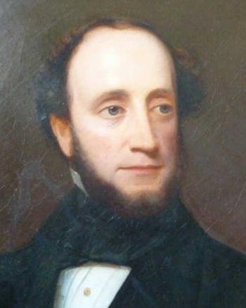

Parents: John Burling Lawrence (1774–1844) and Hannah Newbold (1782–1832).
Spouse: Elizabeth Lawrence (1820–1884).
Children: Woodhull Lawrence (1850–1870), Hannah Newbold Lawrence (1852–1925), John Lawrence Lawrence (1857–1930).
Kinship: Third great-granduncle of the post–World War II Smith generation.
Early Life and Family Background
Alfred Newbold Lawrence was born into a branch of the Lawrence family with longstanding ties to New York commerce and Long Island property. His mother was of the Newbold family, a name repeated across Lawrence descendants, and his marriage to Elizabeth Lawrence continued the custom of family intermarriages.
Career and Business Interests
Lawrence was a dry goods merchant and wholesale chemist, occupations in keeping with the mercantile interests of the Lawrence family in nineteenth-century New York. His business activity placed him among the prosperous urban professional class whose members often sought summer retreats away from the city.
Development of Lawrence, Long Island
In the 1850s, Alfred and his brother Newbold Lawrence began acquiring land on the south shore of Long Island to create an exclusive summer resort colony for affluent New Yorkers. Their efforts led to the development of the community that would become the town of Lawrence, one of the “Five Towns.” The Lawrence brothers built the train station at Lawrence Avenue to facilitate travel from New York City, and the area rapidly became a fashionable retreat.
Notable Incident
The family’s summer properties were subject to the hazards of unoccupied seasonal residences. A contemporary report noted that the country homes of Alfred and his brother Newbold at Far Rockaway were burglarized, with bedding and furniture stolen. Entry was made through a second-story window in one house and by removal of a panel in the back door of the other. As both houses stood close together and were empty except in summer, the thefts were believed to have been committed at the same time.
Death
Alfred Newbold Lawrence died in 1884. His widow, Elizabeth, died the same year.

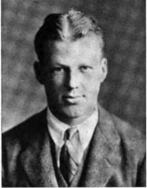
Lawrence, Alfred Newbold (1903–1978)

Parents: John Lawrence Lawrence (1857–1930) and Alice Warner Woke (1875–1966)
Spouse: Marianna Casserly (1908–1971)
Child: Alfred Newbold Lawrence Jr. (1931–2023)
Kinship: Second cousin three times removed of the post–World War II Smith generation
Education
Raised in the community his family helped establish, Alfred prepared at St. Paul’s School (Concord). He then entered Princeton, Class of 1927—where the Bric-a-Brac lists him among the class roll with home address “Lawrence, L. L., N.Y.,” a small but telling marker of place and lineage. He continued on to the Massachusetts Institute of Technology, completing further technical studies in 1929.
Career
Alfred’s work followed the aeronautical supply chain that linked Midwestern plants to East-Coast engine makers:
- United Aircraft Products (Dayton, Ohio) — an aerospace heat-exchanger firm founded in the interwar years and later a long-time supplier to Pratt & Whitney and NASA projects. A NASA technical report notes UAP designing oxidizer heat exchangers under a Pratt & Whitney purchase order; industry profiles describe UAP as specializing in aircraft heat-transfer hardware. This aligns with Alfred’s role in “aircraft sales engineering.”
- Jack & Heintz Precision Industries (Cleveland, Ohio) — a WWII-era Cleveland manufacturer founded in 1940 by Bill Jack and Ralph Heintz that became a symbol of high-volume war production (and later, of the politics of wartime profit control). Alfred’s Cleveland posting fits the firm’s heyday as it supplied aircraft components at scale.
Clubs and Civic Setting
Alfred remained what earlier generations would have called a “Lawrence of Lawrence.” He was born (1903) and died (1978) in the Village of Lawrence, L.I. He was a member of the Rockaway Hunting Club.

Notes on the Next Generation
His son, Alfred Newbold Lawrence Jr. (1931–2023)—“Mike”—kept the seafaring/transport thread alive professionally; his obituary notes the family’s “fourth generation of the founding family of the town.”

Lawrence, Annette “Anita” Townsend (1867–1922)
Parents: Walter Boune Lawrence (1839–1912) and E. Annie Townsend (1841–1902).
Spouse: None recorded.
Children: None recorded.
Kinship: Third cousin three times removed of the post–World War II Smith generation

Background
Annette “Anita” Townsend Lawrence was born into a socially prominent branch of the Lawrence family of Flushing, Long Island. During her adult years she resided at Willow Bank with her parents and her brother, Townsend Boune Lawrence (1871–1951). (See Houses and Estates.) Her upbringing placed her within the respectable New York social world of club life, charity events, and church associations.
The Centre of Divine Ministry
In the early twentieth century, Anita Lawrence became involved in a religious healing movement known as the Centre (also called the Circle) of Divine Ministry. She had been a member for several years before ascending to its presidency in December 1908. She hired a young Englishwoman, Herminia M. M. Barnes (1873–1913), as her secretary; Barnes later served as both a teacher and a member of the Centre’s Advisory Board.
The Centre, headquartered at 36 West Twentieth Street, Manhattan, held daily afternoon religious meetings, while Anita conducted Wednesday morning services at her home. The group had existed for about a dozen years before Anita reorganized it in 1908. Its board included Miss Barnes; Mrs. Theodore Seymour; Miss Talbot; Mrs. John Brooks Leavitt; Mrs. J. Keene; and Mrs. Bertha Thompson, all of Manhattan. Its chief teachers were Mrs. Emma Curtis of Barrytown; Miss Barnes; Mrs. Smith Lee; Miss Lawrence; and Bradley Dresser, the last two being described as the most gifted healers.
Beliefs and Practices
The movement’s core belief, as Anita explained to reporters, was that all men and women can live precisely as Christ lived and do whatever He did. The Centre taught that through “oneness with God,” individuals could attain spiritual and physical perfection. Teachers claimed to cure all ailments, “even cancer and tumors,” through faith-based healing. They stated that healers could treat illness even without the patient’s knowledge, including “absent treatments.” Instruction was unpaid, but healing services could cost up to $1 a day.
Anita emphasized that the Centre was undenominational and insisted:
“We are distinct from Christian Scientists and similar organizations, in that we follow no leader save Christ. Our efforts are to return to the pure teachings of Christ, and we know that all mankind can attain to them.”
Public Exposure and Press Coverage (1909)
The Centre attracted press attention in 1909, when a New York Times reporter attended a meeting. Surprised to discover that Miss Anita Lawrence, a well-known society figure and daughter of a prominent stockbroker, led the movement, the paper described her as “a dignified, white-haired, blue-eyed woman.” Approximately thirty attendees were present, “chiefly women with a scattering of men.”
One article noted that pamphlets and books were displayed prominently on a table—and that “the most conspicuous objects on the table were two Social Registers,” a detail suggesting both the social milieu of the membership and the press’s fascination with the involvement of established families.
Anita stated that the Centre had c. 150 followers. When a reporter asked if they were mostly women, a male associate (Rev. J. M. White—see below) responded, “No, they are not all women,” although the reporter observed fifteen women and one man at the service.
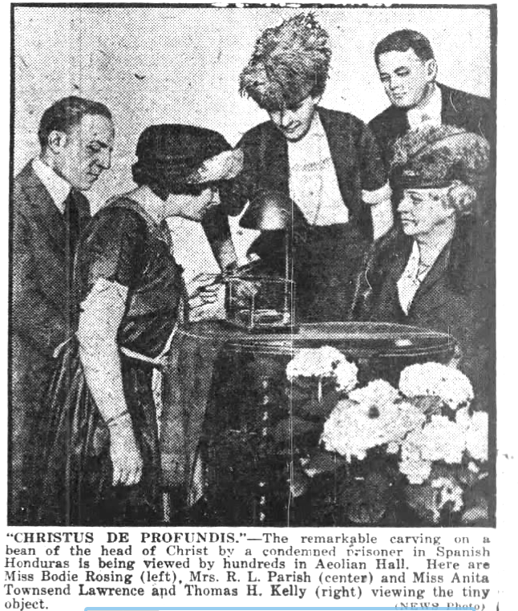
Associates and Notable Connections
An eclectic group surrounded Anita’s ministry:
• Mrs. James R. Keene – mother of Foxhall Keene, who married (and later divorced) Mary Lawrence (1860–1942), thereby linking the movement to another branch of the family.
• Rev. J. M. White – an ex-Roman Catholic priest who had received papal permission to serve as private chaplain to financier Thomas Fortune Ryan. White later became an Episcopalian and acted as spiritual adviser to the Centre.
• The involvement of socially prominent women, often club-connected, alarmed conservative commentators, who feared the Centre might resemble a cult.
Press tone ranged from fascination to skepticism, with one report describing it as a “cult of divine healers” whose leaders claimed that “there is no disease, organic or otherwise, and no trouble, financial or otherwise, which cannot be cured by faith in the power of God.”
Death
Annette “Anita” Townsend Lawrence died in 1922.
Digression on the Centre for Divine Ministry
Overview
The Centre of Divine Ministry was a small, undenominational religious healing society active in New York City in the early twentieth century. It originated in the 1890s and was reorganized in 1908 under the leadership of Annette “Anita” Townsend Lawrence, who served as its president. Its headquarters were at 36 West Twentieth Street, Manhattan, and it held daily afternoon meetings, with additional services conducted at Miss Lawrence’s home in Flushing.
Beliefs and Practices
Although the Centre used Christian language and emphasized the teachings of Jesus, it was not affiliated with any denomination. Its teachings aligned with the New Thought and metaphysical healing movements of the era, which held that illness and misfortune could be overcome by spiritual understanding and bringing the mind into harmony with divine power. Members taught that all people could live as Christ lived and that the divine power demonstrated by Jesus was available to all. The Centre practiced “absent treatments,” believing that healing could occur without the patient’s presence or awareness. Teachers did not charge for instruction, but healers could receive a fee of one dollar per day for their services. The Centre distinguished itself from Christian Science by stating that it acknowledged no founder other than Christ.
Membership and Public Attention
Public attention increased in 1909, not because of the Centre’s size, but because it attracted members of socially prominent families. Attendance at meetings was generally composed of women of society, and reporters noted that copies of the Social Register were displayed prominently at gatherings. The Advisory Board included Herminia M. M. Barnes, Mrs. Theodore Seymour, Miss Talbot, Mrs. John Brooks Leavitt, Mrs. J. Keene, and Mrs. Bertha Thompson, while the chief teachers were Mrs. Emma Curtis of Barrytown, Miss Barnes, Mrs. Smith Lee, Miss Lawrence, and Bradley Dresser. The Centre’s spiritual adviser for a time was Rev. J. M. White, formerly a Roman Catholic priest and briefly private chaplain to financier Thomas Fortune Ryan.
Later History and Context
The Centre of Divine Ministry appears to have declined after 1912 and did not persist as an organization beyond the early twentieth century. It forms part of the wider landscape of American mind-cure, New Thought, and metaphysical Christian movements that flourished between the 1880s and the 1920s.

Lawrence, Anna Louise (1834–1908)
Parents: John Watson Lawrence (1800–1888) and Mary King Bowne (1808–1874)
Spouse: Rt. Rev. Thomas Augustus Jaggar (1839–1912)
Children: Harris Jaggar (1863–1865), May Jagger (1865–1884), Anna Louisa Jagger (1868–1949), Henry Anthon Jagger (1869–1869), Thomas Augustus Jaggar (1871–1953)
Kinship: Second cousin four times removed of the post–World War II Smith generation
Early Life and Marriage
Anna Louise Lawrence was born into the Flushing branch of the Lawrence family. She met her future husband, Thomas Augustus Jaggar, while he was serving as an assistant minister at St. George’s Church in Flushing, where her father was a vestryman and active parishioner. They were married in 1862.
Her Husband’s Ecclesiastical Career
Shortly after their marriage, Thomas Jaggar became rector of the Episcopal Church in Bergen Point, New Jersey. He later rose to prominence within the Episcopal Church and served as Bishop of Ohio from 1875 to 1904. After resigning that office, he returned to parish ministry and in 1905 became rector of St. Paul’s Church in Boston’s Back Bay. During the winter of 1905–1906, Bishop and Mrs. Jaggar resided at 282 Marlborough Street, an address associated with socially prominent Boston families in that era.
Family and Later Years
Anna Louise and Thomas Jaggar lost two of their five children in infancy or early life. Their surviving daughter, Anna Louisa Jagger, lived until 1949, and their son Thomas Augustus Jaggar (1871–1953) became noted in his own right for his work in volcanology and for founding the Hawaiian Volcano Observatory.
Anna Louise Lawrence Jaggar died in 1908. Her husband survived her by four years.

Lawrence, Annie Townsend (1847–1942)
Parents: Effingham Lawrence (1820–1878) and Jane Lucretia Osgood (1829–1863)
Spouse: None recorded
Children: None recorded.
Kinship: First cousin four times removed of the post–World War II Smith generation
Early Life
Annie Townsend Lawrence was born at the Lawrence Homestead in Bayside, Long Island (see Houses and Estates). In 1850, when she was still a young child, the family moved to New Orleans, where her father acquired Magnolia Plantation near the city.
Civil War Period
During the Civil War, her father, Effingham Lawrence, was imprisoned by the Confederate authorities because of his Northern connections and suspected sympathies. Annie, then in her mid-teens, is remembered for carrying food to her father during his imprisonment. The war years and their hardships left a strong impression on her, shaping her sense of duty and family responsibility.
Family Responsibility and Later Life
After the death of her mother in 1863, Annie assumed the care of her younger siblings. Upon her father’s death in 1878, she returned to New York, where she spent the remainder of her life. Her long life spanned from the antebellum era through two world wars, and she became a link between the New Orleans branch of the family and the older Long Island roots of the Lawrences.
Annie Townsend Lawrence died in 1942.

Lawrence, Arthur William (1875–1937)
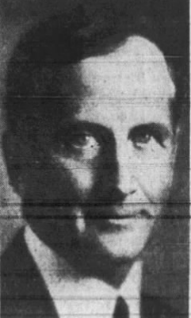
Parents: William van Duzer Lawrence (1842–1927) and Sarah Elizabth Bates (1845–1926)
Spouse: (1) Ida Virginia Heppe (1873–1934); (2) Hilda Seccomb (1879–1978).
Children: William van Duzer Lawrence (1904–1976) and Christopher Lawrence (1909–1954).
Kinship: Fifth cousin three times removed of the post-World War Two Smith generation.

Education
Arthur W. Lawrence was born in Montreal, Quebec. The family relocated to New York City when he was young. He attended the Berkeley School and Yale University, graduating with a B.A. in 1897. He was a member of the Yale Club, Union League Club, Adirondack Farms Golf Club, and Delta Kappa Epsilon fraternity.
Business
Arthur William Lawrence was also associated with Davis & Lawrence Company, the pharmaceutical manufacturing firm founded by his father. The company, originally established in the Bronx, produced proprietary medicines and related pharmaceutical preparations and had been the foundation of the Lawrence family fortune before their extensive real-estate developments in Westchester County. By the late 1920s Arthur W. Lawrence owned and operated the firm, continuing the enterprise while simultaneously directing the family’s real-estate interests in Bronxville and surrounding communities.
Arthur William Lawrence carried forward and expanded the extensive real-estate enterprises founded by his father, William Van Duzer Lawrence, becoming one of the principal developers in Westchester County in the early twentieth century. After joining the family firm following his graduation from Yale in 1897, he helped administer and enlarge the Lawrence interests in Bronxville and surrounding areas. With his brother Dudley B. Lawrence he assumed control of the family’s real-estate operations, including the development and management of Lawrence Park and Mount Kisco, and the creation of Lawrence Park West as an exclusive residential district. Lawrence served as president of Lawrence Park Realty Company and related enterprises, as well as chairman of the board of Lawrence Farms, Inc., and president of the Lawrence Investment Company of Bronxville and its subsidiary corporations. Under his direction the Lawrence developments continued the family tradition of carefully planned suburban communities, helping shape the residential growth of Westchester County in the early twentieth century. He was also involved in related business ventures, serving as a trustee of the Bronxville Trust Company and a director of the Title Guarantee and Trust Company of New York and the Westchester Title and Trust Company of White Plains, and for a time owned the Yonkers Statesman, one of the state’s oldest newspapers.

Political Work
Lawrence was an active Republican and held several leadership roles in Westchester County politics and civic organizations. He ran for U.S. Congress in the 24th Congressional District (seeking the Republican nomination in 1916), but was defeated—attributing the loss partly to lack of recognition; he briefly acquired and later sold the Yonkers Statesman newspaper to build influence.
He served as treasurer of the Westchester County Republican Committee, former chairman of the Westchester County Transit Commission, former president of the Westchester County Chamber of Commerce, and chairman of the executive committee of the Westchester County Commission on Safety (during World War I). As a New York State director of the Association Against the Prohibition Amendment, he advocated for repeal of the 18th Amendment and proposed family-oriented beer gardens in public parks, inspired by German models, to allow outdoor gatherings with music.
In the 1930s, he contributed to Depression-era efforts, including membership in advisory committees for President Hoover's Reconstruction Finance Corporation and Frank Vanderlip's Home Mortgage Advisory Committee, focusing on aiding small homeowners with mortgage burdens.
Food Administrator (World War I)
During World War I, Lawrence served as a "dollar-a-year man" in Washington under Herbert Hoover. He was the Food Administrator for Westchester County, director of the Fuel Administration (or fuel supplies) in the county, and involved in wartime resource management and safety initiatives.
Water Commission (Catskill Aqueduct Condemnation)
Lawrence served on the Catskill Aqueduct Condemnation Commission, gaining expertise in land acquisition, purchasing, and condemnation proceedings for New York City's massive Catskill Aqueduct water supply project. This involved handling property rights and condemnations that affected northern Westchester lands and streams (creating reservoirs). His experience here—managing large-scale public land dealings—directly informed his later success in acquiring over $30,000,000 worth of park lands for Westchester County.
Parks Commission
Lawrence was a charter member of the Westchester County Park Commission from its inception in 1922. He initially served as treasurer, then as vice president under V. Everit Macy, and chaired the purchasing/real estate committee for many years, overseeing the acquisition of extensive properties that formed the backbone of Westchester's magnificent parks and boulevards (a system of worldwide note). He resigned in 1928 but was reappointed in 1930, elected president, and held that role until his death in 1937. He was also a member and director of the New York State Council of Parks.
His work helped develop a comprehensive parkway and park system, emphasizing public access, beauty, and family use. Commissioners credited him with major responsibility for its success.

Lawrence, Augustine Hicks (1770–1828)

Mayor of New York City
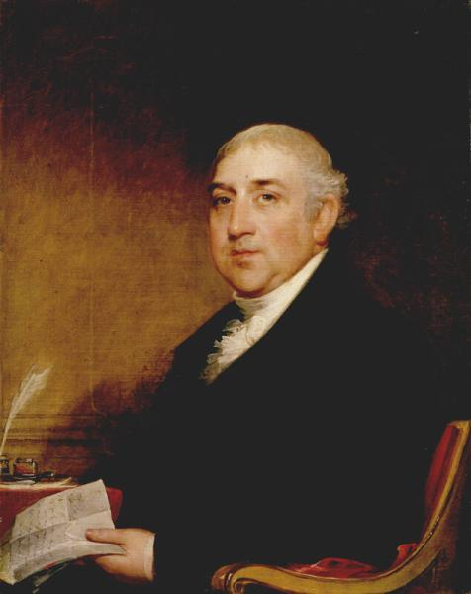

Parents: Augustine Lawrence (1719–1794) and Joanna Annajte van Zandt (1729–1809)
Spouse: (1) Catherine Abramse Luquer (various spellings) (dates as given: 1729–1809); (2): Eloise Lawrence Bogart (1799–1880).
Children: Augustine Nicholson Lawrence (1793–1872), Elizabeth Mastier Lawrence (1796–1843), Joanna Lawrence (1797– ), Sarah Middagh Lawrence (1799–1873), Eliza Augustine Lawrence (1804–1881), Sarah Augustine Lawrence (1807–1888)
Kinship: Third cousin six times removed of the post–World War II Smith generation
Early Life and Family
Augustine Hicks Lawrence was born into a well-connected New York mercantile family. Through his parents, he was linked to established Dutch and early colonial lines in Manhattan and Brooklyn, including the van Zandt family. His first marriage was to Catherine Abramse Luquer, from a prominent Brooklyn family of French Huguenot descent, whose surname appears with multiple spelling variants in the records. After Catherine’s death, he married Eloise Lawrence Bogart.
New York Stock Exchange
Augustine Hicks Lawrence is remembered as the youngest of the twenty-four stockbrokers who signed the Buttonwood Agreement on May 17, 1792, often described as the founding moment of the New York Stock Exchange. The brokers met under a buttonwood tree outside 68 Wall Street to agree upon uniform commission rates and cooperative practices. The organization adopted its constitution on March 8, 1817, as the “New York Stock & Exchange Board,” later the New York Stock Exchange.
Business and Public Life
Lawrence was active in commercial, banking, and civic affairs. He was a partner in several firms, including Lewis & Lawrence; Augustine H. Lawrence & Co.; and Augustine H. Lawrence & Augustine N. Lawrence (with his son). By 1795, his business was located at 40 Wall Street. He became a close friend of DeWitt Clinton, multiple-term Mayor of New York, and earned the nickname “The Chancellor of the Exchequer” for his management of city financial affairs as chairman of the finance committee and alderman of the Third Ward. He held directorships in the New York Insurance Company, Bank of America, Farmers’ Fire Insurance & Loan Company, Globe Insurance Company, and other enterprises.
The 1810 census records the household as owning two enslaved persons, a reminder that even prominent New York families in commerce and finance participated in slavery during the early nineteenth century. Also, manumission was restricted to prevent elderly former slaves from becoming charges upon public welfare.
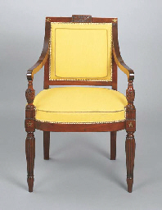
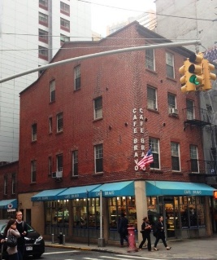
Residences and Legacy
In 1799–1800, Augustine built a Federal-style row house at what is now 94 Greenwich Street (right). Remarkably, the house survived the large-scale destruction of its neighborhood and was designated a New York City Landmark in 2009. It is widely noted that its preservation was due in part to a later tenant, the Pussycat Lounge, a topless bar that occupied the building and unwittingly kept it from demolition.
As alderman, Lawrence commissioned a set of chairs (left) for the new City Hall from the celebrated French-American cabinetmaker Charles-Honoré Lannuier at a cost of fourteen dollars each. These chairs reflected the neoclassical elegance of the period and the civic aspirations of the young city.

Portrait
A portrait of Augustine Hicks Lawrence, attributed to Gilbert Stuart and dated circa 1812–1815, was given to the New-York Historical Society by his granddaughter, Eloise Lawrence Breese Norrie.

Lawrence, Bruce Effingham (1879–1948)
Parents: Octavius Vernon Lawrence (1836–1915) and Jessie Barnard (1847–1939)
Spouse: Alice Maud Kirkham Law (1884–1972)
Children: Percy Lawrence (1920-2011), Jean Lawrence (1921-2007), Verona Lawrence (1921-1981), Grace Lawrence, and Eva Lawrence (1927-2014).
Kinship: Third cousin four times removed of the post–World War II Smith generation
Background and Family Branch
Bruce Effingham Lawrence belonged to the Tasmanian/Australian branch of the Lawrence family that descended from William Effingham Lawrence, who left England for London and whose son later settled in Tasmania. The use of the name Effingham continued through this branch, reflecting the family’s desire to preserve the original New York name.
Life in Australia
Bruce was born in 1879, likely in Tasmania, where his parents resided before moving to mainland Australia. As an adult, Bruce settled in the Gippsland region of Victoria. Electoral rolls and contemporary records place him at Narracan and Trafalgar in the Warragul district, where he worked as a farmer. His siblings also remained in Australia, and his parents lived well into the twentieth century in Victoria.
Marriage and Family
He married Alice Maud Kirkham Law, who survived him by many years. Their known children were Percy, Jean, Verona, Grace, and Eva. Alice later appears to have remarried after Bruce’s death, but this awaits formal confirmation through Victorian marriage records.
Death
Bruce Effingham Lawrence died on 17 September 1948 at Warragul, Victoria, and was described as “late of Narracan” in local notices.

Lawrence, Caroline Bowne (1827–1869)
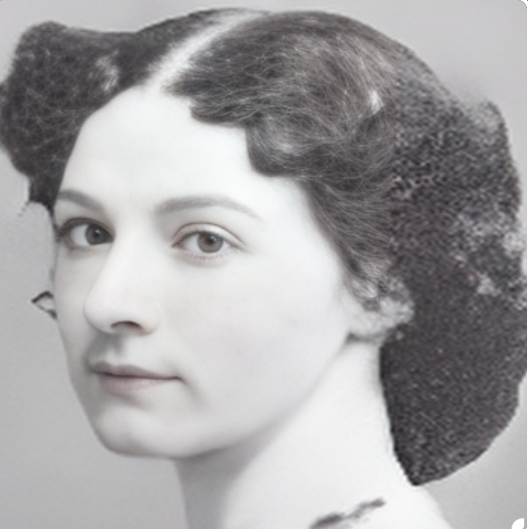0
Parents: Rep. John Watson Lawrence (1800–1888) and Mary King Bowne (1808–1874).
Spouse: Rep. Henry Rutherford Bedinger (1812–1858).
Children: Mary Bedinger “Minnie” (1850–1896), Henry Bedinger (1853–1935), and Caroline Bedinger “Danske” (1854–1914).
Kinship: Second cousin four times removed of the post–World War II Smith generation.
Early Life and Education
Caroline was born in Flushing, Long Island, in the House Below the Hill, the historic Bowne property near the Friends Meeting House. She was named for her great-aunt, Caroline Bowne, who had raised her mother after infancy. Caroline attended the Priory School of New Rochelle. Because her father served in Congress, the family resided at times in Washington, D.C., where Caroline and her sister Lili were introduced to the social world surrounding Congress and visiting diplomatic circles.
Marriage and Diplomatic Life
Caroline met the widower Henry Rutherford Bedinger when he was a member of the U.S. House of Representatives from Charles Town, Virginia. They married in 1847. In 1853 President Franklin Pierce appointed Bedinger as the first United States Minister to Denmark, and the family moved to Copenhagen. Caroline’s letters from Denmark, preserved at Smith College, provide a detailed view of mid-nineteenth-century American diplomatic life in Europe. She wrote of their adjustment to European customs, the formalities of diplomatic protocol, and the social world of Copenhagen, including court events at which she met Princess Anna of Prussia, Prince Frederick William of Hesse–Kassel, and Louise Christine Rasmussen, later Countess Danner.
Widowhood and Later Years
Henry Bedinger died in 1858, and Caroline returned to the United States with her children, settling in Shepherdstown, then in Virginia. During the Civil War the town changed hands repeatedly. Her daughter Minnie later wrote vivid accounts of their wartime experiences, drawing on family memories and correspondence. Caroline fostered a strong literary and educational environment for her children; her youngest daughter, “Danske,” became a published American poet of note. Caroline died in 1869 at the age of 42.
Papers and Legacy
Caroline’s surviving letters, especially those written from Copenhagen, are held in the Smith College Archives. They provide an uncommon first-hand record of the life of an American diplomatic family abroad, the cultural contrasts faced by Americans living in a European capital, and the social and domestic expectations placed upon a diplomat’s wife in the 1850s.

Lawrence, Caroline Effingham Elizabeth (1824–1889)
Parents: Effingham Calvert Lawrence (1785–1837) and Caroline Munro (1795–?).
Spouse: None recorded.
Children: None recorded.
Kinship: Second cousin five times removed of the post–World War II Smith generation.

Caroline was born in the Maldives and died in Middlesex, England.

The UK, Lunacy Patients Admission Registers, 1846-1921 indicate that a Caroline Lawrence was admitted on 9 August 1852 to Grovesnor House, a private lunatic asylum. She was discharged 13 May 1882, “not improved.” If this is the same Caroline Lawrence, it would explain the lack of marriage.

Lawrence, Chester Bulkley (1845–1918)
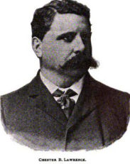

Parents: Effingham Nicoll Lawrence (1815–1892) and Margaret Clendenning Bulkley (1816–1897).
Spouse: Kate Covell Peters (1846–1922).
Children: Kate Effingham Lawrence (1867–1868), George Covell Lawrence (1869–1944), Chester Bulkley Lawrence Jr. (1872–1947), and Marion Lawrence (1882–?).
Kinship: Father-in-law of the third cousin three times removed of the post–World War II Smith generation.
Early Life and Family Background
Chester Bulkley Lawrence was born in 1845 into the Lawrence family of New York. His father, Effingham Nicoll Lawrence, established a substantial warehousing business in the city during a period of rapid commercial growth. Chester was raised in a family that combined both old New York lineage with active mercantile enterprise.
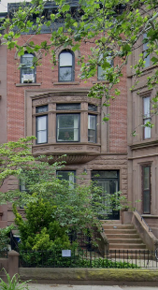
Career
Upon his father’s death, Chester became the senior partner of the family’s warehousing firm. The business served the expanding shipping and commercial needs of New York in the late nineteenth century, when warehousing and storage facilities played an increasingly important role in trade and logistics.
Personal Life and Interests
In 1905 Chester built a residence in Brooklyn, which remains standing today. He was active in social and civic organizations, including the Lincoln Club, the Rembrandt Club, and the Sundown Fishing Club. Politically engaged, he held offices in the Republican Club, reflecting both his social standing and his involvement in local civic affairs.
Later Years and Death
Chester continued his business and social activities into the early twentieth century. He died at his summer home in Bay Shore on 2 July 1918 following a sudden heart attack; his ashes were interred at Greenwood Cemetery, Brooklyn. His widow, Kate, survived him until 1922.

Lawrence, Clement Miner (1897–1918)
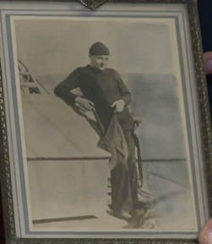

Parents: William Miner Lawrence (1861–1935) and Lavinia Oliver (1869–1916).
Spouse: None recorded.
Children: None recorded.
Kinship: Seventh cousin three times removed of the post–World War II Smith generation. He is the nephew of Ruth Woodhull Lawrence.
Early Life
Clement Miner Lawrence was born in 1897 to William Miner Lawrence and Lavinia Oliver. He grew up in the early twentieth century, a period in which many young Americans were inspired toward national service by the U.S. Navy and the expanding U.S. Coast Guard.
Military Service
Clement enlisted in the United States Coast Guard and attained the rank of Petty Officer First Class. His primary rate was Quartermaster, a rate responsible for navigation, piloting, and maintenance of charts and instruments. In 1918 he was serving aboard the U.S. Coast Guard Cutter Tampa, which had been transferred to the U.S. Navy for wartime duty during the First World War.
Death in the First World War
On 26 September 1918, while in the Briston Channel, returning to port after escorting a convoy from Gibraltar, the cutter Tampa was torpedoed by a German submarine. The ship sank with the loss of all 131 on board, including 111 Coast Guardsmen, 4 U.S. Navy personnel, and 16 passengers and British naval ratings. Clement Lawrence was among the casualties. The sinking of the Tampa was one of the greatest single losses of life in Coast Guard history.
Legacy
Clement’s name is recorded among the Coast Guardsmen who died in World War I. The loss of the Tampa is still commemorated annually by the Coast Guard, and those who perished with her are honored for their service.
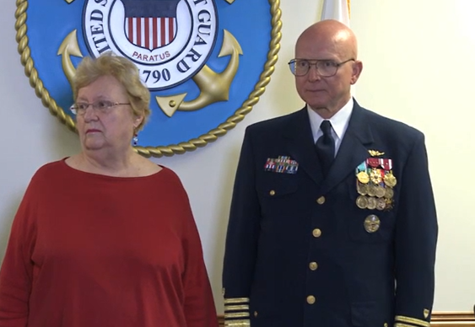
Ann Abel, a relation of Clement, and Commandant Papp
On May 23, 2013, Coast Guard Commandant Robert Papp, Jr. presented the Purple Heart, posthumously to families of Quartermaster Clement Miner Lawrence, who lost his life in the sinking of the Coast Guard Cutter TAMPA in World War I.

Lawrence, Cornelius Van Wyck (1791–1861)
U.S. Congressman, Mayor of New York City

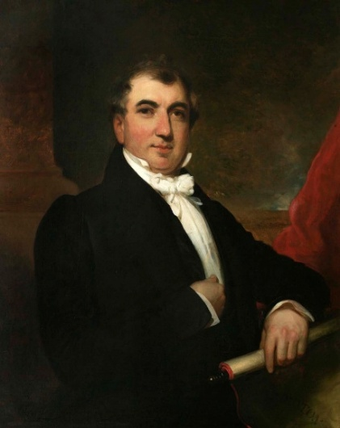

Parents: Henry Lawrence (1767–1824) and Harriet Van Wyck (1771–1812)
Spouse: (1) Maria C. Prall (1797–1820); (2) Rachel Ann Hicks (1798–1838); (3) Lydia Ann Lawrence (1811–1879)
Children: Henry Van Wyck Lawrence (1821–1890) and others (full list follows in later installment)
Kinship: First cousin five times removed of the post–World War II Smith generation
Early Life and Family Origins
Cornelius Van Wyck Lawrence was born on February 28, 1791, into two old Long Island families whose roots reached back into the early colonial period. Through his father, Henry Lawrence, he descended from the Flushing branch of the Lawrences, a family noted for enterprise, local leadership, and an occasional taste for political controversy since the seventeenth century. His mother, Harriet Van Wyck, brought him the Dutch heritage of the Van Wycks, a family respected for public service and property holdings in Queens and Manhattan. This dual inheritance connected Cornelius to a social world in which family alliances, business ventures, and civic duty were tightly interwoven.
Although influenced by Quaker relatives, Cornelius grew up in a New York that was changing swiftly from a provincial seaport into a rising commercial capital. The harbor thronged with ships from the West Indies, Europe, and Asia; the streets bustled with sailors, merchants, and carters driving loads of imported goods toward warehouses and auction rooms. New York was a place where fortunes could be made or lost in a single season, where fires swept through wooden neighborhoods, and where newcomers jostled with old families for position and prosperity.
Entry into Business: Shotwell, Hicks & Co.
In 1812, Cornelius entered the auction and dry-goods firm of Shotwell, Hicks & Co., located on Pearl Street. At that time, auction houses were among the vital organs of New York commerce, handling everything from bankrupt stock to European luxury goods and cargoes newly arrived from the Caribbean or China. The atmosphere was competitive and often hectic, for buyers and sellers crowded the rooms, and the auctioneer’s voice had to rise above the clamor inside and the noise drifting in from the street.
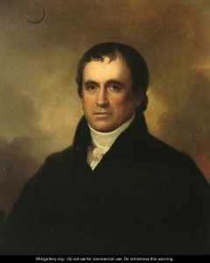
Cornelius soon proved himself an able and trustworthy young merchant. The firm later became Hicks, Lawrence & Co., signifying his advancement. His association with the Hicks family extended beyond business. In 1821, he married Rachel Ann Hicks, daughter of Willett Hicks, a well-known Quaker minister and respected merchant. Willett was a figure of some fascination in his day, for he was widely said (though disputed at the time) to have visited the deist Thomas Paine during his final illness. Through the Hickses, Cornelius entered a wider circle of merchants, religious leaders, and civic influencers whose combined influence extended into politics as well as trade.
Willett Hicks by Rembrandt Peale
Marriage and Family Interconnections
Cornelius’s personal life further strengthened his ties within New York’s closely linked merchant families. His first marriage, to Maria C. Prall, was brief; she died in 1820, only a few years after their union. His second marriage, in 1821, to Rachel Ann Hicks, deepened his connection to the Hicks family, blending commercial, religious, and social networks. This union brought Cornelius into the orbit of influential Quaker households whose members were active in business, reform efforts, and civic affairs.
After Rachel’s death in 1838, Cornelius married for a third time, choosing as his wife Lydia Ann Lawrence, a cousin from the Bayside branch of the family. Lydia had first married her cousin, Edward Newbold Lawrence, who died young, leaving her a widow. Her second marriage, to Cornelius, created yet another link between the Flushing and Bayside Lawrences. These unions were not unusual among old New York families, who valued trusted kinship ties and often preferred to keep property, business interests, and religious associations within the family circle. Later family commentators jested that the Lawrence genealogy resembled a tumbleweed rolling across generations, gathering additional Lawrences as it went.
Prosperity and Retirement from Business
By 1832, Cornelius had retired from active business with what contemporary accounts described as a considerable fortune. His timing proved fortunate. The Panic of 1837, which followed a period of speculative expansion and political struggle over the national banking system, ruined many merchants and left former associates facing bankruptcy. Cornelius, having withdrawn from the firm in advance of the crash, was largely shielded from the worst consequences. His early success gave him financial independence and the freedom to enter public life without dependence on business income.
Foreshadowing a Double Life
Although admired in business circles and well connected through marriage, Cornelius was also known to enjoy the livelier social world available to well-to-do New Yorkers. He moved with ease among merchants and civic leaders, but he was not immune to the entertainments that flourished in the growing city. The theaters, clubs, and “sporting” establishments of Manhattan offered diversions for men of means, and Cornelius’s name would later surface in anecdotes about the more colorful side of urban gentlemanly leisure. In time, these habits would contribute to one of the most whispered-about episodes of his life, when private indiscretions became the subject of attempted blackmail. The full account of that affair belongs to a later section, but its roots can be traced to this period, when his public respectability coexisted with a taste for metropolitan amusements.
Turning Toward Public Office
With financial security established, Cornelius began to shift his attention from commerce to public service. The early nineteenth century offered increasing opportunities for successful businessmen to enter political life. New York, then in the midst of rapid population growth and expanding municipal responsibilities, needed men of experience to serve in government. Cornelius’s reputation for business judgment and his connections among merchants and civic leaders made him a natural candidate. His entry into politics would soon draw him into the turbulence of national debates over banking, currency, and executive power, and would set the stage for his rise to the mayoralty of New York City.
Election to Congress (1832–1834)
Cornelius was elected to the United States House of Representatives in 1832 as a Jacksonian Democrat. His election reflected both his standing in New York’s business community and the growing influence of Tammany Hall, which championed expanded suffrage and the political power of the “common man.” Once in Washington, he aligned himself with President Andrew Jackson’s administration, which was engaged in an increasingly bitter struggle with Nicholas Biddle’s Bank of the United States. Although Cornelius had personal experience with banking and, according to later critics, initially regarded the national bank as useful to commercial stability, party loyalty and political calculation drew him into supporting Jackson’s efforts to dismantle it.
As the Bank War intensified, Cornelius found himself in a difficult position. His opponents later claimed that he had privately expressed reservations about removing federal deposits from the Bank of the United States, but nevertheless voted with the Jacksonians. His enemies seized upon this. Citing his own letters, they said “His judgment was avowedly on one side and his votes on the other. The prospect of adding to his wealth by the sacrifice of his opinions were in one scale–honor and honesty were in the other –in private …he admitted the removal (of the public treasury) was inexpedient.”

They continued: “Yet he voted for the removal on a pledge, well kept, that he would get the fingering of two millions of dollars of these deposits himself, for a bank to be started in Wall street, with special privileges, and called the Bank of the State of New York, of which he and his cronies should have the control, the jugglery of disposing of its shares, etc.

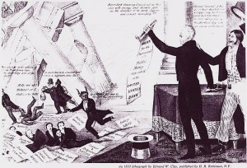
When Cornelius visited New York and his merchant friends asked for an explanation of his actions, he explained that “he had bound himself BY A WRITTEN PLEDGE to uphold the party. Such was his sense of the embarrassments of his situation that HE ACTUALLY WEPT.”

Accusations circulated that he had agreed to support Jackson’s policy in exchange for future influence in the management of state banks that would receive federal deposits. Although such claims were part of the rough political combat of the day and cannot be taken at face value, they show how his business background made him a target for suspicions of self-interest.
A City in Transformation
When Cornelius returned to New York from Washington, he stepped into a city undergoing rapid change. Immigration was swelling the population; new wards and neighborhoods were expanding northward; and issues of public health, water supply, policing, and municipal finance demanded new approaches. The city government—long dominated by a small circle of elites—was evolving toward a more democratic model, and political competition was fierce. Tammany Hall, Whig reformers, and nativist groups contended for influence in a volatile atmosphere in which elections could be as tumultuous as any street market.
The New York Mayoral Election of 1834
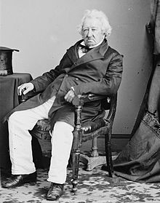
The shift toward popular election of the mayor gave Cornelius an opening for civic leadership. In 1834 he became the first mayor of New York City to be chosen directly by the voters, rather than appointed by the Common Council. Prior to 1834 mayors of the City of New York had been appointed, first by the colonial government, and then by the Common Council, the predecessor of the City Council. In the spirit of democracy, it was decided to let the voters of New York elect the sixty–first mayor. Cornelius Lawrence ran as a Tammany Democrat against Gulian Crommelin Verplanck, the Whig candidate, a poet and former Democrat.

Verplank, The Man with the Soul of a Poet (left)

His enemies described Cornelius’s decision to run in these terms: “the crying congressman, the weeping stock–jobber could have resigned had he disliked the party drill — but it brought him plunder, and he blubbered and held on, and afterwards he lent his name as a candidate for the mayoralty to uphold the gamblers he voted with in public…”
The mayoral election of 1834 was everything the nativists feared. They had warned that: “This country never committed a more fatal mistake than in making its naturalization laws so that the immense immigration from foreign countries could, after a brief sojourn, exercise the right of suffrage. To ask men, the greater part of whom could neither read nor write, who were ignorant of the first principles of true civil liberty, who could be bought and sold like sheep in the shambles, to assist us in founding a model republic, was a folly without a parallel in the history of the world, and one of which we have not yet begun to pay the full penalty.”

An observer described the democratic electoral process: “On the occasion we speak of a gang of Jackson shoulder–hitters, headed by an ex–Alderman, and armed with clubs, sling–shots, and knives, broke into the committee–room of the opposing faction and nearly killed some 15 or 20 of them. Then they tore down the banners, destroyed the ballots, and made a wreck of everything. The Whigs asked the Mayor for help, but he would not furnish it, alleging that all his forces were engaged. The Whigs were left to protect themselves and they did it. In these times elections lasted three days. The second morning Masonic Hall was packed with Whigs who meant to crush the mob. They had a battalion 1,800 strong ready to march at a moment’s notice.

This had the effect of keeping the peace and keeping free access to the polls. But the roughs were all the time firing up with drink, and on the third day were ready for anything. Early in the forenoon they tried to capture from a Whig procession the little miniature frigate Constitution. This led to a fierce conflict in front of Masonic Hall. The hall was assaulted, and the Mayor, Sheriff, and 40 Watchmen, were finally driven off. The Mayor [Gideon Lee] was wounded, and Police Capt. Flagg was killed. The rioters rushed into the hall, and the Whigs were forced to fly through the windows. The Mayor declared the City in insurrection, and called for help from the Navy–yard and Fort Columbus, but the Federal officers could not interfere. Finally, Gen. Sandford called out the military. Even with the military, which was largely pro–Jackson, on his side. Lawrence won by only 181 votes.”

The Stage Set for Conflict
Cornelius entered office at a moment when political passions ran high and the city’s institutions were under strain. The national banking controversy had unsettled financial markets; economic uncertainty loomed; and resentments simmered among working-class immigrants who faced competition for jobs, housing, and social standing. Conflicts over abolition, religion, and immigration—especially between established Protestant communities and newly arrived Catholic Irish—were intensifying. In this charged atmosphere, a spark could ignite widespread unrest.
During Cornelius’s tenure as mayor, that spark was lit. The anti-abolition disturbances that broke out in the summer of 1834, known as the “Farren Riots,” shook the city for four nights. Mobs targeted the homes, businesses, and churches of Black New Yorkers and white abolitionists, exposing deep divisions in urban society. How Cornelius responded, what forces drove the violence, and how these conflicts influenced his later reputation will be explored in the next section.

The Anti-Abolition / “Farren” Riots

The Anti–abolitionist riots of 1834, the Farren Riots, occurred in over four nights, beginning on July 7, 1834. Their origins lay in the combination of nativism and abolitionism among the Protestants who had controlled the city since the Revolution, and the fear and resentment of blacks among the growing underclass of Irish immigrants.
The urban rumor mill was busy manufacturing stories: “In May and June 1834, the silk merchants and ardent Abolitionists Arthur Tappan and his brother Lewis stepped up their agitation for the abolition of slavery by underwriting the formation in New York of a Female Anti–Slavery Society. Arthur Tappan drew particular attention by sitting in his pew with Samuel Cornish, a mixed–race clergyman of his acquaintance. By June, lurid rumors were being circulated by the champion of repatriating “colonization,” James Watson Webb, through his newspaper Courier and Enquirer: abolitionists had told their daughters to marry blacks, black dandies in search of white wives were promenading Broadway on horseback, and Arthur Tappan had divorced his wife and married a black woman.”

So the Irish, resenting competition from free blacks, rioted.
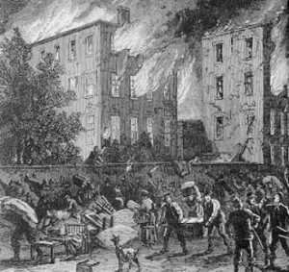
On Wednesday evening, July 9, three interconnected riots erupted. Several thousand whites gathered at the Chatham Street Chapel; their object was to break up a planned anti–slavery meeting. When the abolitionists, alerted, did not appear, the crowd broke in and held a counter–meeting, mocking the “black style” of preaching and calling for deportation of blacks to Africa.

The mob targeted homes, businesses, churches, and other buildings associated with the abolitionists and African Americans. More than seven churches and a dozen houses were damaged, many of them belonging to African Americans. The home of Reverend Peter Williams, an African-American Episcopal priest, was damaged, and his St. Philip’s African Episcopal Church was utterly demolished. One group of rioters reportedly carried a hogshead of black ink with which to dunk white abolitionists. In addition to other targeted churches, the Charlton Street home of Rev. Samuel Hanson Cox was invaded and vandalized. The rioting was heaviest in the Five Points.

the riots were finally quelled when the New York First Division (swelled by volunteers) was called out by the Mayor on July 11 to support the police. The "military paraded the streets during the day and the night of the 12th.: they were all furnished with ball cartridge, the magistrates having determined to fire upon the mob, had any fresh attempt been made to renew the riots."

Water, Sanitation, and the Croton Aqueduct Project
One of the most pressing concerns facing New York during Cornelius’s mayoralty was the city’s inadequate water supply. For decades, residents had relied on wells, cisterns, and private pumps, many of which were contaminated or insufficient for a growing population. Public health, fire protection, and basic sanitation required a far more reliable and abundant source of fresh water.
Cornelius supported the early stages of what would become one of the greatest civic engineering achievements of nineteenth-century America: the Croton Aqueduct. The concept of bringing fresh water from the Croton River in Westchester County to Manhattan had been discussed for years, but during his administration the planning and initial momentum accelerated. Although the aqueduct would not be completed until 1842, his tenure marked a significant step toward transforming New York into a healthier, safer, and more resilient city.

The Great Fire of 1835 and Its Aftermath
In December 1835, only months after Cornelius left office as mayor, New York experienced one of the most devastating urban fires in its history. Beginning on a bitterly cold night, the blaze swept through the heart of the city’s commercial district around Wall Street, consuming warehouses, offices, and many of the most valuable buildings in the metropolis. More than 600 structures were destroyed, and the financial losses were immense.

Although Cornelius was no longer in office, the catastrophe underscored the pressing need for the very improvements that had begun to gain traction during his administration. The inadequacy of the city’s water supply, already recognized as a public health problem, proved disastrous in the face of such a fire. Fire companies struggled to combat the flames, and the urgency of completing the Croton Aqueduct became unmistakable. In the years that followed, the city undertook major reforms to improve fire protection, infrastructure, and urban planning—initiatives that built on foundations laid during Cornelius’s tenure.

Collector of the Port of New York
After serving as mayor, Cornelius continued his public career when President Martin Van Buren appointed him Collector of the Port of New York in 1837, one of the most influential federal posts in the nation. The position carried considerable responsibility for customs administration, revenue collection, and oversight of maritime commerce at what was rapidly becoming the country’s principal port of entry, and tariffs supplied a principal source of revenue for the Federal government.

Cornelius held this office until 1841 and again for a period thereafter, navigating the duties of a role that required both administrative ability and political tact. The Collector’s post was seen as a mark of high confidence within the Democratic Party, and his appointment affirmed his standing as a trusted public servant with substantial experience in commerce and government.

Later Financial and Civic Roles
Beyond elected office, Cornelius remained deeply engaged in the financial and civic life of New York. Over the course of his career, he served as president of the Bank of the State of New York for many years, guiding the institution through periods of economic expansion and contraction. He also held directorships and trustee positions in a number of financial and insurance organizations, including the Bank of America, the New York Life and Trust Company, and prominent fire insurance companies.

His participation in these institutions reflected the close relationship between public service and civic responsibility that characterized New York’s leadership in the nineteenth century. Cornelius belonged to a generation of merchant-statesmen who considered it a duty to contribute their business experience to the development of public and charitable institutions.
Private Life and Scandal
Life was not all work and no play for Cornelius. An older history of New York has the tantalizing outlines of a story: Cornelius “had the ice cream and strawberries of everything in life–in commerce, in politics, in wives, in finances and in religion…. He had a peculiar way of carrying his spectacles behind his back while he looked at all the pretty girls he met: “One of them led him a sad dance. Mr. Lawrence, the most respected man in the city, was led into an ambuscade and made the victim of a plot. It was a sad business, lost the old gentleman a great deal of money, and caused him any quantity of mental misery.”

What had happened is that Cornelius, like almost every other male in New York over the age of 14, had participated in the Sporting Life. This was a libertine male culture, revolving around sports and prostitutes. Cornelius paid blackmailers $100,000 (about $3,000,000 in 2025 dollars, what one reference work estimated as his net worth) to keep his past quiet, so his indiscretions must have been truly spectacular.

The Sacramento Daily Union of November 18, 1856, reported “The Heavy Black Mail Operations. — Some months ago, as will be remembered, Ex–Mayor Cornelius W. Lawrence preferred a charge of perjury against Mr. A. Brown, formerly a Deputy U. S. Marshal of this city, for swearing falsely in one of the Law Courts. It was expected that, during the examination into the merits of this charge of perjury, certain facts relating to enormous black mail operations, which Brown practiced upon the Ex–Mayor, at intervals during a period of eighteen years, by which he obtained from Mr. Lawrence over $100,000, would be brought to the notice of the Court, but owing to the continued absence from Court of Mr. Lawrence on every occasion, when the case was to have been examined, the magistrate, Justice Flandreau, was determined to dismiss the complaint, and did so. Brown, it will be remembered, was stated to have been in possession of certain secrets touching the Ex–Mayor’s intimacy with a female twenty years or longer ago, and by means of threats to expose, he succeeded in getting from Mr. L. large sums of money at various times, in the aggregate amounting to over $100,000.
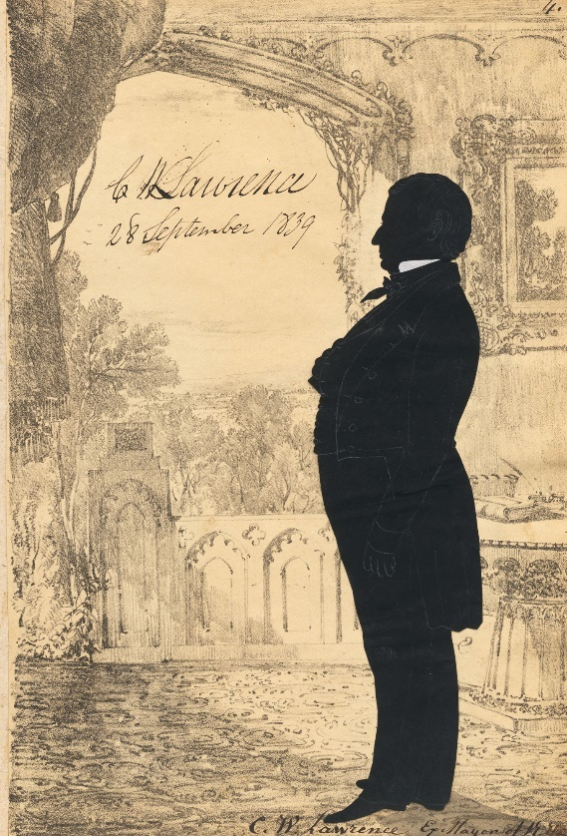
“For years the Ex–Mayor suffered the infamous extortion to go on, but finally he refused giving Brown any more money and then only the circumstances of Mr. L.’s youthful indiscretion was made public, although some of his friends knew of it years ago, and advised him not to give Brown a cent, but to let him make the expose and then have the affair cleared up. Mr. Lawrence, however, declined this course, and has, accordingly, suffered from Brown’s extortions. The latter was under bonds of $5,000 to answer the charge of perjury, but is now discharged and his bondsmen liberated. He was formerly owner of a public house called “the Red House,” at Harlem, and for years past has lived extravagantly.

The Red House tavern in Harlem was a mecca of the fast set’s “manly sports,” sports which were not limited to cricket and horse racing.
Death and Burial
Cornelius Van Wyck Lawrence died on February 20, 1861, closing a life that had spanned a transformative period in New York’s emergence as a commercial and political center. He was interred in the Lawrence family plot at Bayside, a resting place for many members of the extended family whose lives shaped the history of Long Island and New York City.

Legacy

In honor of his service as Collector of the Port of New York, the revenue cutter Cornelius W. Lawrence was named after him. It had a brief and checkered history. It was a Baltimore clipper (i.e., fast), built in Foggy Bottom, and commissioned in October 1848.
“She was assigned to the west coast, with Captain Fraser’s orders being to secure the revenue, enforce U.S. laws on the seas, aid distressed vessels, and to sound and chart the new territory’s harbors and inlets. With a crew of 43 aboard, with most of Fraser’s officers being political appointees with no seagoing experience, Lawrence set sail for the Pacific on 1 November 1848 around Cape Horn. After an arduous voyage of over 11 months, including five weeks spent attempting to sail around the Horn, she arrived in San Francisco on 31 October 1849.

“Difficulties soon visited the cutter though when the crew learned of the vast fortunes being made by those hunting gold inland and Fraser soon found himself without a crew. Even his officers resigned to join the gold rush.”

Eventually the Lawrence sailed again, and went to San Diego, the Hawaiian Islands, and back to San Francisco to help put down mutinies. She ran aground and was lost at the entrance to San Francisco Bay on the night of 25 November 1851. All hands were saved. But in 1982 she was (largely) duplicated and given the name the Californian, becoming the state’s own tall ship.
After his death Cornelius had a fireboat named after him, presumably in honor of his work in the Volunteer Fire Department and his work in bringing water to New York City to prevent fires. It had a longer career.

Lawrence, David (1737–1809)
Parents: John Lawrence (1703–1781) and Mary Betts (1699–1741).
Spouse: Sybil Sterry (1742–1831).
Children: Thomas Lawrence (1764–1852); Caleb Lawrence (1766–1768); Mary Lawrence (1768–1849); Nancy Anne Lawrence (sometimes recorded as “Anne”) (1769–1850);
Charles Lawrence (1771–1846); Caleb Lawrence (1773 - ); Samuel Adams Lawrence (1775–1851); Sarah Lawrence (1775–1854); Lydia Lawrence (1777–1782); Elizabeth Lawrence (1779–1811);William Lawrence (1781–1833).
Kinship: First cousin seven times removed of the post–World War II Smith generation.

Early Life and Career
David Lawrence was born in Newport, Rhode Island, and later settled in Providence, where he became a prosperous merchant. He moved in the commercial and patriotic circles of the Revolutionary period and was acquainted with Benjamin Franklin and Samuel Adams.
Revolutionary War Service
David Lawrence served as a Lieutenant in the Rhode Island troops during the American Revolution, under Captain Jonathan Russell and Colonel Jabez Bowen. He appears in the Rhode Island Military Census of April 1777, recorded at Providence among the men eligible for service. His military service has been verified by the Daughters of the American Revolution, which lists him as Patriot Ancestor A067127. His descendants are eligible for membership in the DAR and SAR.
Hudson, New York
After retiring from business, David moved to Hudson, Columbia County, New York, where he was one of the thirty original proprietors of the town. He became a leading figure in civic affairs, serving as Judge, Recorder, and later Mayor of Hudson. Through his public roles and the marriages of his children, the family became connected with influential households throughout New England and the Hudson River Valley.
Death
David Lawrence died in Hudson on October 18, 1809. Sybil (Sterry) Lawrence survived him by more than twenty years and died in 1831.

Lawrence, Dorothy Quincy (1908–1981)

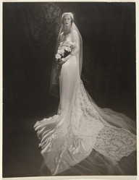

Parents: Effingham Lawrence Jr. (1878–1956) and Dorothea Quincy Gookin (1881–1969).
Spouse: (1) George Robert Fitch (1909–2004) in 1934; (2) Blinn Sill Cushman (1907–1980) in 1949.
Children: Andrew Lawrence Cushman (1953– ).
Kinship: Third cousin twice removed of the post–World War II Smith generation.

Early Life and Family Background
Dorothy was a member of the notable Lawrence family of New York Her father was the fifth generation in direct descent to bear the name Effingham. She was educated at Miss Chapin’s School in New York City, and made her debut at the Hotel Pierre in 1927, reflecting the family’s established social standing.
Marriage and Personal Life
Her first marriage, to George Robert Fitch in 1934, was a prominent society wedding. The reception was held at the Lawrence Homestead, the last family gathering at the historic house built by her ancestor in 1645. After their divorce, she married Blinn Sill Cushman in 1949, with whom she had one son, Andrew Lawrence Cushman.
Legacy
Dorothy’s life bridged two eras of the Lawrence family’s social history, spanning the final years of the family’s occupation of its historic homestead and its transition into the modern period. She preserved the Lawrence name through her son’s middle name, ensuring continuity of the family identity into the next generation.

Lawrence, Edward Arthur (1831–1883)
Parents: Effingham Lawrence (1779–1850) and Anne Townsend (1782–1845)
Spouse: Hannah Russell Mickle (1837–1885), daughter of Andrew Haswell Mickle, Mayor of New York City (1833–1834)
Children: Effingham Edward Lawrence (1854–1911), Julia Townsend Lawrence (1860–1933), August Lawrence (1862–1892), George Lawrence (c. 1865–after 1880), and Mary Kemble Lawrence (1871–1932)
Kinship: Third great-granduncle of the post–World War II Smith generation
Early Life and Family Background
Edward Arthur Lawrence was born into the prominent Lawrence family of Bayside and Flushing, Long Island. His father, Effingham Lawrence, was a well-known landowner and businessman, and his mother, Anne Townsend, came from the respected Quaker Townsend family, further strengthening the long-standing alliances between the Lawrences and Townsends. Assemblyman Solomon Townsend (1746–1811) was his grandfather; State Senator Samuel Townsend (d. 1790) was his great-grandfather.
Marriage and Social Position
On December 6, 1855, Edward married Hannah Russell Mickle, daughter of former New York City Mayor Andrew Haswell Mickle; the wedding was reported in the New York Times on December 8, 1855. The marriage united two influential New York families and was noted in society columns for the elegance of the occasion.
Metropolitan Hotel—Brilliant Wedding.
“Last evening, Mr. Edward Arthur Lawrence, son of Hon. Cornelius W. Lawrence, led to the altar the daughter of Ex-Mayor Mickle. The happy event was celebrated at the Metropolitan Hotel, where the bride’s father has rooms for the Winter, by one of the largest, as it was the most fashionable and distinguished parties of the season. The circle of the immediate relatives and acquaintances of the united families numbered over three hundred guests, and the whole list of accepted invitations embraced a party of over eight hundred ladies and gentlemen. Broadway was fairly blockaded by carriages to a late hour. The occasion was honored by the presence of Senator Crittenden, of Kentucky, Ex-Senator Dickinson, of New-York, Hon. Mr. Denver, M. C., of California, General Escanden, of Mexico, Mr. Stanhope, Prevost of Lima, Judge Roosevelt, Commodore Nicholson, Hon. Preston King, Hon. Robert J. Walker, Hon. Charles H. Morgan, Mr. Thomas F. Meagher, Capt. Charles H. Marshall, Ex-Mayor Kingsland, Gen. Talmadge, and a very large number of distinguished City families. The whole of the splendid and admirably conducted establishment of the Messrs. Leland was thrown open on the occasion, and everything passed off with genuine spirit and hearty enthusiasm. Long live the happy pair! May their way of wedded life be as unclouded as its commencement was joyous.”
It will be noted that the New York Times Daily News ( Dec. 8, 1855) continued the Times journalistic tradition of inaccuracy. Edward Arthur Lawrence was not the son of Cornelius W. Lawrence, but the son of Effingham Lawrence.
Public Service
As a Democrat, he was Supervisor of the Town of Flushing for twelve years, a member of the New York State Assembly (Queens Co., 1st D.) in 1858 and 1859, and a member of the New York State Senate (1st D.) in 1860 and 1861.
Death
Edward Arthur Lawrence died in 1883 at the age of fifty-two. His widow, Hannah, survived him by two years.

Lawrence, Edward Effingham (1830–1890)
Parents: William Effingham Lawrence (1781–1841) and Mary Ann George Smither (1797–1880).
Spouse: None recorded.
Children: None recorded.
Kinship: Second cousin five times removed of the post–World War II Smith generation.
Early Life and Tasmanian Connection
Edward Effingham Lawrence was born in Tasmania in 1830, a son of William Effingham Lawrence—an English settler in Van Diemen’s Land and member of the Legislative Council—belonging to the London-origin Lawrence branch that removed to Tasmania in the 1820s. (For the fuller context of this branch, see the separate “Tasmania” entry.)
Education and Military Service
He returned to England for schooling and in 1856 obtained a Cornetcy in the 7th (Princess Royal’s) Dragoon Guards. He is associated in family materials with British involvement around the Austro–Sardinian conflict of 1860–61 (specific regimental actions for his troop have not yet been located).
Residence and Occupation
After leaving military service he spent a period in Antwerp, and by the 1860s–70s had become a stockbroker in London. In 1880 he occupied chambers on the third floor at No. 3 Craven Street, Strand, where he had resided nearly fourteen years. (Craven Street is the same street where Benjamin Franklin’s London house—No. 36—still stands.)
Legal Matters
• Old Bailey (24 May 1880) — Theft from his rooms.
Lawrence testified in the Central Criminal Court against Frederick Foghill (with Henry Hudson), charged with stealing two portmanteaus, a wooden box, and household linen and clothing (total value c. £43) from Lawrence’s rooms and attic at 3 Craven Street. The published session paper explicitly names Edward Effingham Lawrence as the victim; the defendants were convicted.
On May 21, 1886 Lawrence was a defendant, accused of conspiring to obtain money under false pretenses from the plaintiffs. Judgement was for the defendant.

Death and Inquest
On 20 October 1890 he died by suicide at the Army and Navy Stores, London, by gunshot. At the inquest, his brother stated that Edward had long been an invalid, took morphia to sleep, and had said he “could not bear his sufferings any longer,” though he had given no prior indication of suicidal intent. No further cause was discovered; the coroner’s jury returned temporary insanity. His estate was stated to be over £6,000.

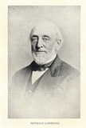
Lawrence, Edward Newbold (1805–1839)

Parents: John Burling Lawrence (1774–1844) and Hannah Newbold (1782–1832).
Spouse: Lydia Ann Lawrence (1811–1879), his first cousin.
Children: Frederick Newbold Lawrence (1834–1916).
Kinship: Third great-grandfather of the post–World War II Smith generation.
Early Life and Family Background
Edward Newbold Lawrence was born in 1805 into the Flushing branch of the Lawrence family, descended from John Lawrence, the seventeenth-century settler, and connected through marriage with the Newbolds, Townsends, Hickses, and other Long Island Quaker families. His mother, Hannah Newbold, belonged to the respected Newbold family of New Jersey, whose Philadelphia and Burlington County branches intermarried frequently with Quaker mercantile families.
Marriage and Residence
He married his first cousin, Lydia Ann Lawrence, daughter of John L. Lawrence of Bayside. Their only child, Frederick Newbold Lawrence, was born in 1834. Lydia survived her husband by forty years. She did not remarry and remained closely connected with the Lawrence family circle. She died in 1879 and is buried in the Lawrence Cemetery.
Career
Edward headed the mercantile commission firm Lawrence, Keese & Co., a New York importing house active in the 1830s.
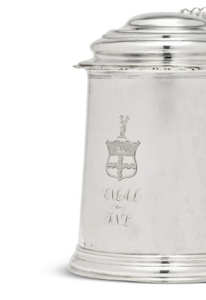
The Firm of Lawrence, Keese & Co.
The firm of Lawrence, Keese & Co. was a New York mercantile and commission house active in the 1830s, dealing largely in imported goods and shipping consignments between New York and Liverpool. The firm appears in contemporary commercial directories among reputable houses engaged in the Atlantic trade. The Keese partner was of the New York Quaker mercantile family connected by marriage to allied Long Island families, and the partnership reflected long-standing commercial ties between the Lawrences, the Keeses, and other Quaker-descended trading houses.
Family Silver Tankard
A silver tankard made about 1750 by Joseph Richardson of Philadelphia was sold at Sotheby’s. It bears the Lawrence arms and the initials of Edward Newbold Lawrence, his wife Lydia Ann Lawrence, and their son Frederick Newbold Lawrence. It was likely engraved for Frederick’s coming of age, perhaps as a twenty-first birthday gift in 1855.

Death
Edward Newbold Lawrence died at Liverpool, England, on 21 October 1839, aged thirty-four. His death occurred while abroad, probably on business, as Liverpool was then a major port linking New York and England. He was buried in the Lawrence family cemetery.
The inscription on his footstone in the Lawrence Cemetery reads:
In Memory of Edward Newbold Lawrence, who departed this life at Liverpool, England, on the 21st day of October, 1839, in the 35th year of his age. Blessed are the pure in heart, for they shall see God.

Lawrence, Edwin Seabury (1842–1900)
Parents: William Augustus Lawrence (1811–1875) and Catherine Elizabeth Ely (1819–1887).
Spouse: None recorded.
Children: None recorded.
Kinship: Fifth cousin four times removed of the post–World War II Smith generation.
Edwin Seabury Lawrence was born in 1842 and spent his life in Flushing, Long Island. He worked as a farmer and market gardener, continuing the longstanding Lawrence involvement in agriculture and nursery cultivation around Flushing. He lived in an old Lawrence family house dating to the seventeenth century, preserving an earlier mode of life even as Flushing began to suburbanize in the late nineteenth century. He died in 1900.

Lawrence, Effingham (1735/34–1806)
Captain
Parents: Richard Lawrence (1691–1781) and Hannah Bowne (1697–1748).
Spouse: Catharine Farmer (1752–1806).
Children: William Effingham Lawrence (1781–1841), John Curson Lawrence (1783–1791), Effingham Calvert Lawrence (1785–1837), Catharine Maria Lawrence (1768–1839), and Edward Billop Lawrence (1790–1861).
Kinship: Fifth great-granduncle of the post–World War II Smith generation.
Early Life and Maritime Career
Effingham Lawrence was born in 1735/34, the third son of Richard Lawrence of Flushing, Long Island, a descendant of William Lawrence, the seventeenth-century settler. He entered maritime service at a young age. His early voyages were typical of New York masters of the period, carrying goods and passengers between New York, the West Indies, and London. In 1761, having recently commanded the brigantine Audrey, he was travelling as a passenger when the vessel was taken by a privateer from Bayonne. The same privateer captured another ship carrying corn from London to Lisbon; its captain ransomed the vessel, and Lawrence and the other passengers transferred to it and continued on to Lisbon.
By 1770 he had become the first captain of the Earl of Dunmore, a newly built and well-appointed New York packet ship for transatlantic service. In that year he conveyed General Thomas Gage, the newly appointed Commander-in-Chief in North America (and later military governor of Massachusetts), and his family to London. His career placed him at the intersection of colonial New York’s maritime commerce and the wider imperial naval world of the later eighteenth century.
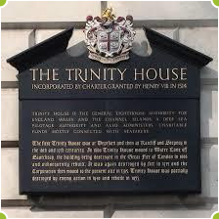
Move to London and Trinity House
Effingham settled in London and continued his maritime career there. In 1796 he became a member of the Elder Brethren of Trinity House. Trinity House, formally the Corporation of Trinity House of Deptford Strond, is the historic English maritime authority responsible for the regulation of pilots, the safety of navigation, the maintenance of lighthouses and beacons, and the oversight of seafarers. Membership among the Elder Brethren was, and remains, a distinction reserved for experienced and respected naval and maritime figures, including admirals, captains, and senior officials. His career, beginning under the British colonial flag in New York and ending with distinction in the heart of Britain’s maritime establishment, illustrates the continued transatlantic ties of certain colonial American families even after the Revolution.
Effingham Lawrence died in 1806.

Lawrence, Effingham (1760–1800)
Parents: John Lawrence (1732–1794) and Ann Burling (1735–1821).
Spouse: Elizabeth Watson (1764–1852).
Children: Mary Watson Lawrence (1787–1863), Watson Effingham Lawrence (1788–1872), Anna Watson Lawrence (1792–1868), John Watson Lawrence (1800–1888).
Kinship: Fourth great-granduncle of the post–World War II Smith generation.
Early Life and Disownment by Friends
Effingham Lawrence was born into the Flushing/Bayside Quaker community of Long Island. As with a number of young Quaker men during the Revolution, he was disowned by the Friends for adopting military dress, wearing a cocked hat and sword.
Druggist and Apothecary
In 1781 Lawrence established his druggist’s and apothecary business at 99 Pearl Street. He served as druggist to the Medical Society, whose examining committee visited his shop quarterly and certified that “his drugs were genuine and his medicines faithfully prepared.” The inspection regime reflected the transitional, pre-professional era of American pharmacy, when merchant-apothecaries provided both imported materia medica and house-prepared compounds.
The Tontine Coffee House
He was among the sponsors of the Tontine Coffee House, a central node of New York’s commercial life, insurance gossip, and exchange of prices and news. In the sponsor lists he appears simply as a “gentleman,” an unusual designation beside merchants and traders and an early sign of the social standing his probity and success had already earned him.
Jefferson’s Purchase
During Thomas Jefferson’s New York sojourn after returning from France in 1790, the Secretary of State purchased red bark (Peruvian bark/quina) and toothbrushes from “Effingham Lawrence, druggist, 227 Queen Street [Pearl Street].” The note captures the everyday realities of elite medical consumption and the expanding availability of personal hygienic goods in the city.
Sale of the Business and Retirement
In 1794 Lawrence sold his shop and stock to Jacob Schieffelin (1757–1835) and John Lawrence, part of a wider consolidation of the New York drug trade as wholesale houses grew. Effingham retired to his country place in Flushing, where he died in 1800.
The Quaker Pharmaceutical Trade
The Quaker networks that shaped the Lawrence family also shaped the early drug trade. Before the Revolution, English Quaker manufacturers controlled a large share of drug and botanical production; their American co-religionists had privileged access to current methods and supply. New York and Philadelphia wholesale houses sold an expansive range—medicines and botanicals, spices, surgical instruments, medicine chests, and even hardware-store staples like paints and glassware—to physicians, plantations, ships, and retail apothecaries. When wartime embargoes cut American buyers off from England, local druggists accelerated domestic manufacture of chemicals and preparations, a capability that persisted into the new century and elevated firms like Schieffelin & Lawrence.

Lawrence, Effingham (1779–1850)
Judge
Parents: Joseph Lawrence (1741–1813) and Phebe Townsend (1740–1816).
Spouse: Anne Townsend (1782–1845), his cousin.
Children: Solomon Townsend Lawrence (1808–1839), Henry Effingham Lawrence (1810–1875), Lydia Ann Lawrence (1811–1879), William Effingham Lawrence (1813–1871), Robert Townsend Lawrence (1816–1842), Effingham Lawrence (1820–1878), Mary Nicoll Lawrence (1822–1896), Joseph Effingham Lawrence (1824–1878), Cornelius B. Lawrence (1826–1896).
Kinship: Fourth great-grandfather of the post–World War II Smith generation.
Early Life and Farm Holdings
Effingham Lawrence belonged to the Bayside branch of the family, a rural area of Queens at a time when the borough extended eastward as far as Hempstead. He owned and managed the Bayside Farm as his principal estate, along with three additional farms, forming a substantial agricultural holding. He chose a landholding and agricultural life rather than the mercantile or maritime careers common among some of his relatives.
Breeding and Agricultural Innovation
In his early years he devoted particular energy to improving livestock. He bred “thoroughbred” cattle, a period term for carefully kept pure strains, and became an early and enthusiastic importer and breeder of Merino sheep. His account books record the purchase of a Spanish ram and two ewes for the considerable sum of $2,200. He corresponded with breeders as far as Canada and the Carolinas to improve stock, and the large Merino flocks he developed became the foundation of flocks in Vermont, Canada, and the Western states. These were said to be the progenitors of the “Canadian mutton” sold in early New York City markets. His account books also record daily farm realities: seed, lime, and fertilizer purchases; fencing; wool sales; seasonal labor; and the ongoing commercial balance between the farm and the growing markets of New York City. He was regarded as an early advocate of the liberal use of plant foods and fertilizers.
Agricultural Leadership in Queens County
By 1817 he was among the prominent men who organized the Agricultural Society of Queens County, formed to “improve the method of farming and raising of stock and advancing rural economy.” Queens then encompassed a large area extending to Hempstead. Rufus King of Jamaica, the statesman and diplomat, was elected the society’s first president, and Judge Lawrence served as one of the two vice presidents. The first meeting was held in the old Mineola courthouse in 1819, and an exhibition was held that same year.
In July 1841 a new Queens County Agricultural Society was formed to replace the original body, and on this occasion Judge Lawrence was elected its president. The first fair under the new organization took place on October 15, 1842, at Anderson’s Hotel in Hempstead. Before the event, William Cullen Bryant, the poet, journalist, and horticulturist, composed an ode that was sung at a local church. Attendance at these fairs ranged from 6,000 to 20,000 visitors, attracted both by the agricultural exhibits and the racetrack. Later fairs were also held at Jamaica.
Horses, Hunting, and Social Life
Judge Lawrence was also known as a breeder of fine horses, and in his younger days he took part in the hunt. In season he would pack up his family for a two-day trip to Smithtown to visit his relative Richard Smith. The countryside around Lake Ronkonkoma provided excellent fox and deer hunting, and these excursions reflected both the social rhythms and country sporting life of the Long Island gentry of the period.
Stone House and Later Life
Stone House (see Houses and Estates) was built in 1822 by Isaac Stansbury for Judge Lawrence on 49 acres overlooking Little Neck Bay in Queens. He continued to oversee and improve his properties into his later years and remained active in agricultural affairs. Judge Lawrence died in 1850 and was buried in the Lawrence Cemetery in Bayside.

Lawrence, Effingham (1820–1878)
Congressman for a Day

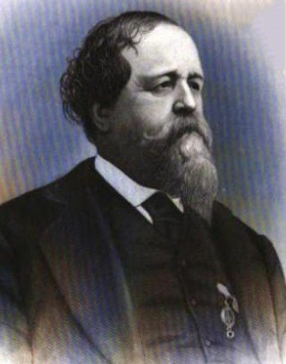
Parents: Judge Effingham Lawrence (1779–1850) and Anne Townsend (1782–1845).
Spouse: (1)Jane Lucretia Osgood (1829–1863) in 1847; Gertrude Cammack (1839-1870)
Children: With Lucretia Osgood: Annie Townsend Lawrence (1847–1942), Jane Lucretia Lawrence (1847– ), Isaac Osgood Lawrence (1850–1870), Jeannie Osgood Lawrence (1852– ), Adele Lawrence (1853– ), Effingham Lawrence (1856–1899), and Bessie Amelia Lawrence (1858–1937); with Gertrude Cammack Horace Claiborne Lawrence (1867-1874) and Gertrude Lawrence (1869- ).
Kinship: Third great-great-granduncle of the post–World War II Smith generation.
Effingham Lawrence was born into a prominent Queens County family and later became a sugar planter and political figure in Louisiana. He served for a term in the state legislature, was a delegate to the Louisiana Secession Convention, and after the Civil War held federal office. His life reflected the social and political transformations of Louisiana in the mid-nineteenth century, including the shift from plantation society through war and Reconstruction.
Early Life and Marriage
Effingham was born in Queens County, New York, the son of Judge Effingham Lawrence of Bayside. In 1847 he married Jane Lucretia Osgood, a Kentucky heiress connected with the Osgood family of Troy, New York. Soon after their marriage, he left New York and settled in Plaquemines Parish, Louisiana. His wife’s family background and resources appear to have facilitated his establishment as a planter on a large scale.

Magnolia Plantation
Effingham purchased Magnolia Plantation in Plaquemines Parish, situated on the Mississippi River about fifty miles below New Orleans.
Effingham served for a term in the Louisiana state legislature in 1854–1855, representing Plaquemines Parish. His participation in local politics and his reputation as a capable planter made him a recognized figure in the parish well before the Civil War.
Toward Secession
As sectional tensions increased in the late 1850s, many Louisiana sugar planters supported separation from the Union. On 27 December 1860, Effingham addressed a meeting of the “Friends of Southern Rights and Separate State Secession” in Plaquemines Parish. He argued that the South had exercised restraint in the face of what he viewed as Northern political pressures, and stated that Louisiana had the right and duty to defend its position. His remarks reflected the prevailing sentiment among planters along the lower Mississippi River at that moment.

Louisiana Secession Convention
Effingham was elected the delegate for Plaquemines Parish to the Louisiana Secession Convention in Baton Rouge. The convention assembled on 23 January 1861, and he took an active role in its proceedings. On 26 January 1861 the convention passed the Ordinance of Secession, and Effingham was among its signatories. He proposed that each signer be presented with a golden pen to commemorate the event. This gesture illustrated the sense, shared by many delegates, that they were participating in a historic and consequential act.

War and Union Occupation
When the Civil War began, Union naval forces gained control of portions of the lower Mississippi River early in the conflict. Plantation operations throughout Plaquemines Parish were disrupted. Effingham remained at Magnolia for much of the period, although he sent his family to New Orleans for safety; his wife died there in March 1863.

Contemporary accounts show that the plantation’s labor system underwent rapid change. Some members of the workforce left the plantation when Union forces arrived in the region, while others returned after encountering uncertainty and hardship in military camps. The Union army was not equipped to sustain the sudden influx of formerly enslaved people, and conditions varied widely. Correspondence from Magnolia indicates tension but not large-scale violence. In mid-1862 the plantation’s overseer sought permission from Union authorities to allow workers to return to their homes, which was granted. By late 1862 Effingham reported difficulty maintaining order and productivity amid the ongoing disruption.
During the occupation, Effingham offered hospitality to Union officers. He served on a levee committee concerned with flood protection, a critical issue for plantations along the river. His stance during this period contrasts with that of some planters who left their properties. The Lawrences had learned that it was wise to imitate the willow, and bend with the wind.
Reconstruction and Public Affairs
After the war, Effingham sought to adapt to the new conditions. Former enslaved workers at Magnolia generally continued to live on the plantation. Some entered wage agreements; others later acquired small parcels of land. Contemporary observers, including two visitors reporting from a Northern perspective, described the arrangements at Magnolia in the mid-1860s as comparatively orderly for the time, with labor compensated by shares of the crop.
Reconstruction politics in Louisiana were turbulent. In 1874 a movement called the White League arose in opposition to the Reconstruction government. It asserted that it opposed corruption and sought to restore local control, but its methods and rhetoric were widely criticized. In August 1874 Effingham published a letter in the New Orleans press rejecting efforts to organize politics along racial lines and warning against attempts to exclude Black citizens from participation in civic life. The New York Times commented that while many in Louisiana privately disagreed with the White League, Effingham was “the only one of large influence” who publicly protested. His stance provoked hostility, and he was threatened and urged to leave the state.
Effingham write a long public letter (Picayune, August 23, 1874) condemning this attempt effectively to disenfranchise blacks..Lawrence admitted that the newly enfranchised black voters had elected corrupt carpetbaggers. The black voters saw the corruption of the white men they had voted for, and were disappointed in their supposed friends; the carpetbaggers then blamed the negro voters for the corruption, thus turning blacks again whites and whites against blacks.
\
Lawrence pointed out that whites also were known to make bad political decisions: “Such lapses in citizenship have occurred among the Anglo–Saxon citizens, and will occur again; but they are not incurable in their character, nor in either the white or black race, such as to lead the patriot to despair of the Republic.”

Lawrence attacked the “scarecrow” of social equality (which seems to have been a code word for miscegenation): “In exceptional cases I have seen white men who, of choice, sought negro association, and negroes who preferred the association of whites; but as the rule, with scarcely an exception, the healthy minded white and colored alike seek domestic affiliations with those of their own race.”

He condemned the attempt to pit white against black: “In my judgment a race organization, political in its character, white or black, is at all times questionable and dangerous. But at this juncture of affairs is evil, only evil, and full of mischief to both races and to the State.”

The New York Times, in recounting Lawrence’s letter, said that it was sure that many responsible Louisianans were ashamed of the White League, but Lawrence was “the only one of large influence who has entered his formal protest against a course which can only end in disaster to the reckless men engaged in it.” Lawrence was insulted, mobbed in the streets, and ordered to leave the state.

The Battle of Liberty Place
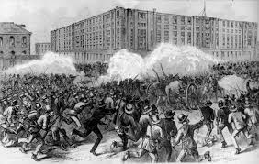
Under former Confederate officers the White League drilled and trained forces until they were better prepared than the police and the state militia. They smuggled in arms, cut telegraph lines to the North, and staged a coup d’état. On September 14, 1874, in heavy street fighting 5,000 members of the League defeated 3,500 police and militia, with 100 casualties (the Battle of Liberty Place). The Republican Governor Kellogg fled for safety to a federal installation. The White League took over all government offices at bayonet point and evicted all incumbents. But President Grant would not tolerate a rebellion; he sent in Federal troops to restore Kellogg.
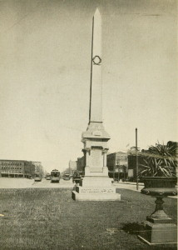
In 1891 New Orleans built a monument to the Battle of Liberty Place.
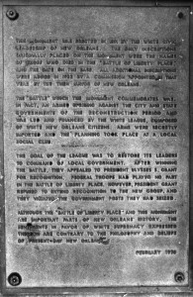
In 1932 a plaque was added:

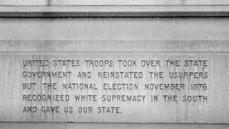
In full it reads: “McEnery and Penn having been elected governor and lieutenant–governor by the white people were duly installed by this overthrow of carpetbag government, ousting the usurpers, Governor Kellogg (white) and Lieutenant–Governor Antoine (colored). United States troops took over the state government and reinstated the usurpers but the national election of November 1876 recognized white supremacy in the South and gave us our state.”
In 1974 the city added a plaque instructing the citizenry to disregard previous plaques: “Although the “Battle of Liberty Place” and this monument are important parts of the New Orleans history, the sentiments in favor of white supremacy expressed thereon are contrary to the philosophy and beliefs of present–day New Orleans.”

The 1993 inscription that covers the 1932 inscription tries to have it both ways.
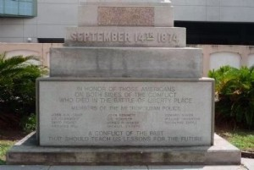
In honor of those Americans on both sides of the conflict who died in the Battle of Liberty Place.
A conflict of the past that should teach us lessons for the future.
But what are the lessons?

The Great Train Journey
In September 1872 Governor Warmoth and Effingham Lawrence went to New York to discuss railroad matters. At 5 PM one evening at the Fifth Avenue Hotel Warmoth unexpectedly ran into his Lieutenant Governor, Pinchback, who said that he was in North giving speeches. The two agreed to meet at 9 PM that evening to make arrangements to return to New Orleans on the same train.

But Pinchback did not show up, and Warmoth went to bed that night with an uneasy feeling. The next morning he went to the hotel and ran into a young man who was travelling with Pinchback, who said that Pinchback hadn’t returned but his luggage was still at the hotel. Warmoth was still uneasy. He ran into Senator Harris, an acquaintance of Pinchback’s, and asked him whether he had seen Pinchback. Harris said that Pinchback had left on the train for Pittsburgh the previous evening. Warmoth immediately spotted Pinchback’s deception and realized he must be up to something.

He and Lawrence opened telegraphic connections all along the route to New Orleans and took the lightning train south. Pinchback had a twelve–hour lead. At Louisville Warmoth and Lawrence learned what Pinchback was up to.

What Pinchback had been doing in New York was conspiring with the Grant faction at achieve a coup d’état in Louisiana to make sure the state delivered its electoral votes to Grant. Pinchback’s supporters in the legislature were waiting for him at Amite, just inside the Louisiana line. There they would “impeach the Governor, Auditor, and some other officers, overturn the city government, reorganize the police, remove all of Warmoth’s appointees throughout the State, especially the registrar of voters, sign the new bills, and continue in session until January next.” They had prepared “plenty of troops to call to protect the coup d’état and maintain by force the raw regime.”

The matter was urgent. Warmoth and Lawrence chartered a special train to meet them at Humboldt: the best locomotive of the Mississippi Central and one car. They telegraphed ahead for the track to be cleared the whole distance south. They told the engineer to open the throttle, but he insisted that Lawrence first sign a bond to be responsible for any damages. Meanwhile Warmoth and Lawrence arranged a little trick of their own.

Pinchback was on the train as it stopped in Canton, Mississippi. A man boarded and asked whether there was a Mr. Pinchback aboard. Pinchback identified himself, and was told there was a telegram at the station office for him but it was to be put direct into the hands of Pinchback and no one else. Pinchback went to the station; thee stationmaster said he needed positive identification. Pinchback rounded up some people who knew him, and then the stationmaster said he had misplaced the telegram and had to search for it. He finally gave it to Pinchback who tore it open only to discover a blank piece of paper. He then realized what had happened and tried to get out but the door was locked. He tried the window and that was locked. He yelled and finally got someone outside to unlock the door. But then he saw the train two hundred yards down the track on the way to New Orleans. It did not stop as he waved his handkerchief and yelled. He was told there would be another train in the morning, so he spent the night in the town.
At dawn he went to the platform and saw a train approaching. “The tall figure of Governor Warmoth is seen on the platform, and his strong voice is heard shouting–‘Hurra! Hulloa! Pinch, is that you? Thought you were with your baggage at the Fifth Avenue. Get aboard and we will take you to the city.’”

Warmoth and Lawrence then unfolded the whole counterplot. Pinchback admitted “you have won another race, and I’ll be d—d if it isn’t the biggest one you ever did or ever will win.”

As their train passed Amite, Louisiana, they saw on the platform the Grant politicians. Pinchback pointed to Warmoth and said, “Captured! Captured!” Warmoth “rose and affectionately and gracefully waved his handkerchief toward the foiled and disgusted conspirators.”

Warmoth and Effingham held court in the St. Charles hotel to receive congratulations in their success on thwarting the Grantites–but, of course, that was not the last move in the game.

Congressman for One Day
In the disputed 1872 congressional election, Jacob Hale Sypher (Republican) was initially declared the victor over Effingham (Democrat). Effingham contested the result before the U.S. House of Representatives. Near the end of the congressional session, the House ruled in his favor. Effingham was sworn in on 3 March 1875, the final day of the session, and served through its adjournment that evening. Although brief, his seating marked the first time since the Civil War that a Democrat from Louisiana’s 1st District had been recognized in Congress. President Rutherford B. Hayes later appointed him Collector of Customs for the Port of New Orleans.

Effingham died at Magnolia on 9 December 1878. He was buried in Greenwood Cemetery, New Orleans.
Context Box
Magnolia Plantation, south of New Orleans, passed into the Warmoth family after Effingham’s death. Economic pressures and changes in the sugar market in the late nineteenth century contributed to its decline. The Lawrence townhouse at 68 St. Louis Street in New Orleans was sold, and the Lawrence children appear to have returned to the North. Mark Twain visited Magnolia in 1893 when it was owned by Warmoth and wrote about the estate’s machinery and setting.

Lawrence, Effingham (1856–1899)
Parents: Effingham Lawrence (1820–1878) and Jane Osgood (1829–1863).
Spouse: Janet Campbell Mickle (1857–1939).
Children: Effingham Lawrence, Jr. (1878–1956) and Anne Mickle Lawrence (1881–1887).
Kinship: First cousin four times removed of the post–World War II Smith generation.
Early Life and Education
Effingham Lawrence was born in Bayside, Queens, into a long-established branch of the Lawrence family whose residence in the area extended for nine generations. He attended Yale College and was graduated with the Class of 1877. During his undergraduate years he achieved distinction as an oarsman, and in 1876 rowed as a member of the Yale crew that competed with success in international regattas.
Career and Activities
Little is recorded of his professional pursuits after Yale. His family position and inherited responsibilities appear to have occupied much of his adult life. Through birth and marriage he was connected to several notable New York families, including the Osgood and Mickle families.
Later Years and Death
He died in 1899 at the Lawrence Homestead in Queens, a property long associated with his branch of the family. His widow, Janet Campbell Mickle, survived him by four decades and maintained the family’s social connections into the early twentieth century.

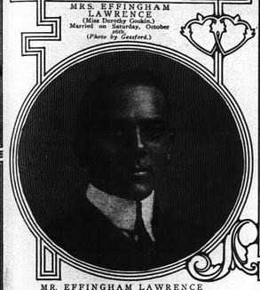
Lawrence, Effingham, Jr. (1878–1956)

Parents: Effingham Lawrence (1856–1899) and Janet Campbell Mickle (1857–1939).
Spouse: Dorothy Quincy Gookin (1881–1969).
Children: Dorothy Quincy Lawrence (1908–1981).
Kinship: Second cousin three times removed of the post–World War II Smith generation.
Early Life and Education
Effingham Lawrence, Jr. was born in New York in 1878, the only surviving child of Effingham and Janet Campbell (Mickle) Lawrence. He attended Swarthmore College for two years before leaving to enter the financial world in New York.
Career
He began his career on Wall Street as a curb broker in 1901, purchased a seat on the New York Stock Exchange in 1903, and became the head of the firm of Effingham Lawrence & Co. He dissolved the firm in 1916, subsequently joined the brokerage house of Taylor, Smith & Hard, and later re-established Effingham Lawrence & Co. His business address was 40 Wall Street.
Military Service
In 1897 he enlisted in the New York Naval Militia and served aboard the U.S.S. Yankee during the Spanish–American War.
Personal Life and Affiliations
Effingham Lawrence, Jr. was active in New York society and belonged to numerous clubs, among them the Union Club, Racquet and Tennis Club, Riding Club, Automobile Club, Down Town Association, and the Piping Rock Club. He was also a Mason and served as president of the Samaritan Home for the Aged at 440 East 48th Street. His residence for many years was at 375 Park Avenue.
Death
He died in 1956. His widow, Dorothy Quincy (Gookin) Lawrence, survived him until 1969.

Lawrence, Effingham Billopp (1834–1908)
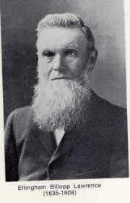

Parents: William Effingham Lawrence (1781–1841) and Mary Ann George Smither (1797–1880).
Spouse: (1) Clara Barnard (1836–1861); (2) Grace Barnard (1840–1928).
Children: With Clara Barnard: Frank Effingham (1858–1890) and Annie Lawrence (1859–1938). With Grace Barnard: Effingham Dryburgh Lawrence (1866–1949), Archie Barnard Lawrence (1867–1945), Clara Nellie Lawrence (1874–1959), Vernon Elliot Lawrence (1875–1949), Flora Gwendoline Lawrence (1878–1962), Owen Effingham Lawrence (1880–1956), and Leonard Linley “Lucky” Lawrence (1883–1967).
Kinship: Second cousin five times removed of the post–World War II Smith generation.
Early Life
Effingham Billopp Lawrence was born in Tasmania in 1834, the sixth son of William Effingham and Mary Ann George (Smither) Lawrence. His parents belonged to the Tasmanian branch of the Lawrence family, descended from Captain Effingham Lawrence, who settled in Tasmania in the early nineteenth century.
Marriage and Family
He married Clara Barnard on 2 April 1857 in Tasmania. Following her death in 1861, he married her younger sister, Grace Barnard, a practice not uncommon among the Lawrences and other families of the period, as it maintained familial continuity and ensured the care of the children within the same kinship circle.
Later Life and Death
Effingham Billopp Lawrence remained in Tasmania throughout his life. He died on 10 August 1908 at Cressy, Tasmania, and was buried in the Cygnet Anglican Cemetery in Cygnet, Tasmania. Grace Barnard Lawrence survived him by twenty years.

Lawrence, Effingham Edward (1865–1911)
Parents: Edward Arthur Lawrence (1831–1883) and Hannah Russell Mickle (1837–1885)
Spouse: Jennie Kingsland Travis
Children: Edward Effingham Lawrence (1907–1989)
Kinship: He is the first cousin four times removed of the post–World War II Smith generation
Early Life and Family Background
The path to Effingham’s marital happiness was strewn with nettles from the very beginning. He was born into the well-connected Lawrence–Mickle circle of New York, with every social expectation of a smooth and prosperous life.
Courtship and Broken Engagement
During an on-and-off engagement, Jennie Kingsland Travis in 1886 sued Mr. and Mrs. James Winslow for $20,000, claiming that Mrs. Winslow had written to Effingham Edward, “saying that Miss Travis was not a fit person to enter the Lawrence family.” Mrs. James Winslow was also a Lawrence, the daughter of William Lawrence, the uncle of Edward Effingham. The Winslows denied writing any letter and denied any attempt to influence Effingham Edward. The supposed letter concerned the long visit of Jack Kingsland, a relative of the Travises, to the Travis house in Great Neck.
The Niantic Club Incident (1887)
The following year, 1887, Effingham Edward was involved in a scene at the Niantic Club. Flushing at that time was rural and had many estates. When business detained them late in New York, prominent men of Flushing would often dine late at the Club.
At the beginning of July 1887, Effingham Edward and some friends arrived late at the Club and ordered dinner. The soup showed up in a reasonable time. But after another lapse, instead of the ordered bluefish, all that showed up was “a diminutive dish of asparagus.” The diners wanted an explanation. The steward arrived at their table and explained that two club members were in residence, and that they must receive their dinner before other members could be served. The hungry diners looked up and were not fed. They began using strong language.
For this they were brought before the governing committee of the Club, which asked questions that Effingham found offensive. The committee suspended Effingham and his friends for conduct unbecoming a gentleman. Some members objected to this and sought an injunction from the Supreme Court of Brooklyn to show why the suspension should not be revoked. After a few weeks, everything seems to have been settled.
The Cook and the Niantic Club Riot
Meanwhile, at the Niantic Club, the cook who had been involved in the original controversy was the 200-lb. Kate O’Connor, who was an excellent cook but who had, as the paper put it, “a taste for strong waters.” The steward who had handled the irate Effingham saw Kate was intoxicated and fired her, telling her she must leave tomorrow. She responded, “The devil I must. Who is going to make me? Take that and that!”
“So saying, she picked up a dish and a gravy bowl and flung them” at the steward. He and the rest of the staff fled.
“Huroo!” said she, as “she swept a couple of dozen dishes from the dresser and hammered them to pieces with a saucepan. ‘Hurooo!’” The local gendarmerie arrived and with difficulty hauled her off.
Marriage and Scandal
In the meanwhile, the Effingham marriage was not going well, but it was not the wife’s behavior that caused the trouble.
Within a year of their marriage in St. Bartholomew’s Church, clouds descended. While Effingham was out, an intoxicated woman called on his wife at the Twenty-Second Street home, claiming that she was the real Mrs. Effingham Lawrence. Jennie’s father had detectives follow Effingham, and they soon had proof of his infidelity.
Jennie sued for absolute divorce; Effingham made a general denial and said she had condoned his behavior. In 1889 Jennie was granted an absolute divorce and resumed her maiden name.
In 1891 she married her cousin Albert Kingsland, the son of the former mayor of New York, apparently the man whose visits to his cousin had set off the first contretemps.

Lawrence, Effingham Nicoll (1887–1963)
Parents: Albert Effingham Lawrence (1851–1923) and Elizabeth Rebecca “Libby” Spooner (1851–1943).
Spouse: Julia Harriman Budd (1892–1981).
Children: Effingham Nicoll “Bob” Lawrence, Jr. (1915–1991), Julia Harriman Lawrence (1917–1993), Ann Hardenburgh Lawrence, and Albert Effingham Lawrence (1932–1991).
Kinship: Paternal first cousin of the wife of the third cousin three times removed of the post–World War II Smith generation.
Early Life
Effingham Nicoll Lawrence was born in 1887, a member of the Lawrence family branch descended from the Manhattanville and Flushing lines. His upbringing reflected the social milieu of the Lawrences and the Spooners, families long established in New York.
Career
Effingham Lawrence became known for his expertise in the rental and cooperative apartment market in New York City during the mid-twentieth century. He was associated with the real estate firm of Pease & Elliman, where he gained a reputation as an authority on apartment rentals and the increasingly important field of cooperative ownership.
He served on the East Side Rental Conditions Committee and sat on the board of directors of the Tenants-Owners Apartment Association of New York, contributing to policy discussions and tenant-owner relations during a transformative period in Manhattan residential real estate practices.
Later Life and Death
Effingham Nicoll Lawrence died in 1963. His widow, Julia Harriman (Budd) Lawrence, survived him until 1981.

Lawrence, Effingham Nicoll Jr. (1915–1991)
Parents: Effingham Nicoll Lawrence (1887–1963) and Julia Harriman Budd (1892–1981).
Spouse: Frances Laurance Geer (1918–2008).
Children: Katherine Lawrence, Julie Lawrence, Anne Hamilton Lawrence (1952– ), and Elizabeth Nicoll Lawrence (1954– ).
Kinship: First cousin once removed of the wife of the third cousin three times removed of the post–World War II Smith generation.
Early Life and Education
Effingham Nicoll Lawrence was born in 1915. He attended the Groton School in Massachusetts and later New York University. His family background reflected the long-established Lawrence ties to New York and Long Island, with ancestral connections reaching back to the seventeenth century.
Marriage and Residence
Following his marriage to Francis Laurance Geer, Effingham settled in Irvington, New York. He was a member of St. Barnabas Church, an institution long associated with the local community and the families of the Hudson River valley.
Historical and Genealogical Interests
Effingham devoted considerable time to historical and genealogical pursuits. He served as a trustee of the Bowne House (see Houses and Estates), the historic Flushing residence of his ancestor who sheltered individuals facing religious persecution in the seventeenth century. He was also an active member of the New York Biographical and Genealogical Society and the Brooklyn Historical Society. Among his projects was the restoration of the Trinity Church graveyard in New York, where many of his Lawrence forebears are interred.
Death
He died in 1991. His widow, Francis Laurance (Geer) Lawrence, survived him until 2008.

Lawrence, Esther Gracie (1832–1893)
Parents: William Beach Lawrence I (1800–1881) and Esther Rogers Gracie (1801–1857).
Spouse: Dr. William Lamont Wheeler (1834–1887).
Children: None recorded.
Kinship: Sixth cousin four times removed of the post–World War II Smith generation.
Early Life and Family Background
Esther Gracie Lawrence was born into a family distinguished for its social, intellectual, and political connections. Her father, Judge William Beach Lawrence, was a noted jurist and diplomat, and the owner of Ochre Point in Newport, Rhode Island. It was he who transformed that stretch of coastline into one of the most fashionable enclaves of the Gilded Age, selling parcels of the property to leading families who would shape Newport society. He placed the property in trust, and the terms of that trust later proved a source of disagreement among his heirs. Esther’s mother, Esther Rogers Gracie, belonged to the prominent Gracie family of New York. One of Esther’s sisters, Cornelia, became the Baroness von Klenck.
Marriage and Personal Life
In 1881, at an age when many women of her social circle had long since established households of their own, Esther married Dr. William Lamont Wheeler. The marriage proved difficult and ended tragically with Dr. Wheeler’s suicide in 1887. Esther thereafter devoted herself to literary pursuits and to preserving her husband’s memory; she eventually erected a memorial chapel in Manville, New York, where they are both interred.
Literary Career
Writing under the name Mrs. Lamont Wheeler, Esther gained recognition for her books and dramatic sketches that captured the manners, atmosphere, and social nuances of her time. Her works include Stray Leaves from Newport and A Washington Symphony, the latter offering a vivid portrayal of the social and political world of Washington during the late nineteenth century. She also wrote for the stage, including Cupid’s Little Game: A Play of Newport Society, a light comedy set amid the resort world with which she was intimately familiar, and A Cup of Tea Drawn from 1773, a short dramatic sketch evoking pre-Revolutionary social life.
Her writing was marked by a perceptive eye for character, custom, and setting, and offers a valuable contemporary perspective on American society in the Gilded Age.
Later Years and Death
In her later years, Esther divided her time between Newport, New York, and Boston, where she continued to write and remained active in literary and artistic circles. Her life came to a sudden end in 1893 when she was struck by a runaway horse in Boston, opposite the Public Library. She died from her injuries shortly thereafter.

Annotated Bibliography of Works by Esther Gracie (Lawrence) Wheeler
(Published as “Mrs. Lamont Wheeler”)
Stray Leaves from Newport
Newport, privately printed, 1881.
A series of social sketches and reflective essays portraying the early society of Newport before its full emergence as the Gilded Age resort. With a tone that is observant, conversational, and occasionally nostalgic, Wheeler offers glimpses of local character, custom, and landscape. Contemporary readers valued it for its intimate knowledge of Newport life, and it has since served as a minor but useful primary source for early Newport social history.
A Washington Symphony
New York: Fords, Howard & Hulbert, 1888.
A lightly fictionalized panorama of social and political life in late nineteenth-century Washington, composed in short “movements” that together form a satirical portrait of the capital’s official and unofficial society. Wheeler’s commentary is urbane and perceptive, noting the interplay between politics, social ambition, and personal foibles. Reviewers praised its wit and its keen observation of Washington personalities and manners.
Cupid’s Little Game: A Play of Newport Society
First produced c. 1880.
A comedic one-act play set within Newport’s summer social season, centered on flirtations, misunderstandings, and the light etiquette of seaside society. Though lightly constructed, it is valuable as a contemporaneous reflection of Newport’s social codes and amusements. It appears to have circulated privately and may not have been formally published.
A Cup of Tea Drawn from 1773 (1888)
A brief dramatic sketch set shortly before the American Revolution, using the domestic ritual of tea-drinking to evoke themes of loyalty, colonial identity, and shifting political sentiment. Written with charm and period detail, it reflects Wheeler’s interest in American historical settings and genteel patriotic nostalgia. It was well-received for amateur performance in literary clubs and historical salons.

Lawrence, Esther Gracie (1872–1976)
Parents: Brig. Gen. Albert Gallatin Lawrence (1836–1887) and Evelyn McLean Taylor (1845–1917), niece of President Zachary Taylor.
Spouse: Felix Ludwig Eugen Graf von Voß (1856–1931).
Children: None.
Kinship: Seventh cousin three times removed of the post–World War II Smith generation.

Early Life and Family Background
Esther Gracie Lawrence was born in 1872 into a family distinguished by military, social, and political prominence. She was a granddaughter of Archibald Gracie, the Scottish-born New York shipping merchant whose country estate, Gracie Mansion, is now the official residence of the Mayor of New York City. Her father, Brigadier General Albert Gallatin Lawrence of the Union Army, was celebrated for his gallantry in the 1865 assault on Fort Fisher, North Carolina, in which he lost his left arm. His marriage to Evelyn McLean Taylor ended in a widely publicized divorce that drew the attention of society on both sides of the Atlantic.
Guardianship and Upbringing
Following her parents’ divorce, custody of Esther was awarded to her father. At his death in 1887, he left no estate, and Esther’s circumstances changed abruptly. She was sent to Dresden to live with her sister, the Baroness von Klenck, and remained there through her early adolescence. In 1891, at the age of seventeen, she returned to the United States. Her guardian, her uncle James Gore King Lawrence, petitioned the New York Supreme Court to allow increased expenditures from her trust, stating that he had been spending $2,500 annually for her maintenance, but that it was now necessary to provide a suitable chaperone of mature years and standing, and to ensure that Esther resided “at such proper places as befits her fortune and position in life.” The court granted his request, authorizing an allowance of $10,000 a year—equivalent to approximately $400,000 today.
Marriage and Later Life
Esther married Felix Ludwig Eugen Graf von Voß, a member of the Prussian nobility, establishing herself thereafter within European society. She spent much of her married life in Germany and maintained cultural interests consistent with her education and upbringing.
Literary Activity
Esther authored Zwölf Monate in einem Blumengarten (“Twelve Months in a Flower Garden”), a work reflecting her interest in horticulture and the cultivated life, and demonstrating her graceful command of prose in German.
Longevity and Death
Esther lived to the remarkable age of 104, dying in 1976 after a life that bridged the Gilded Age, two world wars, and the modern era.

Lawrence, Eliza Southgate “Lily” (1828–1858)
Parents: John Watson Lawrence (1800–1888) and Mary King Bowne (1808–1874).
Spouse: Armistead Thomson Mason Rust (1820–1887).
Children: Lawrence Rust (1850–1851), Frederick Goodwin Rust (1851–1917), Armistead Rust (1853–1856), and Rebecca Rust (1855–1882).
Kinship: Second cousin four times removed of the post–World War II Smith generation.
Early Life and Background
Eliza Southgate “Lily” Lawrence was born in 1828 into the established Lawrence and Bowne families of Flushing, Long Island. Her upbringing was marked by close family ties, lively correspondence among siblings, and a strong attachment to her childhood home. Her letters reveal a young woman of affectionate nature, keen observation, and gentle wit.
Marriage and Virginia Life
In 1849 she married Armistead Thomson Mason Rust, a graduate of the United States Military Academy at West Point who later resigned his commission. Lily accompanied him to Virginia, where they made their home at Rockland (see Houses and Estates), the Rust family plantation in Loudoun County. Her surviving correspondence records her adjustment to Southern plantation life, far from the familiar world of Flushing. She wrote of dinners, weddings, visits among neighboring families, and local customs, and though she was treated with hospitality, a thread of homesickness appears in her letters.
Letters and Personal Reflections
Lily’s letters are marked by candor, a lightness of touch, and an unpretentious grace. From the early period of her marriage, she wrote with affectionate humor of her new life and the cultural contrasts she encountered:
“Armistead is as kind and attentive as one could be, and I begin to feel more at home, though everything is so different from what I have been used to that at moments I could almost fancy myself in a foreign land. Everyone has been most hospitable and full of civilities, yet I long sometimes for one good talk with those who know me as I really am. Armistead laughs at my Northern ways, and I tell him that in time I shall make a Virginian of him, if he does not make a Southerner of me first.”
Her tone deepened after the death of her third child, Armistead, early in 1856. In a letter to her sister Mary, dated January 24, 1856, she wrote:
“I have scarcely written a line since our little boy’s death – three weeks on Sunday. It seems double that time. After the first feeling that death must always cause with a parent, the knowledge that he was so much better off than he could have been had he lived to become the healthiest member of our little family, has made me not only resigned but I may say thankful. God was merciful. Poor little sufferer, four times he had been brought to the brink of the grave and, even as he would rally, I allowed myself to believe that his delicate nature would be supplanted. Up to the last his appetite continued good, and though for three or four weeks his weakness, added to more evident emaciation, made me feel that he must die, it was hard to realize that I could do no more for him.”
Together, these excerpts capture both her early light-hearted adjustment to marriage and the deep faith and resignation with which she later met sorrow. Her letters offer a valuable primary source for the domestic, emotional, and social life of a young Northern wife living on a Virginia plantation in the decade before the Civil War.
Death
Lily’s life was brief. She died in 1858 at the age of thirty, leaving three surviving children.

Lawrence, Emlen Newbold (1837–1925)
Parents: George Newbold Lawrence (1806–1895) and Mary Ann Newbold (1808–1895)
Spouse: None recorded.
Children: None recorded,
Kinship: Third cousin four times removed of the post–World War II Smith generation
Early Life and Background
Emlen Newbold Lawrence was born into a cultivated New York family noted for its scientific and cultural interests. His father, George Newbold Lawrence, was a respected ornithologist associated with leading figures in American natural history, and the household fostered education, curiosity, and engagement with the world beyond New York.
Journey to the Upper Missouri (1861)
In April 1861, as the Civil War began, Emlen Lawrence joined William de la Montagne Cary, later known for his paintings and illustrations of the American West, and their friend W. H. Schieffelin on an extended journey into the Upper Missouri region. Equipped with camping gear and letters of introduction from Pierre Chouteau, Jr., a leading figure in the Missouri River trade, the three young New Yorkers traveled west to St. Louis and continued by steamer upriver.
During the voyage, the steamer on which they were traveling caught fire after an accident in the hold, and the passengers escaped before the vessel exploded. Lawrence and his companions survived but lost much of their equipment. They returned to Fort Union, where they remained for several weeks before continuing their travels. While in the region, they attempted to construct a skin tipi purchased from Indigenous people near Fort Union, but eventually sought the assistance of two Native women to complete it properly. On another occasion, they dined with a Crow chief and later learned that the “antelope” they had enjoyed was in fact dog. A subsequent misunderstanding at their camp led to a tense confrontation with a group of Crow warriors, who briefly detained the travelers before releasing them after gifts and provisions were exchanged. The party eventually continued upriver to Fort Benton, then traveled overland to the West Coast and returned to New York by sea.
Civil War Service
Upon his return east, Lawrence served with the Seventh Regiment of New York in the Civil War. The regiment, composed largely of New York’s socially prominent families, was among the first to respond to the call to defend the capital and was noted for its discipline and esprit de corps.
Career
After the war, Lawrence entered the wholesale drug business in New York. He worked in the trade for thirty years, establishing a solid professional reputation before retiring in 1890.
Residences and Social Life
Lawrence resided in New York City, most recently at 45 East Twenty-first Street. He was a member of the Union League Club, reflecting his place in socially active and civic-minded circles of the city.
Death
Emlen Newbold Lawrence died at his home in New York City in 1925 at the age of eighty-eight.
Legacy
Though he left no descendants, Lawrence’s youthful expedition with Cary preserved a glimpse of life along the Upper Missouri at a moment of transition, before the region was irrevocably changed by war, settlement, and federal policy. Their “boyhood idyll,” undertaken on the eve of the Civil War, contributed to the record of the frontier during its final years in its earlier form.

Lawrence, Francis Effingham, Rev. (1827–1879)
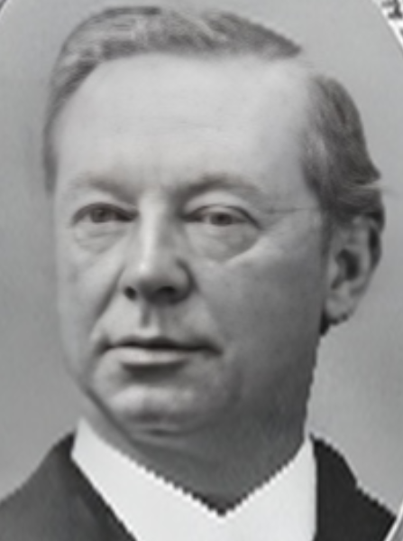
Parents: Effingham Watson Lawrence (1788–1872) and Rebecca Prince (1805–1845).
Spouse: None recorded.
Children: None recorded.
Kinship: Second cousin four times removed of the post–World War II Smith generation.
Early Life and Education
Francis Effingham Lawrence was born in 1827 into the Lawrence and Prince families of New York. He entered the ministry of the Protestant Episcopal Church at a time of theological ferment, when American Anglicanism was negotiating the influence of both Evangelical piety and the Oxford Movement. He was ordained deacon in 1853 and priest in 1854.
Clerical Career and Churchmanship
In 1854 he was appointed assistant at the Church of the Holy Communion in Manhattan, founded by the Rev. Dr. William Augustus Muhlenberg, the foremost advocate of “Evangelical Catholic” churchmanship in the United States. Muhlenberg, like the English Ritualists, believed that beauty, music, and symbolism in worship were aids to devotion, particularly for the poor, who found bare churches and long doctrinal sermons spiritually uninviting.
Lawrence remained at Holy Communion throughout his ministry. In 1877, upon Muhlenberg’s death, he succeeded him as rector and continued his distinctive liturgical and pastoral ethos. Under Muhlenberg’s influence, the Church of the Holy Communion had been the first in New York to place flowers upon the altar at Easter. After the service, the congregation processed with the flowers to the church’s hospital, delivering them to the sick—a gesture of charity and cheer that captured the spirit of the parish. This became the seed of the New York custom that later evolved into the public Easter Parade.
Reflections on Liturgical Practice
As the custom spread beyond its original charitable purpose, Lawrence viewed with unease the increasing extravagance with which Easter flowers were displayed. In his funeral sermon for Muhlenberg in 1877, he remarked:
“…a practice now indeed carried to such a silly and wasteful extreme, many churches seeming rather flower–shops at Easter than Sanctuaries of the Almighty, that he almost regretted that he had introduced the custom.”
The charitable procession eventually yielded to the Fifth Avenue promenade—more social than devotional. Irving Berlin’s later lyrics, immortalized by Judy Garland and Fred Astaire, captured the transformation into a spectacle of fashion and status. The custom spread beyond New York; the Baltimore Sun reported in 1927 that nearly 100,000 Baltimoreans participated in the Easter Parade on Charles Street, a tradition that still persisted in 1950.
Personal Life
Lawrence never married, a circumstance that, in the social climate of the nineteenth century, drew mild comment. His bachelor status, coupled with his refined churchmanship and aesthetic sensibilities, made him the subject of occasional parish gossip, though nothing discreditable was ever attached to his name. He lived quietly and with dignity, devoted to his parish, its charitable work, and the cultivation of reverent worship.
Later Years and Death
He remained rector of the Church of the Holy Communion until his death in 1879. His life and writings reflect the aspiration of nineteenth-century American Anglicanism to unite beauty in worship with service to the poor, while guarding against the temptations of religious display.

Lawrence, Frederick Arthur (1818–1882)
Parents: Judge Effingham Lawrence (1779–1850) and Anne Townsend (1782–1845)
Spouse: Sarah Van Dyne in 1840.
Children: None recorded.
Kinship: Third great-granduncle of the post–World War II Smith generation

Early Life and Family Background
Frederick Arthur Lawrence was born into the well-established Lawrence–Townsend family of Flushing, Long Island. His father, Judge Effingham Lawrence, was a respected figure in local public life, and the family was connected to many of the most prominent old New York and Long Island families.

Career
Frederick became a lawyer and appears to have practiced in New York. Though not a major public figure, he was well known in legal and social circles.
Private Life and Health
Frederick’s later years were marked by declining health. He suffered from a combination of painful ailments, for which he made use of morphine and opium, both commonly prescribed in the nineteenth century. As often happened in that era, the drugs to relieve pain led to dependence and depressive episodes.
Death
Newspapers reported that he died by suicide, stating that “He committed suicide by blowing his brains out. He was afflicted by a complication of diseases and suffered excruciating pain. The excessive use of morphine and opium to alleviate pain threw him into fits of melancholy, in one of which he committed the act.” He died in 1882.
Legacy
Frederick’s tragic end was noted in the press as an early illustration of the dangers of opiate dependency, long before the addictive effects of such drugs were fully understood.

Lawrence, Frederick Newbold (1834–1916)
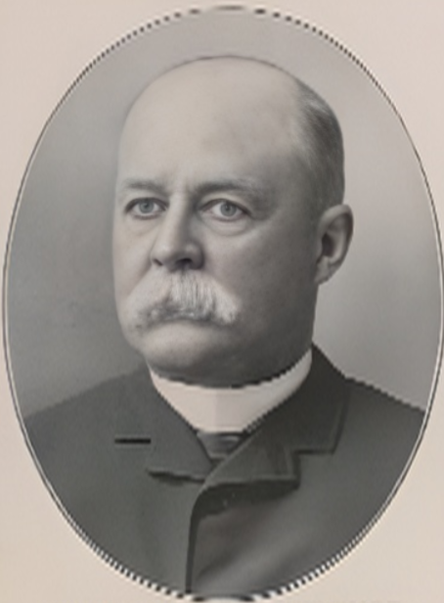
Parents: Edward Newbold Lawrence (1805–1839) and Lydia Ann Lawrence (1811–1879).
Spouse: Elizabeth Miller Boyce (1835–1894), in 1855, in South Carolina.
Children: Lydia Ann Lawrence (1857–1920), Mary Lawrence (1860–1942), Elizabeth Boyce Lawrence (1862–1906), and Virginia Lee Lawrence (1864–1891).
Kinship: Second great-grandfather of the post–World War II Smith generation.
Early Life and Education
Frederick Newbold Lawrence was born in 1834 into the New York branch of the Lawrence family. His father died when he was a child, and he was raised within a close network of Lawrence relatives. He graduated from Columbia College in 1854.
Civil War Service
During the Civil War he served with distinction in the Union Army and attained the rank of colonel. His military title continued to be used by friends and the press throughout his life.
Career in Finance and Public Life
After the war, Lawrence entered the financial world and became a prominent figure on Wall Street. He served twice as president of the New York Stock Exchange, in 1882 and 1883. In 1882, as president, he was called to testify regarding the expulsion of a broker accused of dishonest practices. The presiding judge—inevitably, in New York of that era—was another member of the family, Judge Lawrence.
In 1888, during a visit to New York by President Grover Cleveland, Lawrence delivered the official welcome and spoke in praise of Cleveland’s administration.
Interests and Social Life
Frederick Newbold Lawrence was a well-known figure in New York society and maintained a town house at 18 West 53rd Street, as well as an apartment at the Croisic. He was particularly associated with the sport of trotting horses, a popular pastime among New York gentlemen at the turn of the century. In May 1900 he achieved notice when Carlyle Carne, a trotter driven by Col. Lawrence—described in the press as “the veteran road rider”—defeated Cobwebs, driven by Nathan Straus, before a crowd of some 2,500 to 3,000 spectators.
Descriptions of such races had something of the tone of the society columns: the horses’ equipment, lineage, and price were discussed with the same relish as gowns and jewels. Carlyle Carne, a flea-bitten grey gelding of more than sixteen hands, foaled in 1891 in Portland, Oregon, and purchased by Lawrence in 1899 for $1,375 (approximately $40,000 in 2024 dollars), was spoken of much as a society reporter might describe a debutante’s dress. In November 1900, deciding to retire temporarily from driving, Lawrence sold Carlyle Carne at auction; the buyer was his son-in-law, Foxhall Keene.
Trotting as a Gilded Age Gentleman’s Sport
In the last decades of the nineteenth century, trotting was a favored recreation among affluent New York gentlemen. The sport combined breeding, speed, skill in handling the reins, and a keen sense of style. The Harlem River Speedway became a social stage where families such as the Lorillards, Vanderbilts, and Keenes displayed their horses just as they displayed their fashions. For many, it served the same social function as the opera, the ballroom, or the Newport season: one was seen, one competed, and one belonged. Lawrence moved comfortably within this milieu, and his reputation as a capable “road rider” gave him a certain distinction among sporting men of his era.
His Daughter’s Marriage to Foxhall Keene
His daughter, Elizabeth Boyce Lawrence, married the celebrated sportsman Foxhall Parker Keene in 1894. Keene, one of the most prominent amateur athletes of the age—famed for polo, racing, and coaching—was a striking figure in international sporting circles. The marriage, however, proved unhappy. Elizabeth eventually left Keene and returned to her father’s household. Although she resumed the Lawrence name and protection, the marriage was not dissolved, and she predeceased her father in 1906.
Later Years and Death
In March 1908 the New York Times reported that Lawrence had suffered a serious accident in his apartment at the Croisic, where he was found unconscious beneath a fallen cheval mirror. Pneumonia developed, and his condition was grave, but he ultimately recovered. His physician attributed his survival to his “twenty-year course of vegetarianism,” then an unusual practice.
Frederick Newbold Lawrence died in 1916, having lived through a period of enormous change in American social and economic life, to which he contributed both through public service and his long association with the New York Stock Exchange.

Lawrence, George Newbold (1806–1895)
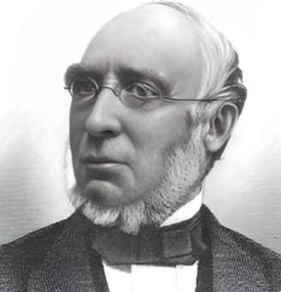
Parents: John Burling Lawrence (1774–1844) and Hannah Newbold (1782–1832).
Spouse: Mary Ann Newbold (1808–1895), a cousin..
Children: Emlen Newbold Lawrence (1837–1925) and John Burling Lawrence (1844–1929).
Kinship: Third great-grandfather of the post–World War II Smith generation.
Family Background
George Newbold Lawrence was born into a family whose roots combined the New York mercantile Lawrences with the New Jersey Newbolds and, through his wife, with the Emlens, a prominent Quaker family of Philadelphia. His marriage to his cousin Mary Ann Newbold strengthened the ties between these three influential families.
Early Life and Love of Ornithology
From his youth, Lawrence displayed a strong interest in birds, devoting his leisure to observing and studying them. At the age of fourteen he was permitted to have a gun, and during summers at his father’s country seat, Forest Hill (see Houses and Estates), he spent long hours collecting specimens and learning their habits. Forest Hill lay about eight miles from City Hall, on the high ground overlooking Manhattanville and the Hudson River, not far from the later site of the American Museum of Natural History. It was during the family’s residence there that John James Audubon acquired land nearby and built his home, now known as Audubon Park. Lawrence formed a friendship with Audubon’s sons, Victor and John, though he saw little of Audubon himself, who was then in failing health.
Business Career
At sixteen, Lawrence entered his father’s business as a clerk and, by the age of twenty, had become a partner. He remained engaged in business throughout his life, but it was his work as an ornithologist that won him distinction.

Contributions to Ornithology
Lawrence made important contributions to American ornithology. He undertook Pacific bird surveys for Spencer Fullerton Baird and John Cassin, with whom he later co-authored Birds of North America in 1860, a foundational work in the field. His personal collection of bird skins, numbering approximately 8,000 specimens, was sold to the American Museum of Natural History in 1887, greatly enriching its holdings. His fellow ornithologists honored him by naming a bird genus and twenty species after him, including Lawrence’s Goldfinch (Spinus lawrencei), which bears both his common and scientific name.

Later Years and Death
George and Mary Ann Lawrence died within five days of one another at the beginning of 1895. Their combined estates amounted to $528,900, which was divided between their two sons, Emlen and John.

Gilbert Lawrence (1775–1870)

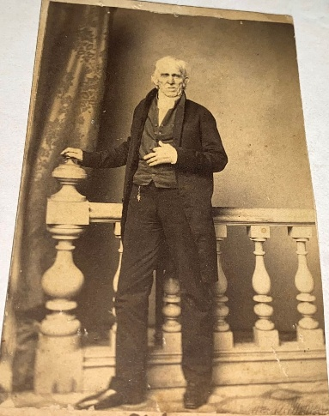

Parents: Leonard Lawrence (1741–1821) and Margaret Doughty (1749–1821).

Spouse: Esther Pearsall (1772–1847).

Children: Deborah A. Lawrence (1818-1886), William Lawrence (1820–1893), and Amy Lawrence.

Kinship: Third cousin six times removed of post-World War II Smith generation.

From his obituary it was apparent that he preserved his Quaker legacy.

Died at his residence in Flushing, on the 21st, Gilbert Lawrence, in the 95th year of his age. Precious indeed is the memory of our beloved friend, whose setting sun went down in brightness, after a long life of usefulness. He was a faithful elder in the meeting of which he had always been a member, and being clothed with a liberal spirit, he manifested that sweetness of disposition which endeared him to his friends. Long shall we miss his venerable form from its accustomed place in the house of worship, and listen in vain for the words of encouragement which frequently fell from his lips, giving evidence of his great concern for the welfare of society. His funeral took place from the meeting house on the 25th inst., where a very large concourse had assembled to pay the last tribute of respect to him who was worthy of double honor. Several testimonies were borne on the solemn occasion.

His residence, the Gilbert Lawrence House, survived at least until 1922.

Lawrence, Hannah (1758–1838)

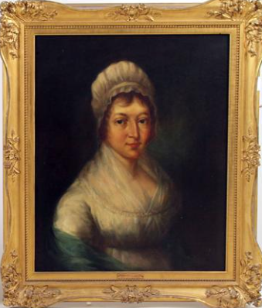
Parents: John Lawrence (1732–1794) and Ann Burling (1735–1821)
Spouse: Jacob Schieffelin (1757–1835)
Children: Edward Lawrence Schieffelin (1781–1850), Henry Hamilton Schieffelin (1783–1865), Anna Maria Schieffelin (1788–1843), Effingham Schieffelin (1791–1863), Jacob Schieffelin (1793–1880), John Lawrence Schieffelin (1796–1866), and Richard Lawrence Schieffelin (1801–1899)
Kinship: Fourth great-grandmother of the post-World War II Smith generation

Early Life and Family Background
Hannah Lawrence was born in New York City into two deeply rooted colonial families. Her father, John Lawrence, came of the Flushing Quaker line that had long been associated with civic leadership, trade, and the early settlement of Manhattan and Long Island. Her mother, Ann Burling, was of a prominent Quaker family whose members were active in mercantile, civic, and religious life. Hannah was raised within the disciplined culture of the Society of Friends, among relations who valued modesty, plain living, and obedience to the Meetings that governed Quaker conduct.

In the years before the American Revolution, the Lawrences maintained a position of influence in New York’s affairs, and many of their kin enjoyed social standing in the city and in the rural estates across the East River. Hannah was given an education above the ordinary scope of young women of her day, and she early displayed a literary gift which her family encouraged, though always within the bounds of propriety expected of Friends.

A Quaker Upbringing in Troubled Times
The Revolution presented a severe trial to Quaker families. Friends, committed to peace and to obedience to lawful authority, sought to remain neutral. Yet in New York, where the British occupied the city from 1776 to 1783, neutrality itself appeared suspicious. Members of the extended Lawrence and Burling families responded in differing ways: some adhered strictly to peace testimony; others leaned toward the Patriot cause; and a few, particularly among the younger men, joined militias or engaged in acts that strained or violated Quaker discipline.
Hannah’s sympathies lay unmistakably with the American cause. Though she remained outwardly within the Society, her writings reveal a patriotic feeling and a critical eye toward the occupation of New York by British troops. Her verses, shared privately among trusted friends, showed a wit and boldness unusual in a young Quaker woman of her station.

Courtship
It was amid this tense and divided atmosphere that Hannah met Jacob Schieffelin, a young officer in the British service. Born in Germany and raised in Montréal, Jacob had been serving as a lieutenant in the British Army when he was captured by American forces. His escape to New York brought him into the circle of Loyalist households, and it was likely in such company that he first saw the young Quaker poet whose reputation for charm and intelligence had already attracted notice.

Jacob was smitten. He contrived to be billeted near the Lawrence home; then, with a boldness equal to his affection, he sought an introduction. Hannah was cautious. She noted in her journal, written with candor under the name “Lavinia,” her struggle between feeling and duty. But affection deepened quickly. “Opportunity almost hourly of discovering new merits,” she confessed, and her reserve yielded to attachment.

Yet her family, and the Society of Friends still more, would consider any union with a British officer not merely imprudent, but a breach of religious and communal duty. Hannah foresaw the storm that would follow. “The World, the world will condemn me for imprudence,” she wrote—a line that reveals at once her awareness of the consequences and her resolve to follow her heart.

A Secret Marriage and Its Consequences
Unable to secure her family’s consent, and knowing that Friends’ Meetings would not sanction a marriage to a British officer, Hannah chose the only course open to her conscience and affection: she married Jacob secretly at a friend’s house on July 29, 1780.

When the marriage became known, the reaction was swift and severe. Two days later, Hannah was formally disowned by the Meeting. For Friends, disownment was not an act of cruelty, but of discipline intended to preserve the unity and testimony of the Society. Yet in this instance, given the political passions of the time, the censure was particularly sharp. To many Friends, any alignment with the military—British or American—was a violation of the peace testimony. To marry a British officer in occupied New York, where Friends were already under scrutiny, was judged a grievous breach.

“The World Will Condemn Me”: Disownment and Departure
The disownment did not lessen Jacob’s devotion, nor did it diminish Hannah’s resolve. She had surrendered the approval of her family and Meeting for the sake of a union she believed right. Jacob, having obtained military orders to return to Canada, carried his bride with him. Their journey northward was difficult and sometimes perilous, for travel in wartime was uncertain, and Loyalist movements drew suspicion on both sides. Yet their marriage, begun in controversy, was strengthened by adversity.

In later years Hannah looked back upon this episode not with regret, but with a serene consciousness that she had acted according to her heart and judgment, though at a cost. Her writings after this period reflect a maturity of tone, in which affection, principle, and reflection are blended with a sure command of language.

Journey to Canada
The newly married couple travelled first to Montréal and Québec, then onward to Niagara, where Jacob received a post. Hannah kept a journal of the journey, written with a vividness and descriptive power that reveal her as a gifted observer of natural scenery. Her account of Niagara Falls, then little known to Europeans or Americans, is one of the earliest extended descriptions by an American woman.

A Passage from her Niagara Journal (c. 1780)
“A considerable River first appeared, rolling down a gradual descent, and forming with the rapidity of its motion over the broken rocks, as we approached nearer the bank which had been worn away to an amazing depth, we were struck with motionless astonishment at the stupendous object that met our view, neither our surprize nor the deafening noise we heard, would admit of exclamation, we therefore stood gazing in silent awe and admiration. The whole River rushing abruptly down a terrific precipice, and rebounding in shattered particles, from the violence of its fall on said rocks, to nearly the height from whence it had precipitated itself. The earth seemed to tremble at the shock, and our sinking hearts corresponded with the idea.”
Her reflections blend the sensibility of the 18th-century traveler with a personal spirituality that saw in natural grandeur a manifestation of divine power. The journal, still preserved among descendants, shows a cultivated mind capable of picturesque description and moral sentiment.

Among the British and Their Indigenous Allies
During their travels, Hannah encountered not only Loyalist society but also the Indigenous allies of the British, including the celebrated Mohawk leader Molly Brant (Konwatsi'tsiaienni), sister of Sir William Johnson’s consort, and a formidable figure in her own right. Hannah’s record of meeting Indigenous families reveals both her curiosity and her surprise at customs unfamiliar to a young Quaker woman raised amid the refinement of New York.

She described one evening scene by a wilderness fire:
“Their heads were shaved and painted, and their appearance altogether savage, but their manners were not at all so — I was shocked to see a scalp dangling by my side from one of their ears; it was the size of a dollar, and fixed in a wooden ring, while a lock of beautiful dark hair hang on his horrid shoulder. On my observing it, he pointed to his head and pronounced the word ‘Yankee.’”
The frankness of her account reflects the complex moral and cultural world of the northern frontier during the war, where European loyalties, Indigenous alliances, and American resistance were entangled.

A Poet Revealed
Only after her marriage—and after her removal from New York—did it become widely known among her intimates that before her elopement Hannah had been the anonymous author of several satirical verses sharply criticizing the conduct of British officers quartered in the city. These poems, circulated privately in manuscript and occasionally dropped in the streets near Trinity Church, displayed a talent for pointed wit.

The following verse, “Address’d to a Canary Bird,” though not political, is characteristic of her style: graceful, observant, and touched with moral reflection.
Address’d to a Canary Bird⟨/center⟩
––––––––––––
Pensive warbler cease thy fear
Charmer there’s no danger near
Rest contented, quite secure
From the Ills thy race endure.
If you wing the open air
Ah! what woes await you there!
…
Lovly warbler, rest content,
All those cruel Ills prevent.
(The spelling and punctuation are preserved as written in the original manuscript.)
Her most daring poem, “On the Purpose to which the Avenue Adjoining Trinity Church has of late been dedicated, 1779,” lampooned the airs and idle behavior of British officers in occupied New York, and especially their habit of using the cemetery walk of Trinity Church as a fashionable promenade. The satire was bold for a young female Friend in wartime, and though she concealed her authorship under the name “Mathilda,” her verses were whispered about with admiration.
From “On the Purpose to which the Avenue Adjoining Trinity Church has of late been dedicated, 1779”
––––––––––––
This is the scene of gay resort,
Here Vice and Folly hold their court,
Here all the Martial band parade,
To vanquish — some unguarded Maid.
Here ambles many a dauntless chief
Who can — oh great ! beyond belief,
Who can — as sage Historians say,
Defeat — whole bottles in array!
Heavens! shall a mean, inglorious train,
The mansions of our dead profane?
A herd of undistinguish’d things.
That shrink beneath the power of Kings!
Sons of the brave immortal band
Who led fair Freedom to this land,
Say — shall a lawless race presume
To violate the sacred Tomb?
And calmly, you, the insult bear —
Even wildest rage were virtue here.
Shades of our Sires, indignant rise,
Oh arm! to vengeance, arm the skies.
Oh rise! for no degenerate son
Bids impious blood the guilt atone,
By thunder from the ethereal plains.
Avenge your own dishonored Manes,
And guardian lightnings flash around,
And vindicate the hallow’d ground!
Her poems circulated widely enough that, had her authorship been known at the time, she might have drawn unwelcome attention from British authorities — and stronger censure from Friends.

Return to New York
At the close of the war, Hannah and Jacob returned to New York, where Jacob entered mercantile life and, in conjunction with his brothers-in-law, developed property north of the settled city. The Lawrences, Schieffelins, and Buckleys were among the early planners of the area later known as Manhattanville. There the couple established a country residence, and Hannah resumed a more settled domestic life, though not again within the Society of Friends. She had forfeited membership in the Meeting, but not her moral standing among many who respected her character, talents, and devotion to family.

The Schieffelins became leading figures in the social, commercial, and civic life of New York. Jacob prospered in the pharmaceutical trade (later known as Schieffelin & Co.), and the family remained identified with culture, philanthropy, and refinement. Hannah’s literary inclination, awakened in youth, survived in her children and descendants.

Later Life and Legacy
Hannah lived to the age of eighty, retaining to the last a cultivated mind and affectionate nature. Though the boldness of her early life—her secret marriage, her disownment, and her satirical verses—might have seemed to foreshadow a restless career, hers was in fact a life of domestic fidelity, maternal care, and quiet influence. Her writings, when read today, reveal not only a lively poetic gift but also the inner world of an American woman of sensibility living through revolution and exile.

Her descendants preserved her poems and journals, and they provide a rare female voice from the Revolutionary era: tender, spirited, observant, and morally reflective. Hannah’s Niagara account is valued as one of the earliest American women’s descriptions of the Falls, and her poem on Trinity Church yard remains a vivid lampoon of British occupation manners.
She occupies an unusual place within the Lawrence family: a woman of Quaker upbringing who, for love, defied her Meeting and cast her lot with a soldier of the opposing side; a poet who wrote patriotic satire while living under British rule; and a traveler who recorded, with freshness and awe, the grandeur of the American wilderness before it was widely known.

Assessment
Hannah Lawrence Schieffelin stands as one of the most compelling women of her generation within the Lawrence family. Her life illustrates the tension between Quaker discipline and personal conviction during the Revolution, and her writings enrich American literary and social history. She was a figure of sensibility, courage, and originality, whose voice—once private—now offers a window into the emotional and moral landscape of the era.
Modern scholars regard Hannah Lawrence Schieffelin as a figure of uncommon interest among Revolutionary-era American women. Her writings offer a rare female perspective on occupied New York, Loyalist exile, and the moral dilemmas that divided Quaker families during the war. Her Niagara journal is now recognized as one of the earliest descriptive accounts of the Falls by an American woman, notable for its blend of picturesque observation and spiritual reflection. Her satirical verses, privately circulated under a pseudonym, reveal that women could participate in political expression not through arms but through wit and moral protest. For historians of women’s history, Quaker studies, and early American literature, her life and work illuminate the tensions between faith, family loyalty, personal conscience, and national upheaval.

Lawrence, Henry Effingham (1810–1875)
Parents: Effingham Nicholl Lawrence (1779–1850) and Anne Townsend (1782–1845)
Spouse: Frances Emily Brashear (1819–1895) in 1844
Children: Robert Brashear Lawrence (1847–1929), Walter Brashear Lawrence (1847–1882), Townsend Brashear Lawrence (1848–1908), Nancy Brashear Lawrence (1851–1882), Margaret Barr Lawrence (1858–1909), and Lydia Lee Lawrence (1858–1925)
Kinship: Third great-granduncle of the post–World War II Smith generation

Early Life and Background
Henry Effingham Lawrence was born into the well-established Lawrence family of New York, with ancestral roots in Flushing and Manhattan. His father was a respected member of the Lawrence line connected with civic leadership, mercantile affairs, and early Manhattan social history. Through his mother, Anne Townsend, Henry also belonged to the influential Townsend family, further linking him to a network of prominent Long Island Quaker-descended families.
Little is recorded of Henry’s early education or professional pursuits, but by the mid-19th century he had settled with his wife, Frances Emily Brashear, among her family connections in Louisiana. The Brashears were a respected Southern family of Kentucky and Louisiana, involved in law and landholding, and the young Lawrence family resided for a time in the region before later returning north.

Later Life
Henry appears to have lived a comparatively quiet life, without notable public office or business prominence. His surviving records suggest that his later years were largely devoted to family responsibilities, including arranging suitable educational and domestic provisions for his children, whose needs were considerable. He died in 1875, and Frances survived him by two decades.

Family Health and Education
All of the six children of Henry and Frances were born deaf. Their parents sought the best specialized education then available, as the mid-19th century saw the development of formal schooling for the deaf in North America. For families of means, it was customary to send children to established institutions, often far from home, where instruction in sign language, speech training, and academic subjects could be provided.

The Lawrence children attended several such schools over the course of their youth. They were enrolled at the Louisiana Institution for the Deaf and Dumb and the Blind at Baton Rouge, one of the earliest state-supported schools in the South. Later, some were sent to the Whipple School at Mystic River, Connecticut, a respected school for deaf students emphasizing academic and social refinement. The daughters subsequently attended the Hellmuth Ladies’ School in London, Ontario, a distinguished Anglican institution known for providing a cultured education to young women. Their schooling across multiple locales reflects the seriousness with which Henry and Frances pursued educational opportunities at a time when options for deaf instruction were limited.
Nineteenth-century medical records rarely identify the cause of congenital deafness, and contemporary sources offer no explanation for the condition within this branch of the Lawrence family. While hereditary factors may have been present, no documented conclusion links the deafness to consanguinity or to any specific medical cause. The family’s efforts to secure proper schooling demonstrate a conscientious and forward-looking response to their children’s needs.

Assessment
Although Henry Effingham Lawrence did not play a public role in civic or commercial affairs like some of his relations, the story of his family remains notable for the challenges they faced and the thoughtful measures taken to provide for their children’s education and welfare. Their experience also offers a window into the history of deaf education in the United States and Canada during the mid-19th century, and illustrates how families of standing sought to adapt with dignity and responsibility to unexpected circumstances.

Lawrence, Henry Effingham (1829–1890)

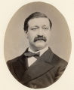
Parents: Joseph Lawrence (1796–1860) and Rosetta Townsend (1805–1875)
Spouse: Lydia Greene Underhill (1830–1913)
Children: Edith Lawrence (1861-1934), Margaret Lawrence (1864-1931), Joseph Lawrence (1866-1898), and Mary Trimble Lawrence (1869-1945).
Kinship: Second cousin four times removed of the post–World War II Smith generation

Early Life and Family Background
Henry Effingham Lawrence was born into a distinguished New York family whose influence in the city’s mercantile and financial life was considerable. His father, Joseph Lawrence, was one of the early presidents of the United States Trust Company and also served as president of the New York State Bank. His mother, Rosetta Townsend, belonged to the Townsend family of Oyster Bay, thereby reinforcing the long-standing web of kinship among the Lawrence, Townsend, and Underhill families of New York and Long Island.

Marriage
In 1850 Henry married Lydia Greene Underhill of a prominent Quaker family on Long Island. Lydia’s decision to marry outside the Society of Friends led to her being read out of meeting, a customary disciplinary measure imposed when a Friend married a non-Quaker. Despite the loss of formal membership, Lydia remained closely connected to her birth family and retained the gentle manners and moderated style associated with her upbringing.

They had four children: Edith, Joseph, Margaret, and Mary Trimble Lawrence. The youngest daughter was given the middle name Trimble in honor of Merritt Trimble, the husband of Lydia’s sister, Mary Underhill.

Career and Residences
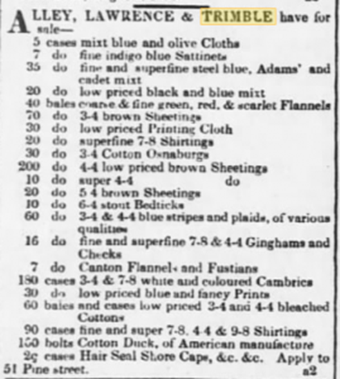
Henry was introduced into the dry-goods firm of Lawrence, Trimble & Co., in which his father was a partner. Following the tragic suicide of Daniel Trimble in 1850, the firm underwent several reorganizations and name changes, later known as Lawrence, Taylor & Co., with premises at 314 Broadway.

The Lawrences lived at 57 East 25th Street near Madison Square, an address then favored by prosperous New York families. Merritt Trimble resided next door, and other branches of the extended Lawrence kin occupied houses on the same block, illustrating the close residential clustering of the family in that period. The Lawrences worshipped at Grace Church, where they occupied a pew immediately behind that of the family of Edith Wharton, then Edith Jones—an indication of the social milieu in which they moved.

Henry died in 1890 at his residence known as “Cliffside.” His estate was divided with consideration and generosity: each of his four children received $30,000 (approximately $800,000 in 2015 values), with the remainder left to his widow.

Assessment
Henry Effingham Lawrence lived a life typical of many well-connected New York gentlemen of his era: educated within a network of influential families, introduced into an established mercantile house, and settled in a comfortable style near the city’s social and ecclesiastical centers. While not a public figure, he stands as a representative of the mid-19th-century Lawrence generation that maintained the family’s social position and continued the patterns of interrelated kinship that shaped New York’s mercantile elite.

Lawrence, Isaac (1768–1841)
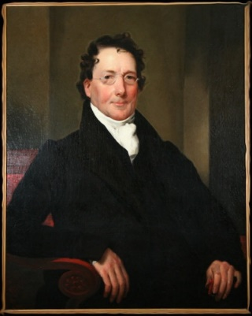

Parents: William Lawrence (1729–1794) and Anne Brinkerhoff (1733–1770)
Spouse: Cornelia Beach (1777–1857)
Children: William Beach Lawrence (1800–1881), Cornelia Ann Lawrence (1802–1874), Harriet Lawrence (1804–1889), Isaphene Catherine Lawrence (1806–1868), Julia Beach Lawrence (1809–1870), and Hannah Eugenia Lawrence (1815–1844)
Kinship: fourth cousin six times removed of the post–World War II Smith generation

Early Life and Education
Isaac Lawrence was born into a well-established New York family of Dutch and English descent, with roots in both the colonial mercantile community and the early settlement of Long Island. He attended Princeton College, where he intended to study law, but fragile health compelled him to abandon that plan and turn instead to commerce.

Mercantile Career
During the Revolutionary War period, the Lawrence family was engaged in business in New York. Isaac’s elder brother, John Lawrence, conducted his trade from 162 Queen Street (later Pearl Street). In 1795, after two years serving as a clerk, Isaac formally entered the firm, and the new sign of John & Isaac Lawrence was raised at 154 Water Street, corner of Fly Market.
The firm prospered. John & Isaac Lawrence became importers and shippers, conducting an extensive West India trade. Their success was aided by family connections in the Caribbean, including their brother William Lawrence (1770–1803), who owned a plantation in Demerara, British Guiana, and died there. Another brother, Richard Lawrence, was also engaged in commerce, with a country seat at Hell Gate, where he died in 1816.

The partnership of John & Isaac Lawrence dissolved in 1803. At the time of dissolution, the store was located at 208 Pearl Street. Isaac remained in business at the same address until 1814, after which he retired temporarily from active mercantile pursuits.

Banking and Public Life
Isaac returned to public life in 1817 when he became President of the United States Branch Bank newly established in New York City. The bank’s office was located at 65 Broadway. Before this appointment, he had served—as had his brother John—as a director of the earlier United States Bank in New York. Isaac’s position placed him among the leading financial men of the city during a period of expanding national banking organization.

His residences reflected his rising circumstances. At the time of his bank presidency, he was living at 480 Broadway. Later, he built and occupied a handsome house at 498 Broadway, above Broome Street, then a fashionable area of the growing metropolis.

Family
Isaac married Cornelia Beach in 1799. She survived him by sixteen years. Of their children, the most distinguished was William Beach Lawrence (1800–1881), diplomat, jurist, Lieutenant Governor of Rhode Island, and a noted writer on international law and Newport history (see his separate entry). Their daughters married within circles reflecting the family’s social standing in New York and Rhode Island.

Assessment
Isaac Lawrence represents the type of quietly influential New York merchant who bridged the period between the Revolution and the early Republic. Though not a public figure in the manner of his more prominent son, he contributed to the commercial life of New York during its formative growth and later played a role in the establishment and management of early federal banking institutions in the city. His career reflects the continuity of the Lawrence family’s engagement in mercantile and financial leadership across generations.

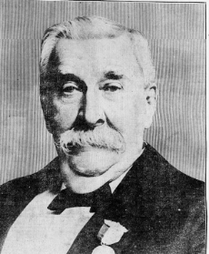
Lawrence, Isaac (1828–1919)

Parents: William Beach Lawrence (1800–1881) and Esther R. Gracie (1801–1857).
Spouse: Lee Gwynn (1857–1946).
Children: William Beach Lawrence (1886–1954) and George L. Lawrence (1888– ).
Kinship: Sixth cousin four times removed of the post–World War II Smith generation.
Biography:
Isaac Lawrence was born in 1828 in London, reportedly in the American Embassy during his father’s diplomatic service. He graduated from Columbia College and from Harvard Law School. Early in his career he was associated with The Democratic Review, and he later became President of the American Tariff Reform League. Active in New York society, he was a member of the St. Nicholas Club and presided at its Wassail in 1884. A New York Times notice of October 1893 described the reopening of his New York residence at 15 East 80th Street, furnished in luxurious style and displaying some sixty valuable oil paintings. In the same season he and his wife, recently out of mourning, were expected to entertain extensively.
Although some secondary sources have claimed that he served as a United States Consul at Coburg, this appears to be an error resulting from confusion with a different Isaac Lawrence connected with the U.S. Consulate at Cobourg, Ontario. Isaac Lawrence of New York did not hold a U.S. consular appointment. He died in 1919.

Lawrence, Isabella (1846–1914)
Parents: John Watson Lawrence (1800–1888) and Elizabeth Bowne (1815–1891).
Spouse: Lemuel Dandridge (1842–1919).
Children: Edmund Pendleton Dandridge (1880–1959).
Kinship: The fourth cousin three times removed of the post–World War II Smith generation.
Early Life and Ancestry
Isabella Lawrence was born in Flushing, Queens, New York, in 1846, into one of the most distinguished Quaker families of colonial and early republican New York. Her father, John Watson Lawrence, was a merchant and shipowner and served as president of the Flushing Bank; her mother, Elizabeth Bowne, was a descendant of John Bowne (1627–1695), the Quaker pioneer whose resistance to Governor Stuyvesant’s persecution of dissenters became a foundational episode in American religious liberty.
Marriage and Religious Life
In 1876 Isabella married Lemuel Dandridge, a Virginian Episcopalian who had settled in New York after the Civil War. Their marriage symbolized the union of North and South within a shared patrician culture: the mercantile Quakers of Flushing and the landed Dandridges of Virginia. Although raised in the Society of Friends, Isabella became an Episcopalian after her marriage, reflecting a gradual accommodation common among Quaker descendants in the later nineteenth century.
Character and Family Role
She was remembered by her son, Bishop Dandridge, as “gentle, reticent, and devout,” her Quaker inheritance showing itself in simplicity of manner and a quiet moral discipline. The Lawrence family tradition of philanthropy—particularly toward schools and hospitals—continued in her descendants through the Rutter and Reynal lines.
Isabella Lawrence Dandridge died in Flushing in 1914 and was buried in the Lawrence family plot in the Flushing Cemetery.

Lawrence, James Gore King (1844–1895)
Parents: William Beach Lawrence (1800–1881) and Esther Rogers Gracie (1801–1857)
Spouse: Catherine Augusta LeRoy (1858–1932)
Children: William Beach Lawrence (1881–1924), James Gore King Lawrence (1889–1936), and Eleanor LeRoy Lawrence (1894–1972)
Kinship: Sixth cousin four times removed of the post–World War II Smith generation

Early Life and Education
James Gore King Lawrence, bearing the surnames of both the Gore King and Gracie families, was born into a distinguished New York lineage whose connections extended to diplomacy, banking, and society. He graduated from Harvard University and pursued legal studies, preparing for a professional career appropriate to his family’s standing.

Career and Public Life
Although trained in the law, James’s principal sphere of activity was in the world of equestrian sport. He became one of the leading figures in late–19th–century American horse racing. He served the Coney Island Jockey Club in several capacities, including handicapper, secretary, and ultimately president, during the period when the Brighton Beach and Sheepshead Bay courses held prominence in New York sporting life. He was also a manager of the National Horse Show Association and owned steeplechasers and hurdle racers, maintaining a stable that earned him recognition in sporting circles. His close friendship with William K. Vanderbilt placed him within the inner group that shaped elite American equestrian culture of the Gilded Age.

Residences and Social Standing
A man of social ease and club life rather than of commerce or public office, James moved comfortably in the world formed by the Gracie, LeRoy, and Vanderbilt families. His marriage to Catherine Augusta LeRoy in 1879 connected him with one of New York’s old mercantile and social families, strengthening a network that blended antebellum Knickerbocker respectability with Gilded Age leisure and sport.

Family
James and Catherine Augusta LeRoy Lawrence were the parents of three children. Their eldest son, William Beach Lawrence, continued the family’s tradition of bearing the Beach name; their younger son, James Gore King Lawrence, carried his father’s name into the next generation; and their daughter Eleanor LeRoy Lawrence preserved the LeRoy connection.

Assessment
James Gore King Lawrence represents the type of well-placed Knickerbocker gentleman whose life was shaped less by profession than by education, club leadership, and sporting culture. His influence rested not in politics or commerce, but in helping to cultivate the social and recreational life of New York’s upper tier during the late 19th century. He stands as an example of the Lawrence family’s adaptation to the social patterns of the Gilded Age, in which public service or business achievement gave way, in some branches, to leadership in the spheres of leisure, equestrian sport, and elite society.

Lawrence, Jeanne Osgood Effingham (Jeanne Nuola) (1840–1934)
Parents: Effingham Lawrence (1820–1878) and Jane Lucretia Osgood (1829–1863).
Spouse: None recorded.
Children: None recorded.
Kinship: First cousin four times removed of the post–World War II Smith generation.

Early Life and Education
Jeanne Osgood Effingham Lawrence was born into the Louisiana branch of the Lawrence family and spent her early years at Magnolia Plantation, the family seat on the Mississippi River. Showing early promise in music, she was sent by her father to a convent school in France. There her vocal gifts were recognized and encouraged, and she came under the musical influence of Charles Gounod, who admired her voice and supported her training.

Stage Career
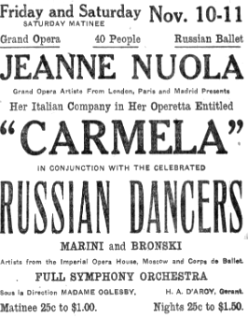
For her musical and theatrical pursuits she adopted the stage name Jeanne Nuola, a creative construction drawn from New Orleans and Louisiana—Nu–O–La. She began her professional career singing with the opera company of Sir Augustus Harris, appearing in the English provincial theatres.

Her career, however, was not without reversals. In 1896 the Infanta Eulalia of Spain engaged her to sing at the opera house in Madrid, but the engagement was abruptly cancelled owing to anti-American sentiment arising from the Cuban conflict and the political estrangement between Spain and the United States.

Performances and Later Career
In 1904, with the assistance of influential friends, she sang at the White House. Her program, entitled “Le Cantori Neapolitana,” consisted of traditional Italian street and gondolier songs, which she performed in Neapolitan costume to considerable effect.

Jeanne later undertook theatrical production herself. She founded a small company to present her operetta “Carmela.” According to the Brooklyn Eagle (2 November 1911), she sang the leading rôle in the first American production in Easton, Pennsylvania. The operetta, which she had already staged in Paris and Madrid, received an enthusiastic reception. It featured Russian dancers, Mlle. Marini and Bronski, and incorporated Italian folk music and costuming. The waltz song in the second act had been composed by Arditti on his eighty-third birthday. A mandolin quartet added to the color of the performance. Jeanne led a modest tour of the operetta to Altoona, Lancaster, South Bend, East Liverpool, Mansfield, and Zanesville, but the production closed before reaching Wheeling. By 1917 she was in New York offering private voice instruction.

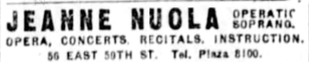

Poetry
Jeanne also wrote poetry, sometimes under her stage name. The following poem, published in the Marion Daily Star (Ohio) in 1923, reflects her religious and sentimental style:

IN MEMORIAM.
[By Mme. Jeanne Nuola.]
Grieve not brave heart
So tried by Fate's decrees
That mortal man might
Understand—God took thine own—
So great in soul, in heart so true—
To teach humanity
The depth of immortality—
All he did undertake
Was by divine decree,
And in his “weakness,”
By the world so called,
Was his immortal strength.
By love and tenderness,
By fellowship for man,
He won all hearts to him:
Now bowed in grief too deep:
To realize the greatness of the man.
Grieve not brave heart!
A soldier of the cross was he—
This valiant man of destiny.

Assessment
Jeanne Nuola’s life illustrates the flowering of artistic talent within the Lawrence family during the late nineteenth and early twentieth centuries. She blended the cultural heritage of New York and New Orleans with European training and experience, and although her career never reached the highest operatic stages, she achieved a measure of distinction as a singer, impresario, and poet. Her work shows a distinctly romantic and devotional temperament, and she stands as a rare example of a Lawrence woman who made her livelihood in the performing arts.

Lawrence, John (1618–1699)

Mayor of New York City

Parents: William Thomas Lawrence (d. 1625) and Joane Antrobus (later married John Tuttle)
Spouse: Susanna Batchelor (traditionally said to have been born c.1624; her parentage is sometimes given as connected to the Rev. Stephen Bachiler, but documentary proof is lacking)
Children: John Lawrence (m. Sarah Cornell Willett), Thomas Lawrence, Joseph Lawrence, Susanna Lawrence (1654–1738) (m. first Mayor Gabriel Minvielle; second Alderman William Smith), Mary Lawrence (m. 1660 William Whittinghame), and other children including Jonathan, Samuel, Isaac, and Nathaniel
Kinship: Eighth great-granduncle of the post–World War II Smith generation

Early Life and Migration
John Lawrence sailed from England to New England in 1635 aboard the Planter with his mother, stepfather, and siblings. After brief residence at Plymouth and Ipswich, he removed to Long Island, where he became one of the early English settlers under Dutch jurisdiction. In 1644 he was among the patentees of Hempstead by grant of Governor Willem Kieft, and in 1645 he, his brother William, and others received another patent for Flushing. These grants were confirmed when the English assumed control in 1666.

Mercantile Career and Public Service under Dutch Rule
By the 1650s John Lawrence settled in New Amsterdam, where he engaged in mercantile trade. He owned the vessel Adventurer, with which he traded along the Hudson River and about Long Island. He became a burgher of the city and was regarded with favor by Governor Peter Stuyvesant. In 1663 he was appointed a Commissioner to confer with representatives of the General Court at Hartford on the disputed boundary between New England and New Netherland. In 1664 he purchased an enslaved African for 345 florins, a transaction recorded in city papers.

Officeholding under English Rule
After the English conquest of 1664, Lawrence’s civic career continued. He was appointed an alderman in 1665 and was appointed mayor of New York in 1672. On 12 August 1673, when the Dutch briefly retook the city, Mayor Lawrence surrendered the civic insignia—the seal, mace, and magistrates’ gowns—to the Dutch authorities. His Dutch friends intervened to prevent the plundering of his house, a courtesy not shown to all English officials.

Upon the restoration of English rule in 1674, Governor Andros reestablished municipal government, and Lawrence became deputy mayor. He served on the Governor’s Council in 1674, was again alderman in 1687, and Justice of the Peace for New York in 1689. He sat as one of the Commissioners who tried Jacob Leisler for rebellion in 1691, a proceeding that left lasting divisions in the colony. In the same year he was reappointed to the Governor’s Council and again chosen mayor of New York in 1691. In 1693 he became a Justice of the Supreme Court. A later dispute with Governor Bellomont led to his suspension.

Family and Legacy
John Lawrence and his wife Susanna were the ancestors of several prominent New York families. Their daughter Mary Lawrence married William Whittinghame, a Harvard graduate. Their daughter by this marriage, Mary Whittinghame, noted for her learning and benefactions to Harvard and Yale, married Governor Gurdon Saltonstall of Connecticut, founding the distinguished Saltonstall line.

John Lawrence was one of the earliest English mayors of New York City, serving two non-consecutive terms (1673–1675 and 1691). His ability to retain regard under both Dutch and English rule, and the forbearance shown him by Dutch citizens in 1673, attest to his prudence and character in a politically volatile age. In his will he wrote of his children: “Soe I pray God Bless them as my children & make them His children, by faith and love in Christ Jesus.”

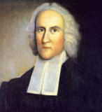
Lawrence, John (1685–1765)

Parents: Captain John Lawrence (1657–1729) and Deborah Woodhull (1654–1752).
Spouse: Patience Sackett (1701–1772).
Children: John Lawrence (1721–1764), Joseph Lawrence (1723–1793), Richard Lawrence (1725–1781), Nathaniel Lawrence (1727–1762), William Lawrence (1729–1794), Samuel Lawrence (1735–1810), Jonathan Lawrence (1737–1812), Daniel Lawrence (1739–1807), and Thomas Lawrence (1733–1817).
Kinship: Second cousin eight times removed of the post–World War II Smith generation.
Biography:
John Lawrence was born in 1685, the eldest son of Captain John Lawrence of Newtown, Long Island. He inherited a substantial portion of his father's lands in Newtown and Jamaica and expanded his holdings through purchase and careful management, becoming a prosperous farmer for his time. He took part in the civic life of the community, serving as a magistrate and on several town committees concerned with local affairs. The Lawrence and Sackett families were associated with the Church of England during this period, and John appears to have remained within that tradition. Although respected in his community for his public service and integrity, he did not attain the prominence later achieved by several of his sons. He died in 1765.

Lawrence, John (1721–1764)
Parents: John Lawrence (1685–1765) and Patience Sackett (1701–1772).
Spouse: Catherine Livingston (1733–1807), sister of Governor William Livingston of New Jersey, in 1759.
Children: None recorded.
Kinship: Third cousin seven times removed of the post–World War II Smith generation.
Biography:
John Lawrence was the eldest son of John Lawrence of Newtown, Long Island. He became a successful merchant and privateer during the French and Indian War. He was part owner of the privateer Charming Sally (26 guns) and the Harlequin (18 guns). In 1758 he owned the Catherine and applied for a commission for Nathaniel Lawrence as her commander. Later he joined his father-in-law, Philip Livingston, as co-owner of the Tartar and applied for a commission for his brother Thomas Lawrence to command that vessel.
John Lawrence died in 1764. The revivalist George Whitefield preached his funeral sermon in the Presbyterian meeting-house, and he was interred in Lord Stirling’s vault in Trinity Churchyard, New York. A later historical novel by James Otis Kaler, The Charming Sally: Privateer Schooner of New York: A Tale of 1765 (1898), drew upon the history of the vessel in which John Lawrence held an interest. Some writers have suggested that this earlier Charming Sally may have been the same vessel that later served during the American Revolution and was destroyed in the Penobscot Expedition, but the identification is not certain.

Lawrence, John Burling I (1774–1844)
Parents: John Lawrence (1732–1794) and Ann Burling (1735–1821).
Spouse: Hannah Newbold (1792–1832).
Children: Edward Newbold Lawrence (1805–1839), George Newbold Lawrence (1806–1895), Newbold Lawrence (1810–1885), Alfred Newbold Lawrence (1813–1884), John Burling Lawrence II (1817–1887), and Thomas Newbold Lawrence (1820–1889).
Kinship: Fourth great-grandfather of the post–World War II Smith generation.
Biography:
John Burling Lawrence was born in 1774 into a well-established New York Quaker mercantile family. In the late 1790s he became associated with the business founded in 1781 by his brother-in-law, Jacob Schieffelin, and by the early 1800s he entered into partnership, after which the firm became known as Lawrence & Schieffelin. This firm evolved into one of New York’s oldest and most enduring commercial houses, later known as Schieffelin & Co.
With Jacob Schieffelin, he played a leading role in the development of Manhattanville. Beginning in the first decade of the nineteenth century, the two men acquired and subdivided land on the Hudson River, laid out the village plan, and encouraged commercial and residential growth. The enterprise established the foundation of Manhattanville as a distinct community within New York.

Lawrence, John Burling II (1817–1887)
Parents: John Burling Lawrence I (1774–1844) and Hannah Newbold (1792–1832).
Spouse: Mary Adelina Furman (1842–1884).
Children: None recorded..
Kinship: Third great-great-granduncle of the post–World War II Smith generation.
Biography:
John Burling Lawrence was born in 1817 into the Manhattanville branch of the Lawrence family. He pursued a medical career and graduated from the College of Physicians and Surgeons in New York in 1851. He practiced medicine in New York City for several decades, appearing in professional directories and physicians’ registers through the mid-nineteenth century. He was part of the family circle that maintained commercial and social ties to Manhattanville and to the wider Lawrence and Schieffelin networks.
Dr. Lawrence should not be confused with another New York physician of the same name practicing in the same period. He died in 1887.

Lawrence, John Burling (1844–1929)
Parents: George Newbold Lawrence (1806–1895) and Mary Ann Newbold (1808–1895).
Spouse: Katherine Dilworth Wisner (1847–1920).
Children: Wisner Lawrence (1871–1873) and Mary Newbold Lawrence (1874–1956).
Kinship: First cousin four times removed of the post–World War II Smith generation.
Biography:
John Burling Lawrence was born in 1844, the son of the noted ornithologist George Newbold Lawrence. He became a drug and chemical merchant and was associated with Schieffelin & Co., the successor firm to Lawrence & Schieffelin. He served as a vice-president of the company and remained connected with it during its transition to the succeeding generation of Schieffelins. His fortune was derived principally from his long association with Schieffelin & Co. and from Manhattan real estate holdings.
He occupied a prominent place in New York society. A vestryman of Trinity Church, he was also a member of the Metropolitan and Church Clubs and of the St. Nicholas Society. In 1902 his daughter Mary married Heth Lorton, and he presented her with a house at 62 East 54th Street as a wedding gift. Contemporary reports styled her the heiress to his fortune of $7,000,000, a very large sum for the time.
In 1909 he and Emlen Lawrence sold the last parcel of land that the Lawrence family owned in Manhattanville, closing a connection to that district which the family had maintained since the early nineteenth century. John Burling Lawrence died in 1929.

Lawrence, John Lawrence (1785–1849)
New York State Senator and New York City Comptroller
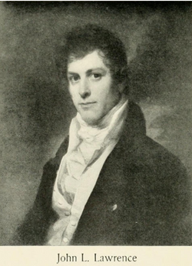

Parents: Jonathan Lawrence (1737–1812) and Ruth Riker (1746–1818).
Spouse: Sarah Augusta Smith (1794–1877).
Children: John Smith Lawrence (1818–1880), Sarah Augusta Lawrence (1820–1866), Lydia Lawrence (c.1820– ), Margaret Ruth Lawrence (1822–1890), Ann Middleton Lawrence (1823–1870), Richard Montgomery Lawrence (1824–1843), Charles William Lawrence (1827–1895), Mary Judith Lawrence (1828– ), William Thomas Lawrence (1830–1893), Charles Jeffery Lawrence (1831–1884), Abraham Riker Lawrence (1832–1917), and Lydia Smith Lawrence (1835–1894).
Kinship: Fourth cousin six times removed of the post–World War II Smith generation.
Biography:
John Lawrence was born in New York City in 1785, the son of Jonathan Lawrence, a merchant and New York State Senator, and Ruth Riker of the notable Riker family. He graduated from Columbia College in 1803. From June 7, 1814 to May 19, 1815 he served as Chargé d’Affaires of the United States at Stockholm, representing American interests during the absence of Minister Jonathan Russell, at a time when U.S.–Swedish relations were influenced by the concluding phase of the War of 1812 and the diplomatic climate surrounding the Treaty of Ghent.
Returning to New York, Lawrence entered public life. He was a member of the New York State Assembly from New York County in 1816–1817 and a delegate to the New York State Constitutional Convention of 1821. He served as Treasurer of Columbia College and was the first President of the Croton Aqueduct Commission, overseeing the early stages of the monumental public works project that brought fresh water to New York City. In 1840 he was a presidential elector, voting for William Henry Harrison and John Tyler. He served in the New York State Senate (4th District) in 1848 and 1849. In May 1849 he was appointed New York City Comptroller, but his tenure was cut short when he died two months later in the cholera epidemic of 1849.

Lawrence, John Lawrence (1857–1930)
Parents: Alfred Newbold Lawrence (1813–1884) and his cousin Elizabeth Lawrence (1820–1884).
Spouse: Alice Warner Work (1875-1966), a descendant of Governor William Bradford of Plymouth Colony.
Children: Alice Work Lawrence (1898–1987), John Lawrence Lawrence (1902–1969), Alfred Newbold Lawrence (1903– ), and Josephine Lawrence (1903–1978).
Kinship: First cousin four times removed of the post–World War II Smith generation.
Biography:
John Lawrence was born in 1857 into the Long Island branch of the Lawrence family. He became a prominent civic figure in the early development of Lawrence, Long Island. He was among the founders of the village and served as its first president from its incorporation in 1897 until 1906, guiding its initial growth as an affluent residential community. During his tenure he oversaw early public works, local governance, and the establishment of community standards that shaped the character of what later became known as the Five Towns.
Lawrence had a business career in the utilities field and served as president of the National Meter Company, a major manufacturer of water meters at a time when cities across the United States were modernizing their water systems. He was active in social and sporting circles, holding membership in the Calumet Club, the Rockaway Hunt Club, and the Seawanhaka–Corinthian Yacht Club, one of the country’s most prestigious yachting associations. John Lawrence died in 1930.

Lawrence, John Smith (1818–1880)
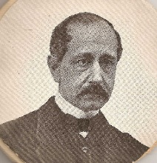

Parents: John Lawrence (1785–1849) and Sarah Augusta Smith (1794–1877).
Spouse: Sarah Elizabeth Mauran (1823–1878).
Children: John Smith Lawrence (c.1847–c.1848), Elizabeth Mauran Lawrence (1849– ), Emma McAllister “Emmie” Lawrence (1853–1914), Grace Mauran Lawrence (1855–1858), John Smith Lawrence II (1860–1903), Frank Lawrence (1862– ), and [Infant Lawrence] (died shortly after birth).
Kinship: Fourth cousin six times removed of the post–World War II Smith generation.
Biography:
John Smith Lawrence was born in 1818, the son of John Lawrence, Chargé d’Affaires of the United States to Sweden, and Sarah Augusta Smith. He was educated at Columbia College and studied law. He practiced in New York City from an early age, entering the profession in his twenty-first year. For many years he was associated with his brother-in-law, Mr. Horn, in Wall Street; after the dissolution of the firm in 1864, he continued to practice independently. He acquired a respected reputation at the Bar, and in later life frequently served as Referee in important cases by consent of the parties. He held membership in the Bar Association, the State Bar Association, the Law Institute, the Medico-Legal Society, and other professional bodies. Although a Democrat in politics, he consistently declined office. Shortly before his death, the Legislature appointed him as one of the Commissioners to revise and review local assessments for improvement, in conjunction with the Mayor and the Comptroller.
He died at his residence, 36 East 19th Street, New York City, in 1880.
Contemporary Obituary
JOHN S. LAWRENCE
Mr. John S. Lawrence, eldest brother of Judge Abraham R. Lawrence, of the Court of Common Pleas, died yesterday morning, at his late residence, No. 36 East Nineteenth-street, in the sixty-second year of his age. He was descended from the Commodore Lawrence who, in dying, uttered the famous command: “Don’t give up the ship!” His father, John L. Lawrence, was at one time Chargé d’Affaires, and subsequently United States Minister, at Sweden, and was a United States Senator at the time of his death. John S. Lawrence was born at the family country seat, Mastic, Long Island. He was educated at Columbia College, and afterward studied law. He began to practice in this City in his twenty-first year. For many years he was associated with his brother-in-law, Mr. Horn, in Wall-street. In 1864 the firm was dissolved, and Mr. Lawrence took offices where the Boreel Building now stands, afterward removing to No. 150 Broadway. His ability was recognized as very great, and of late years he has acted as Referee by consent in many cases of extreme importance. His decisions in these cases are scattered throughout the standard text-books as embodying the correct principles of law. It is only a few days since the Legislature appointed him one of the Commissioners to revise and review the local assessments for improvement, in conjunction with the Mayor and Controller. He was a member of the Bar Association, the State Bar Association, the Law Institute, the Medico-Legal Society, and other similar organizations. In politics he was a Democrat, but would never accept office. He was offered and refused the nomination for Judge of the Court of Common Pleas, now occupied by Judge Van Hoesen. He leaves two sons and two daughters. Two other brothers — Charles W. Lawrence, of the Controller’s office, and William T. Lawrence — survive him.”
Editorial Note on Obituary Claims:
The obituary reflects how contemporaries viewed John Smith Lawrence and his family, but it contains two inaccuracies. The statement that he was descended from Commodore James Lawrence (1781–1813) of “Don’t give up the ship!” fame is incorrect; that branch of the Lawrence family was unrelated to the Newtown and Manhattanville Lawrences. In addition, his father, John Lawrence (1785–1849), served as U.S. Chargé d’Affaires to Sweden, but was not a United States Senator; he was a New York State Senator. The obituary is otherwise consistent with verified records of his education, legal career, and public reputation.

Lawrence, John Smith II (1860–1903)
Parents: John Smith Lawrence (1818–1880) and Sarah Elizabeth Mauran (1823–1878).
Spouse: Sarah Ray Wynn (1864–1904).
Children: John Smith Lawrence III (1882–1945), Sarah Ray “Dimple” Lawrence (1884–1902), [Infant Lawrence] (died in infancy), Margaret Mauran Lawrence (1894–1967), and Anna Schiller Lawrence (1897–1988).
Kinship: Sixth cousin four times removed of the post–World War II Smith generation.
Biography:
John Smith Lawrence II was born in 1860, the son of John Smith Lawrence, a respected New York lawyer, and Sarah Elizabeth Mauran. He inherited a considerable sum from his father. He entered the oyster trade and served as an agent supplying oysters to hotels and restaurants in New York City. He lived in Lawrence and later in Hempstead, Long Island.
In August 1903, the bodies of his daughter Sarah Ray “Dimple” Lawrence and Clarence Foster were discovered in Shinnecock Bay near Good Ground. Louis A. Disbrow was accused in the widely reported case. (See Sarah Ray Lawrence for a full treatment.) After the death of his daughter, John Smith Lawrence II went into a rapid decline and died a few months later, in 1903.

Lawrence, John Watson (1800–1888)
U.S. Congressman
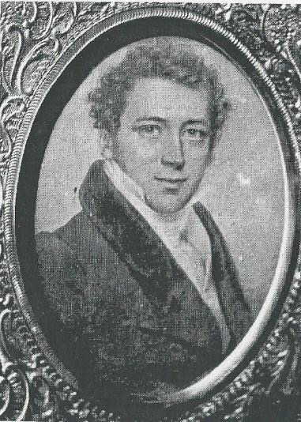

Parents: Effingham Lawrence (1760–1800) and Elizabeth Watson (1763–1852).
Spouse: Mary King Bowne (1808–1874), daughter of Walter Bowne, Mayor of New York City.
Children: Caroline Bowne Lawrence (1827–1869), Eliza Southgate Lawrence (1828–1858), Mary Bowne Lawrence (1830–1898), Emily Lawrence (1832–1910), Anna Louise Lawrence (1834–1908), Walter Bowne Lawrence (1839–1912), Frances Lawrence (1840–1934), Rebecca Lawrence (1841–1848), Isabella Lawrence (1846–1914), and Robert Bowne Lawrence (1852–1942).
Kinship: First cousin five times removed of the post–World War II Smith generation.
Biography:
John Watson Lawrence was born in Flushing, New York, on August 19, 1800. He attended local schools and began his career as a mercantile clerk, in which he soon prospered. In 1836 he built his residence, Willow Bank (see Houses and Estates), on a portion of the Lawrence estate on the Flushing River originally granted to William Lawrence. Willow Bank became one of the best-known early river estates in Flushing, noted for its landscaped grounds and its association with prominent visitors. His marriage into the Bowne family linked him to generations of Bowne civic leadership in Queens and strengthened his own role in local affairs.
He served as president of the village of Flushing from 1835 to 1845, and was a member of the New York State Assembly for Queens County in 1841 and 1842. He was elected as a Democrat to the Twenty-ninth Congress, serving from March 4, 1845, to March 3, 1847. Lawrence later served as a trustee of the village of Flushing from 1860 to 1875. He died in 1888 and was buried in Flushing.

Lawrence, John Watson II (1868–1895)
Parents: Walter Bowne Lawrence (1839–1912) and E. Annie Townsend (1841–1902).
Spouse: None recorded.
Children: None recorded.
Kinship: Third cousin three times removed of the post–World War II Smith generation.

Biography:
John Watson Lawrence was born in 1868. He graduated from Harvard College in 1891, and afterward worked in the family firm of W. B. Lawrence & Co. In the winter of 1893–1894 he suffered a severe attack of influenza (“the grippe”), from which he never fully recovered. His physician recommended a warmer climate, and it was decided that a period abroad might restore his health. His younger brother, Townsend Bowne Lawrence (1871–1951), was sent with him as companion and caretaker.
In April 1895 the two brothers sailed for Europe on the Berlin and landed at Southampton. They began a bicycle tour through the southern English counties, but John Watson, still weakened, suffered a serious sunstroke and fell unconscious from his bicycle. Although he revived, he remained unwell, dazed, and complained of severe headaches. A Paris physician advised complete rest. Townsend decided to abandon the tour and bring his brother home at once. They reached Le Havre only minutes before the departure of the steamship La Bourgogne and boarded so hastily that their names were not recorded on the passenger list.
At about 5:30 a.m. on May 27, while Townsend was in their stateroom, John Watson walked on deck. He wore a straw hat, which a sudden gust of wind blew across the deck. According to two steerage passengers who witnessed the event, he ran after it and, in attempting to catch it, fell over the stern rail into the sea. The witnesses did not immediately report what they had seen. When Townsend came on deck some twenty minutes later and could not find his brother, he questioned those nearby and then informed the ship’s officers. La Bourgogne was turned about and a boat lowered, but no trace of John Watson could be found.
The circumstances of his fall led to speculation. His father rejected any suggestion of suicide, but acknowledged that his son’s weakened physical and mental state after months of illness and despair at returning home unhealed may have clouded his judgment. Walter Bowne Lawrence, waiting at the New York docks for his sons’ return, went home alone to Willow Bank to begin mourning. In a further unhappy coincidence, a seaman on La Bourgogne fell overboard four days later and was also lost.
John Watson Lawrence was 27.
Editorial Note
The death of John Watson Lawrence was widely reported in American and European newspapers, and a brief inquiry was held by the steamship line. The testimony of the two steerage passengers was accepted, and the incident was formally ruled an accident. Some press accounts speculated on suicide due to his prolonged illness, but the family firmly rejected this interpretation and contemporary reports emphasized his impaired health and state of exhaustion rather than intent.

Lawrence, Jonathan (1737–1812)
Major, New York Provincial Militia
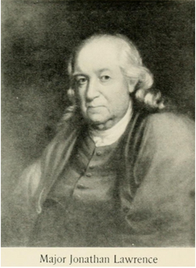

Parents: John Lawrence (1685–1765) and Patience Sackett (1701–1772).
Spouse: (1) 1766, Judith Fish (1749–1767). (2) 1768, Ruth Riker (1746–1818), of the Riker family for whom Rikers Island is named.
Children: Jonathan Lawrence (1767–1850), merchant (m. Elizabeth Rogers); Judith Lawrence (1769–1827), m. John Ireland; Margaret Lawrence (1771–1851); Samuel Lawrence (1773–1837), U.S. Representative (m. Elizabeth Ireland); Andrew Lawrence (1775–1806), died abroad of “African fever”; Richard M. Lawrence (1778–1856), merchant and insurance executive; Abraham Riker Lawrence (1780–1863), early president of the New York & Harlem Railroad; Joseph Lawrence (1783–1817); John Lawrence Lawrence (1785–1849), diplomat; N.Y. State Senator (m. Sarah Augusta Smith); William Thomas Lawrence (1788–1859), merchant (m. Margaret Sophia Muller).
Kinship: Third cousin seven times removed of the post–World War II Smith generation.
Early Life and Mercantile Career:
Jonathan Lawrence was born in 1737 into a prominent Long Island and New York mercantile family. As a young man he traveled to Europe and the West Indies in the employ of his elder brother, John Lawrence, gaining commercial experience at a time when New York’s overseas trade was rapidly expanding. He later joined the firm of Watson, Murray & Lawrence, one of the significant mercantile houses of pre-Revolutionary New York. By the early 1770s, after the death of his brothers John and Nathaniel (the latter dying unmarried in the West Indies), he inherited their estates and retired from commerce at around the age of thirty-four. He purchased from his sister and brother-in-law, Anna Lawrence and William Sackett, a property at Hell Gate (Hurlgate), originally part of the Sackett family estate.
Revolutionary Era and Military Service:
In 1772, during the final years of royal authority in New York, Lawrence was appointed captain in the provincial militia. After the outbreak of the American Revolution, the New York Provincial Congress reorganized the militia in 1775, and Lawrence was appointed major of the Queens and Suffolk County brigade under Brigadier General Nathaniel Woodhull.
In August 1776, on the eve of the Battle of Long Island, the brigade was ordered to drive livestock eastward to prevent it from falling into British hands—an operation intended to deprive the advancing British army of provisions. Woodhull was subsequently captured by British forces, wounded, and died days later from mistreatment and infection. Because the livestock-removal mission preceded these events, later accounts sometimes linked Lawrence to the tragedy. Contemporary records, however, show that Major Lawrence had been ordered north to Harlem to seek reinforcements from General George Washington and was not responsible for the circumstances of Woodhull’s capture or death. His service in this period reflects the complex and shifting military demands placed on local officers during the chaotic early months of the war.
Political Leadership in Revolutionary New York:
Lawrence played an important role in the civil government that emerged as royal authority collapsed. He served as a member of the 1st, 3rd, and 4th New York Provincial Congresses between 1775 and 1777. The Provincial Congress served as the de facto government of New York during the Revolution and drafted the first New York State Constitution. When that constitution came into force, Lawrence entered the New York State Senate, representing the Southern District in the 1st through 6th Legislatures (1777–1783).
He was twice elected to the powerful Council of Appointment, in 1778 and 1782. The Council had sweeping authority to appoint nearly all civil and military officials in the state and was one of the most influential bodies in New York government in the late 18th century. Lawrence later served as chairman of the committee supporting the re-election of Governor George Clinton, who was a central figure in Revolutionary and early national politics and later served as Vice President under both Thomas Jefferson and James Madison.
Later Life and the Cayuta Lake Settlement:
After the war, Major Lawrence acquired a tract of approximately six square miles surrounding Cayuta Lake, part of what became known as the Watkins and Flint Purchase in central New York. This was among many post-Revolutionary land investments undertaken by New York families as settlement moved westward. Three of his sons—Samuel, Joseph, and William—relocated to the area and established residences there. Samuel’s home became known as the Lawrence Homestead; William built an estate on the east side of the lake, called “Lawrence Villa,” later known as “White Gates.” The Lawrence presence contributed to the early development of that region of the state.
Connections to Prominent New York Families:
Through the marriages of his children and grandchildren, Major Lawrence’s line became connected to several leading New York families. These included the Rikers, Irelands, Floyds, Pells, Duanes, Livingstons, Hamiltons, and Waynes. These marriages linked the Lawrence family with figures such as William Floyd, signer of the Declaration of Independence, and families prominent in politics, the military, and civic life in the early Republic.
A fuller account of the Ireland descendants is given under Ireland Family.
Death:
Major Jonathan Lawrence died in New York City on September 4, 1812.

Lawrence, Jonathan Jr. (1759–1802)
Captain

Parents: Jonathan Lawrence (1695–1775) and Elisabet Van Klocek (1729–1816).
Spouse: (1) Jeanette Neale (1767–1790); (2) Mary Mann (1763–1835)
Children: With Jeanette Neale: Charles Lawrence (1786–1854), Herbert Lawrence (1788–1882), Eleanor N. Lawrence); with Mary Mann: Jonathan Lawrence III (1795–1883), Jennet Lawrence (1797–1870), George M. Lawrence (1799–1872).
Kinship: Third cousin seven times removed of post-World War II Smith generation.

There were numerous men named Jonathan Lawrence, all related, many of them contemporaries, and several of whom served in Revolutionary forces. The following account concerns Jonathan Lawrence Jr. (1759–1802) and appears to be the most reliable reconstruction of his life and service.
Jonathan Lawrence Jr. was born in 1759, the son of Jonathan Lawrence Sr., a New York City businessman. His grandfather, Jonathan Lawrence the Elder Senior, had purchased the house later known as the Big House on what is now Route 9W in 1747 from Henry Ludlow, who had constructed it circa 1736.
In 1775, Jonathan’s father was appointed one of three commissioners charged with overseeing construction of a new Hudson River fortification, Fort Constitution (later West Point). Jonathan Jr. and his parents were present there in May 1776, when his mother was accused of selling tea at an illegal price. Later that year, Jonathan Jr. was living at the Big House with his grandfather and helping to guard the Hudson River, which was threatened by British warships advancing north from New York City. By December 1776, although only seventeen years old, he was serving at Fort Constitution as a “clerk of the cheque.”
In March 1777, Jonathan Lawrence enlisted in Colonel William Malcom’s regiment as a Second Lieutenant. He spent two months with the Continental Army at Valley Forge and fought at the Battle of Monmouth while marching north. During the summer of 1778, he was promoted to First Lieutenant and served as Acting Assistant Adjutant General at Fort Clinton, overlooking the Hudson River near Bear Mountain.
In the spring of 1779, Malcom’s regiment was merged with another unit, and Lawrence lost his Continental Army position. He returned to the Big House, which was then owned by his uncle Nathaniel Lawrence following his grandfather’s death in 1777. Soon afterward, he was appointed a captain in the militia—units composed of local men who enlisted for six-month terms.
As a militia captain, Lawrence gathered intelligence on British movements, which was forwarded to General George Washington. Washington referred to him several times in his correspondence, describing him as sensible and discreet. On July 21, 1780, Captain Lawrence captured the well-known British Loyalist spy James Moody near Englewood, New Jersey.
In the fall of 1780, soldiers from the Corps of Sappers and Miners were stationed near the Big House constructing a blockhouse overlooking Snedens Landing; its remains were reportedly visible on Woods Road until relatively recent times. On June 19, 1781, Washington issued an order appointing Jonathan Lawrence, Esq., to the rank of Captain in the Corps of Sappers and Miners. His service in the Corps proved brief. On August 28, 1782, Lawrence wrote requesting permission to retire from active duty due to ill health. A certificate signed by the hospital surgeon at West Point stated:
“Captain Lawrence of the Corps of Sappers and Miners, from indisposition, is rendered unfit for the fatigue of Military duty. His complaints of the breast are of such an alarming nature as require the strictest and earliest attentions to remove.”
Lawrence returned to the Big House to recover and to resume civilian life. Although major fighting had ended, widespread looting by both British and American forces had impoverished the countryside. On November 11, 1783, Lawrence wrote to Washington seeking assistance. Washington replied within days, expressing regret that he could not help because Lawrence had resigned his commission before the formal conclusion of the war.
In 1784, at the age of twenty-four, Jonathan Lawrence married Jennette Neal, then seventeen. Over the next six years they had three children—two sons and a daughter. In 1788, Lawrence was awarded 200 acres of land in Ohio on the grounds that he had not resigned from Colonel Malcom’s regiment but had instead been declared supernumerary. He sold the land, likely out of necessity. In 1790, Jennette Lawrence died; her sandstone tombstone survives in the Palisades Cemetery.
Facing financial and personal hardship, Lawrence submitted a renewed appeal for veterans’ benefits, which appears to have been successful. In 1794, at age thirty-four, he married Mary Mann, age thirty-one, the daughter of his near neighbor George Mann, whose house, built in 1784, still stands. That same year, Jonathan Lawrence repurchased the Big House, which had been sold out of the family by a relative in 1792. Jonathan and Mary had three additional children and lived there together for several years.
Jonathan Lawrence Jr. died in 1802 at the age of forty-two, probably of tuberculosis, a disease with which he had struggled for many years. His tombstone, and that of his second wife Mary, are both located in the Palisades Cemetery.
Captain Lawrence was the third of four men named Jonathan Lawrence to live in the Big House, his grandfather having purchased the house and approximately 504 acres in 1749. During the Revolutionary War, he played an active role in combat and intelligence gathering and is remembered in particular for the capture of James Moody in 1780.
It is traditionally said that during the Revolution, General George Washington, the Marquis de Lafayette, and Baron von Steuben were guests of Captain Jonathan Lawrence Jr. at the Big House and may have dined at the table now preserved in the Palisades Library. Given that all three officers were present at the nearby trial of Major John André in Tappan in 1780, and that Washington personally supervised construction of the blockhouse overlooking Snedens Landing that same year, such a gathering is entirely plausible.

Lawrence, Joseph (1783–1817)
Parents: Major Jonathan Lawrence (1737–1812) and Ruth Riker (1746–1818).
Spouse: Mary Sackett (1793–1879).
Children: Andrew Lawrence (1813, died young), Elizabeth Ann Lawrence (1814–1863), Mary Ruth Lawrence (1815– ), and Joseph A. Lawrence (1817–1889).
Kinship: Fourth cousin six times removed of the post–World War II Smith generation.
Biography:
Joseph Lawrence was the fifth son of Major Jonathan Lawrence. As a young man he entered the East India trade and twice sailed to India, a hazardous undertaking during the period of the Napoleonic Wars and the War of 1812. The risks of maritime life led him to abandon seafaring and turn to farming, first in Westchester County, and later with his brother Samuel at Cayuta Lake in central New York, on land their father had purchased after the Revolutionary War.
The two brothers left New York City for Cayuta Lake in the autumn of 1814. The journey survives in a vivid contemporary account recorded by their kinsman, Hon. Abraham Lawrence, in the centennial history of the town:
“...they passed from Hoboken, N.J., northward to Montgomery, on the Newburgh and Cohocton turnpike, following it west of the Delaware River, which they crossed at Cohocton and went thence through the famous ‘beech woods’ to Great Bend on the Susquehanna, which they crossed and followed its north bank to Owego; thence passing up the Owego, Catatunk and Cayuta Creeks through the ‘Dutch Settlement’ to Johnson's Settlement—the journey having occupied about two weeks’ time. They remained there several weeks, as neither of their homes were ready for occupancy, and then moved into the one intended for Joseph Lawrence.”
Joseph and Samuel selected the sites for their homes and engaged the builder Samuel Winton, with David Beardsley and Elijah S. Hirman as partners in the work. Bricks for both houses were made from clay taken from the Hirman property, and Hirman served as mason for the many fireplaces. The houses were built close to one another: Joseph’s residence, known as the Lake House, remained little altered over time; Samuel’s home was later enlarged and became the Fontainebleau Inn.
Joseph’s stay at Cayuta Lake was short. Ill health forced him to leave his new home, and he returned with his family to Newtown, Queens County, for the winter. In the spring of 1817 he attempted to go back to Cayuta Lake, but died en route at Bloomingburgh, Sullivan County. His widow and children never returned to Cayuta Lake, and after his estate was settled the property passed out of the family.

Lawrence, Joseph A. (1817–1889)
Parents: Joseph Lawrence (1783–1817) and Mary Sackett (1793–1879).
Spouse: Elizabeth D. Gorsline (1823–1904).
Children: Joseph Alfred Lawrence (1845–1902), Margaret Douglas Lawrence (1847–1920), Mary Ann Lawrence (1851–1915), Peter Gorsline Lawrence (1854–1899), and Elizabeth Anna Lawrence (1858– ).
Kinship: Fifth cousin five times removed of the post–World War II Smith generation.
Biography:
Joseph A. Lawrence was the youngest child of Joseph Lawrence, who had settled for a short time at Cayuta Lake before his early death, and of Mary Sackett of the longstanding Sackett family of Newtown. Joseph spent his life in Newtown, Long Island, which later became part of the Borough of Queens, New York City, upon consolidation in 1898. He engaged in the lumber business, a trade of increasing importance as Long Island developed during the mid-nineteenth century.
Lawrence took an active role in local civic affairs. A Republican in politics, he served as Receiver of Taxes for the town of Newtown and also held other minor local offices, including Town Auditor and School Trustee. Contemporary notices described him as a useful and public-spirited citizen who took an interest in the management and improvement of local affairs. He died in 1889 and was buried in Maple Grove Cemetery, Kew Gardens, Queens, New York.

Lawrence, Joseph Effingham (“Joe”) (1824–1878)
Parents: Judge Effingham Lawrence (1779–1850) and Anne Townsend (1782–1845).
Spouse: None recorded.
Children: None recorded.
Kinship: Third great-great-granduncle of the post–World War II Smith generation.

Early Life and Family Background
Joseph Effingham Lawrence was born in 1824. He graduated from Columbia College in 1841, the only printed record in which his full name regularly appears. In later life he dropped “Effingham” and preferred to be known simply as Joe Lawrence.
His siblings were Lydia Ann Lawrence (1811–1879), noted Spiritualist known for her cousin marriages; Henry Effingham Lawrence (1810–1875), New Orleans merchant and father of six children, four of whom were deaf and subsequently significant in the history of deaf education in the Old South; and Effingham Lawrence (1820–1878), owner of Magnolia Plantation in Louisiana.
Journey to California and the Gold Rush
He was in Louisiana, likely visiting his brother Effingham at Magnolia Plantation, when news of the 1849 Gold Rush reached him. At the age of twenty-five he crossed Texas and Mexico by mule to reach California, where he decided to pursue a career in journalism.
The Press and Public Life in Sacramento
Lawrence became editor of the Sacramento Placer Times (later the Times and Transcript) from 1850 to 1854. Life as a newspaper editor in Gold Rush California was often hazardous, and Lawrence experienced several public confrontations. In July 1851, after a dispute over a published paragraph, the future governor of California, J. Neely Johnson, assaulted him by twisting his nose; Lawrence drew a pistol and might have fired had bystanders not intervened. In another incident, his criticism of the conduct of the Sacramento chain gang provoked threats and abuse. An assault in 1858 resulted in the attacker being fined. These episodes illustrate both the volatility of early California civic life and Lawrence’s willingness to expose abuses.
“Colonel” Lawrence
Although frequently referred to as “Colonel,” Lawrence did not earn this rank through military service. He received the courtesy title when Governor John Bigler appointed him to his staff as an aide-de-camp, a common honorary appointment of the era. One contemporary writer observed that such offices were an easy way for the United States to acquire so many “colonels,” remarking humorously that in Lawrence’s case the appointment should have read “place him where France least wants a soldier.”
Editor of The Golden Era
Lawrence’s greater legacy lay in literary culture. From 1854 to 1867 he served as editor of The Golden Era, a San Francisco literary weekly that became one of the most influential periodicals of the early American West and an important platform for emerging writers. His editorial office was regarded as a kind of Bohemian West salon. He was described as “the very pattern of paternal patronage”—a genial, pipe-smoking figure with “an air of literary mystery,” one writer calling him “a pillar of cloud” at his editorial chair. He encouraged the early work of several writers who later became significant figures in American literature, including Bret Harte, Prentice Mulford, and, somewhat later, Joaquin Miller.
Return to Flushing and Final Years
Lawrence retired from the Golden Era in 1867 and returned to Flushing, New York. He purchased one of the old Lawrence family houses and became editor of the Flushing Journal. His sister Lydia contributed Spiritualist articles. Joe also held a position at the New York Custom House. One humorous contemporary sketch noted: “He presides with dignity over the Society for the Prevention of Cruelty to Animals, nurses the same old meerschaum, and luxuriates on cold tea with a stick in it.” He remained active in the Society of California Pioneers.
Joaquin Miller left a memorable description of their last meeting:
“Lawrence came to me in New York a few years back leaning on the arm of Prentice Mulford. The courtly, handsome, heroic gentleman of the old heroic days was dying. I took them to the theater, for Lawrence seemed so very sad. His brain was failing him—sunstroke, he said—but he could not stay out of the play. He arose with something of his old-time courtliness, for there were ladies in the box, shook hands gently with us all. And then he and Mulford went out into the night and—beyond the night, please God.”
Joseph Effingham Lawrence died at Toms River, New Jersey, on July 14, 1878.

Lawrence, Julia Townsend (1860–1933)
Parents: Edward Arthur Lawrence (1831-1883) and Hannah Russell Mickle (1837-1885).
Spouse: (1) Robert Lyon Burnett (1839–1900); (2) Constantine Scaramanga-Ralli (1854–1934).
Children: With Burnett: Francis Edgar Burnett (1886-1964)
Kinship: First cousin four times removed of the post–World War II Smith generation.
Julia Townsend Lawrence was the daughter of Edward Arthur Lawrence and Hannah Mickle. After the death of her first husband, Robert Lyon Burnett, she married Constantine Scaramanga-Ralli, who had been born Constantine Ralli but adopted the surname Scaramanga-Ralli. He spent many years in banking, was an advocate of compulsory military training, and contributed articles on military and related topics to leading journals. He was a Life Governor of the Brompton Hospital for Consumption and Diseases of the Chest, a Justice of the Peace in Hampshire, and Vice-President of the Allotments and Small Holdings Association of England. He also published a work of speculative fiction, Vanessa: A Romance of the New Century and the New World (1904), set in a near-future New York under oligarchic rule.
Scaramanga-Ralli, Constantine (1854–1934)
Parents: Originally born Constantine Ralli; parentage not included in family line as he married into the Lawrence family.
Spouse: Julia Townsend Lawrence (1860–1933).
Children: None recorded..
Kinship: Husband of Julia Townsend Lawrence, who is the first cousin four times removed of the post–World War II Smith generation.
Early Life and Name
Constantine Scaramanga-Ralli was born in London in 1854 as Constantine Ralli. He later adopted the hyphenated surname Scaramanga-Ralli, combining names associated with two branches of an Anglo-Greek merchant family. The name change preceded his public and literary career and was used consistently thereafter.
Career and Public Service
Scaramanga-Ralli spent much of his life in the banking profession. He was a Life Governor of the Brompton Hospital for Consumption and Diseases of the Chest, one of London’s leading medical institutions. He served as a Justice of the Peace for Hampshire and was Vice-President of the Allotments and Small Holdings Association of England, which promoted small-scale agriculture and land access for working families.
Advocacy and Writings
An advocate of compulsory military training, Scaramanga-Ralli wrote on military preparedness and related subjects for leading British journals and periodicals in the late nineteenth and early twentieth centuries. His writings addressed national defense, civic responsibility, and contemporary military policy.
Literary Work
In 1904 he published a speculative novel, Vanessa: A Romance of the New Century and the New World. Set in a near-future New York governed by a small oligarchy, the story depicts rising social unrest and popular revolt in response to political and economic concentration. Though his only work of fiction, it is an early example of British interest in American dystopian themes and reflects contemporary anxieties regarding modernity and social change.
Death
Constantine Scaramanga-Ralli died in Hampshire in 1934.

Lawrence, Lydia Ann (1811–1879)
Parents: Judge Effingham Lawrence (1779–1850) and Anne Townsend (1782–1845).
Spouse: (1) Edward Newbold Lawrence (1805–1839) on June 4, 1833; (2) Cornelius Van Wyck Lawrence (1791–1861) on June 5, 1844.
Children: Frederick Newbold Lawrence (1834–1916).
Kinship: Great-grandaunt of the post–World War II Smith generation.
Early Life and Family Background
Lydia Ann Lawrence was born into the Long Island branch of the Lawrence family, a line with deep roots in Bayside and Flushing, Queens. Through both parents she was connected to the interwoven Lawrence, Townsend, and related Quaker-descended families who shaped the civic, political, and cultural life of early nineteenth-century New York. Her upbringing was one of refinement, education, and familiarity with both New York civic affairs and Quaker traditions that still influenced the family.
First Marriage and Motherhood
On June 4, 1833, Lydia married her cousin, Edward Newbold Lawrence. Their union produced one son, Frederick Newbold Lawrence, born in 1834. Edward died in 1839, leaving Lydia a young widow. His letter announcing the birth of their son reveals an affectionate family tone, and reflects the Quaker-influenced language still in use among some branches of the Lawrences at that time:
“It becomes my duty, my dear mother, to inform thee of the arrival of a young stranger this morning, in whom thee will doubtless feel an interest. My dear Lydia was this morning at 6 o’clock delivered of a fine boy. I say a fine boy, as the nurse and doctor both pronounce him so. He is judged to weigh full 15 pounds and looks bright and healthy… Lydia desires me to give her best love to thee and all the family.”
Second Marriage: Mrs. Cornelius Van Wyck Lawrence
On June 5, 1844, Lydia married her second cousin, Cornelius Van Wyck Lawrence, a prominent figure in New York public life. He served in Congress, was Collector of the Port of New York, and became the first popularly elected Mayor of New York City. The marriage united two influential branches of the Lawrence family and brought Lydia into a more public social sphere of Manhattan and Long Island society.
The “Three Lawrences” Anecdote
A newspaper notice at her death recorded with some astonishment that although Lydia had been twice married, she had never changed her surname. Born a Lawrence, married first to a Lawrence, and then again to a Lawrence, she was sometimes referred to with affectionate humor as “Lydia Ann Lawrence Lawrence Lawrence.” A contemporary comment captures both the curiosity and admiration she attracted:
“A lady died on Saturday in Bayonne [in fact, Bayside], Long Island, who had been twice married, but never changed her name… She was a lady of remarkable grace and accomplishments, an authoress, her last book having been published only a few weeks ago. It was entitled Do They Love Us Yet? and was a discussion of the relation of the dead to the living. She has had the problem solved more speedily than she had perhaps expected.”
Portrait: “Long Island Madonna and Child”
In 1836, an unknown artist painted a work later known as the Long Island Madonna and Child, depicting Lydia with her infant son, Frederick. The painting was created in Bayside, and family tradition held that Lydia served as the model. The portrait remained in the possession of Lawrence descendants well into the twentieth century. It was remembered not only as a tender family image, but as a symbol of Lydia’s early life before the experiences that later drew her toward Spiritualism.
Spiritualism: Origins of Her Belief
After the death of Cornelius Van Wyck Lawrence in 1861, Lydia entered a period of deep reflection. Like many bereaved women of the mid-nineteenth century, she sought comfort in the belief that communication with the departed was possible. Her interest developed within a cultural moment in which Hicksite Quakerism, with its emphasis on the Inner Light and ongoing revelation, made the transition to Spiritualism more accessible for some Friends. Lydia wrote that her first experience came unexpectedly, through automatic writing in the presence of a medium, when she believed her late mother communicated with her:
“Your mother, my dear child, now writes to you—not from the grave, but from heaven. Angels, my daughter, clothed with light and love, have been permitted by a divine Providence to return to earth, and through the medium of a known law move with their dear friends, sounding heavenly echoes, telling them the grave need have no terrors, that death is a pleasant change, and that your mother still lives and loves and ever watches over you.”
From this moment, Lydia wrote, her interest in the subject “never ceased.” She found in Spiritualism what she understood to be a continuation of divine guidance, consistent, in her view, with Quaker spiritual sensitivity.
Messages and Experiences
Many of Lydia’s Spiritualist experiences occurred at Forest Hill, the Lawrence summer house overlooking the Hudson River in what is now Fort Tryon Park. She described both written communications and raps around the room during séances. One message she believed to be from her husband, Cornelius, linked earthly affection with heavenly presence:
“I hope, dear W., that you will be mild and love E. with all power. Remember I am with your spirit, loving always to hover around you. Mysterious as you may think it, my spirit is permitted by a divine Providence to come to you here at F. H., that place I spent so many happy hours gazing in the magnificent scenery, the work of God’s hands. Adieu.”
Other messages came from relatives, Friends, and those she regarded as spiritual guides. Some used the language of Quaker piety familiar to Lydia. One message, attributed to a Quaker relation newly “in the spheres,” read:
“I cannot commune more with thee tonight, as thee knows I have not been long an inhabitant of these lovely spheres, but I will try to come to thee again soon.”
Lydia also recorded guidance about how one should prepare to receive communications, echoing the quietist practice of Friends’ meetings:
“Whenever thee desires to communicate with us, put aside all work and care and worldly thought, and wait, as in the olden time we waited at our weekly meetings for whatever may come of the spirit.”
Theological Themes in Her Writings
The messages Lydia collected reveal both familiar Christian consolations and ideas associated with nineteenth-century Spiritualism. Many stressed the continuity of life after death, the ministry of angels, and the nearness of loved ones. One passage, reflecting traditional Christian sentiment, declared that the departed “love us still with all the old love of earth and all the new love of heaven together.”
A sermon of St. Cyprian, quoted in her volume, comforted those who had lost family to disease:
“There await us a multitude of those whom we love—fathers, brothers, and children—who are secure already of their own salvation, and concerned only for ours.”
At the same time, Lydia included passages reflecting ideas more characteristic of Spiritualism, such as the continuance of personality in the afterlife and the activity of spirits in the physical world. She quoted Swedenborg’s teaching that those entering the next life are surprised to find themselves still able to hear, see, and speak as before. She also included metaphysical reflections on the soul’s liberation from the limitations of the body, consistent with some Victorian spiritual and philosophical currents.
Publication of Do They Love Us Yet? (1879)
In her later years Lydia wrote articles for the Flushing Journal, edited by her brother Joseph E. Lawrence. She collected her experiences, reflections, and selected spiritual communications in her book Do They Love Us Yet?, published in New York by James Miller in 1879, only weeks before her death. The volume attempted to offer comfort to the bereaved, to show the closeness of the spiritual and earthly worlds, and to suggest that the bonds of affection are not broken by death.
Her writing aimed to harmonize Spiritualism with Christian faith, presenting it not as a replacement for religion but as a continuation of divine consolation. The book stands as a personal testament to her search for assurance of continued love and communion with those who had passed on.

Death and Contemporaneous Reflections
Lydia Ann Lawrence died in 1879 at Bayside, Long Island. News of her death was noted for the unusual circumstance that she had been twice married without ever changing her surname. Contemporary reports described her as a woman of grace and accomplishment, and commented with poignancy that her inquiry into the love of the departed had “been solved more speedily than she had perhaps expected.” Her book, published so near the end of her life, was regarded by those

Lawrence, Mary (1640–1704)
Parents: John Lawrence (1618–1699) and Susanna (c.1622–1688)
Spouse: William Whittingham (1645–1672)
Children: John Whittingham (b. c.1667), William Whittingham (b. c.1670), Samuel Whittingham (b. c.1672), Mary Whittingham (1679–1730)
Kinship: First cousin nine times removed of the post–World War II Smith generation
Early Life
Mary Lawrence was born into the second generation of the Lawrence family in New England. Her father, John Lawrence, served multiple terms as alderman and was Mayor of New York. The Lawrence family belonged to the rising merchant and civic elite whose influence extended across New York and New England during the late seventeenth century.
Marriage and Children
Mary married William Whittingham, likely connected to the family associated with Rev. Samuel Whiting of Lynn, Massachusetts. They had four children. William died in 1672 at a young age, and Mary did not remarry.
Connection to the Saltonstall Family
Mary’s youngest child, Mary Whittingham (1679–1730), married Gurdon Saltonstall (1666–1724) in 1698. Saltonstall, a New London minister who entered public life, became Governor of Connecticut in 1708 and served until his death in 1724. Through this marriage, Mary Lawrence became the ancestress of the influential Saltonstall family of Connecticut and Massachusetts.
Children of Mary Whittingham and Gov. Gurdon Saltonstall
Gurdon Saltonstall (1709–1765), judge; married Mary Winthrop
William Saltonstall (1710–1736), Yale graduate
Anne Saltonstall (1712–1794), married first Rev. William Hart, second Rev. Jonathan Parsons
Mary Saltonstall (1714–1718)
Elizabeth Saltonstall (1715–1790), married Rev. William Russell
Nathaniel Saltonstall (1718–1791), judge; married Katherine Winthrop
Katherine Saltonstall (1720–1751), married Rev. Joseph Fish
Margaret Saltonstall (1723–1786), unmarried; known for piety and charitable works
Legacy and Descendants
Through her daughter’s marriage to Gurdon Saltonstall, Mary Lawrence’s descendants included judges, ministers, public officials, and civic leaders. The Saltonstalls remained a distinguished New England family for generations, active in Massachusetts politics, higher education, and public life.

Lawrence, Mary Bowne (1830–1898)
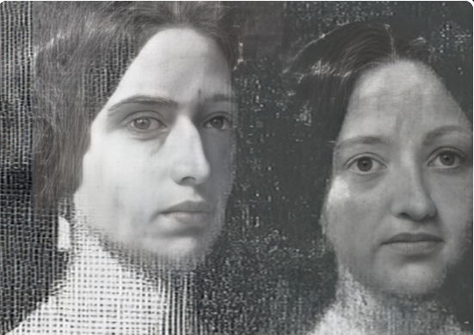
Mary on right
Parents: John Watson Lawrence (1800–1888) and Mary King Bowne (1808–1874).
Spouse: Henry Augustine Bogert (1827–1905).
Children: Mary “Minnie” Lawrence Bogert (1855–1893), married William Elliman, Henry Lawrence Bogert (1857–1933), attorney; married Caroline “Carrie” Lawrence Osgood, John Lawrence Bogert (1858–1956), engineer and inventor, Emily Eloise Bogert (1860–1864), Edward Ludlow Bogert (1862–1863), Walter Lawrence Bogert (1864–1959, James Lawrence Bogert (1867–1867), Marston Taylor Bogert (1868–1954), eminent chemist; Columbia professor; Priestley Medal (1938), Frances “Fannie” Lawrence Bogert (1870–1947), married Robert Hare Egerton Elliott, Theodore “Theo” Lawrence Bogert (1875–1947).
Kinship: Second cousin four times removed of post-World War II Smith generation.

They lived in Robinshurst, 72 Lawrence Street, Flushing, across the street from Willow Bank.

Lawrence, Mary Elizabeth Van Sinderen (1840–1933)
Parents: Isaac Lawrence (1808–1862) and Julia A. M. Sturges (1811–1845).
Spouse: George Gilchrist Martin (1832–1909).
Children: Agnes Martin (1865–1900).
Kinship: Sixth cousin four times removed of the post–World War II Smith generation.
Mary Elizabeth Van Sinderen Lawrence spent her early life in New York before settling in Washington, D.C., where she became known for her work in patriotic and lineage societies. She was a charter member of the National Society of the Daughters of Founders and Patriots of America, and was the founder and first Regent of the Emily Nelson Chapter of the Daughters of the American Revolution in Washington, D.C. She also served on various national committees of the D.A.R. during the society’s formative period, contributing to the development of its educational and historical initiatives.
Her husband, George Gilchrist Martin, held government service positions in Washington, including roles in the U.S. Treasury Department and later the Government Printing Office. Their only child, Agnes Martin, was active in Washington charitable society and was occasionally mentioned in the society pages before her early death in 1900.
The Martins lived for most of their married life in the Dupont Circle–West End area of Washington, D.C., a neighborhood then home to many families engaged in government, diplomatic, and cultural life. Mary Elizabeth remained active in lineage, historical, and civic circles into her later years. She is buried in Rock Creek Cemetery, Washington, D.C.

Lawrence, Newbold (1809–1885)
Parents: John Burling Lawrence (1774–1844) and Hannah Newbold (1792–1832).
Spouse: Anna Hough Trotter (1821–1893) of Philadelphia.
Children: Annie “Nan” Trotter Lawrence (1852–1931), Caroline “Carrie” Trotter Lawrence (twin) (1852–1937), Newbold Trotter Lawrence (1855–1928), Susan Newbold Lawrence (1856–1923), and Mary Gertrude “Gertie” Lawrence (1860–1941).
Kinship: Third great-great-granduncle of the post–World War II Smith generation.
Early Life and Family Background
Newbold Lawrence spent his childhood summers at Forest Hill (see Houses and Estates), the country seat built by his uncle, John Watson Lawrence, overlooking the Hudson River. The estate afforded space for outdoor pursuits, and family recollections noted that it was “a perfect place for shooting.” His early years formed part of the close-knit Lawrence–Bowne family circle anchored in upper Manhattan and Flushing.
Marriage and New York Residence
After his marriage to Anna Hough Trotter of Philadelphia, Newbold settled in Manhattan. By 1848 the couple were living at 45 East 29th Street, a three-story brick row house in what had only recently been farmland. The house remained the family’s winter residence for over seventy years. Both Newbold and Anna lived there until their deaths, and the house stayed in the family until at least the 1920s. Their daughter Caroline, who never married, was its last inhabitant.
Family Life and Domestic Culture
The Lawrence home on East 29th Street was known for its warm hospitality and for the family’s cultural pursuits. Newbold and Anna encouraged amateur theatricals, and the family established what was known as the Home Dramatic Society, which staged productions for relatives and friends.
[Insert your theatrical details, cast list, and/or 1876 program here.]
The family preserved Quaker heritage even after moving into New York society. Caroline was photographed wearing the Hicksite Quaker wedding dress of her grandmother, Ann Hough, a garment the family cherished and retained. On one occasion, a surprise party was held for Caroline so she “might have a share in the generosity brought forth at the marriages and anniversaries of the other sisters,” and she was presented with gifts of silver. The last family function at the house took place in 1924, a wedding reception for a granddaughter. Guests recalled the “old-fashioned party to suit the house, illumined only by candlelight,” and that the bride and groom departed down the staircase amid a shower of rose petals “which afterward lay inches deep on the floor.”
Development of Lawrence and Cedarhurst
Together with his brother Alfred, Newbold played a key role in the development of what would become Lawrence and Cedarhurst on the South Shore of Long Island. At the time the area was remote and difficult to reach, and development could not proceed without a railroad connection. The Lawrence brothers worked to secure a rail line to serve their planned community, a project that helped transform the region from rural farmland into what later became known as part of the “Five Towns.” Newbold also built his country house in Lawrence, which the family occupied during summers, maintaining the longstanding Lawrence pattern of a city residence for the winter season and a country home for the warmer months.
Legacy
Newbold Lawrence’s legacy endures in two distinct spheres: in the family’s cultural memory—embodied in the traditions, theatricals, and gatherings in the East 29th Street house—and in the physical landscape of Long Island, where his role in the founding and development of Lawrence and Cedarhurst helped establish a residential community that still bears the family name.

Lawrence, Mary (1860–1942)
Parents: Frederick Newbold Lawrence (1834–1916) and Elizabeth Miller Boyce (1835–1894).
Spouse: (1) Frank Worth White (1856–1887); (2) Foxhall Parker Keene (1867–1941).
Children: Loomis Lawrence White (1879–1948).
Kinship: Great-grandaunt of the post–World War II Smith generation.
Early Life and Marriage to Frank Worth White
Mary Lawrence was raised in the prominent Lawrence family of Bayside and Flushing, New York. On October 3, 1878, she married Frank Worth White at St. George’s Church, Flushing. Their son, Loomis Lawrence White, was born November 2, 1879. Frank, a graduate of Trinity College, was admitted to the New York Stock Exchange in 1881 and entered his father’s brokerage firm, Loomis, White & Co.
The couple participated actively in New York and Lenox society. In 1883 they leased Tucker Cottage in Lenox for the season. Frank died of pneumonia on January 18, 1887, at the age of thirty, leaving Mary a widow at twenty-seven.
Society Life and Tableaux Vivants
Following her widowhood, Mary remained active in society. In February 1884 she appeared in a large charity tableaux event at Madison Square Garden before an audience of three thousand, portraying Helen of Troy. One critic praised her as “in every way worthy to represent the lovely Helen,” while another, more sardonic, wrote that although her beauty was undeniable, she was “thin, hollow-chested and bow-backed,” yet possessed “glorious” eyes and a remarkably clear complexion.
In March 1886 she took part in a Lenten charity entertainment at which she sang “My Marguerite.” Newspapers nationwide reported her appearance, noting her gray spring suit embroidered with tiny black and white flowers—a level of detail that reveals the intense public interest in the minutiae of New York society fashion.
That same year she again participated in tableaux vivants at the Metropolitan Opera House to benefit St. George’s Seaside House. She appeared as “The Sibyl” after the painting by F. S. Church, one critic remarking that she was “a beautiful picture of a pretty woman,” though more suited, the writer thought, to a muse of love than a prophetess
Marriage to Foxhall Parker Keene
Mary became engaged to Foxhall Parker Keene in August 1891 and married him on December 10, 1892, at her home at 19 East 22nd Street in New York. Foxhall “Foxie” Keene was one of the most celebrated American sportsmen of his era, noted for polo, racing, yachting, and international society. Mary accompanied him to sporting and social events, as well as to the opera and major charitable entertainments.
Fashion and Public Attention
Mary’s clothing attracted continuous press notice nationwide, an early example of a socialite functioning as a style influencer. At the Metropolitan Opera she was described as wearing a pale blue velvet gown trimmed with silver embroidery, with a rose-colored velvet bodice and a diamond tiara. Reports from cities as far away as Lincoln, Nebraska, and St. Louis, Missouri, detailed her street suits, furs, and hats, showing that her fashion sense was followed beyond New York society.
In September 1899 Mary appeared in a charity theatrical in Newport organized by the Earl of Yarmouth. She sang a French ballad to considerable praise. At a 1904 charity fair at Harbor Hill, the home of Clarence and Katherine Mackay, Mary worked as a “saleslady” in period costume, her presence noted for charm and effectiveness.
A long-circulated story claimed that Chicken à la King originated at Delmonico’s in the late 1890s at the suggestion of either Mr. or Mrs. Foxhall Keene, and was first known as Chicken à la Keene. Although impossible to verify with certainty, the story was widely repeated.
Separation and Divorce
Despite their glamorous social life, the marriage did not endure. In 1904 Mary left Foxhall Keene and returned to her father’s household. The reasons were never publicly disclosed. There were hints of financial disagreements, despite both being independently wealthy. Mary, like her father, was a vegetarian, which contemporary gossip occasionally mentioned in speculation about “incompatibility,” but no substantial explanation ever appeared in the press. In 1909 Mary obtained a divorce from Foxhall on the grounds of abandonment.
Later Life and Death
Mary continued to appear occasionally at charitable and civic events. In June 1911 she served as a judge at a working-horse parade, where her attire—an elegant black gown and hat trimmed with black ribbon—was still described in detail by reporters, though the tone was more respectful than breathless. Over time she withdrew from the social scene. She lived quietly in New York during her later years and died there in 1942 at the age of eighty-two.

Lawrence, Mary Anne (1854–1915)
Parents: Joseph A. Lawrence (1817–1889) and Elizabeth D. Gorsline (1823–1904).
Spouse: John Burkhardt, a widower with nine children.
Children: None recorded..
Kinship: Sixth cousin four times removed of the post–World War II Smith generation.
Biography
Mary Anne Lawrence was raised in Newtown, Queens, where her branch of the family had settled after leaving Cayuta Lake. Unlike many of her Lawrence relatives, who married within mercantile, professional, or socially prominent circles, she married John Burkhardt, a farmhand and widower with nine children. By doing so, she assumed immediate responsibility for a large stepfamily.
After the deaths of her parents, Mary Anne inherited the Lawrence home and surrounding property. At her death in 1915, her estate was valued at about $250,000 (roughly $8,000,000 in 2025). The Lawrence homestead was later torn down, and the land was divided into building lots, marking the end of that tangible piece of Lawrence family history in Newtown.
Context and Significance
Mary Anne’s marriage stands out in the Lawrence family record, as it crossed a clear social and economic boundary. Her choice illustrates that, even within a lineage known for endogamous marriages and shared class expectations, individual paths diverged from the prevailing family pattern.

Lawrence, Mary Bowne (1830–1898)
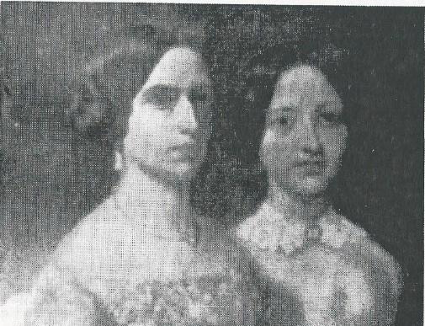
Mary Bowne Lawrence (left), Anna Louise Lawrence (right)
Parents: John Watson Lawrence (1800–1888) and Mary King Lawrence Bowne (1808–1874).
Spouse: Henry Augustine Bogert (1827–1905).
Children: Mary “Minnie” Lawrence Bogert (1855–1893), Henry Lawrence Bogert (1857–1933), John Lawrence Bogert (1857–1956), Emily Lawrence Bogert (1860–1864), Edward Ludlow Bogert (1862–1863), Walter Lawrence Bogert (1864–1959), James Lawrence Bogert (1867–1867), Marston Taylor Bogert (1868–1954), Francis Lawrence Bogert (1869–1869), Frances Lawrence Bogert (1870–1947), and Theodore Lawrence Bobert (1875–1947).
Kinship: Second cousin four times removed of the post-World War II Smith generation.

Mary Bowne Lawrence married Henry Augustine Bogert, a Columbia graduate and a successful lawyer. They had eleven children, but infant mortality was high, and heartaches many.
Frank (July 11, 1869 – July 19, 1870) was Mary’s ninth child.
On July 19, 1870, she wrote this letter to her sister Anna:
Dear Anna,
God has taken my beautiful baby – Frank died this morning at 4 o’clock. He was sick only two nights and one day, commenced on Saturday night with a slight diarrhea which seemed checked Sunday morning, but returned Sunday afternoon…I thought the disease controlled, but his head became affected last night he suffered greatly with his head until death released him.
I need not tell you how great the shock, you have gone through the same trouble dear, and know that death never comes to us thus, in our children without bitter pain, even while we own God’s love and wisdom in all his doings.
I felt so safe about little Frank because he had so good a wet nurse. He had grown so beautiful and seemed so well I scarcely dreaded the summer, but this intense heat and teething were too much for him.
I feel that everything was done that could be, for Mrs. Pettit and Maggie and I watched him carefully, but God willed it, and just one year from the time of his last summer’s sickness, God took him to Himself.
I have four darlings now in Heaven. How blessed to know them safe. I do not think I am a very good manager with children, so God takes some of them to bring up for me and in Heaven they will be mine forever. I wondered how I should manage with three babies next winter. God has answered the doubt for me, tho not quite in the way I would have chosen.
It is so hard to look forward to bringing more children into the world only to see them die.
The other children are well, and I hope your little ones are too.
You sent me a little note of your safe arrival. Do, if you can, write me some particulars and why you staid at Worcester instead of Centre Harbor.
Dear Anna, life has many trials for all of us; let us not receive them in a bitter spirit, but as Christians walk humbly with God receiving all things from His hands, remembering that in another world we shall see clearly the reasons for much that now appears mysterious.
May God give you Grace, dear, to bear and forbear until this life shall merge into the better one above.
Your loving sister,
Mary

Lawrence, Mary Trimble (1869–1945)
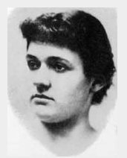

Parents: Henry Effingham Lawrence (1829–1890) and Lydia Greene Underhill (1830–1913).
Spouse: François Michel Louis Tonetti (1864–1929).
Children: Oliver Pellier Tonetti (d. 1901), Ann Elizabeth Tonetti (1903–1990), Lydia Lawrence Tonetti (1904–1943), Joseph Lawrence Tonetti (1905–1963), Marie Françoise “Chrissie” Tonetti (1907–1972), and Alexandra Tonetti (1909–1991).
Kinship: Third cousin three times removed of the post–World War II Smith generation.
Early Life and Family Background
Mary Trimble Lawrence was born in New York City in 1869 into a cultivated and socially prominent Lawrence family. She was the youngest of five children of Henry Effingham Lawrence and Lydia Greene Underhill. Her sisters Edith and Margaret, her brother Joseph, and her sister Lillian formed a close-knit sibling circle. The family lived in Manhattan on East 25th Street, next door to Mary’s beloved Aunt Annie Underhill Trimble and her husband, Merritt Trimble. Mary’s middle name honored Merritt Trimble, and her warm relationship with her Aunt Annie remained one of the formative influences of her early life.
The family attended Grace Church on Broadway and Tenth Street, where they occupied the pew directly behind the celebrated author Edith Wharton, reflecting the Lawrences’ placement within New York’s cultivated society. Summers, however, were spent in the countryside, where Mary’s artistic sensibilities were awakened and encouraged.
Childhood at Snedens Landing and Family Circle
Mary’s father purchased a farm at Snedens Landing, across the Hudson from Dobbs Ferry. The property, known as Arcadia, included the country house he built and named Cliffside.. Snedens Landing would become an enduring part of Mary’s identity and later a magnet for artists, writers, and actors. In Mary’s childhood, it served as a place of family intimacy and imaginative freedom.

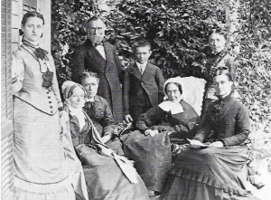
The Family at Snedens Landing
L to r: Edith Lawrence, Grandmother Underhill, Mrs. Merritt Trimble, Merritt Trimble, Joseph Lawrence, Lydia Greene, Annie Underhill, Mrs. Henry E. Lawrence
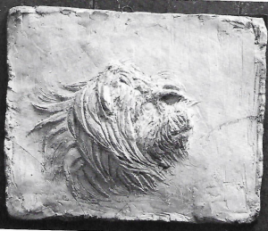
Snedens Landing was also the site of early artistic influence from beyond the family. The Lawrences bought their shoes from Bernard St. Gaudens, father of the sculptor Augustus Saint-Gaudens. In 1876, when Mary was about seven years old, the young Augustus Saint-Gaudens visited Snedens Landing to give drawing lessons to several children in the area. It is likely that Mary was among his pupils, and this early exposure to a rising artistic figure foreshadowed the professional connection that would later shape her career. With her early artistic promise encouraged and nurtured, Mary soon progressed from childhood sketching at Snedens Landing to more intentional artistic study and expression.
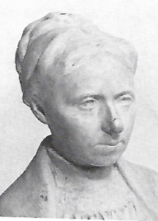
First Artistic Work and Early Sculptures
Mary’s family recognized her artistic talent early. At Snedens Landing she converted a small summer house on the property into her own studio. Her earliest surviving sculpture was a touching model of her dog Dandy, a work that demonstrates both sensitivity and a natural instinct for form.
Family encouragement remained constant. Her Aunt Annie Underhill Trimble, in particular, took an active interest in Mary’s creative development. The cultivated atmosphere of both the Lawrence and Underhill families fostered a belief that artistic pursuits were not merely acceptable for a young woman, but admirable. This atmosphere, combined with the influence of early contact with Augustus Saint-Gaudens, gave Mary an unusual confidence for a woman pursuing sculpture in the late nineteenth century.
Anne Trimble, by Mary (Left)

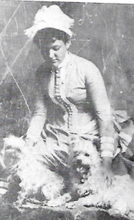
European Travel and the Grand Tour (1886–1887)
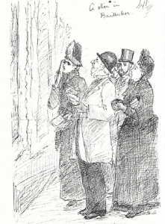
In 1886–1887 Mary and her sister Edith embarked on the Grand Tour of Europe, accompanied by their aunt, Annie Underhill Trimble. Mary kept a highly entertaining illustrated journal of the trip, capturing social observations, humorous commentary, and sketches of what she saw along the way. She gently mocked those who admired according to guidebooks rather than their own eyes, remarking that “everyone knew what to admire because Baedeker put a star next to the thing.”

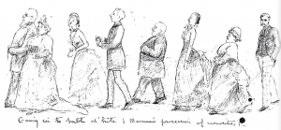
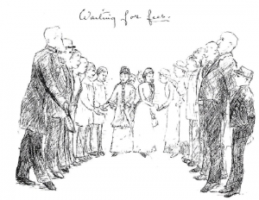
Hotels and hotel life particularly amused her. She sketched the parade of personalities in the grand hotel dining rooms, corridors, and lobbies, noting how the “important” people performed themselves in public. She recorded her encounters with tipping culture, writing that “one must run the gauntlet of tipped individuals before one can escape a hotel alive.” Her humorous sketches of waiters, porters, chambermaids, and other travelers form a vivid social record of European travel in the 1880s.
Mary also commented on the contrast between fashionable European dress and her own practical instincts. After a dressmaker in Paris proposed an elaborate strolling costume suitable for promenading in the Bois de Boulogne, Mary noted wryly that she had grown up in the country and had quite different ideas of what proper walking attire should be.
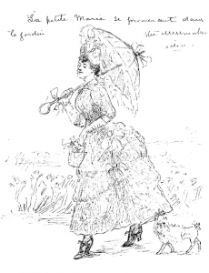
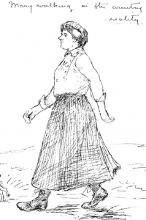
By the end of the journey, Mary returned home with broadened cultural horizons, sharpened artistic judgment, and a portfolio of illustrated impressions that reveal both her observation skills and her wry sense of humor. The Grand Tour had confirmed her artistic vocation and prepared her for more formal study.

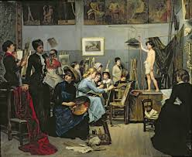
Training in Paris and the Art Students League
“The Studio” by Académie Julian student Marie Bashkirtseff.
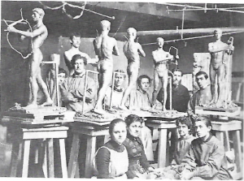
In April 1887, Mary Trimble Lawrence entered the Académie Julian in Paris, as women were not admitted to the École des Beaux-Arts until 1897. Within a week of her arrival, she was invited to visit the studio of Auguste Rodin, where Camille Claudel, a young student and Rodin’s assistant and companion, also worked. Mary observed the preparation of models for The Burghers of Calais and various figures for The Gates of Hell. She later wrote that the experience “opened my eyes to the intensity of modern sculpture and the precision of French ateliers,” capturing both her admiration and the disciplined atmosphere of the studio.
The Art Students League
Mary is seated, second from left.
St. Gaudens is standing, second from right
After completing her time at the Académie, Mary returned to New York in 1888 to work with Augustus Saint-Gaudens. She later returned to Paris in December 1893 to continue her studies before assuming teaching duties in New York at the Art Students League, where she instructed under the guidance of Saint-Gaudens and mentored younger students in sculpture techniques. Her early work from this period reflects careful observation of form and an attention to naturalistic detail, likely inspired by both Rodin and Saint-Gaudens.
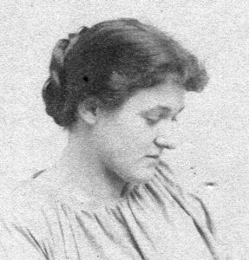
Mary in a Work Smock (right)
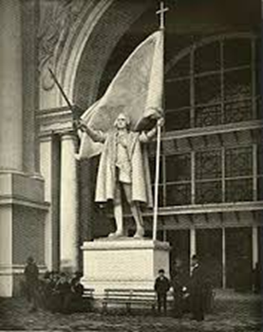
The Columbus Statue and Major Public Works
In 1891, plans for the Columbia Exhibition in Chicago included a central statue of Christopher Columbus. Saint-Gaudens recommended Mary to model and execute the main figure. At only twenty-three years old, Mary undertook the commission, producing a work praised for its vigor and breadth. Frank Millet, a fair organizer, attempted to move the statue to a less prominent location near the train station, but the architect Charles Follen McKim, who had become enamored with Mary’s skill and character, successfully restored it to its intended placement. Saint-Gaudens later commented, “Miss Mary Lawrence, now Mrs. François M. L. Tonetti, modeled and executed it; and to her goes all the credit of the virility and breadth of treatment which it revealed.”
Model of Christopher Columbus for the Chicago World’s Fair, 1893 (left)
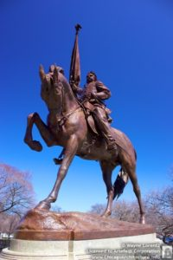
Following this project, Mary assisted Saint-Gaudens with the General John A. Logan monument in Grant Park, Chicago. Her work during this period demonstrates both technical mastery and an early professional confidence, establishing her reputation in American sculpture. Her contributions were recognized by contemporaries as reflecting both her skill and her capacity to interpret monumental subjects with sensitivity and authority.

General Logan Monument (left)

Marriage and Artistic Partnership with François Tonetti
Mary Trimble Lawrence met François Michel Louis Tonetti through artistic circles in New York and Paris. François, who was taken with Mary, persuaded Monnies to send him to New York to assist with the completion of sculptures for the Brooklyn Memorial Arch on Grand Army Plaza. They were engaged in 1899. St. Gaudens was delighted. He wrote to Mrs. Lawrence: “I never knew two people more made for one another, and that they should have been brought together is a smile of fortune. Besides the qualities that befit him peculiarly for Mary, he is a most affectionate and loveable man…I know they will be happy together.”
They married in 1900 at Grace Church, New York, when Mary was thirty-two and François thirty-six. Following their marriage, they converted the former Murray Hill Presbyterian Church at 135 East 40th Street (where the Rum, Romanism, and Rebellion sermon was preached) into a combined residence and studio. The space allowed Mary to continue her sculptural work while François executed commissions for significant public monuments.
Mary and François spent summers and weekends at Snedens Landing, where Mary had grown up. The property became a lively artistic hub, attracting painters, sculptors, and other creatives. Mary’s studio there served as a space for experimentation and teaching, while François worked on commissions including the Brooklyn Memorial Arch. The couple maintained a blend of domestic life and professional practice, balancing their children’s upbringing with an active artistic schedule.
Snedens Landing as an Artistic Colony
Snedens Landing became a collaborative and educational environment. Mary encouraged young artists, sometimes taking over Saint-Gaudens’s classes at the Art Students League when he returned to Paris. She continued producing public works, teaching techniques, and supervising apprentices. The estate hosted notable figures of the American Renaissance, including Chester French, Saint-Gaudens, and other sculptors, who collaborated on various projects. Mary also worked on portraits and private commissions, demonstrating her ability to manage multiple complex projects simultaneously.
About 1900, judging from the age of the models, Mary did a sculpture of Louis Comfort Tiffany’s twins, Louise Comfort and Julia DeForest. Katherine Cornell, the actress, who had a house at Snedens Landing apparently liked the sculpture so much that when she moved from Snedens Landing in 1965, Mary’s daughter Anne Gugler gave the sculpture to her as a housewarming present. Cornell installed it over the door at her new residence at 328 East 51st St., where it can be seen today.
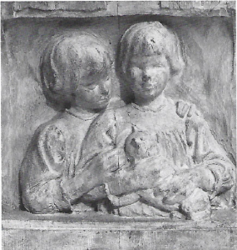
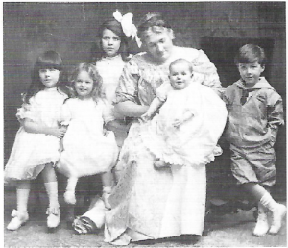
Children and Family Life
Mary and François had six children: Oliver Pellier Tonetti, who died shortly after birth in 1901; Ann Elizabeth Tonetti (1903–1990), who married architect Eric Gugler; Lydia Lawrence Tonetti (1904–1943), who married Robert McKee Hyde; Joseph Lawrence Tonetti (1905–1963), who married Susan McKee Hyde; Marie Françoise “Chrissie” Tonetti (1907–1972), who married first John Drury Ratcliff and then Allan B. Sheldon; and Alexandra Tonetti (1909–1991), who married Harwood A. White. Despite a busy professional life, Mary ensured her children were educated and exposed to the arts, continuing the family tradition of cultural engagement.
Later Life, Final Works, and Legacy
In the 1920s and 1930s, Mary Trimble Lawrence continued to produce sculptures, focusing on portraits and commemorative works. She maintained her studio at Snedens Landing and the Murray Hill residence, balancing family responsibilities with artistic production. Her teaching, which began under Saint-Gaudens and continued at the Art Students League, influenced a generation of sculptors, and her estate at Snedens Landing remained an informal artistic hub.
Mary also completed commissions for private patrons and participated in exhibitions, demonstrating her sustained prominence in American sculpture. Her works were noted for attention to naturalistic detail, expressive composition, and technical skill, reflecting the combination of French academic training and American Renaissance influence she received throughout her career.
Death and Burial
Mary Trimble Lawrence died in 1945 at the age of seventy-six. She was survived by her children and grandchildren, many of whom continued the family’s artistic and professional legacy. She is remembered as a pioneering female sculptor, teacher, and mentor, whose contributions bridged American and European sculptural traditions. Mary is buried in the family plot, alongside her parents and siblings, leaving a lasting imprint on both her family and the broader American artistic landscape.

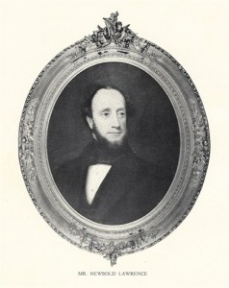
Lawrence, Newbold (1809–1885)

Parents: John Burling Lawrence (1774–1844) and Hannah Newbold (1732–1832)
Spouse: Anna Hough Trotter (1821–1893)
Children: Annie Trotter Lawrence (1852–1931), Caroline Trotter Lawrence (1852–1937), Newbold Trotter Lawrence (1855–1928), Susan Newbold Lawrence (1856–1923), Mary Gertrude Lawrence (1860–1941)
Kinship: Third great-granduncle of the post-World War II Smith generation.
Childhood and Forest Hill
Newbold spent the summers of his childhood at Forest Hill, the estate built by his father Joseph Lawrence. The property, now located at 133rd Street and Riverside Drive, provided an expansive landscape ideal for outdoor activities, including shooting and exploration.
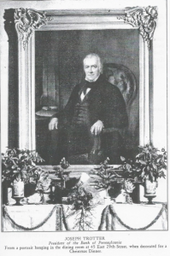
Manhattan Residence
In 1851, Newbold and Anna Hough Trotter moved into 45 East 29th Street in Manhattan, a three-story brick row house built on recently developed farmland. They lived there each winter season until their deaths. The parlor was decorated for Christmas, including a portrait of Joseph Trotter over the mantle, reflecting the family’s artistic and social culture.
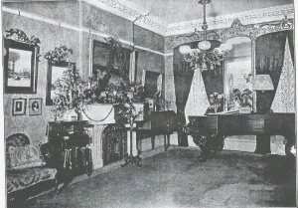

Home Dramatic Society and Theatrical Productions
The Lawrence family maintained a Home Dramatic Society, staging amateur performances in their Manhattan home. The year 1876 saw a variety of productions that engaged the children and reinforced the family’s cultural interests.
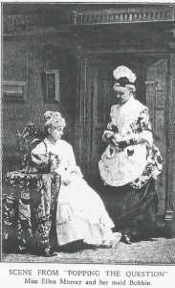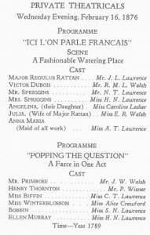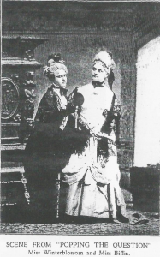

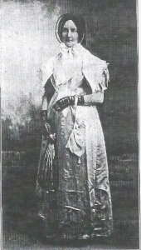
The house remained in family hands at least until the 1920s, with Caroline (1852–1937) as the final inhabitant. She never married. A surprise party was given one evening to the unmarried daughter who still lived in the house. Gifts of silver were presented to her, that she might have a share in the generosity brought forth at the marriages and anniversaries of the other sisters.

Caroline Trotter Lawrence in grandmother Ann Hough’s Quaker wedding dress (right)
The last family function was held in 1924, a wedding reception for a granddaughter: “It was an old fashioned party to suit the house, illumined only by candle light and gay with flowers. As the bride and groom descended the staircase their departure was in the midst of a shower of rose petals, which afterward lay inches deep on the floor!”

Lawrence, Owen Effingham (1881–1956)
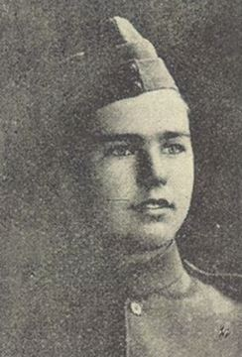

Parents: Effingham Billopp Lawrence (1835–1908) and Grace Barnard (1840–1928)
Spouse: Erica Caroline Gatenby (1884–1956)
Children: Norman Owen Lawrence (1917–1994), Edward Effingham Lawrence (1925–1943)
Kinship: Third cousin four times removed of the post-World War II Smith generation
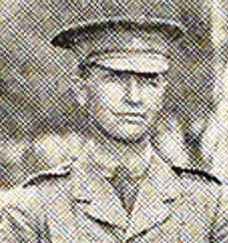
Owen Effingham Lawrence was born in Tasmania in 1881. He served in the Boer War as part of the 1st Tasmanian Imperial Bushmen and the 1st Tasmanian Imperial Bushmen Mounted Infantry, under the command of Major R.C. Lewis and Captain A.A. Sale. He sailed for South Africa aboard the Manhattan on 26 April 1900 and served from June 1900 to June 1901.
Owen appears to have served in the military at a later date, though records are incomplete. He died in South Africa in 1956, having maintained a distinguished connection to both Tasmanian and British military service.

Lawrence, Richard (1725–1781)
Parents: John Lawrence (1693–1765) and Patience Sackett (1701–1772)
Spouse: (1) Elizabeth Fowler; (20 Amy Berrien (1738-1881).
Children: With Elizabeth Fowler: Melancton Lawrence (1750-1790)
Kinship: Third cousin seven times removed of the post-World War II Smith generation
Revolutionary War Service
Richard Lawrence was commissioned Captain of the Newtown Troop of Horse at the start of the Revolutionary War. In 1776, he was captured by Loyalists and confined at the Provost Prison in New York City. His health deteriorated, and he was eventually allowed to return home, where he died on 21 November 1781. Before his death, he received news of Cornwallis’s surrender and reportedly expressed satisfaction that the American cause had triumphed.
Letter of Amy Berrien Lawrence, March 2, 1776
A letter written by his wife, Amy Lawrence, shortly before Richard was forcibly taken to the Provost Prison, survives among the Sackett Family manuscripts. It is addressed to “Mrs. Hannah Delancy at Cortlands Manor”:
March ye 2d 1776
My Dear Cousin,
The receipt of yours of ye 26th of last month gave me a great deal of pleasure as it ascertained me of your existence… My Mr. Lawrence is very sick, and brother Daniel is very ill, and brothers Joseph and Thomas are both in a bad state of health… Our house is filled with soldiers, forts are erecting, batteries forming… Your brothers I hope will be preserved through all the dangers… Be pleased to give my duty, with Mr. Lawrence's to our Honored Uncle and Aunt and accept a large share to yourself… Your loving cousin, Amy Lawrence.

Lawrence, Robert Bowne (1852–1942)
Parents: John Watson Lawrence (1800–1888) and Mary King Bowne (1808–1874)
Spouse: Elizabeth Hyde Clements (1864–1949)
Children: Robert Rutherford Lawrence (1889–1952)
Kinship: Second cousin four times removed of the post-World War II Smith generation
Education and Career
Robert graduated from Columbia College and Columbia Law School. He practiced law in Manhattan and maintained his residence at Willow Bank in Flushing. He was active in Masonic affairs, representing the New York Grand Lodge at the Texas Grand Lodge at the time of his death in Houston, Texas.
Birding, Hunting, and Ornithological Collections
Robert B. Lawrence was an avid naturalist, focusing on birding, fishing, and hunting. The Center for Brooklyn History holds three scrapbooks compiled by him, containing newspaper and magazine clippings from 1870 to 1933, along with indexes. One scrapbook specifically documents his bird hunting and egg collecting activities in Flushing (Queens, NY), Long Island, and other areas of the United States.
Notable Observations
The scrapbook includes detailed information on bird sightings, correspondence with fellow naturalists, and photographs. Among the photographs are a Louisiana heron and a Great-tailed grackle, taken on Green Island, Long Island, New York, in 1927.
Legacy
Robert Bowne Lawrence’s scrapbooks are a significant primary source for early 20th-century ornithological studies in New York. They provide insights into local bird populations, field observation methods, and the leisure practices of an accomplished amateur naturalist of his era.

Lawrence, Robert William (1807–1833)
Parents: William Effingham Lawrence (1781–1841) and Mary Ann George Smither (1797–1880)
Spouse: Anne Emily Wedge (1808–1833)
Children: Anne Emily Wedge Lawrence (1833–1920)
Kinship: Second cousin five times removed of the post-World War II Smith generation
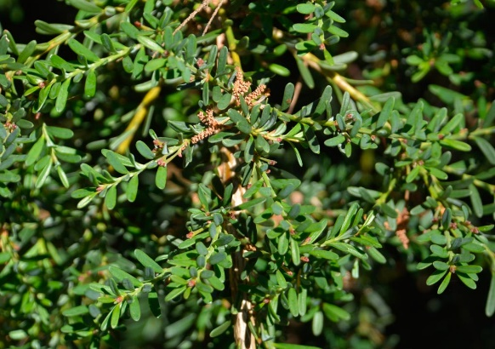
Early Life and Botanical Pursuits
Robert was the first-born son of William Effingham Lawrence. Born and educated in England, he arrived in Van Diemen’s Land (Tasmania) in 1825 aboard the Elizabeth. He became acquainted with Sir William Jackson Hooker, Regius Professor of Botany at the University of Glasgow and later Director of the Kew Botanical Gardens. Through this friendship, Robert developed a passion as an amateur botanist, sending numerous specimens from the colony to Kew, contributing to Hooker’s Flora Tasmaniae (1860).
Robert Lawrence introduced botanist Ronald Campbell Gunn to Hooker. The native fuchsia mountain correa was named Correa lawrenciana (right) by Hooker in honor of his young protégé.
The Black Line (1830)
The Tasmanian government initiated the Black Line to remove Aboriginal inhabitants from settled districts. Thousands of men were hired to march in a cordon spanning approximately 300 kilometers from north to south of the island. This operation detained 2,200 men in the field for eight weeks during October and November 1830, affecting most of the island’s 23,000 inhabitants.
For six weeks, Robert Lawrence led a party of ten men on foot as part of this operation. His journal recorded daily events and provides insight into the campaign’s execution. The Line consisted largely of convicts and soldiers pressed into service. The campaign largely ignored its stated objective of capturing Aboriginal people, resulting in widespread dissatisfaction and general recognition of its failure.
Residences and Personal Life
Robert lived in the house Vermont (see Houses and Estates), built by his father near Launceston, before moving to his father’s estate Formosa, where he served as overseer. In 1832, he married Anne Emily Wedge, who died the following year giving birth to their daughter Anne Emily
Death and Legacy
Robert Lawrence died weeks after his wife, on 18 October 1833, at the age of 26. Gunn wrote to Hooker:
“It is with feelings of the deepest regret I have to communicate to you the death of our mutual friend Mr. W. R. Lawrence. This melancholy event took place at Formosa… Twelve months ago poor Lawrence married a young and most amiable Lady… on 2 September last I left them in the enjoyment of excellent health; next day Mrs. Lawrence was safely delivered of a daughter, but from delicacy of constitution, or too sudden an exposure after her confinement, she was in a few days seized with a fever which terminated fatally within a month… fatally to Lawrence’s happiness and peace.”
The coronial jury delivered a verdict that Robert “died by a visitation of God.” His infant daughter, Anne Emily Lawrence, was raised by her maternal grandparents in Van Diemen’s Land and later Port Phillip. She eventually married Monckton Synnot.

Lawrence, Robert William (1807–1833)
Parents: William Effingham Lawrence (1781–1841) and Mary Ann George Smither (1797–1880).
Spouse: Anne Rachel Wedge (1808–1880), daughter of Edward Dumaresq Wedge and niece of surveyor John Helder Wedge.
Children: According to most Tasmanian accounts, Anne Jane Lawrence (born 1833), who survived childhood; however, some Lawrence family records in England give the child’s name as Anne Maria Lawrence (1833–1833) and state that she died in infancy.
Kinship: First cousin six times removed of the post–World War II Smith generation.
Early Life and Emigration to Van Diemen’s Land
The eldest son of William Effingham Lawrence, Robert William grew up in England in a family of cultivated outlook and international connections. He accompanied his parents to Van Diemen’s Land, where the Lawrence family established themselves as significant landowners at Formosa on the Lake River.
Marriage and Domestic Life
On 18 October 1832 he married Anne Rachel Wedge, uniting two of the colony’s prominent settler families. The young couple lived at Formosa and moved within the most educated circles in northern Tasmania, where Robert’s curiosity, refinement, and literary interests distinguished him among the younger generation of colonial-born settlers.
Patronage of the Arts and Friendship with John Glover
Robert William’s lasting significance lies in his influence on early Tasmanian cultural life. He became a close friend and correspondent of the English landscape painter John Glover, who had settled in Van Diemen’s Land in 1831. Their discussions on landscape, art, and the natural environment helped shape Glover’s developing vision of the Tasmanian bush. Glover found in Robert a sensitive and enthusiastic conversationalist, receptive to artistic ideas uncommon in the rough and still-forming colony. Several of Glover’s letters and remarks suggest deep affection and esteem for the young man, and he later lamented Robert’s early death as a cultural loss to the colony.
Illness and Early Death
Robert and Anne’s married life was brief. Within a year of their marriage, and soon after the birth of their daughter, Robert fell ill and died on 2 September 1833 at the age of twenty-six. His death was felt keenly among the colony’s small cultural and intellectual circle. Glover mourned him as a young man of rare promise, whose intellect and artistic sensibility might have enriched Tasmanian life had he lived longer.
Legacy
Although his life was short, Robert William Lawrence occupies a small but distinguished place in the early cultural history of Tasmania. His friendship with Glover helped nurture the colony’s first stirrings of artistic self-awareness, while his marriage linked the Lawrence and Wedge families for subsequent generations. Whether or not his daughter survived infancy, his memory endured within both families as that of a young man of talent, sensibility, and uncommon charm whose potential was never fully realized.

Lawrence, William Effingham (1813–1871)
Parents: Effingham Lawrence (1779–1850) and Anne Townsend (1782–1845).
Spouse: (1) Caroline Augusta Lawrence (1815–1841); (2) Rachel Augusta Mickle (1828–1863), daughter of Andrew Hutchins Mickle, Mayor of New York City (1846–47).
Children: Edward Newbold Lawrence (1841–1866); Caroline Augusta Lawrence (1849–1925) [needs full documentation]; Andrew Mickle Lawrence (1853–1888); Effie Lawrence (1856–1934) [needs full documentation]; William Effingham Lawrence (1857–1902); Grace Townsend Lawrence (1859–1929) [needs full documentation]; Louisa T. Lawrence (1863–1876).
Kinship: Third great-granduncle of the post–World War II Smith generation.
Early Life and Family Background
William Effingham Lawrence was a member of the Bayside branch of the Lawrence family, descended from early Long Island settlers with longstanding commercial and marital ties to the Townsends. His first wife was his cousin, Caroline Augusta Lawrence, who died young in 1841. His second marriage to Rachel Augusta Mickle linked him to the New York City political world through her father, Andrew H. Mickle, a mid-nineteenth-century mayor.
Residences and Family Connections
He lived principally in New York and Bayside, Queens, where the Lawrence family maintained deep roots. The family is represented in the Lawrence Cemetery at Bayside, where William, his first wife, and several of his children are buried. The youngest child, Louisa T. Lawrence, is recorded on the family monument as having died in Detroit in 1876.
Children and Generational Continuity
His eldest son, Edward Newbold Lawrence, died in 1866 at Funchal, Madeira, a common destination for convalescence.

Lawrence, Robert William (1807–1833)
Parents: William Effingham Lawrence (1781–1841) and Mary Ann George Smither (1797–1880)
Spouse: Anne Emily Wedge (1808–1833)
Children: Anne Emily Wedge Lawrence (1833–1920)
Kinship: Second cousin five times removed of the post-World War II Smith generation
Early Life and Botanical Pursuits
Robert was the first-born son of William Effingham Lawrence. Born and educated in England, he arrived in Van Diemen’s Land (Tasmania) in 1825 aboard the Elizabeth. He became acquainted with Sir William Jackson Hooker, Regius Professor of Botany at the University of Glasgow and later Director of Kew Gardens. Through this friendship, Robert developed a passion as an amateur botanist, sending numerous specimens to Kew and contributing to Hooker’s Flora Tasmaniae (1860).
The Black Line (1830)
The Tasmanian government initiated the Black Line to remove Aboriginal inhabitants from settled districts. Thousands of men marched in a cordon spanning approximately 300 kilometers from north to south. For six weeks, Robert led a party of ten men as part of this operation, keeping a journal that records daily events. The campaign largely ignored its stated objective and was widely recognized as a failure.
Residences and Personal Life
Robert lived in the house Vermont, built by his father near Launceston, before moving to his father’s estate Formosa as overseer. In 1832, he married Anne Emily Wedge, who died the following year giving birth to their daughter Anne Emily Lawrence.
Death
Robert died on 18 October 1833 of an apoplectic fit, weeks after his wife’s death. His infant daughter was raised by her maternal grandparents in Van Diemen’s Land and later Port Phillip, marrying Monckton Synnot.

Lawrence, Robert Bowne (1852–1942)
Parents: John Watson Lawrence (1800–1888) and Mary King Bowne (1808–1874)
Spouse: Elizabeth Hyde Clements (1864–1949)
Children: Robert Rutherford Lawrence (1889–1952)
Kinship: Second cousin four times removed of the post-World War II Smith generation
Robert graduated from Columbia College and Columbia Law School, practiced law in Manhattan, and lived at Willow Bank in Flushing. He was active in Masonic affairs. His scrapbooks, held at the Center for Brooklyn History, document birding, fishing, and hunting between 1870 and 1933, including bird observations and photographs from Long Island.

Lawrence, Ruth Lavinia (1902–1992)
Parents: William Miner Lawrence (1861–1935) and Lavinia Olivia Oliver (1869–1916)
Spouse: M. Stuart Briggs (1901–1957)
Children: Stuart McCrate Briggs (1927–1989), William Miner Lawrence Briggs (1930– ), Rita Lavinia Briggs (1936–1989)
Kinship: Seventh cousin three times removed of the post-World War II Smith generation
Ruth graduated from Wellesley College in 1925 and married in 1926.

Lawrence, Ruth Woodhull (1866–1956)
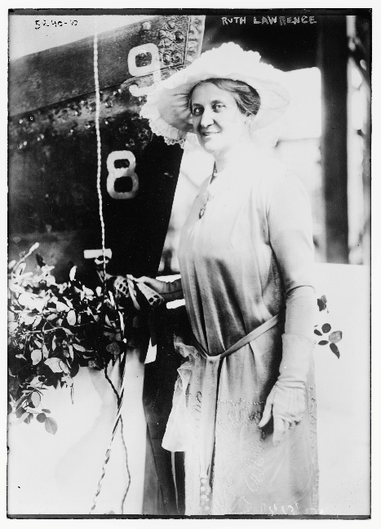
Parents: Abraham Riker Lawrence (1832–1917) and Eliza Miner (1838–1915)
Spouse: None recorded.
Children: None recorded.
Kinship: Sixth cousin four times removed of the post-World War II Smith generation
Ruth was a founder of the National Society of Colonial Dames in New York in 1893 and belonged to several historical societies: the Daughters of Cincinnati, Daughters of Founders and Patriots and Lords of the Manor. For many years Miss Lawrence was an editorial supervisor for books on Colonial families, published by National Americana Publications, Inc.
She christened the USS Lawrence in 1920 (above), was one of only five non-family members to inherit from Hetty Green, and, because of her fluency in several languages, served as a World War I censor. She died in the house purchased by her ancestor Major Thomas Lawrence in 1656.

Lawrence, Samuel (1767–1850)
Parents: Jonathan Lawrence (1737–1812) and Ruth Riker (1746–1818)
Spouse: Elizabeth Rogers (1771–1851)
Children: Judith Lawrence (1799–1805), Henry W. Lawrence (1800–1881), Judith Lawrence (? 1804–1828), Jonathan Lawrence (1807–1833), Richard Lawrence (1810–1881), Isabella Lawrence (1811– ), Adrianna L. Lawrence (1815–1895)
Kinship: Fourth cousin six times removed of the post-World War II Smith generation
Cayuta Lake Exploration
Samuel was the first Lawrence to see and explore the Cayuta Lake area in Tioga County, New York. He was accompanied by Judge Phineas Catlin, a locally prominent man. They camped along the lake shore. In the fall of 1814, Samuel and his brother Joseph traveled from New York City to Cayuta Lake, following a route that took them northward from Hoboken to Montgomery, across the Delaware River at Cohocton, through the "beech woods" to Great Bend on the Susquehanna, and up the Owego, Catatunk, and Cayuta Creeks through the Dutch Settlement to Johnson's Settlement. The journey took approximately two weeks. They remained at the lake until their homes were ready for occupancy.
Public Offices and Career
Samuel was appointed judge of the Marine Court of New York City and served in several public roles including member of the New York State Assembly (New York County) in 1811, and Clerk of New York County from 1811 to 1812. He moved to an estate on the margin of Cayuta Lake in 1814. He was a presidential elector in 1816, voting for James Monroe and Daniel D. Tompkins, and returned to the State Assembly in 1820–1821. Samuel was elected as an Adams–Clay Democratic–Republican to the 18th United States Congress, serving from March 4, 1823, to March 3, 1825.
Cayuta Lake Residences
Samuel and his brother Joseph built their houses in close proximity at Cayuta Lake. The house of Joseph, known as the Lake House, has remained largely unchanged. Samuel’s house was altered and enlarged, becoming the Fontainebleau Inn, set well off the road with a long driveway leading to the front entrance.

Lawrence, Samuel Adams (1775–1851)
Parents: David Lawrence (1737–1809) and Sybil Sterry (1742–1775)
Spouse: Catherine Remsen (1786–1867)
Children: Samuel Sterry Lawrence (1804–1876), Catherine Remsen Lawrence (1805–1875), Ferdinand Lawrence (1807–1893), John R. Lawrence (1807), Julia Lawrence (1809–1873), Henry Lawrence (1810–1879), John Remsen Lawrence II (1811–1834), Horace Lawrence (1814–1851), Charles David Lawrence (1817–1852), Maria Varick Lawrence (1819–1903), Eugene Lawrence (1823–1894)
Kinship: Second cousin six times removed of the post-World War II Smith generation
Career
Although he initially studied medicine, Samuel Adams Lawrence changed career paths. In The New York of Yesterday (1908), historian Hopper Striker Mott wrote, “He became an extensive importing and commission merchant, widely known and highly respected at home and abroad.” He was a partner in Augustine H. Lawrence & Co. and a director of several corporations and institutions.
Residences and Social Life
The Lawrences had a summer home in the Bloomingdale section of Manhattan on the upper west side of the island. Frequent guests included his close friend De Witt Clinton.
Philanthropy
Lawrence used his significant fortune for various causes. Hopper Striker Mott noted, “Ever ready with his means and efforts to ameliorate the condition of the poor, he was also a strong advocate of the cause of education as well as a munificent patron of the arts and sciences.”
Death
Samuel Adams Lawrence died in his West 19th Street house.

Lawrence, Sarah Ray “Dimple” (1884–1902)
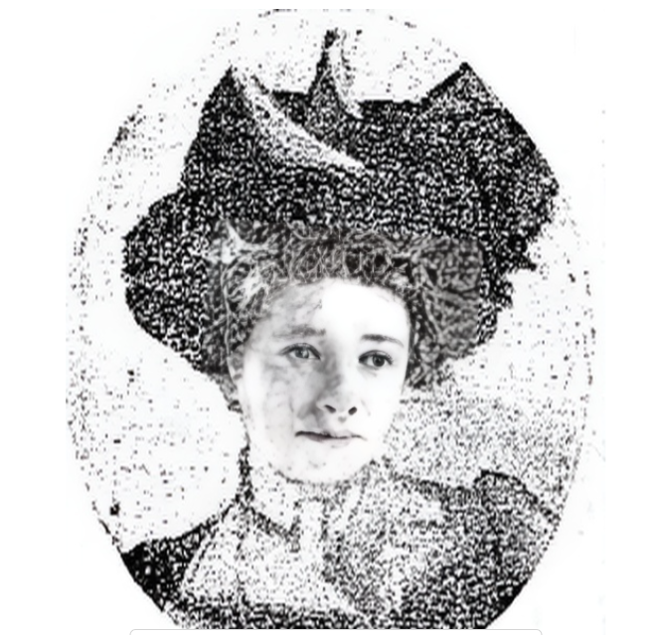

Parents: John Smith Lawrence II (1860–1903) and Sarah Ray Wynn (1864–1904).
Kinship: the seventh cousin three times removed of the post-World War II Smith generation.

Sarah Ray Lawrence seems to be the only member of the extended family who was either an alleged victim or alleged perpetrator of a murder. Therefore, I am including a detailed analysis, almost hour by hour, of the case.

Early Life
Dimple was her childhood name which stayed with her. Dimp, as everyone knew her, grew up in Lawrence, Long Island, which had been founded by her relatives. Her family later lived in Hempstead. She briefly attended a convent school in Mount Vernon.

Her somewhat mysterious death led to a newspaper feeding frenzy and several thousand articles nationwide, because the principals were from New York Society (not really), and involved wild young things, sex, and maybe murder.

Criminis personae
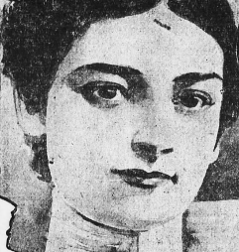
Sarah Ray “Dimple” Lawrence, 17. She was described as an “heiress,” and at home on the water. Her father at the trial said she was a good swimmer, although others said she could not swim.

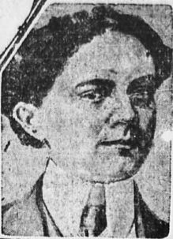
Clarence T. Foster, 23, lived in Center Moriches and in Good Ground in the summers. He was short, muscular, and dark, and an expert waterman, During the summers he sailed the house boats of local hotels. He was so expert that he was not allowed to compete in amateur yachting contests. He was a station agent and hotel clerk at Good Ground. He married Lelia Penney in March, 1902, over the strenuous objections of his bride’s parents.
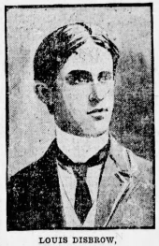
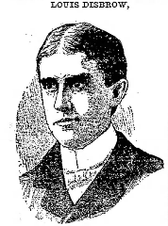
Louis A. Disbrow 25, was also “wealthy” but came from a non–old–money background. His father was a Fulton Market meat dealer and later a fertilizer manufacturer. He summered in Good Ground. There he met the sisters Edna and Jessie Evertt, whose father kept a livery stable in Jamaica. Around 1898 he married Jessie, who was then 15 years old. Disbrow had been working as a bookkeeper for Swift and Co., but quit his job when the couple went to live with her parents. They were soon separated when his father–in–law insisted that Disbrow find a job. Before he left the Everett household, he had an altercation with another man about his wife and shot the man in the arm. He spent summers in Good Ground, and he and his brothers raced bicycles on the Long Island roads.
Dr. John Nugent, Coroner in Good Ground
Livingston Smith, District Attorney for Southhampton
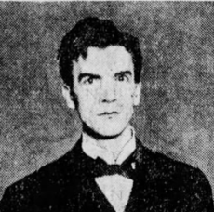
Rowland Miles, a political rival of Livingston Smith and the attorney for the accused Louis Disbrow

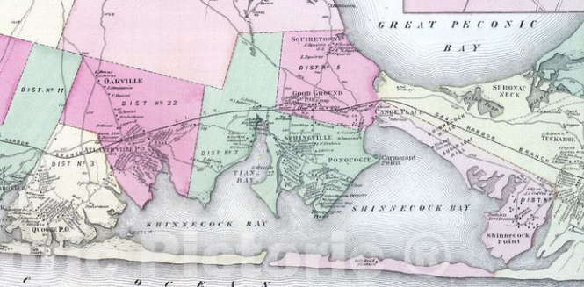

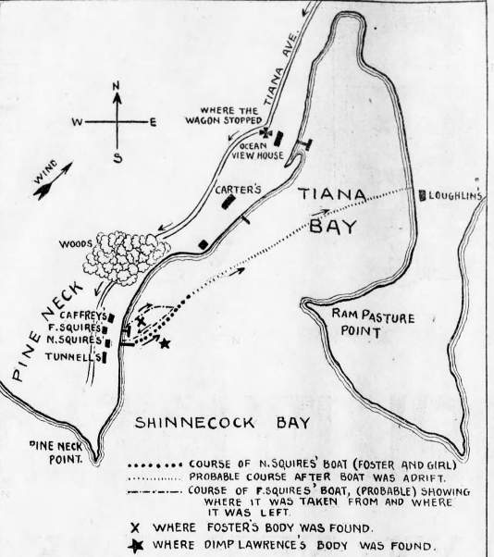
The Vicinity of the Two Deaths
Chronology
March 9, 1902. Clarence Foster married Leila B. Penney at the Methodist parsonage in Good Ground, Long Island. Her parents had strenuously opposed the marriage and did not learn of it until the witnesses told them.
Second week in May, 1902. Mrs. Lawrence and Dimp move into the Ocean View House in Good Ground, on Tianna Bay, an offshoot of Shinnecock Bay. They had spent summers here previously.
Nearby was the home of George Foster, to which Clarence Foster brought his bride for their honeymoon. But she was in poor health, and Clarence took many outings with Dimp.
End of May, 1902. Louis Disbrow arrives from Richmond Hill and took a room at Ternell’s Hotel. He too had been in the town in previous summers.
End of May, 1902. Dimp disappears from the hotel. Mrs. Lawrence summoned her husband from New York. His reply, it was said, was that he was tired of doing that sort of thing. Dimp returned and said she had been staying with relatives and friends. Foster was gone from Good Ground at the same time. It later turned out they were at Coney Island and Rockaway Beach, where they had their pictures taken together. One picture was found in Foster’s clothes after he was drowned. Desbrow was also a frequent visitor. Mr. Lawrence expressed strong disapproval of Desbrow.
Early June, 1902. Disbrow was staying at Ternell’s Hotel in Good Ground. Opposite his room was the room of Anna Pearsall. Another Pearsall was also in the same hotel
Sunday June 1, 1902. Miss Pearsall met Dimp at the hotel. Dimp had been out sailing and gotten soaked and asked to borrow a dry coat.
Monday, June 9, 1902. Foster arrived at the Ocean View Hotel and asked to take Dimp for a drive. Her mother initially said no, but eventually consented, if the Pearsalls went along. But the Pearsalls, mother and daughter, never went with them.
Foster and Dimp met Disbrow and dined with him the Hampton Pines Clubhouse, to which Disbrow had telegraphed several days previously to arrange a dinner for three.
Monday, June 9, around 11 PM. The three leave the Hampton Pines Clubhouse.
Tuesday, June 10, after midnight. The three drove from the Hampton Pines Clubhouse on Tiana Ave., which went past Ocean View House. Mrs. Lawrence heard a rig and went outside. She called out to her daughter, and she thought she saw her daughter and two men in the carriage, but without answering they drove swiftly by to Pine Neck Point, and went to Ternell’s Hotel, where Disbrow had a room.
Tuesday, June 10, small hours. Miss Pearsall about 2–3 AM heard Dimp’s voice and the familiar voice of Disbrow and another male voice. That voice said
“Well, Lou, I guess I’ll say goodbye.”
Disbrow responded: “All right, Clarence, tell ‘Dimp’ goodbye for me.”
Pearsall then heard a woman’s voice in the room.
But within a few minutes, 15 at most, Foster returned, and the two men began speaking heatedly, then they argued, and then she heard a scuffle and breaking china. Then one man left and slammed the door.
Pearsall then heard a man and woman talking, and heard the word boat and then heard the woman say, “All right, I’ll go if Lou goes too.” Pearsall watched the two men and the girl walk to the bayside. The girl seemed cheerful and there was no evidence of compulsion. The landing where the rowboat was kept was about 100 yards from the hotel. It was about a mile’s walk from Ternell’s Hotel to the Ocean View Hotel. There was no breeze on the bay; the wind did not pick up until 5:00 A.M.

Tuesday, June 10, 4:30 AM. John Carter, 19, who slept in a house 20 yards from where the skiff he was using was moored, later said he got up to go to work and found the boat gone. He saw “footprints on the sand near where the boat had been, these footprints indicating that there had been a violent conflict on the beach that night. He also observed that the footprints of a woman were intermingled with those of the men.” Carter said the skiff was leaky and could not have lasted half an hour with two people in it.
Tuesday, June 10, dawn. Pearsall was awakened by the front door of the hotel opening and heard Disbrow greet her dog which was in the hallway.
Tuesday, June 10, breakfast. Pearsall saw Disbrow at breakfast. He seemed nervous.
Tuesday, June 10, morning. Disbrow returned his horse and rig to the liveryman Wells and paid with a bad check, which he had been doing all over town. Wells mentioned to Disbrow that Mrs. Lawrence had reported her daughter missing. Disbrow said “I drove Clarence and Dimp to the Ocean View Hotel and there I left them. I drove this rig back to the Ternell House, and hitched the horse for the night.” Wells said that Disbrow looked normal and did not appear to have been in a fight.
Tuesday, June 10, 1902, 10:00 A.M. William Walton was at the station in Good Ground and expressing a wish to a friend that he could go to Quogue for the day but lacked the money. Disbrow came up and offered him the money for the fare. Foster was a station agent there; he had not shown up with the keys and the other agent Topping asked where Foster was. Disbrow told him that he had left Foster asleep after their party of the previous night.
Walton and Disbrow took a train to Quogue. There Disbrow passed another bad check to hire a rig to go to Eastport. There he sent a long telegram to Mrs. Lawrence : “I am sure that Dimp and Clarence are together, and I will not rest until I find them.”
Tuesday, June 10, morning. A flat–bottomed skiff belonging to the hotel was missing. It was later found adrift and half full of water. One broken oar was also found in it.
Tuesday, June 10, morning. There was another boat that had been beached near the missing skiff. Its owner, Frederick Squires, on Monday morning went to look for it, and discovered it had been moved to a dock near the Squires house. It had been beached only slightly and the footprints of one man led away from it.
Tuesday, June 10, late morning. Walton later said that he and Disbrow took the train to Quogue; there Disbrow cashed a check for $20 (it was bad); they hired a buggy to Eastport. Disbrow went to the station and sent a message to his estranged wife Jessie to meet him. She and her sister Edna drove to the station. They later reported that “he looked terrible. His face was scratched up and bruised. His clothing torn and he looked like he had been in a regular fight.” Disbrow and his estranged wife went off for a conversation. The wife’s family said this was what happened, but refused to elaborate. However, the father later said that the report that his son’s face was scratched and it looked like he had been in a fight was false.
Tuesday, June 10, afternoon and evening. Walton and Disbrow drank together and then went to a boarding house where they shared a room for the night.
Wednesday, June 11, 1902, 3 A. M. Walton later reported that he was awakened by Disbrow’s pacing the room. Walton asked, “What’s the matter?’ Disbrow replied: “I’m heartbroken…Foster won my girl away from me.” Disbrow then related how at Ternell’s Hotel, Foster called him to come down. “We had a fight on the beach, and Foster choked me. He did me bad. He was too much for me. Then he and Dimp went off in a rowboat, leaving me there.”
Wednesday, June 11, 1902, during the day. Dimp’s cap and lap robe were found halfway between Ocean View and Ternell’s; also found was a bottle of whiskey.
Saturday, June 14, daybreak. John Caffrey of the Life Saving Station was surveying the shore to see any damage from the last night’s gale. Near the shore, about 300 yards from where the rowboat had been moored, he saw the body of a man. He retrieved it and recognized it as Foster; it was discolored and for severe abrasions above the left eye.
Saturday, June 14, 8:00 A.M. The Coroner, Dr. John Nugent arrived and looked at the body. He did not examine it carefully, he later explained, because of the state of decomposition. Dr. T. T. Chattle was asked by newspapermen to look at the body. He saw an abrasion over an eye which could have been due to natural causes, as drowned bodies frequently strike against obstructions.

Shortly after that, the body, still wearing the clothes it was found in, was interred in the Methodist cemetery in Good Ground.

Saturday, June 14, 1902, 10:00 A.M. Willis Wells, the liveryman, was driving a party along the shore and saw another body about 50 yards from where Foster’s body was found. He recognized it as Dimp’s; he said there was not a mark on the body. He dissuaded Mrs. Lawrence from viewing it and sent it to an undertaker’s. Coroner Nugent returned and said he could not make a determination of accident or murder, but wanted to question Disbrow.
Saturday, June 14, 1902. Coroner Nugent rules the deaths accidental drownings. Foster relatives claim the pair were murdered. Foster’s mother claimed that Disbrow had kept her son drunk for two weeks before the night of his death.
Saturday, June 15, 1902. A man resembling Disbrow committed suicide by jumping off the Brooklyn Bridge. It was some time before it was determined it was not Disbrow.
Monday, June 16, 1902. Disbrow and his brothers showed up briefly at his parents’ house, but Disbrow went off again.
Monday, June 16, 1902. William Walton, 25, a painter in Good Ground, told the Coroner Dr. Nugent that he had spoken to Disbrow at Eastport. Disbrow told him there was a violent fight on the beach over the girl Dimp and that he, Disbrow, was worsted. Walton had told this story to some of his friends on Saturday night. Nugent said the story was significant, but that he did not know who the local district attorney was or how to contact him.
Monday, June 16, 1902. Charles Fremont Foster the father of Clarence Foster made a formal request that his son’s body be exhumed and an autopsy performed.
District Attorney Livingston Smith decided the case needed investigation and turned it over to the Pinkertons
Wednesday June 18, 1902. The body of Clarence Foster was exhumed. Coroner Nugent and Dr. Benjamin performed an autopsy and said there was no evidence of foul play. But the advanced decomposition of the body would have obliterated any cuts or abrasions.
Disbrow was said to have issued a statement through a friend. He admitted he had quarreled with Foster on the beach over Dimp. They fought and Foster knocked him senseless. When he came to Foster and Dimp were gone; he assumed they had eloped. He returned to his hotel and thought he should leave town soon to escape the consequences of all the bad checks he had passed. The statement was not confirmed.
Miles, Disbrow’s lawyer, issued a statement that his client would not appear at an inquest unless legally compelled.
District Attorney Livingston said there was not enough evidence to have Disbrow arrested on suspicion of murder.
Disbrow’s father and his attorney Miles paid off all the bad checks that Disbrow had passed in Good Ground, removing a reason to arrest Disbrow.
Thursday, June 25, 1902. Disbrow’s wife tries to serve papers on him for divorce, but his attorney, Rowland Miles, returns them.
Friday, June 27, 1902. A warrant was issued for Disbrow on suspicion of murder.
Saturday, June 28, 1902. Miles agrees to produce Disbrow on Tuesday morning.
June 30, 1902. Newspapers report that Dr. Chattle had examined Foster’s body when it was found. Chattle discovered a wound over the left eye which could have caused a concussion. Newspapers reported that when Miss Lawrences body was discovered, her face but not the rest of her body was black; that might indicate she had been strangled. This supposed fact was never brought up in court.
Tuesday, July 1, 1902. Disbrow arrived in Southampton with his attorney Miles and surrendered himself. The court and the district attorney were unprepared.
September 25, 1902. The Grand Jury of Suffolk County indicted Disbrow on 6 counts of murder of Clarence Foster. He pled not guilty. He was jailed.
Monday, January 12, 1903. The trial of Disbrow began.
The prosecution’s case was:
- Foster and Disbrow, both married men, were in love with Dimp Lawrence.
- They quarreled over her in the hotel.
- They fought over her on the beach.
- Disbrow, Foster, and Dimp got into the leaky boat and rowed toward Dimp’s hotel.
- They abandoned it and got into the second, better boat. (How?)
- Only one man returned to shore.
- Prosecution witness Dr. John H. Benjamin testified that the condition of the body indicated to him that Foster was dead when he entered the water.
- Foster had a cut above his eye when his body was found.
- Disbrow left town and behaved very strangely for several days.
- There was testimony about the fight on land but no eyewitness testimony about what happened afterwards.
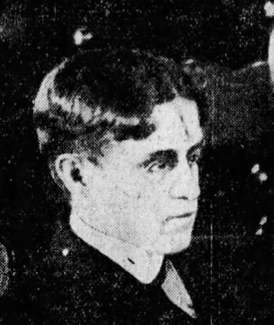
Disbrow in court
The defense responded:
- Under cross examination Dr. Benjamin he also said that medical experts would differ on how to interpret the condition of Foster’s body.
- Dr. William Scovill, the Disbrow family physician, testified that he had treated Disbrow on April 17 for a fractured arm, and in May for fractured ribs. When Scovill saw Disbrow on May 17, Disbrow was still disabled and could not raise his hand above his shoulder. It would take six months for his arm to heal. The accident was mentioned in a newspaper story of April 26, 1902.
- Harold Squires testified he had a fight with Foster the day before his death and hit him above the eye.
- Miles reminded the jury that this was a capital case and only circumstantial evidence tied Disbrow in any way to the two deaths, and that in such cases the laws of New York instructed the jury to give every benefit of the doubt to the defendant.
- Miles also denounced the yellow press for circulating falsities.
Friday, January 16, 1903, afternoon. The jury deliberated 40 minutes and returned a verdict of Not Guilty. The town of Southampton had not had a conviction for murder in 266 years.
Saturday, July 26, 1902. Mrs. Disbrow is granted an annulment of her marriage to Louis. The grounds were that she was only fifteen years old at the time of the marriage, which is under the age of consent. She had already resumed her maiden name Everett and her son was known as Everett.
The case was kept in the public eye for a while because of a series of deaths of the persons involved in it.
January 31, 1903. Louis Foster, age 19, the brother of Clarence Foster, disappeared while oystering on Tiana Bay. His boat was laden with oysters and a gust apparently capsized it.
February 2, 1903. Louis Foster’s body was found in the bay. His boots were off, indicating that he had removed them and attempted to swim to shore.
February 2, 1903. Louis’s and Clarence’s grandfather, Edward H. Foster, age 88, already ailing, died of shock upon receiving the news of his grandson’s death.
March 31, 1903. Charles T. Bellows, a cousin of Clarence Foster, while oystering drowned in Tiana Bay within sight of his home.
April 1, 1903. John Smith Lawrence II, the father of Dimples Lawrence, had gone into a rapid decline after the death of his daughter; he died of asthma.
August 8, 1903. The widow of Clarence Foster, Lilia Belle Penny Foster, married George B. Brown in Bellport, Long Island.
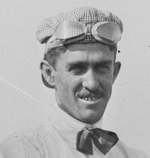
December 17, 1904. Mrs. John Smith Lawrence (Sarah Ray Wynn), age 40, died in Philadelphia.
Louis Disbrow (1876–1939) after the trial was hired as a chauffeur mechanic for Joan Newton Cuneo, a race car driver. Disbrow became a professional race car driver and raced in four Indianapolis 500s. He married Mary Meighan and died at the age of 62 in 1939.
Misinformation c. 1900
There were thousands of articles all over the country about this sordid affair. These were the Gilded Youth of Society, maybe in a ménage à trois, misbehaving and even murdering.

The Brooklyn Eagle was a reputable paper, and on June 19 it decided it was necessary to preach a little.
\ “The first province of a newspaper is to print the news. This is a truism which, in these days of sensation–mongering, may be repeated definitely to the benefit of all and to the detriment of none. Nothing is gained by the distortion of fact or by the magnification of the unimportant.
“Certain newspapers … are more than anxious that the lamentable tragedy at Good Ground should turn out to have been a double murder.
“But supposing that Clarence Foster and Sarah Lawrence were murdered, what is the use of lending a fictitious interest to the case by misstatement. Foster has been described as an ‘amateur yachtsman’ of such extraordinary skill that he was invariably barred out of all club contests on Shinnecock Bay. Miss Lawrence was described as a ‘great beauty’ and an ‘heiress.’ Both were ‘fearless’ and ‘skillful’ swimmers; therefore they could not have been accidentally drowned, and so on until the unintelligent reader lost sight of the most obvious explanation of the miserable affair, that a drunken baymen afloat in a leaky boat was unable to save either himself or his companion from the effects of an unexpected capsize. Foster was not an ‘amateur yachtsman,’ with all the social status that the name implies. He made his living largely by sailing as the servant of others, and for this reason, and not because he was so expert at handling tiller or sheets, was he debarred from competitions limited to those who were amateurs within the accepted meaning of the term. He was just an ordinary swimmer, too, and Sarah Lawrence could not swim a stroke, so that death by drowning was quite possible, and, in fact, quite likely, under the known circumstances of the case. Miss Lawrence was not a beauty and she was not an heiress, and the attempt to make her either or both belongs to the category of misdirected effort mainly responsible for the delusion of that part of the public which daily invests faith and money in the purchase of yellow journals.”

The most egregious example was the story that got circulated about a supposed eyewitness: “A bayman named Otto Schwanecke later said that he was sleeping in a boat when he was awaked by the cries of men. From the cockpit of his catboat he saw two rowboats on the water. Each contained a man; they were fighting. One contained a woman; she was screaming for her companion to sit down before he capsized the boat, Schwanecke then saw an oar flash across the woman’s head and hit her companion on the forehead. He fell into the water. Schwanecke cowered from fear in the cockpit. When it was quiet he looked up and saw an empty boat floating. Shortly he saw a man rowing toward shore; he beached his boat and ran into the trees.”

There was no such person and no such catboat. The story is a total fabrication.

Disbrow was tried and acquitted after a 40–minute deliberation by the jury. His doctor testified that he had a serious arm injury and had difficulty moving that arm.

But he had been tried and convicted in the press, and the millions who had read it never got the truth, and probably assumed that Society had protected its own.

My Take
I suspect that on the night of the drownings, Disbrow knew that Foster and Dimps had died, and that he would be blamed for it, if only because of the fight that immediately preceded their deaths. Perhaps he saw the boat sink and heard cries for help; with only one good arm he could not row out to them.

Disbrow decided to get out of town before he was questioned. He met with Rowland Miles, his lawyer, who told him to say nothing, because any inconsistencies would be pounced upon; Miles also told him not to return to Good Ground unless he was legally compelled to do so.

Miles also told him not to testify at the trial: there was no need to, and it would only open him to cross examination.

Lawrence, Thomas (1588/89–1624/25)
Parents: —
Spouse: Joane Antrobus (1592–1661)
Children: John Lawrence (1618–1699), Thomas Lawrence (1619–1703), William Lawrence (1622–1680), Jane Antrobus Lawrence (1614–1680), Mary Lawrence (1625–1715)
Kinship: Ninth great-grandfather of the post-World War II Smith generation
Thomas Lawrence is the earliest identified ancestor of the post-World War II Smith generation. After his death, his widow Joane later remarried John Tuttell, who accompanied her and her sons to the Massachusetts Bay Colony aboard the Planter in 1635. This migration established the Lawrence family in America.

Lawrence, Thomas (1619/20–1703)
Major
Parents: Thomas Lawrence (1588–1624/25) and Joane Antrobus (1592–1661)
Spouse: (1) Name not preserved; (2) Mary Ferguson
Children: William (by first wife); by Mary Ferguson: Thomas (1644–1703), Elizabeth (165?–1683), Martha (1653–1699), Jonathan (1659–1729)
Kinship: Eighth great-granduncle of the post–World War II Smith generation
Early Life and Emigration
Thomas Lawrence was among the earliest members of the Lawrence family to arrive in North America. In 1635, he sailed on the Planter with his mother, her second husband John Tuttell, and his brother. The family first settled in Ipswich, Massachusetts, before relocating to Long Island.
Settlement and Landholding
By 1644, Thomas had become one of the original patentees of Hempstead under a land grant from Dutch Governor Willem Kieft. This marked the beginning of his long association with landownership and civic affairs on Long Island. He later settled in Newtown, Queens County, where he developed into a prominent landowner and farmer.
Civic and Legal Activity
Thomas played an active role in establishing and securing the civic structure of early Long Island communities. He participated in town governance, property distribution, and boundary organization. His involvement in regional affairs occasionally led to legal entanglements, including a 1651 incident in New Haven regarding funds belonging to Governor Peter Stuyvesant, indicating his participation in regional trade and financial matters.
Military Service
By 1690, he had been commissioned as Major of Horse for Queens County. His appointment reflected both his local standing and his capabilities as a militia leader during a period when Long Island towns relied heavily on local defense forces.
Political Alignment
Thomas supported Jacob Leisler during Leisler’s Rebellion (1689–1691), aligning himself with the Protestant settler faction challenging the appointed colonial administration of New York. His stance placed him within the populist faction opposing the established mercantile and political elite.
Family and Later Life
Of his known children, the lines of his daughters Elizabeth and Martha appear to have ended, while his sons continued the family’s presence on Long Island. After Thomas’s death, his widow Mary Ferguson reportedly encountered difficulties with her stepson William concerning family property.
Legacy
Thomas Lawrence’s role as an early settler, landowner, town official, and militia officer helped establish the Lawrence family’s continuing prominence on Long Island. His civic, military, and political involvement contributed to shaping the early development of Queens County and the Long Island communities in which his descendants remained influential for generations.

Lawrence, Thomas (1733–1817)
Captain

Parents: John Lawrence (1695–1765) and Patience Sackett (1701–1772)
Spouse: Elizabeth Fish (1741–1822)
Children: Nathaniel Lawrence (1761–1797), John Lawrence (1763–1768), Sarah Lawrence (1765–1838), Patience Lawrence (1767–1768), Thomas Lawrence (177–1825), Mary Lawrence (1773–1818), Elizabeth Lawrence (1775–1812), Jane Lawrence (1775–1838), William Lawrence (1773–1804), Jane Fish Lawrence (1785–1814)
Kinship: Third cousin seven times removed of the post-World War II Smith generation

Thomas Lawrence pursued both military and civic careers. At twenty-five, he was appointed captain of the Tartar, serving in the French war, demonstrating early leadership and maritime skill. After his military service, he settled on a farm overlooking Flushing Bay, where he managed agricultural operations while maintaining an active role in the local community. In 1784, he was appointed a judge of Queens County, a position he held with distinction, overseeing legal matters in the growing community.

Lawrence, Thomas S. (1819–1902)
Parents: Thomas Lawrence (1776–1848) and Thamer Fisher (1775–1870)
Spouse: (1) Ellen Alker Fenno (1819–1872), (2) Leila Augusta Kane (1852–1887), (3) Catherine Ferris (1823– )
Children: Ellen Lawrence (1852–?), William Fenno Lawrence (1856–1939), Gilbert Fenno Lawrence (1859–?), Thomas Everit Lawrence (1874–1939), Leila Marie Lawrence (1875–1915)
Kinship: Fifth cousin five times removed of the post-World War II Smith generation

Early Life and Family Background
Thomas Lawrence was born on May 16, 1819, at his father’s house on Grand Street in New York City, in a family steeped in civic and military service. His paternal grandfather had served in the Continental Army, rising to Lieutenant Commander, while his maternal grandfather, Gilbert Fisher, fought with the “Minute Men” and scouts during the Revolutionary War under Major Jonathan Paulding Norton. His upbringing combined urban and rural influences, alternating between his father’s properties in New York City and his maternal family’s farm at Mount Pleasant, Sing Sing.
Thomas’s youth was marked by rigorous educational opportunities: he attended district schools, private academies, and Mount Pleasant Academy. His early work experience ranged from clerical roles in a law office to teaching and even employment in a jewelry store, reflecting the varied professional paths often pursued by ambitious young men in mid-19th-century New York.
Move to Illinois and Early Career
In 1842, in response to ill health, Thomas relocated to Clayton, Illinois, in the Mississippi River region. There, he embraced a pioneer’s life, engaging in surveying, farming, teaching, and running a mail stage. He traveled extensively, even venturing to Cincinnati by steamboat. These formative years instilled in him resilience and adaptability, traits that would define his later legal and civic career.
Returning to New York in 1846, Thomas managed his father’s farm while resuming legal studies under the mentorship of Smith & Barker. By 1852, he was admitted to the bar, embarking on a career that combined private practice with civic engagement.
Legal Career and Civic Service
Thomas Lawrence built a distinguished career in law, serving as attorney for institutions such as the Irving Building and Mutual Loan Association and Citizens Mutual Loan Association. He was elected to the New York State Assembly and subsequently served as District Attorney of Rockland County for four years. He also held the office of Justice of the Peace and frequently acted as referee or surrogate, exemplifying a commitment to both judicial process and community governance.
His civic engagement extended to fraternal organizations. A member of the Odd Fellows, Thomas rose to the position of Grand Patriarch of the Grand Encampment of New York State, reflecting his stature in the social and civic networks of the era.
Political Views and Civic Engagement
Thomas Lawrence was a committed Jeffersonian Democrat, reflecting the political traditions of both his grandfathers. He strongly opposed Abraham Lincoln’s policies during the Civil War and organized Peace Meetings advocating for Southern interests. These actions drew criticism and threats of imprisonment or lynching, demonstrating the intensity of political partisanship in mid-19th-century America.
Here is an article on Thomas S. Lawrence’s Peace Meeting in Schaalenberg, Bergen County, New Jersey, July 30th, 1861 (Bedford (Pennsylvania) Gazette, August 9, 1861):
“Northern Conservatism! Common Sense Reviving! A Gleam of Hope for the Country
An immense and enthusiastic Democratic Peace Meeting was held at Schaalenberg, Bergen County, New Jersey, Tuesday afternoon, July 30th. The meeting was called to order by N. H. Blauvelt, Esq., who nominated the Hon. Ralph Demarest for President. The meeting was addressed by Thos. S. Lawrence, Esq., and Thomas Dunn English. The following resolutions were unanimously adopted:
- Resolved, That as citizens of the State of New Jersey, a sovereignty always faithful to the compact which she entered into with the other States, her peers, and which has always strictly sustained the Constitution, we are loyal to the General Government to the full extent of its limited and specified powers, and devoted to that Union which was founded on the consent of its creators, and ratified by the several States, its members.
- Resolved, That loyalty to the Union is only compatible with strict fidelity to the Constitution, and that those who violate the provisions of the latter, even under the hypocritical pretense of preserving the former, are enemies to be confronted and resisted.
- Resolved, That we firmly protest against the attempts made, under color of the tyrant’s excuse, “necessity,” to consolidate this government, to reduce the rights of States to subjection, and to rob free white citizens, for whom this government was formed, of their constitutional rights and privileges.
- Resolved, That the Union being based on the consent of States, and the good will of the people, cannot be preserved by the bayonet and sword of the soldier, and that the result of continued civil war can only be permanent dissolution of a Union which, up to this period, was a blessing to the people, and which would continue to be so throughout all time if administered according to its true spirit and intent.
- Resolved, That we charge the awful responsibility for the pending Civil War, for all its sacrifice of valuable lives, its lavish waste of treasure, and the deadly blow it has stricken at our prosperity as a people—upon the agitators in the hearts of all; and that a spirit of brotherly love (the only safeguard of liberty) should once more assume its sway in the Councils of the Nation.
- Resolved, That we as wives, mothers, and sisters, are ever ready to sacrifice all that we hold dear on earth, upon the altar of our common country; but we cannot believe that a war like the present can ever reconstruct the Union, that glorious inheritance of our fathers, that gem of liberty for which they shed the best and purest blood that ever animated life, that they might leave to their posterity this priceless boon of freedom.
- Resolved, That we believe with the lamented Douglas “that War is Disunion, certain, irrevocable, and eternal separation;” and that peace, reconciliation, and compromise, are the only honorable means by which the Union can be saved, the government maintained, and the laws enforced, and to secure these happy results we pledge our unceasing and undivided efforts, believing that whatever the public feeling may be at present, the time will come when all humanity will applaud the course of those who now advocate Peace to our country.
After the adoption of these resolutions, the band struck up a few lively tunes, and the crowd dispersed. The utmost good feeling prevailed throughout the entire proceedings.”
His advocacy for peace exposed him to threats of imprisonment and violence but highlighted his commitment to principle over personal safety.
Marriages and Family Life
Thomas married three times over the course of his life. His first marriage to Ellen Alker Fenno in 1850 produced three children, though he was widowed in 1872. In 1873, he married Leila Augusta Kane and relocated to Virginia for health reasons. During this period, he temporarily abandoned the practice of law to focus on farming and edited the weekly newspaper Rural Messenger. After Leila’s death in 1887, he married Catherine Ferris in 1888, consolidating family and social connections. His children pursued varied professional paths, sustaining the Lawrence family’s influence in New York society.

Lawrence, Townsend Bowne (1871-1951)

Parents: Walter Bowne Lawrence (1839 and Annie Townsend.
Spouse: (1) Herminia Barnes (1874–1913), 12 September 1912; (2) Caroline Lawrence Bogert (1881–1942), 10 June 1915.
Children: With Herminia Barnes: David Lawrence (1913–1913); Adopted: Gordon Brown (son of Caroline Lawrence Bogert by her first marriage to Francis Gordon Brown, Jr.).
Kinship: Third cousin three times removed of the post–World War II Smith generation.

Education and Military Service
Townsend Bowne Lawrence graduated from Harvard University in 1894. On 15 January 1896 he enlisted in Troop 2, Squadron A Cavalry, New York City. He was transferred on 21 November 1896 to Troop 1 of the same squadron and was mustered into Troop A, New York Volunteer Cavalry, on 20 May 1898 at Camp Black, Hempstead, Long Island.

On 6 July 1898 he was commissioned a First Lieutenant in the 2nd United States Volunteer Engineers and assigned as aide to Major General Oswald H. Ernst. Lawrence participated in the Puerto Rico campaign, landing at Ponce in August 1898 and accompanying General Wilson’s column to Coamo. On 14 August 1898, the day following the signing of the Protocol of Peace, he entered the Spanish lines under a flag of truce, becoming the first American officer to inspect the Spanish positions at Aibonito.

When Major General Ernst was appointed Inspector General of Cuba on 13 December 1898, Lieutenant Lawrence accompanied him and served in Cuba until returning to the United States in April 1899. He resigned from volunteer service on 26 May 1899, rejoined Squadron A, and was honorably discharged on 29 September 1899.

During his service in Squadron A he served alongside two relatives: Francis Draper Bowne (1894–1904; 1909–1914) and Thomas Nisbet Lee (1896–1898).

Marriage and Family Life
Townsend Lawrence fell in love with his sister Anita Lawrence’s social secretary, Herminia Barnes, an Englishwoman. They were married at the Church of the Transfiguration (“the Little Church Around the Corner”) on 12 September 1912 and made their home at Willow Bank, the ancestral Lawrence residence.

Herminia Lawrence died suddenly on 15 May 1913 while giving birth to their son, David Lawrence, who also died at birth. Both Herminia and Anita Lawrence were members of a faith-healing group. Although other deaths were reportedly associated with this group, there is no direct evidence that faith-healing practices contributed to the deaths of Herminia or her child.

On 10 June 1915 Townsend married his distant cousin Caroline Lawrence Bogert, widow of Francis Gordon Brown, Jr., and daughter of Henry L. Bogert. The marriage took place at the Church of the Heavenly Rest in Manhattan. Lawrence adopted Caroline’s son, Gordon Brown, who thereafter bore the Lawrence name.

Career and Interests
Lawrence worked as a stockbroker, a profession that appears frequently among members of the Lawrence family in this period.

He was an enthusiastic amateur photographer and an avid outdoorsman, particularly fond of moose hunting in New Brunswick. He once reported photographic evidence placing him close enough to observe the movement of a moose’s eyelids. He was also a devoted golfer, pursuing the sport with sufficient intensity that he suffered injury during play.

Clubs and Associations
Townsend Bowne Lawrence was a member of the Union Club, Knickerbocker Club, Harvard Club, Squadron A Club, the St. Nicholas Society, and the Turf and Field Club.

Lawrence, Virginia Lee (1864–1891)
Parents: Frederick Newbold Lawrence (1834–1916) and Elizabeth Miller Boyce (1835–1894).
Spouse: Louis Meredith Howland (1855–1921) on December 19, 1883, at St. George’s Church, Bayside, Long Island.
Children: Elizabeth Lawrence Howland (1885–1973), Hortense Howland (1886–1975), and Nathalie Mary Howland (1887–1931).
Kinship: Great-grandaunt of the post–World War II Smith generation.
Early Life and Family Background
Virginia Lee Lawrence was born into the prominent Lawrence family of Bayside, Long Island, and was raised within the social world of New York’s established merchant families. Her father, Frederick Newbold Lawrence, was a leading figure in Long Island society; her mother, Elizabeth Miller Boyce, came from a respected New York family.
Marriage and Wedding Celebrations
Virginia’s marriage to Louis Meredith Howland was celebrated with notable elegance and social distinction. Despite snow and wind, the church was filled with guests brought from New York City by special train. Her gown of white satin was overlaid with old family point lace, and her point lace veil—an heirloom—was secured by a diamond star gifted by her mother. The veil remained in the family and was worn by her mother and by a later descendant at their weddings.
After the ceremony, guests returned by special train to the Lawrence homestead for a reception. The house was decorated with holly and cedars, and the parlors displayed the many wedding gifts. Among them were a thousand-dollar bill from the groom’s father and five hundred dollars from the bride’s father. Mr. Roosevelt, the best man, presented a repoussé silver tête-à-tête tea set.
Social Connections
The guest list included numerous Lawrences (a prolific family), as well as Townsends, Embrees, Schencks, and other leading families of Long Island and New York. The event served as a major gathering of the interconnected Lawrence-Townsend-Embree-Schenck social circle.
Later Life and Death
Virginia enjoyed only ten years of married life. She died in 1891, leaving three young daughters. She is buried in the Lawrence Cemetery in Bayside.

Lawrence, Walter (1781–1872)
Parents: Joseph Lawrence (1741–1813) and his second wife, Susan Eaton (c. 1750–1796).
Spouse: Jane Stuart (1764–1815), widow of Captain Robert S. Packard, and only daughter of Archibald Stuart, merchant of Providence.
Children: John S. Lawrence (1802–1858), William Henry Lawrence (1803–1803), Archibald Stuart Lawrence (1806–1831), Caroline S. Lawrence (1808–1809), Charles S. Lawrence (1810–1827), and Adeline M. Lawrence (1813–1852).
Kinship: Fourth great-great-granduncle of the post–World War II Smith generation.
Early Life and Naval Service
Walter Lawrence expressed a desire to follow the sea from an early age. Through the influence of his father’s friends, he obtained a warrant as a midshipman in the United States Navy and served aboard the frigate George Washington in 1800–1801. The vessel, under the command of Captain William Bainbridge, was bound for Algiers during a period of tense diplomatic relations and early American naval activity in the Mediterranean.
Marriage and Family
After his return from naval service, Walter married Jane Stuart, the widow of Captain Robert S. Packard. Jane was the only daughter of Archibald Stuart, a merchant of Providence. Walter and Jane had six children, though several died young, a common occurrence in the early nineteenth century. Their surviving son, John S. Lawrence, lived to adulthood.
Later Life
Walter lived a long life spanning the tumultuous early national and antebellum periods of the United States, outliving all but one of his children. He died in 1872 at the advanced age of ninety-one.

Lawrence, Walter Bowne (1839–1912)
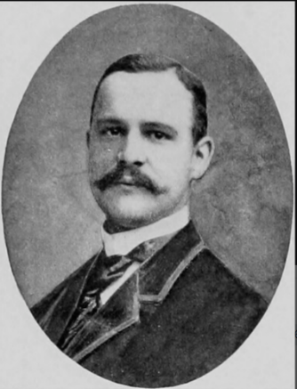

Parents: John Watson Lawrence (1800–1888) and Mary King Bowne (1808–1874).
Spouse: E. Annie Townsend.
Children: Annette “Anita” Townsend Lawrence (1867–1922), John Watson Lawrence (1868–1895), and Townsend Bowne Lawrence (1871–1951).
Kinship: Second cousin four times removed of the post–World War II Smith generation.
Early Life and Education
Walter Bowne Lawrence was born into two prominent old New York families. Through his father he descended from the Bayside Lawrences; through his mother he descended from the Bowne and King families of Flushing, which included Quaker leader John Bowne (1627–1695) and New York City Mayor Walter Bowne (1770–1846). He graduated from Columbia College in 1861.
Career
Walter pursued a career in finance and became a respected leader in New York’s financial community. He served as president of the New York Stock Exchange, a position that placed him among the leading figures of Wall Street in the late nineteenth century, a period of consolidating markets, railroad expansion, and emerging regulatory frameworks. His role suggests a reputation for probity and sound judgment within the financial sector.
Residences and Estate
At his death in 1912, Walter’s estate was valued at approximately $220,000 (about $7 million in 2024 dollars). He left his residence, known as Sothe House, to his son. His property holdings reflect the stability and influence of the Lawrence–Bowne family network during this era.
Family Connections
Walter’s marriage to E. Annie Townsend strengthened long-standing ties among the Lawrence, Bowne, and Townsend families, three interrelated Quaker-origin lineages long prominent in New York. His children continued these social and familial connections, though his elder son, John Watson Lawrence, died young at age 27.

Lawrence, Watson Effingham (1788–1872)
Parents: Effingham Lawrence (1760–1800) and Elizabeth Watson (1763–1852).
Spouse: Augusta Maria Nicoll (1792–1864), great-granddaughter of William Nicoll, the original patentee of Islip, Long Island.
Children: Jane Nicoll Lawrence (1810–after 1870), Elizabeth Watson Lawrence (1814–1867), Edward M. Lawrence (1815–after 1860), John Nicoll Lawrence (1816–1817), Augusta Nicoll Lawrence (1818–1820), Charlotte Augusta Lawrence (1823–1858), Watson Augustus Lawrence (1825–1841), Mary Yallman Lawrence (1828–1909), Emma Augusta Lawrence (1832–1902), Charles Edward Lawrence (1836–1907), and Ann Watson Lawrence (1839–1898).
Kinship: First cousin five times removed of the post–World War II Smith generation.
Early Life and Inheritance
Watson Effingham Lawrence inherited a substantial fortune from his branch of the Lawrence family of Flushing. His lineage connected him to both the Long Island Lawrences and, through his marriage, to the influential Nicoll family, long prominent as landowners and public officials in Suffolk County.
Public Service
He served as a magistrate of Flushing, a position reflecting both his family’s standing and his personal reputation for judgment and civic responsibility. He held this office until 1825, when he relocated to New York City.
Industrial and Land Development Ventures
Seeking new investments beyond inherited land and securities, Watson purchased extensive property in Ulster County along the Hudson River. Recognizing the growing demand for hydraulic cement—particularly with the boom in canal, bridge, and public-works construction—he established cement works on his land.
His operations produced what was then known as “natural hydraulic cement,” similar to that used in major regional infrastructure projects. Lawrence demonstrated unusually progressive employer practices for the era: he built housing for his workers and laid out a small company town that he named Lawrenceville. With the mill, quarrying operations, housing, and supporting trades, Lawrenceville grew into a local industrial center.
Wealth and Later Years
His cement enterprise proved highly successful, and by the mid-nineteenth century he was regarded as the wealthiest citizen in that part of the State. His investments in land, industrial production, and local development created a durable family fortune that carried into the next generation. He remained active in his business interests into old age and lived to 84.

Lawrence, William (c. 1622–1680)
The Settler
Parents: Thomas Lawrence (d. 1625) and (probably) his first, unnamed wife; after his father’s death he was raised by his stepmother, Joan Antrobus, who married John Tuttell.
Spouse: (1) [name unknown], by whom he had at least two sons; (2) Elizabeth Smith (m. 1664), widow of Richard Smith of Smithtown.
Children: By first wife: John Lawrence and William Lawrence; with Elizabeth Smith: Mary Lawrence (b. 1665), and possibly other daughters named in some secondary accounts.
Kinship: Eighth great-grandfather of the post–World War II Smith generation.
Origins and Migration
Born in England, probably in 1622, William Lawrence was the son of Thomas Lawrence and Thomas’s first wife, whose name has not survived. William was baptized on 28 July 1622 at the Abbey Church of Saint Alban in St. Albans, Hertfordshire, England. Thomas died when William was still a small child, and William was raised by his mother Joan Antrobus, who had married
In April, 1635, he departed Plymouth, England, aboard the Planter with his brothers John and Thomas and arrived at Plymouth, Massachusetts. By 1645 he moved to New Netherland, settling on Long Island, where he would establish himself as one of the most substantial landowners and civic leaders of Flushing.
Landholdings and Settlement
Lawrence received a grant of approximately 900 acres from the Dutch authorities at Flushing and became one of the patentees of Flushing, Long Island, in 1645. His principal estate lay at Tew’s Neck, later known as Lawrence’s Neck, an extensive peninsula projecting into Long Island Sound, today known as College Point. Additional holdings included land at Whitestone, parcels in the center of Flushing—where he likely operated a retail shop—acreage in Newtown, meadows across the Sound in Westchester, land near Smithtown, and property in lower Manhattan, including a warehouse.
Public Service and Office
William Lawrence played a central role in the civil and military life of early Queens County. He served as a deputy to the council in 1657, was one of the eighteen original incorporators of the town of Flushing in 1665, and was appointed Captain of the Queens County Militia the same year. In 1673 he served as schout, or sheriff, of Flushing. During the Dutch reconquest of New York in 1672–1673, Lawrence was one of two Englishmen selected to administer the oath of allegiance on Long Island, reflecting the confidence placed in him by the authorities.
Relations with New Netherland Authorities
Surviving correspondence between William Lawrence and Director-General Pieter Stuyvesant shows that Lawrence was a respected intermediary between New Netherland and Connecticut, particularly on questions of jurisdiction over western Long Island. Along with his brother, he acted as a key liaison during periods of political uncertainty and transition.
Religious Affiliation and Quaker Connections
Evidence strongly suggests that William Lawrence was a member of the Society of Friends. His second marriage, in 1664, to Elizabeth Smith, daughter of the Quaker leader Richard Smith of Smithtown, further embedded him within Long Island’s Quaker network. His eldest son, Major William Lawrence, was also an active Friend and served as a record keeper for the local monthly meeting. When Lawrence’s estate was assessed after his death, John Bowne, one of the most prominent Quakers in Flushing, was appointed as one of the overseers.
Death and Estate Administration
William Lawrence died intestate on 14 March 1680. Under the Duke’s Laws of 1665, an inventory of his estate was required within forty-eight hours of the official inquiry into his death. Because of the scale and complexity of his holdings, the inventory and appraisal were conducted over several days by Richard Cornell, John Bowne, John Lawrence, and Abraham Whearly. His widow Elizabeth and his eldest son William were appointed administrators and granted full legal authority to manage, divide, and dispose of the estate.
Wealth and Material Culture
The estate inventory portrays Lawrence as a gentleman planter of considerable wealth. His personal apparel included a waterproof coat, wool suits and cloaks, and a beaver fur hat—practical but substantial clothing suitable for a prosperous Quaker merchant. The total assessed value of his lands, chattels, and effects amounted to £4,432:01:10½, a very large sum for 1680. Although the absence of a detailed list of debts and credits limits precise interpretation, Lawrence was almost certainly among the richest men in the colony and one of the largest proprietors in the region, owning well over 800 acres.
The inventories are unusually informative, itemizing rooms individually and recording the type, quality, color, and material of household goods. The appraisers acknowledged that some small or low-value items were omitted by mutual consent, and others likely belonged to Elizabeth Lawrence as marriage goods and were therefore excluded.
Enslaved and Indentured Labor
At his death, William Lawrence owned ten enslaved Africans valued at £285: John, Tommy, Harry, Mingo, Peter, Jane, Sue, Ned, and a “mulatto boy” named Harry, most of whom likely arrived via trade with the West Indies. He also held one Native American boy named Phillip at his Manhattan warehouse. Ownership of eleven enslaved persons placed Lawrence well above the norm in Flushing, where, according to the 1698 census, 113 enslaved Africans lived among 530 European inhabitants, and most farmers owned fewer than five.
In addition, Lawrence employed one indentured servant, an English boy named Bishop, valued at £5, with a term of “a yeare & some months.” Restrictions under the Duke’s Laws and the difficulty of attracting white indentured labor to New Netherland contributed to the colony’s reliance on slave labor.
Legacy
William Lawrence appears to be the principal progenitor from whom the major Lawrence lines of this family descend, not only in North America but also in England, Tasmania, and Australia. Through land, office, religious affiliation, and family alliances, he established a lineage that would remain prominent for generations in the Atlantic world.

Lawrence, William (1776–1848)
Parents: Thomas Lawrence (1731–1804) and Elizabeth Hadley (1737–1825).
Spouse: Thamar Fisher (1775–1870).
Children: Horatio Gates Lawrence (1794–1870), Edward W. Lawrence (1795–), Caroline S. Lawrence (1803–), Thamar Ann Bell Lawrence (1805–1855), Napoleon Bonaparte Lawrence (1809–1851), and Thomas Lawrence (1819–1902).
Kinship: Fourth cousin six times removed of the post–World War II Smith generation.
Early Life and Marriage
William Lawrence grew up in a Quaker-connected Long Island family. His future wife, Thamar Fisher of North Castle, Westchester County, eloped with him at age nineteen on August 15, 1795, and the couple settled in New York City. Despite the unconventional beginning, the marriage proved long and stable, producing six children.
Pioneer in American Pharmaceutical Manufacturing
William Lawrence is credited with being the first manufacturing druggist in North America. Prior to the 1790s, most medicines sold in America were imported or compounded in small batches by apothecaries. Lawrence established a business that produced drugs, medicinal compounds, and chemical preparations on a larger, commercial scale. His enterprise helped transition the American pharmaceutical trade from small-shop apothecary work to industrial-scale manufacture, and he became well known in New York mercantile circles for the quality of his products.
Military Service
During the War of 1812, he served in the New York forces (traditionally identified with the city militia or state levies). His service occurred during a period of significant vulnerability for New York City, particularly surrounding the 1814 coastal defense measures.
Later Career and Public Standing
By the 1820s and 1830s, Lawrence had established himself as a respected figure in the commercial community of New York City. His business interests in drug manufacturing, and possibly in related mercantile ventures, continued into his later years. He lived to the age of seventy-two, while his wife Thamar survived him by more than two decades, reaching ninety-five.

Lawrence, William (1823–1898)
Parents: William Effingham Lawrence (1782–1841) and of Mary Ann George Smither (1797–1880).
Spouse: Mary Isabella Lannon (1839–1875)
Children: Alfred William Lawrence (1862–1900), Cornelius Henry Lawrence (1864–1940), Maria Jane Lawence (1866–1926), Harriet Lawrence (1868–1943), Robert Effingham Lawrence (1869–1939), George Lawrence (1870–1943), Mary Isabella Lawrence (1872–1945), and Mary Jane Lawrence (1878–1926).
Kinship: Second cousin five times removed of the post-World War II Smith generation.

William Lawrence was born in Tasmania. He inherited the family estate Formosa when his brother died, but never lived there. He travelled extensively in Europe during 1851–1855. He married Mary Isabella Lannon in St. John’s Church, Cork, Ireland in 1861. William seems to have settled at his estate Verulam in Southland, New Zealand. In 1884 this advertisement appeared:
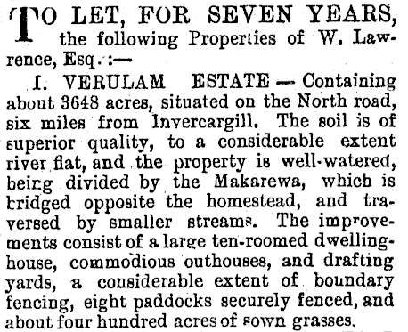

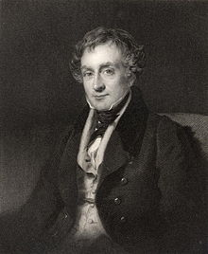
Lawrence, William Beach (1800–1881)

Parents: Isaac Lawrence (1768–1841) and Cornelia Ann Beach (1777–1857).
Spouse: Esther Rogers Gracie (1801–1857) in 1821.
Children: Isaac Lawrence (1823–1824), William Beach Lawrence Jr. (1825–1870), Isaac Lawrence (1828–1919), Esther Gracie Lawrence (1831–1893), Archibald Gracie Lawrence (1833–1850), Gratia Lawrence (1834– ), Hester Rogers Lawrence (1835–1836), Albert Gallatin Lawrence (1836–1887), Cornelia Beach Lawrence (1839–1924), Caroline Lawrence (1840– ), James Gore King Lawrence (1844–1895), and Francis Ogden Lawrence (1845–1930).
Kinship: Fifth cousin five times removed of the post–World War II Smith generation.
Education and Early Career
An imposing and cultivated figure in nineteenth-century American public life, William Beach Lawrence graduated from Columbia College in 1818, where he was a member of the Philolexian Society. He studied law at the Litchfield Law School and was admitted to the bar in 1823. He quickly entered diplomatic service and, in 1826, was appointed Secretary of Legation to Great Britain. The following year he served as chargé d’affaires in London, gaining valuable experience in international affairs.
Legal and Diplomatic Career
Upon his return to New York in 1829, Lawrence practiced law in partnership with Hamilton Fish, later Governor of New York and U.S. Secretary of State. He was active in civic and commercial initiatives, notably serving on the executive committee that promoted the building of the Erie Railroad, a transformational project for New York State. He developed a reputation as a scholar of international law, publishing essays, annotated editions of standard texts, and treatises that were influential in diplomatic and legal circles. In 1836, he became a vice-president of the New-York Historical Society.
After settling in Rhode Island in 1850, Lawrence entered state politics. He was elected lieutenant-governor in 1851 and served as acting governor in 1852. He also participated in Rhode Island’s constitutional convention. Later, in 1873, he argued a case before the United States Supreme Court.
Controversial Views on Slavery
Lawrence’s reputation was damaged by his outspoken defense of slavery. In an 1860 letter to the Journal des Débats in Paris, he argued that slavery “civilized and elevated” enslaved Africans under a “superior race” and criticized France for antislavery sentiment while benefiting from American cotton. His writings are now cited as a prominent example of Northern elite intellectual justification of slavery.
Later Life and Legacy
Following the Civil War, Lawrence withdrew from active political life but continued his scholarly work in international law. His annotated editions of Wheaton’s Elements of International Law and his writings on neutrality, maritime rights, and European diplomacy were well regarded in his time and influenced both American and European jurists. He died in Newport, Rhode Island, in 1881.

Lawrence, William Beach Jr. (1825–1870)
Parents: William Beach Lawrence (1800–1881) and Esther Rogers Gracie (1801–1857).
Spouse: None recorded.
Children: None recorded..
Kinship: Sixth cousin four times removed of the post–World War II Smith generation.
Family Background
William Beach Lawrence Jr. was the son of William Beach Lawrence, the distinguished Rhode Island jurist, international-law scholar, diplomat, and politician who served as Lieutenant Governor and Acting Governor of Rhode Island. Through his mother, Esther Rogers Gracie, he was connected to the prominent Gracie family of New York, placing him within the social and commercial elite of the antebellum Northeast.
Unlike his father, whose public career and writings are well documented, the younger William Beach Lawrence lived largely outside public office and appears only sporadically in the historical record.
Siblings (for Context)
His brothers and sisters included:
- Isaac Lawrence (1828–1919), lawyer and Democratic candidate for Governor of Rhode Island.
- Esther Gracie Lawrence (b. c. 1830), who married Dr. W. L. Wheeler.
- Albert Gallatin Lawrence (1836–1887), Union brigadier-general and U.S. Minister to Costa Rica.
- Cornelia Beach Lawrence, who married Baron von Klenck of Hanover.
- James Gracie King Lawrence (b. 1845), who married Catherine Augusta Le Roy.
Political Views and the 1860 Letter
William Beach Lawrence Jr. emerges most clearly in the fall of 1860, on the eve of the Civil War, through a letter reprinted and criticized by the St. Albans Weekly Messenger (Vermont) on 11 October 1860. The newspaper identified the writer as “not an office-holder,” “a Breckinridge man,” and a resident of Rhode Island, and named him explicitly as William Beach Lawrence. The son appears to hold the same political beliefs as his father; or possibly the father wrote the letter and it was attributed to the son because of the similarity of their beliefs.
The letter:
“He isn’t an office holder—is a Breckenridge man—lives in Rhode Island—his name is —William Beach Lawrence.
He has written a letter to some gentleman who owns a Cotton Mill, and to whom he utters the solemn warning that if Lincoln is elected, “a dissolution of this Confederacy is inevitable.” But he goes further than this,—and thus sets forth his own sentiments:
“Far be it from me to aggravate the complaints on the part of the South. But if a president is elected with the avowed object of creating a servile war, exposing, through missionaries of abolitionism and incendiary publications, (for the distribution of which the Post Offices are to be made subservient,) the property of the planters to conflagration and ruin, and their wives and daughters to horrors infinitely worse than death; no human man, however ardently attached to the Union, could object to their anticipating the fatal blow, not only by refusing obedience to the Federal authorities, but by even invoking, as did our ancestors of the Revolution, foreign aid.”
Now Mr. William Beach Lawrence, we conjure you not to dissolve this Union. People this way think a great deal of it, and certainly won’t allow it to be done if they can prevent such a dire calamity, and, Mr. Lawrence,—they think they can,”
The letter, addressed to the owner of a cotton mill, warned that the election of Abraham Lincoln would make “a dissolution of this Confederacy… inevitable.” It asserted that a Republican victory was undertaken “with the avowed object of creating a servile war,” accused abolitionists of inciting violence through publications distributed via the Post Office, and claimed that Southern planters faced not only economic ruin but threats to their families. The letter argued that under such circumstances no one, however devoted to the Union, could object to Southerners refusing obedience to federal authority and even invoking foreign aid, as had the American Revolutionaries.
The Messenger responded with an editorial rebuke, urging Lawrence not to promote the dissolution of the Union and insisting that Northern public opinion would not permit so catastrophic an outcome.
Attribution and Identification
The identification supplied by the St. Albans Weekly Messenger allows the letter to be attributed with high confidence to William Beach Lawrence Jr., rather than to his father. The explicit description of the writer as “not an office-holder” effectively excludes William Beach Lawrence Sr., whose service as Lieutenant Governor and Acting Governor of Rhode Island was widely known and would almost certainly have been emphasized had he been the author. The characterization of the writer as an active partisan supporter of John C. Breckinridge further supports attribution to the younger Lawrence, a private citizen of political age, rather than to the elder Lawrence, whose public persona was that of a cautious jurist and international legal scholar.
Historical Context and Significance
The letter places William Beach Lawrence Jr. among Northern Democrats and conservative Unionists who, in 1860, echoed Southern fears of abolition, “servile insurrection,” and constitutional overreach. Such views were not uncommon in Northern commercial and professional circles with economic or cultural ties to the South, and they illustrate the depth of sectional anxiety even outside the slaveholding states.
Although William Beach Lawrence Jr. never held public office and left no known descendants, his brief appearance in the political discourse of 1860 provides a revealing contrast with the more measured and institutionally oriented career of his father. It also underscores how members of prominent Northern families could articulate sharply divergent responses to the crisis of the Union on the eve of civil war.

Lawrence, William Beach (1886–1954)
Parents: Isaac Lawrence (1828–1919) and Lee Gwynne (1857–1946).
Spouse: Mabel Dawson (1884–1936).
Children: Gwendoline (“Gwynne”) Lawrence (1909–1954), Mabel G. Lawrence (1910–1920), Ada Lawrence (1912–2004), and William Beach Lawrence (1919–2009).
Kinship: Seventh cousin three times removed of the post–World War II Smith generation.
Early Life and Family Background
Born into the socially prominent Lawrence and Gwynne families, William grew up between New York City and Newport, Rhode Island. His mother, Lee Gwynne, was a well-known figure in New York society, and William inherited the tradition of Newport summer residency from both parental lines. His upbringing was characteristic of old New York families of the period, combining private education, club life, and seasonal movement between the city and resort communities.
Career and Military Service
Like many men of his social class, William’s professional life combined club, military, and civic engagements rather than a single career. He served in the Seventh Regiment, National Guard of New York, a socially prestigious unit whose membership was drawn heavily from New York’s old families. His military involvement continued through middle age, including training camps and peacetime regimental activities.
Residences and Social Life
William and his family divided their time between Newport, Rhode Island, and Bar Harbor, Maine, both central nodes in the early twentieth-century American “summer colony” circuit. His Newport residence placed him among the “cottage” society that persisted after the Gilded Age, while the Bar Harbor estate reflects the shift of upper-class summering patterns northward in the early 1900s.
He was a member of the New York Athletic Club. His participation in club life, Newport social events, and the Bar Harbor summer colony placed him in the last generation of New York society to maintain the pre-World War II seasonal social rhythm before World War II and postwar suburbanization altered it.
Later Years and Death
William outlived his wife by nearly two decades and saw the transformation of Newport from an exclusive summer colony into a more diversified community. Two of his children—Ada and William Jr.—lived well into the twenty-first century, preserving family connections to both Newport and Bar Harbor. He died in 1954.

Lawrence, William Effingham (1781–1841)
Parents: Effingham Erasmus Lawrence (1735–1806) and Catherine Farmer (1752–1806).
Spouse: Mary Ann George Smither (1797–1880).
Children: Robert William Lawrence (1807–1833), Charles Lawrence (1818– ), Mary Ann Lawrence (1821–1881), William Lawrence (1823–1898), Eliza Lawrence (1825–1844), John Effingham Lawrence (1828–1874), Edward Effingham Lawrence (1830–1890) and Effingham Billopp Lawrence (1830–1908) (twins), Emily Lawrence (1832–1855), Octavius Vernon Lawrence (1836–1915), Caroline Lawrence (1837–1865), and Fermor Lawrence (1840– ).
Kinship: First cousin six times removed of the post–World War II Smith generation.
Early Life and Family Background
William Effingham was the eldest son of Captain Effingham Erasmus Lawrence, a London merchant and member of the Corporation of the Elder Brethren of Trinity House, and his wife Catherine, née Farmer. With his brother Edward Billopp Lawrence, he continued his father’s mercantile business, principally in shipping, maintaining houses in London, Liverpool, and New York.
Connections and Decision to Emigrate
Highly educated, intellectually curious, and well connected, William was a close friend of the philosopher Jeremy Bentham. When William contemplated emigration for reasons of health and business concerns, Bentham wrote to Buenos Aires in 1822: “Our excellent friend on his way to Australia is not without thoughts of touching at Rio de Janeiro: a worthier man, a more benevolent cosmopolite, never left any country; and very few better informed or more intelligent.”
Having arranged with the British government to receive an Australian land grant in lieu of Treasury compensation for the loss of a ship, he purchased the cutter Lord Liverpool (71 tons) and sailed for Van Diemen’s Land in May 1822.
Brazil and the Struggle for Independence
Stopping at Rio de Janeiro for provisions, he arrived at a pivotal moment: Brazil was breaking from Portugal. There he befriended José Bonifácio de Andrada e Silva, the liberal statesman and principal architect of Brazilian independence under Dom Pedro. Lawrence remained for several months, became a confidant of José Bonifácio, and was urged to stay permanently. Captivated by events yet committed to his Australian venture, he sailed on.
Settlement and Landholdings in Van Diemen’s Land
William reached Van Diemen’s Land in 1823 and, jointly with his brother, received a grant of 4,000 acres with a further 4,000 acres reserved after five years. Due to surveying irregularities, the estate eventually comprised about 12,000 acres. The principal property, Formosa, lay along the Lake River. He later acquired major additional properties, becoming one of the colony’s largest landowners. His holdings included areas in and around Launceston such as Vermont (310 acres), Lawrence’s Paddock (164 acres), the Punchbowl (924 acres), and Penquite (1,832 acres). He expanded further with Billopp (2,000 acres) near Formosa, Point Effingham (9,651 acres), and Danbury Park (3,500 acres) on the Tamar River.
Surveyor John Helder Wedge, sent to investigate the size of the grant, became a lifelong friend, and Wedge’s niece Anne later married William’s son, Robert William Lawrence, in 1832.
Public Career and Civic Contributions
Under Lieutenant-Governor Sir John Franklin, Lawrence was appointed to the Legislative Council in 1837 and remained a member until his death. He was regarded as a man of independent principle, public spirit, and considerable talent.
He took a leading role in banking, commerce, and early education. In 1828 he helped found the Cornwall Bank and later served as a director of the Bank of Australasia after it absorbed Cornwall’s affairs in 1836. He also helped found the Tamar Steam Navigation Company in 1832, which operated vital river steamers—the Tamar, the Steam Packet, and later the Gipsy—promoting commerce between Launceston, George Town, and the Tamar Valley.
A strong proponent of education, in 1826 he drafted a plan for the Cornwall Collegiate Institution, intended as a center of scientific and liberal education, with laboratories, a botanical garden, and a public reading room. Although the institution did not succeed in its initial form, his advocacy laid groundwork for later educational initiatives, including the Church of England Grammar School at Launceston, established in 1846.
Reputation and Death
William Effingham Lawrence died at Launceston on 18 April 1841. Contemporary tributes praised his intellect, integrity, and public service. One obituary wrote that he was “foremost in advocating popular rights… a valuable friend, an able advocate, a disinterested patriot… by pursuing an honest and honourable course of public life… he had rendered himself greatly prized and esteemed.”
(Adapted in part from the Australian Dictionary of Biography.)

Lawrence, William Effingham (1888–1974)
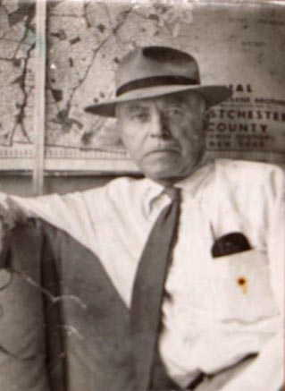

Parents: William Effingham Lawrence (1857–1902) and Emma Bradford Rose (1863–1920).
Spouse: Anita Livingston Ord (1894–1955).
Children: William Effingham Lawrence III (1922–2011), Jean Ord Lawrence (1926–) and Roger Ord Lawrence (1928–2001).
Kinship: Second cousin three times removed of the post-World War II Smith generation.
He attended school in Toms River, New Jersey, and worked as a realtor. He was a member of St Peter’s Episcopal Church in Port Chester.

Lawrence, William Effingham (1896 [1892]–1947)

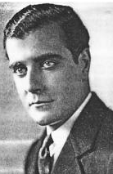

Parents: James Armitage Lawrence (1854–1900) and Ida Taber (1853–1931).
Spouse: None recorded.
Children: None recorded.
Kinship: Fifth cousin three times removed of the post-World War II Smith generation.

I have noted the discrepancy in the birth date. As an actor, he seems to have made himself a little younger in various documents than he actually was.

He also went by the names W. E. Lawrence, Babe Lawrence, L. W. Lawrence, W. A. Lawrence, W. E. ‘Babe’ Lawrence. You will note the absence of Effingham. He also gave up “Babe” Lawrence after 1924, because ”Babe” Lawrence (no relation) had committed a spectacular murder and was in the headlines.

W. E. appeared in 120 films, mostly silent, the most famous of which is W. G. Griffith’s Intolerance, in which he played Henry of Navarre. He starred with Douglas Fairbanks in Flirting with Fate

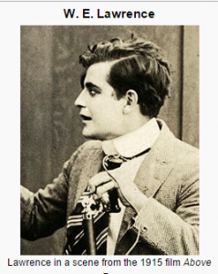
W.E. career reached its highpoint in the silent era. He seemed to play mostly himself: upper crust, old family WASP.

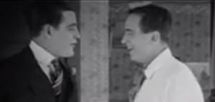

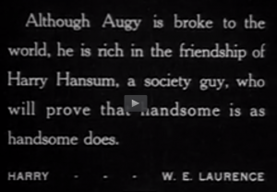

Initially he was in starring and leading roles; but with age and the talkies he became downwardly mobile, although still kept his active career as an actor: The Whole Town’s Talking (1935) as Customer, I’ll Love You Always (1935) as Furniture salesman, West of Carson City (1940) as Card man, Cigarette Girl (1947) as Doorman.

He died in 1947, shortly after his last acting job.

Lawrence, William Miner (1861–1935)
Parents: Abraham Riker Lawrence (1832–1917) and Eliza Williams Miner (1838–1915).
Spouse: Lavinia Oliver (1869–1916).
Children: Oliver Philips Lawrence (1892–1975), Clement Miner Lawrence (1897–1918), and Ruth Lawrence (1902–1992).
Kinship: Sixth cousin four times removed of the post–World War II Smith generation.
Early Life and Education
William Miner Lawrence was born in New York City on August 20, 1861, into a long-established New York legal and civic family. He attended Columbia College, graduating in 1883. A notice in The Columbia Spectator at the time of his graduation described him as “a young man of thoughtful character and steady application to his studies.”
Family
His younger sister, Ruth Woodhull Lawrence (1864–1949), was one of the founders of the National Society of the Colonial Dames of America in the State of New York in 1893; she did not marry.
On December 12, 1891, William married Lavinia Oliver (1869–1916), daughter of Charles Augustus Oliver, M.D., of Philadelphia, an ophthalmologist associated with Wills Eye Hospital. They had Oliver Philips Lawrence (1892–1975), U.S. Navy veteran; Clement Miner Lawrence (1897–1918), who died during World War I in the Bristol Channel; and Ruth Lawrence (1902–1992), who married Stuart M. Briggs, son of G. Loring Briggs, in 1926. Ruth, a 1925 graduate of Wellesley College, was one of only five non–family beneficiaries of the estate of Hetty Green, through a close mentorship with Green’s son, Colonel Edward Howland Robinson Green.
Career
After graduation, Lawrence entered New York real estate as a partner of Bryan L. Kennelly, a leading auctioneer and realty specialist. The Real Estate Record & Guide later recalled that the Kennelly firm “became a significant factor in Manhattan property transactions in the closing years of the century.”
Lawrence was elected as a Democrat to represent Manhattan in the 114th New York State Legislature, serving in the Assembly from January 1 to December 31, 1891. A brief profile in The New York Evening Post at the time referred to him as “a clear-headed and courteous young legislator whose manner commends him to both sides of the chamber.”
Following his legislative term, Lawrence had a long career in New York City government. He served as Assistant Secretary and Chief Clerk of the New York City Board of Estimate and Apportionment during the administrations of George B. McClellan Jr., William Jay Gaynor, and John Purroy Mitchel. Upon his retirement in 1924, The New York Times noted that he had been “for many years one of the trusted administrative officers of the Board of Estimate, valued for his accuracy and discretion.”
He also served with the New York State Board of Elections, first as Assistant Secretary and later as Secretary. A contemporary political column described him as “a painstaking and non-partisan official whose knowledge of electoral procedure was often sought across party lines.”
Later Life and Death
After retiring from public service, Lawrence remained active in civic circles and Columbia alumni affairs. At his death on March 26, 1935, The New York Times wrote that he was “widely known in municipal and State circles” and “held in esteem for an unassuming efficiency that marked his long public career.”

Lawrence, William Thomas (1788–1859)
Parents: Jonathan Lawrence (1737–1812) and Ruth Riker (1746–1818).
Spouse: Margaret Sophia Müller (1799–1877), daughter of Governor Johannes (Jan) Willem Müller, Dutch governor of St. Martin.
Children: John William Lawrence (1826– ); Augustus Lawrence (1828–1850), died unmarried; and Eliza Riker Lawrence (1831–1907), who married Dr. Alexander S. Wheeler of Elmira, New York.
Kinship: Fourth cousin six times removed of the post–World War II Smith generation.
Early Life and Family Background
William Thomas Lawrence was born in New York on September 5, 1788. He entered the mercantile business in the store of his elder brother, Abraham R. Lawrence, continuing the longstanding commercial tradition of the Lawrence family in New York.
Military Service
During the War of 1812, Lawrence served in several units of the United States Army. He first enlisted in the 4th Infantry, New York Artillery, and subsequently served with the 2nd Infantry from April 1812 until his transfer to the 8th Infantry in May 1815, covering the duration of the conflict and its immediate aftermath.
Move to Cayuta Lake and the Building of Lawrence Villa
In 1825, Lawrence moved to the east side of Cayuta Lake (Schuyler County, New York) and built an impressive residence there, known as Lawrence Villa. A vivid description of the home was recorded by Lawrence Beebe, who was born in the house:
“It is a tradition that William T. Lawrence boasted that he was going to have the finest house upstate. He brought his skilled workmen from Albany and built from virgin timbers on the estate. Like all the Colonial homes situated near water, it had a land front and a water front, the land front reached by an avenue of beautiful elm trees, the water front with an open porch. The large columns on the land front extended above the second story and were hewn from single trees. The timbers [were] pegged together and leaded pane rose windows [were] in the gables. The house was heated by fireplaces which were capacious. An intricate system of bell pulls was installed to summon servants to any part of the house. Dutch ovens were provided in the kitchen chimneys, and a smoke room off the kitchen flue in the attic for curing meat, also a wine room in the basement.”
The estate was regarded as one of the most notable country homes in the region. Later genealogical sources repeated the claim that at the time of its construction Lawrence was the fifteenth wealthiest man in the United States.
Career and Public Service
Lawrence became a judge and took an active civic role in his region. In national politics he was elected as a Whig to the Thirtieth United States Congress, serving from March 4, 1847, to March 3, 1849, representing New York.
Later Years and Death
After the death of his widow in 1877, Lawrence Villa—later known as White Gates—passed out of the family. William Thomas Lawrence died at his country home near Cayutaville on October 25, 1859. He was interred in the Lawrence family cemetery on Shore Road in the Borough of Queens, New York.

Lawrence, William Thomas (1817–1893)
Parents: John Lawrence Lawrence (1785–1849) and Sarah Augusta Smith (1784–1877).
Spouse: Sophie Clinch Tilley (1832–1894).
Children: Sarah Lawrence (1854–1857); Sophia St. Germain Lawrence (1858– ); Alice Montgomery Lawrence (1863–1895); and Margaret Woodhull Lawrence (1866– ).
Kinship: Fifth cousin five times removed of the post–World War II Smith generation.
Early Life and Family Background
William Thomas Lawrence was born in New York City on February 7, 1817. He was a member of the long-established Lawrence and Smith families of New York. Through his mother, he was descended from the Smiths of Smithtown, Long Island.
Career
Lawrence spent his career in New York financial institutions. He served as cashier of the Institution for the Savings of Merchants’ Clerks, a prominent mutual savings bank founded in 1820 to encourage thrift among mercantile employees. The annual reports of the Institution describe the cashier as a senior administrative and fiduciary officer, responsible for day-to-day financial operations, bookkeeping oversight, and custodianship of funds.
Later Life and Death
He lived most of his life in Manhattan, later residing in Brooklyn. William Thomas Lawrence died in Brooklyn on November 5, 1893, at the age of 76.

Lawrence, William Van Duzer (1842–1927)
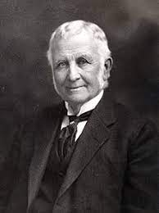

Parents: Robert David Lawrence (1808–1896) and Keturah (Catherine) Louisa van Duzer (1809–1896).
Spouse: Sarah Elizabeth Bates (1845–1926).
Children: Alice Manning Lawrence (1868–1960), Louise Adele Lawrence (1871–1965), Anna Bates Lawrence (1871–1950), Arthur William Lawrence (1875–1937), and Dudley Bates Lawrence (1875–1970).
Kinship: Fourth cousin four times removed of the post–World War II Smith generation.
Early Life and Family Background
William Van Duzer Lawrence was born in Elmira, New York, on February 28, 1842. His parents possessed a pioneering spirit and moved west to Michigan during his youth, where he grew up. At the age of nineteen he returned to New York City. He was commonly known as “Van” in both his business and social circles.
Early Career in Pharmaceuticals
After returning to New York, Lawrence worked for five years in the drug store of S. R. Van Duzer & Co. Through savings from his employment, he moved to Canada and became a representative for several pharmaceutical companies, including the firm Perry Davis & Son of Providence, Rhode Island, manufacturers of the patent medicine known as Pain-Killer.
Pain-Killer and Patent Medicines
Perry Davis’s Pain-Killer, first patented in 1845, was among the earliest nationally advertised remedies marketed specifically for the relief of pain rather than for a particular ailment. It became widely distributed, including through missionary channels abroad. Its formulation, based principally on opiates and ethyl alcohol, reflected the common medical practices of mid-nineteenth-century patent medicines. One period advertisement declared it “the great family remedy for internal and external pain,” and another assured customers that “no household should be without a bottle at hand.”
Lawrence gained increasing responsibility within the firm. In 1888, by then a partner in the renamed Davis & Lawrence Company, he returned to New York City. He and his family resided in the mansion he commissioned at 969 Fifth Avenue and summered at Kelp Rock (see Houses and Estates).
Related Ventures
In addition to his role in Davis & Lawrence, he established and operated the Fellows Medical Manufacturing Company while retaining the presidency of Davis & Lawrence. The company also issued household and nursing manuals, such as Nursing the Sick, later cited in Culinary Landmarks: A Bibliography of Canadian Cookbooks 1825–1949.
Family and Social Life in New York
Sarah Lawrence took an active interest in charitable work. She became prominently involved in the New York Exchange for Woman’s Work, a philanthropic retail outlet providing a means of support for women in need through the sale of their handiwork. The New York Tribune described it as “one of the most practically helpful institutions in the city.”
As their children grew, the Lawrence family remained socially active. Announcements in the early twentieth century recorded the engagements and marriages of their children, including the engagement of Arthur to L. Virginia Heppe of Philadelphia in 1902 and the marriage of Dudley Bates Lawrence to Katherine Clitherall Birch in Birmingham, Alabama, in 1905. In 1908, William and Sarah Lawrence accompanied Mrs. George B. Custer, widow of General Custer, on a three-month motor tour of France, Italy, Germany, and Austria.
Real Estate Development and the Creation of Lawrence Park
In the 1890s, Lawrence began shifting his primary focus from pharmaceuticals to real estate. In 1890 he purchased the 86-acre Prescott Farm in what would become Bronxville, New York. His concept was to create a planned suburban community of architect-designed homes. He commissioned architect William A. Bates to design a series of speculative cottages in a variety of picturesque styles, including Colonial Revival, Tudor Revival, and Queen Anne Shingle-style. The first houses were completed in 1891.
As the homes sold, Lawrence had Bates renovate the original mansion on the property into an inn, the Manor House. The community, named Lawrence Park, quickly developed a reputation for attracting artistic and literary residents and was described by 1896 as “an exclusive literary and artistic development.” By 1916 he had begun work on his own estate there, Westlands (see Houses and Estates).
Bronxville’s Exclusivity
Lawrence Park and the surrounding Bronxville community cultivated a socially selective environment. An advertisement in House and Garden in 1925 stated, “Restrictions? Yes! Bronxville has been carefully guarded in its development… The index of desirability has always been character, culture, and the ability to fit easily and naturally into the social scheme.” Later observers noted that social and religious exclusivity was a defining feature of early twentieth-century Bronxville, a characteristic that drew both admiration and criticism in retrospective accounts.
A landmark local institution from this era was the Gramatan Hotel, which Lawrence developed atop Sunset Hill. From 1905 until 1972, it became a celebrated gathering place for prominent figures of stage and society, hosting guests such as Greta Garbo, the Barrymores, Gloria Swanson, and Theodore Dreiser.
Founding of Sarah Lawrence College
Sarah Elizabeth Lawrence died on May 9, 1926. In her memory, William founded Sarah Lawrence College on his Bronxville estate, Westlands. Its academic design emphasized close faculty mentorship and individualized programs of study. In a letter to his children, he explained that colleges begin modestly but grow over time and “will live on undoubtedly for centuries to come, perpetuating the names of their founders while even our presidents and the greatest men of our country are forgotten.”
Founding of Lawrence Hospital
Lawrence also founded Lawrence Hospital after one of his sons fell critically ill and required transport to New York City for treatment. Desiring accessible medical care for his community, he established a local hospital in Bronxville. It later became part of the New York-Presbyterian network.
Later Years and Death
William Van Duzer Lawrence remained active in business and civic affairs into his later years. He died in Bronxville on November 23, 1927.
Advertising and Publicity
Lawrence was an inventive and prolific advertising promoter. His pharmaceutical ventures used distinctive and memorable advertising campaigns, including brochures, almanacs, booklets, and striking illustrated newspaper ads. One promotion styled Pain-Killer as “the great remedy of the age,” while another assured families that “from the nursery to the sick-room, it brings comfort and relief.” His marketing techniques helped establish Davis & Lawrence as one of the best-known patent-medicine enterprises of the period.

Lawrence House at 45 East 29th Street
Location: North side of East 29th Street, east of Madison Avenue, Manhattan, New York City.
Built: c 1850

Architectural Description

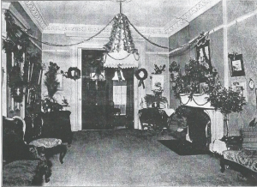
The house was a three-story brick row house of a type common among prosperous mid-Victorian families in Manhattan. Its interiors included a formal parlor with a marble mantel, upholstered seating, framed paintings, and decorative finishes consistent with the taste of the 1850s–1870s. Surviving photographs show richly furnished rooms capable of accommodating both social gatherings and amateur theatrical performances. The scale and layout allowed parlors to be temporarily transformed into performance spaces, reflecting the flexibility of elite domestic architecture of the period.

The parlor at Christmas

Ownership and Occupancy
In 1851, Newbold Lawrence and his wife, Anna Hough Trotter Lawrence, moved into 45 East 29th Street and established it as their winter residence. They occupied the house seasonally, spending winters in Manhattan while maintaining other residences elsewhere. Both remained associated with the house until their deaths, after which it continued to be occupied by members of the Lawrence family. The property remained in family hands into the twentieth century, with Caroline Trotter Lawrence (1852–1937) as its final long-term resident.
Home Dramatic Society and Theatricals

One of the most distinctive features of life at 45 East 29th Street was the Lawrence family’s Home Dramatic Society. Amateur theatrical performances were staged within the house, particularly during the 1870s, engaging children and young adults in structured cultural activity. In 1876, the family mounted several productions, including Ici l’on parle français, a fashionable drawing-room scene, and Popping the Question, a one-act farce set in 1799. Printed programs list multiple Lawrence family members in the casts, demonstrating the participatory nature of these events.
The theatricals were carefully staged and costumed, with surviving photographs showing performers posed in period dress. These productions reinforced public speaking skills, historical awareness, and social confidence, and aligned the family with a broader nineteenth-century tradition of elite amateur theatricals practiced in affluent urban homes.

Later Years and Caroline Trotter Lawrence
As siblings married and established their own households, Caroline Trotter Lawrence remained in residence. Unmarried throughout her life, she became the last family member to live in the house. One account records a surprise party given in her honor, at which gifts of silver were presented so that she might share symbolically in the generosity associated with the marriages and anniversaries of her sisters.
A notable photograph (left) shows Caroline wearing her grandmother Ann Hough’s Quaker wedding dress, a gesture that consciously linked generations and reflected the family’s reverence for ancestry and tradition.
Final Family Gathering
The last recorded Lawrence family function in the house took place in 1924, when it hosted a wedding reception for a granddaughter. Contemporary descriptions emphasize the deliberate preservation of tradition: the rooms were illuminated only by candlelight and richly decorated with flowers. As the bride and groom descended the staircase, guests showered them with rose petals, which afterward lay “inches deep on the floor.” This event marked a ceremonial conclusion to more than seventy years of continuous Lawrence family life within the house.

Lawson, Lawrence Milton (1880–1969)
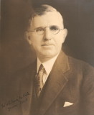

Parents: Gaines Lawson (1840–1906) and Laura Lawrence (1845–1894).
Spouse: Marie Joseph Macias (1887–1979).
Children: Laura Marie Lawson (1910–1985) and Catherine Lawson (1915–1999).
Kinship: Fifth cousin three times removed of the post–World War II Smith generation.
Family Background
Lawrence Milton Lawson was born in Tennessee on June 29, 1880. His mother, Laura Lawrence, was the daughter of Horace Lawrence (1814–1851), who in turn was the son of Samuel Adams Lawrence (1775–1851), linking him to the Lawrence family of Queens, New York. His father, Captain Gaines Lawson, served with distinction in the Union Army during the Civil War and was awarded the Congressional Medal of Honor for his actions at Minville, Tennessee, on November 29, 1863.
Medal of Honor Citation
Captain Gaines Lawson received the Congressional Medal of Honor for gallantry at Minville, Tennessee, risking his life under heavy fire to rescue wounded comrades from the battlefield. After the Civil War, he continued his military service in the West, including participation in the 1876–77 campaigns involving the Lakota and the aftermath of the Battle of the Little Big Horn.
Education
Lawson attended private schools in California and graduated from Stanford University. His education prepared him for a professional career in engineering and public works.
Career
Lawson began his professional life as a civil engineer, working on water and irrigation projects throughout the American Southwest during a period of substantial development in reclamation and river-management infrastructure.
President Calvin Coolidge appointed Lawson as United States Commissioner of the International Boundary Commission, the bi-national body responsible for maintaining the boundary between the United States and Mexico. His tenure was notable for its continuity: he retained his position through successive presidential administrations, serving through the New Deal era and into the Eisenhower administration.
The International Boundary Commission
The International Boundary Commission, established by the 1889 convention between the United States and Mexico, was responsible for surveying, marking, and maintaining the international boundary and for resolving disputes arising from changes in the course of boundary rivers. During Lawson’s tenure, the Commission focused on the rectification of the Rio Grande, transforming shifting meanders into a stabilized channel to prevent border disputes, improve flood control, and aid local development. His supervision of the El Paso–Juárez segment was considered one of the most technically and diplomatically sensitive phases of the project.
Later Life and Death
After his retirement from federal service, Lawson resided in California. He died on February 19, 1969, in San Diego.

Leisler’s Rebellion (1689–1691)
Background and Origins
Leisler’s Rebellion was a political and social upheaval in the Province of New York that unfolded between 1689 and 1691, during the broader imperial crisis triggered by the Glorious Revolution in England. In November–December 1688, King James II was deposed and fled to France, replaced by his Protestant daughter Mary and her husband, William of Orange, who ascended as William III and Mary II. While the transition of power in England was comparatively orderly, the political shock waves were felt across the Atlantic. In North America, colonial populations, long resentful of James II’s consolidation of control, seized the opportunity to challenge or overthrow his appointed officials.
Collapse of Dominion Government in America
Under James II, New York had been incorporated into the Dominion of New England, a centralized administrative structure that abolished local assemblies and placed several colonies under the authority of Governor Edmund Andros. When news of the revolution reached Massachusetts, the people of Boston arrested Andros on April 18, 1689. In New York, his lieutenant governor, Francis Nicholson, faced mounting opposition and fled to England in June. With the dominion apparatus disintegrating, there was no settled constitutional basis for a government in New York, unlike in New England colonies that could revert to earlier charters. This vacuum contributed to deep divisions over who held legitimate authority in the province.
“The government here being dissolved, we know not by what authority any man shall command us.” (New York resident, 1689)
Rise of Jacob Leisler and the Provisional Government
In June 1689 a Committee of Safety—formed by New Yorkers seeking to preserve order—appointed Jacob Leisler, a prominent merchant of German (Huguenot-Walloon) background, to command Fort James on Manhattan. By August he acted as the colony’s chief executive. Leisler governed in the name of William and Mary and considered himself a defender of Protestant liberties. Although he had not initially sought power, the political conflict soon became identified with him personally, and supporters and opponents were labeled Leislerians and Anti-Leislerians.
Factional Divisions and Escalation of Conflict
New York’s population at the time was ethnically and religiously diverse, including English, Dutch, Huguenot, Walloon, and German settlers. Divisions over Leisler’s regime reflected longstanding tensions. Leislerians tended to come from Dutch and Huguenot backgrounds, supported more rigorous Calvinist Protestantism, and included many artisans, small merchants, and farmers. Anti-Leislerians included some of the colony’s leading English families and officeholders, often associated with the former royal administration or with established commercial and landholding interests. The political divide penetrated deeply into counties, towns, congregations, and families.
“Those who favor Leisler cry that the Popish party would betray us to France.”
(Letter from New York to Boston, 1690)
Leisler’s suspicion of Catholic influence led him to govern assertively. He referred to opponents as enemies of the Protestant succession and imprisoned several critics. Albany initially resisted his authority, especially with French Canada threatening the northern frontier. Following a devastating French and Indigenous raid on Schenectady in February 1690, Albany finally acknowledged Leisler’s authority under pressure, and an assembly was called to raise funds for a Canada expedition, which ultimately failed.
Overthrow and Execution
By late 1690, Leisler’s support had eroded. Meanwhile, the English government resolved New York’s political uncertainty. In early 1691, Colonel Henry Sloughter arrived as the new royal governor. Sloughter and his officers sided with the Anti-Leislerians. Leisler initially refused to surrender the fort, believing he was upholding William III’s authority. When he yielded, he and his principal associate, Jacob Milborne, were arrested and charged with treason. After a controversial trial, both were executed on May 16, 1691. Their deaths generated lasting bitterness among supporters, who regarded them as martyrs to the Protestant cause.
“We die for the cause of our King and the Protestant religion.” (Jacob Leisler on the scaffold, 1691)
Aftermath and Legacy
Leisler’s Rebellion did not lead to civil war, but it inaugurated decades of factional politics in New York. The labels Leislerian and Anti-Leislerian persisted into the early eighteenth century, shaping elections, appointments, and alliances. Later historians have interpreted the conflict through various lenses, including ethnicity, religion, class, and family networks. Most agree that no single cause explains the rebellion; rather, New York’s unique social composition, lack of a charter-based political tradition, and the Dominion’s collapse created a volatile environment in which personal rivalries and family connections played decisive roles.
Key Terms
• Dominion of New England (1686–1689): A royal consolidation of several colonies under one appointed governor, Edmund Andros, abolishing local assemblies.
• Committee of Safety: A provisional body formed by New Yorkers in 1689 to maintain order after the collapse of dominion government.
• Williamites and Jacobites: Williamites supported William III and Mary II; Jacobites supported James II. In New York, these terms aligned loosely with Leislerian and Anti-Leislerian factions.
• Fort James: The principal fortification in Manhattan, later renamed Fort William Henry, Fort Anne, and Fort George at different times.

Leisler’s Rebellion and the Lawrences
Overview
The factional split of 1689–1691 ran through multiple Lawrence branches. Some aligned with the Leislerian provisional regime that governed “for William and Mary”; others joined the Anti-Leislerian coalition that restored royal control and presided over Jacob Leisler’s treason trial in 1691. In practice, alignments reflected office-holding, militia command, Dutch–Huguenot ties, and marriage networks with leading New York families.
Leislerian-Aligned Lawrences
Evidence from contemporary and near-contemporary sources places Major Thomas Lawrence of Newtown (c.1621–1703) in active provincial service under the revolutionary government. An order of 29 July 1690 directs “Major Thomas Lawrence” to press men—horse and foot—indicating his command of Queens County forces during the crisis, which corresponds with Leisler’s mobilization after the Schenectady raid.
Later provincial rosters show a William Lawrence sitting on the Governor’s Council in the early 1700s (under Lord Cornbury), a post commonly held by men who had navigated the 1690s partisan landscape into the restored royal order. While this does not, by itself, prove 1689 Committee of Safety membership, it confirms a Lawrence presence at the apex of provincial government soon after the rebellion.
Anti-Leislerian Lawrences
The clearest Anti-Leislerian identification is John Lawrence (1618–1699), twice Mayor of New York City (1672 and again 1691). After Governor Henry Sloughter arrived, John Lawrence sat as a judge on the special Court of Oyer and Terminer that tried Leisler and Jacob Milborne for treason—an unmistakable signal of Anti-Leisler alignment.
Patterns Across Branches
Queens/Long Island militia leadership (Newtown/Flushing) placed some Lawrences in the orbit of the provisional government’s defensive measures against French and Indigenous incursions; Manhattan municipal and mercantile positions drew others toward the Anti-Leisler restoration centered on the new royal governor and council. These are not absolute rules—kinship and patronage frequently crossed factional lines—but they map onto the principal split visible in 1690–1691. The political bitterness after the May 16, 1691 executions kept the labels “Leislerian” and “Anti-Leislerian” alive in New York for decades. history.nycourts.gov+1
Women, Marriages, and Alliance Networks
Women of the Lawrence family appear in the record chiefly through marriage alliances that linked Lawrence lines to dominant Dutch-English houses on both sides of the divide (e.g., Bayard, Van Cortlandt, Beekman/Schuyler circles). These marriages often eased later reconciliation, even where immediate kinsmen had been on opposing sides in 1689–1691.
Consequences for the Family
For Anti-Leislerians like John Lawrence, restored royal favor translated into office-holding and judicial preferment in the early 1690s. For Leislerian-adjacent lines in Queens, militia service in 1689–1690 signaled local authority and community standing during the emergency, though association with the fallen regime could be a handicap in the immediate aftermath. In the longer run, however, both strands re-entered provincial life: by the early 1700s a William Lawrence is recorded on the Governor’s Council (1702–1708 cohort), exemplifying how the name persisted at the top of New York politics despite the fracture.

Lenox
Early History of Lenox
Lenox, located in the Berkshires region of western Massachusetts, was first settled in the mid-18th century. The area, originally known as Yokuntown, saw its initial European inhabitants arrive around 1750, with Jonathan Hinsdale and his family among the pioneers. The town was officially incorporated in 1767 and named after Charles Lennox, the Third Duke of Richmond. Early residents were primarily farmers, traders, merchants, and innkeepers, and the community played an active role in the Revolutionary War, with local figures like Colonel John Paterson contributing to key battles.

By 1784, Lenox became the county seat of Berkshire County, hosting courts and fostering growth through institutions like the Old Red Inn (now the Curtis Hotel). Education was a cornerstone, with Lenox Academy established in 1803 and schools run by figures like Mrs. Charles Sedgwick attracting students from Boston and New York.
In the mid-19th century, the arrival of railroads improved accessibility, drawing literary and artistic figures to the area's scenic mountains, lakes, and countryside—often compared to Switzerland's landscapes. Notable early visitors included Nathaniel Hawthorne, who wrote The House of the Seven Gables and Tanglewood Tales nearby, Herman Melville, Fanny Kemble, and painter George Inness. This cultural allure set the stage for Lenox's transformation into an elite retreat.
The Gilded Age: Lenox as a Favored Spot
The Gilded Age, spanning roughly from the end of the Civil War in the 1870s to the early 1900s, marked Lenox's peak as a summer haven for America's wealthiest families. During this era of rapid industrialization and economic boom, titans in railroads, steel, banking, oil, and manufacturing—such as the Vanderbilts, Morgans, Astors, Carnegies, and Sloanes—amassed enormous fortunes and sought escapes from urban heat and congestion in New York and Boston. Lenox, often dubbed the "Inland Newport," became one of the richest towns in the U.S., with about 35 mansions built by 1880, doubling to 75 within two decades. The town was the epicenter of the Berkshires' social season, hosting garden parties, balls, musicales, and sporting events that created a vibrant ecosystem of luxury and status.

Several factors made Lenox particularly favored:
- Natural Beauty and Climate: The rolling hills, tranquil lakes, cool mountain air, and lush landscapes provided a refreshing contrast to city life, evoking European idylls and promoting health and relaxation.
- Accessibility: Railroads allowed easy travel from major cities, enabling families to transport staff, luggage, and even horses, while maintaining seclusion.
- Social Prestige and Competition: The area fostered an "architectural arms race" among elites, who built opulent "cottages" (a modest term for grand estates) to display wealth, host society events, and emulate European nobility. This social emulation boosted the local economy through employment of vast staffs—including butlers, chefs, maids, and gardeners—and investments in community infrastructure like churches and libraries.
- Cultural Foundation: The pre-existing literary and artistic community added intellectual appeal, with figures like Edith Wharton (who designed her own estate) enhancing the area's reputation.
These estates were self-contained worlds of extravagance, often inspired by global styles like Beaux-Arts (symmetrical and ornate), Shingle Style (asymmetrical and landscape-integrated), Colonial Revival (echoing American heritage), and Jacobean Revival (featuring brickwork, gables, and tall chimneys). Building peaked from the 1880s to the 1920s, with properties on prominent peaks symbolizing informal country life amid formality.
Notable Gilded Age Mansions in Lenox
Many of these "cottages" have been preserved as museums, hotels, or cultural sites, offering glimpses into the era's opulence. Here are some key examples:

- The Mount: Built in 1902 by Edith Wharton (with architect Ogden Codman, Jr.) in a classical style inspired by European villas. This 42-room estate with gardens was where Wharton wrote Ethan Frome. It now serves as a cultural center with tours, exhibits, events, and weddings; it's restored and open to the public.
- Ventfort Hall: Constructed in 1893 for George and Sarah Morgan (Sarah was J.P. Morgan's sister) in Jacobean Revival style. This 28-room Elizabethan-style mansion featured a great hall, wood paneling, 15 bedrooms, 13 bathrooms, and 17 fireplaces. It hosted lavish events and is now a Museum of the Gilded Age with ongoing restoration, open for tours, lectures, and performances; it's on the National Register of Historic Places.
- Bellefontaine (now part of Canyon Ranch): Built 1896–1898 for Giraud Foster in a French-inspired style modeled after the Petit Trianon at Versailles. It symbolized wealth display and is integrated into a luxury spa and health resort.
- Blantyre: Completed in 1901 for Robert Paterson in Tudor Revival style with feudal elements like towers, turrets, and gargoyles, modeled after a Scottish ancestral home. It was used for elite gatherings and is now a luxury resort, hotel, spa, and event venue open year-round.
- Wyndhurst (formerly Ethelwynde): Originally built in 1875 (rebuilt 1928) with various styles, including nickel fixtures in later versions. It served as a family retreat hosting royalty and politicians, with gardens featuring exotic trees. It's now part of Wyndhurst Manor & Club.
Other notable Berkshires mansions near Lenox, like Shadowbrook (built 1893 for Anson Phelps Stokes, later owned by Andrew Carnegie, now Kripalu Yoga Center) and Wheatleigh (1893, Italian palazzo-style, now a hotel), contributed to the region's allure. Many original wooden structures were prone to fires and replaced or demolished.
Decline and Legacy
The Gilded Age in Lenox waned after World War I due to factors like the introduction of income taxes, the 1929 stock market crash, labor shortages as industrial jobs drew away servants, and shifting social norms. Maintaining vast estates became unsustainable, leading to conversions into hotels, schools, or health centers. A new chapter began in the 1930s with cultural developments, most notably the Boston Symphony Orchestra establishing Tanglewood in 1937 on a former estate site, turning the Berkshires into a world-class summer music and arts destination attracting over 300,000 visitors annually. Today, preserved sites like Ventfort Hall and The Mount serve as museums, preserving the era's legacy while boosting tourism. Lenox remains a cultural hub, blending its opulent past with modern festivals in theater, music, and dance.

Leroy Place
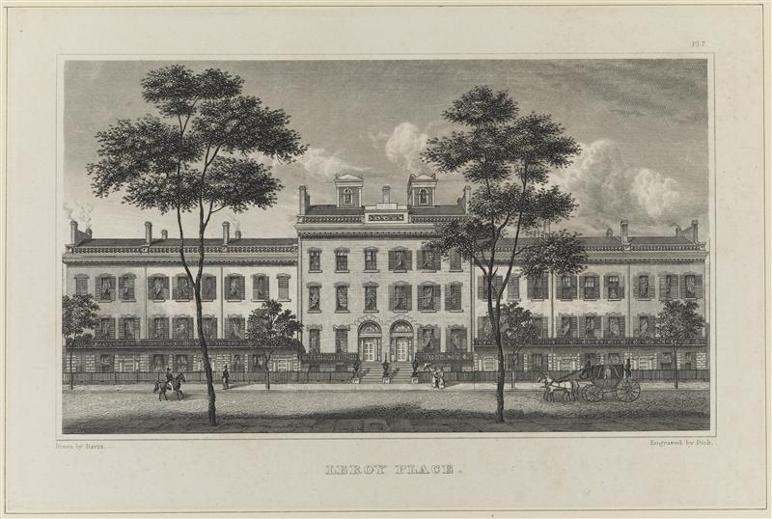
Location: the south side of the block between Mercer Street and Greene Street in what is now Greenwich Village, Manhattan, New York.
Built: c. 1830.
Architect: Alexander Jackson Davis.

Architect
Alexander Jackson Davis (1803–1892) was one of America's most influential architects of the 19th century, renowned for his mastery of the Picturesque movement and his versatile work across multiple revival styles, including Greek Revival, Gothic Revival, Italianate, and Egyptianate. Born in New York City, he began his career as a draftsman and partnered early with Ithiel Town, contributing to landmark designs like the New York Custom House and various state capitols. After parting ways, Davis became a leading figure in country house design during the 1840s–1850s, advocating for romantic, asymmetrical compositions that harmonized with natural landscapes—exemplified in masterpieces like Lyndhurst (Tarrytown, NY) and contributing to Leroy Place as an early urban project showcasing his Federal-style elegance before his shift toward more eclectic and Gothic forms.

Architectural Description
Leroy Place was conceived as a unified residential terrace modeled on the “terraces” of London: a continuous row of identical attached townhouses designed as a single architectural composition rather than as individual speculative houses. The development consisted of Federal-style row houses, harmonized by consistent height, materials, and proportions, and set back behind small but orderly front yards that reinforced the sense of elegance and uniformity.
Isaac G. Pearson commissioned the architect Alexander Jackson Davis, one of the leading American architects of the period, to design the terrace. The houses were constructed of granite, an unusually substantial material for New York row houses of the era, underscoring the ambition and expense of the project. The restrained Federal detailing, regular fenestration, and disciplined rhythm of the façades gave Leroy Place a distinctly refined character, setting it apart from more piecemeal urban development.
History
Leroy Place was developed in the early nineteenth century by Isaac G. Pearson, who not only built the terrace but successfully persuaded the city to rename the block in honor of the development. The name “LeRoy Place” commemorated Jacob LeRoy, a prominent Knickerbocker merchant, thereby linking the project to established mercantile prestige.
According to Gotham: A History of New York City to 1898, the Federal-style houses sold for the substantial sum of twelve thousand dollars each, placing them firmly in the upper tier of the city’s residential market. The terrace quickly attracted residents from some of New York’s most prominent families, including the Stuyvesants, Clintons, and Beekmans, reinforcing its status as a fashionable and socially significant address.
Among its residents was Edward T. Thebaud (1798–1854), a member of the prominent Thebaud mercantile family, who lived at Leroy Place alongside these well-connected neighbors. His presence there situates Leroy Place within the broader social and economic networks of early nineteenth-century New York commerce and society.

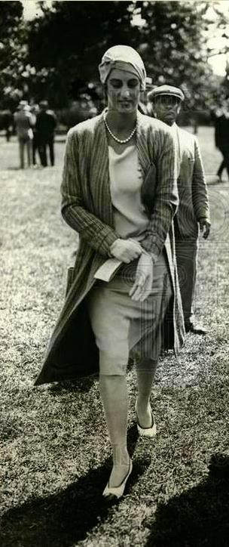
Loomis, Anne (1890–1948)

Parents: Dewitt Loomis (1850–1907) and Anne Williams Wallace (1869–1940).
Spouse: James Henry Alexandre (1883–1956).
Children: James Henry Alexandre III (1915–1963), Dewitt Loomis Alexandre (1917–1982), and Lawrence Jerome Alexandre (1923–2001).
Kinship: Wife of the granduncle of the post–World War II Smith generation.
Early Life and Family Background
Anne Loomis was born in 1890, the daughter of Dewitt Loomis and Anne Williams Wallace. She grew up in a family with social ties in the Northeast and received the upbringing typical of a young woman of her class in the early twentieth century.
Marriage and Family
She married James Henry Alexandre in 1911. The couple lived in New York society, and Anne was frequently mentioned in the press for social and charitable events. They had three sons: James Henry Alexandre III, Dewitt Loomis Alexandre, and Lawrence Jerome Alexandre.
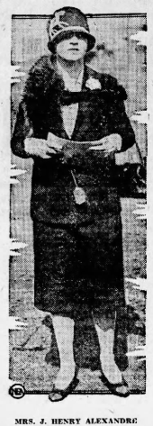
Public Life, Fashion, and Society
Anne Alexandre became known for her interest in horse racing and was a familiar figure at major tracks and at the associated social gatherings. Her fashion sense attracted notable press attention. Newspapers across North America cited her wardrobe as exemplary of refined taste, particularly in tailored suits and sporting attire.
“A shimmering white satin sports blouse was Mrs. J. Henry Alexandre’s choice for wear with her O’Rossen tailored suit of navy blue worsted, fashioned with a wrap-around skirt and a slight nip-in at the waistline of her jacket.”
She was often presented in society columns as setting a model for appropriate dress—elegant, understated, and impeccably tailored.
Later Years and Death
Anne lived an active social life, balancing family, society, and interests in equestrian circles. She died in 1948.

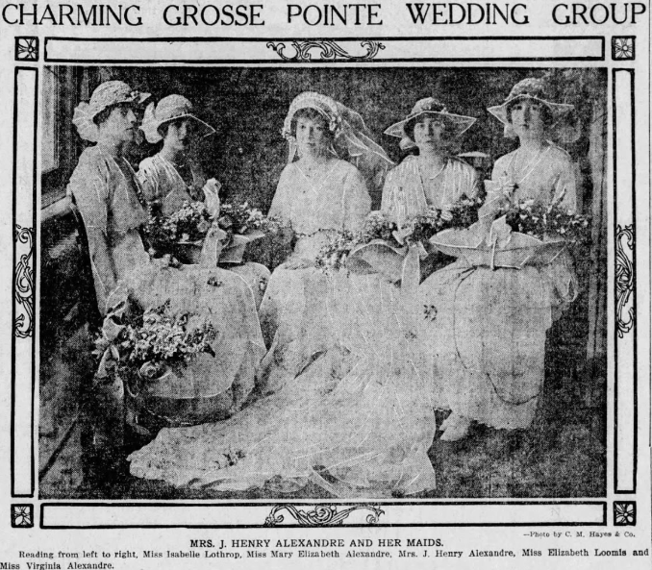

Los Vientos
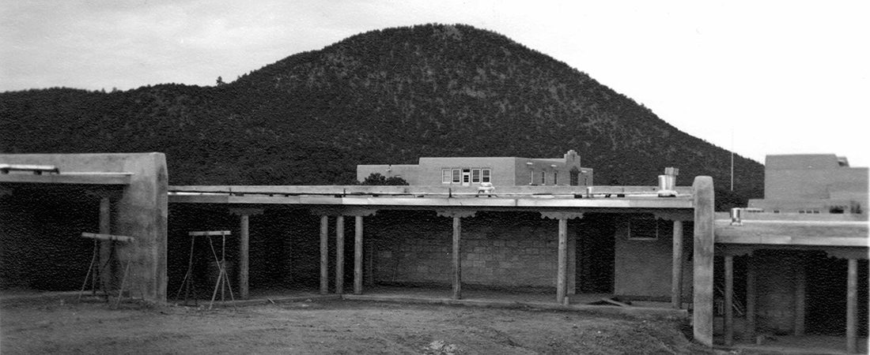
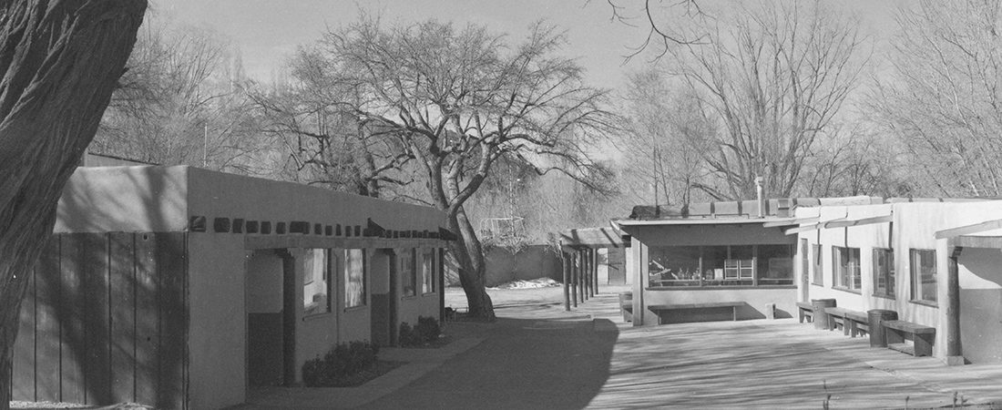
Location: Upper Canyon Road, Santa Fe, New Mexico
Built: 1926 with later additions by John Gaw Meem.

Architectural Character
Los Vientos was originally a ranch-style residence influenced by Santa Fe’s adobe and Pueblo Revival traditions, consistent with Upper Canyon Road’s informal, site-responsive architecture. Early descriptions suggest a low, rambling structure adapted to terrain and climate, with terraces and outdoor spaces integrated into daily life. Precise architectural documentation is limited, but family testimony emphasizes its unpretentious, organic character rather than formal architectural display.
Later Alterations
As the family’s needs changed, Los Vientos underwent significant remodeling. Architect John Gaw Meem, a close family friend and a leading figure in Santa Fe architecture, was engaged with the intention of preserving the original adobe character. Family recollections indicate that this goal was compromised by later decisions to add a second story, a glass-brick greenhouse, and a white stucco exterior. These alterations substantially altered the building’s appearance, and the original architectural charm of Los Vientos was regarded within the family as having been permanently lost.

Landscape and Grounds
The property included terraces, orchards, and a water feature that evolved into a swimming pool. Family accounts describe the physical labor involved in shaping the grounds, including enlarging an existing duck pond with teams of horses. At one point, the Santa Fe River was diverted through the pool and returned to its bed, allowing for winter freezing and improvised curling on the ice. The grounds supported a lively menagerie of animals—ducks, geese, and other creatures—reflecting the property’s ranch-like, experimental atmosphere.
Name and Origin
Los Vientos—Spanish for “the winds”—was a deliberately playful name. It functioned as a near-translation and Spanish pun on The Breeses, echoing the naming tradition established by James Lawrence Breese’s Gilded Age house The Breezes in Tuxedo Park, New York. According to family recollection, the Spanish name was suggested by local Hispanic neighbors shortly after the family settled on the property.
History
James Lawrence Breese Jr. first encountered Santa Fe during an aviation journey, when strong headwinds forced his tri-motored Ford aircraft to land in the area. Captivated by the landscape, climate, and culture, he later acquired land on Upper Canyon Road and established Los Vientos as a permanent base. He lived there while he invented the Breese Burner.

His daughter reminisced:
My father gathered his children and their friends together on the promise of a swimming pool if we all helped. It was hard work under the hot sun, carrying those heavy rocks. I still have a photograph of Andres behind a team of horses hitched to a plow digging out and enlarging the existing duck pond on the terrace below the house. That first summer, the only pool that came to be was still used exclusively by geese and ducks. I especially remember the geese who weren't very friendly to little girls. Later, of course, a real swimming pool did materialize. A friend who was around in these days writes that Dad diverted the Santa Fe River through the pool and back into the river bed. In winter, the pool sometimes froze; and some of the older children went out curling with broomsticks and skates.
Artist Randall Davey, who lived and kept his studio about a mile up Canyon Road from us (now a notable Audubon museum property), often came to Los Vientos to swim. He and Dad thought it would be a "bully" idea to install two trapezes, one at either end of the oblong pool. Each trapeze was reached by a ladder, topped by a small platform. Once on the platform, the next step was to throw out a grappling hook and pull in the trapeze. Somebody on the opposite platform would hurl out his trapeze, while at the same time the person going over would time leaving his platform to swing out so there could be a midair transfer leap from one trapeze to the other above the pool. Davey loved to show his trapeze artistry by including a somersault before grasping the on-coming trapeze, while, of course, all onlookers clapped enthusiastically. There was always a beginner who confidently let go with both hands and, because of poor timing, missed the on-coming trapeze completely, plunging into the water amidst howls of laughter from the sidelines. We smaller children soon figured a sure-fire way to make it across, avoiding the disgrace of missing and falling in. The trick was to get hold of the on-coming trapeze with one hand before letting go of the other trapeze. This method was looked down upon, however, and dubbed "monkey style".
Speaking of monkeys, we acquired a real monkey quite soon after moving into Los Vientos. My parents were telling a house guest of a remarkable drugstore on the plaza run by Martin Gardesky. He had the reputation of getting anything a customer wanted, no matter how bizarre the order. Our friend made a bet with Dad that Mr. Gardesky couldn't get us a monkey. He lost the bet; and Chango, "monkey" in Spanish, joined the growing menagerie. He was the special pet of my sister NC, who would go everywhere with him riding on her shoulders, hanging on tenaciously to her long braids. Chango caused havoc around the house, and I can remember my mother in tears when a favorite pueblo pot was broken. On one occasion, we all got up from the dining room table to greet a guest at the front door and returned to the dining room to find Chango sitting smack in the middle of what had been a beautiful bowl of Pink Floating Island pudding. He was eating with much gusto, as he flung pieces of egg white around the table. One summer, Chango became apathetic, lost his appetite and got so weak that we children kept him in a little doll buggy. The vet could not determine the cause of his sickness, but when he finally died an autopsy revealed arsenic in his system. He had eaten apples from one of our trees, which had in those days been sprayed with arsenic.
When Los Vientos needed additions and remodeling, Meem, an old friend of our family, was called in. He wanted to preserve the character of the original old adobe, which he would have done expertly, but my stepmother insisted on his making changes that included a second story, an attached greenhouse of glass brick, and an exterior of white stucco. The original charm of Los Vientos was lost forever.

